Create a Google tag manager account and integrate google analytics account and check when trigger is fired it will reflect in the google analytics as well as in Google Tag Manager

Google Tag Manager:
GTM uses tag, trigger and Variable.

Tag:
GTM provides template (snippets, a piece of code basically in javascript code) for different tools like google analytics, google ads, facebook pixel and etc.
We have to include this template to our site’s web page’s header tag to get activate.

Otherwise, we can simply use the GTM interface to activate it.

Tag’s main functionality is to track the specific action like if the audience is clicked the shop now button, or any other conversion button, click the submit button, or scroll the page.

By using Tag we will connect the google analytics to the Google Tag Manager.

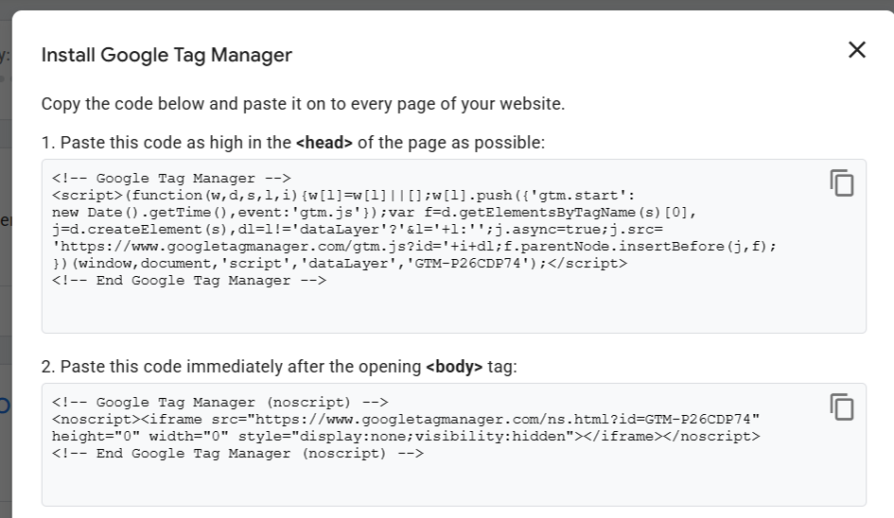

Trigger:
In our webpage when an event(page view, button clicked, page scroll, and etc) is executed our tag will be triggered.
For example in our website if a shop now button is clicked then the tag is triggered is called a trigger.

That process is called the trigger.

Variables:
Variables are placeholders that can have a different values that can be used in tag. They can capture information such as url, text , class name, and etc.

For this website



The shop now button has text “Shop now”

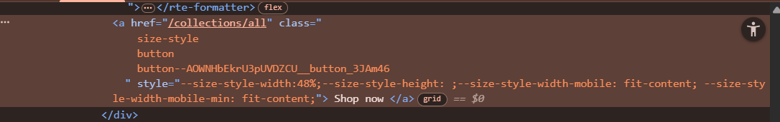
<a href="/collections/all" class="
size-style
button
button--AOWNHbEkrU3pUVDZCU__button_3JAm46
" style="--size-style-width:48%;--size-style-height: ;--size-style-width-mobile: fit-content; --size-style-width-mobile-min: fit-content;">
Shop now
</a>

Create a Google Tag Manager:

Visit google tag manager site.

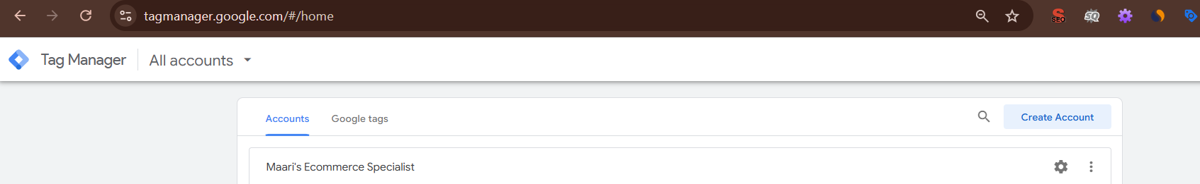

Here create account:

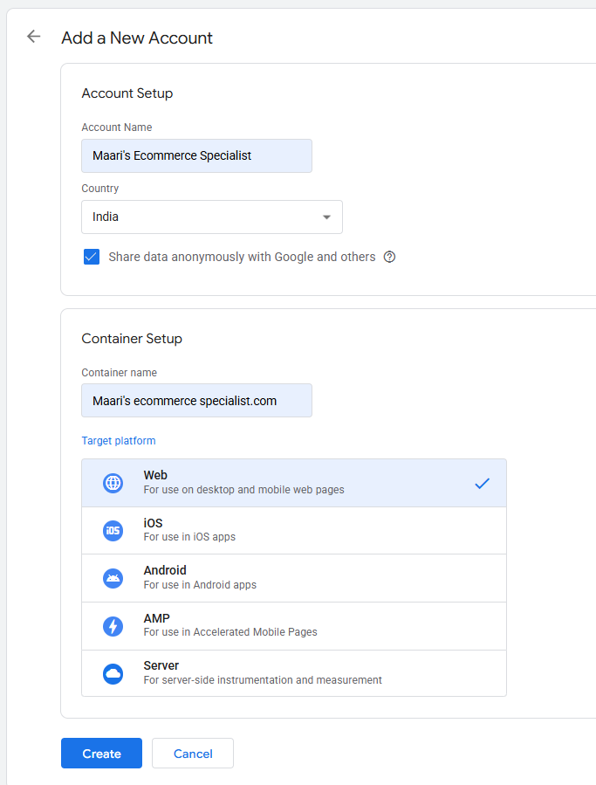

Account name and Container name and for only identification purpose so we can give any name that we suitable for us.
Here we create a tag for a website so we select the web here if we want to create a tag for android app we can select android app.

Once we created it will show like this.

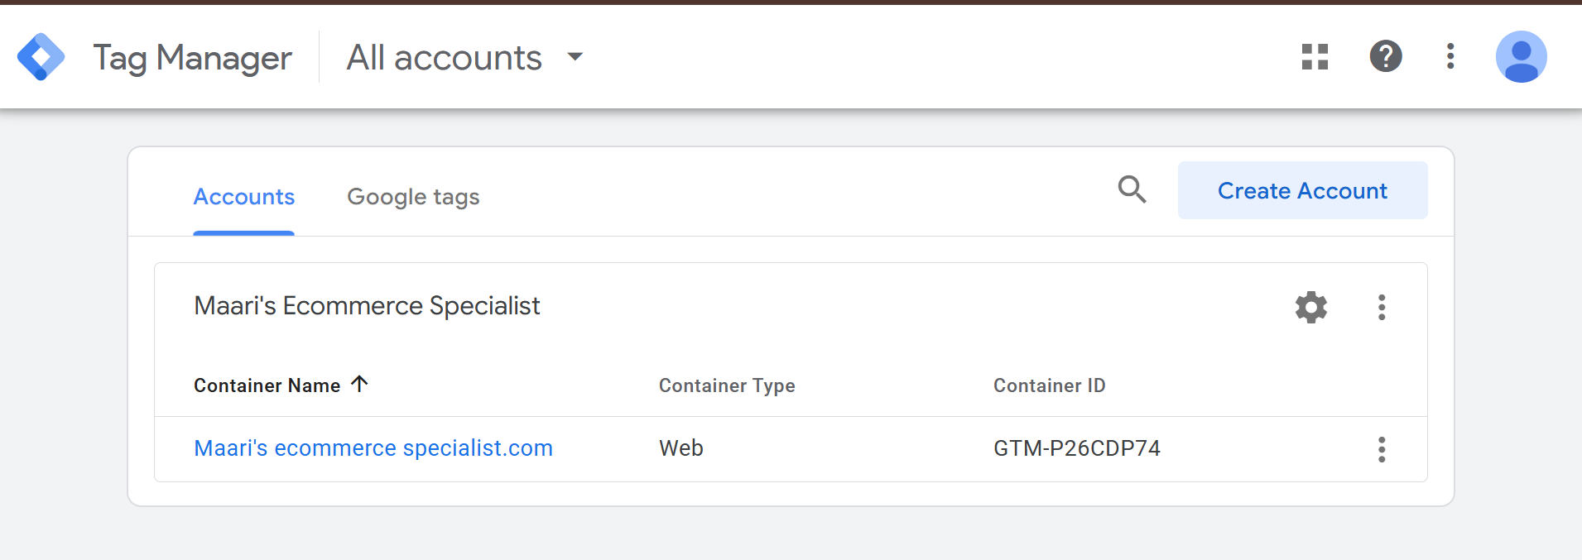

In workspace click container id

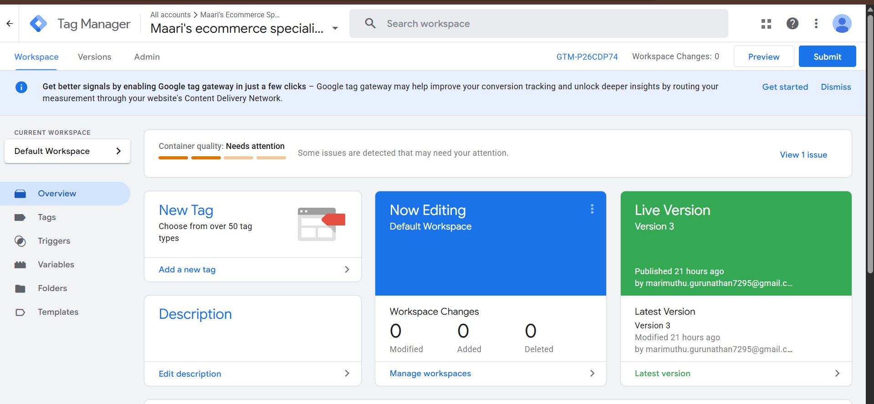

To get the code to copy to our website.
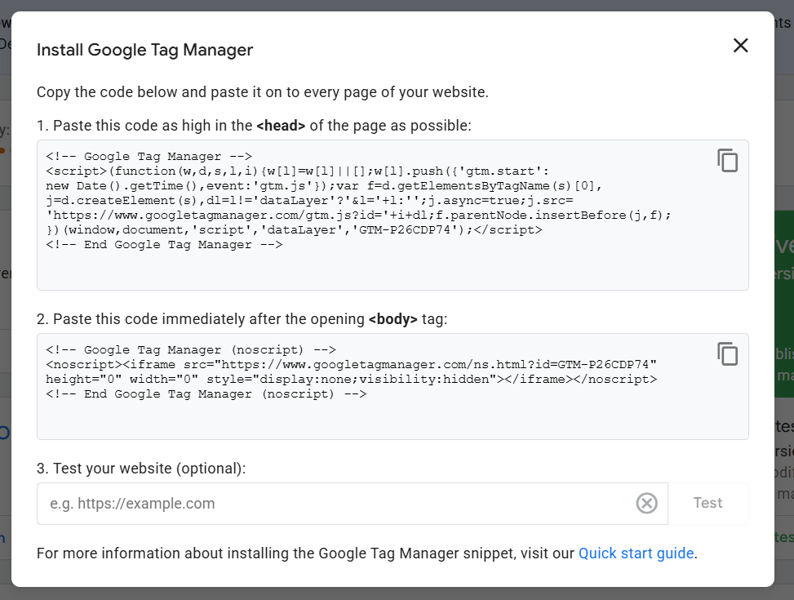

This code is used in google analytics, facebook pixel, and linkedin ads and etc.

Here I use a shopify store so i have to add that code to my shopify site.

Path:
shopify>online store>theme>click meatball icon>edit code

> layout>theme.liquid

Paste the code
Under head and body tag

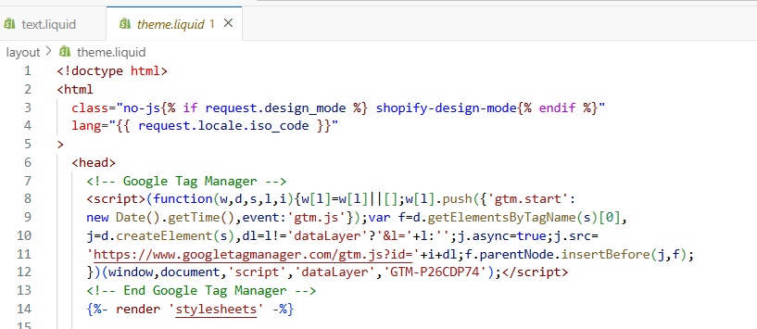

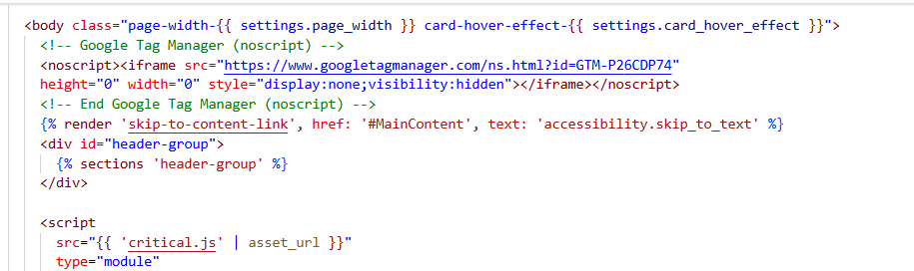

To check if we correctly paste the code in our website to check
Paste our website link and test

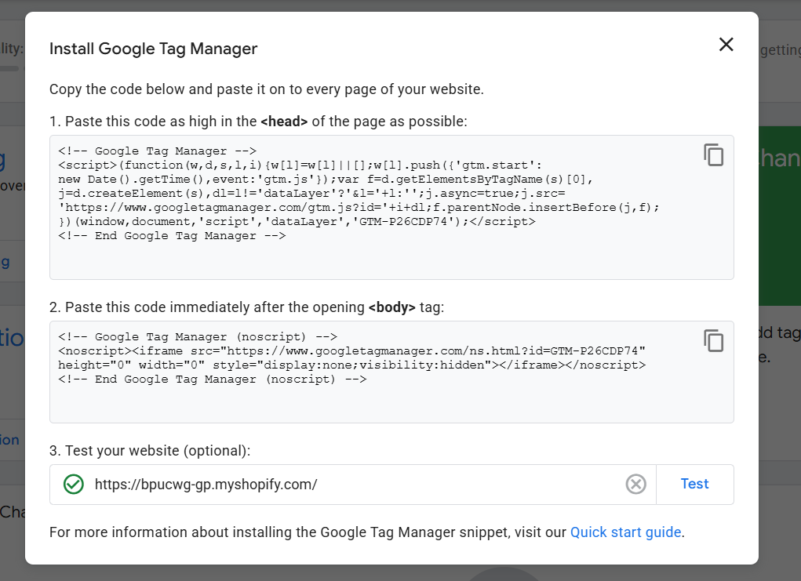

Here our website linked with Google tag manager.

To connect google analytics to Google tag manager.

By using tag we are going to connect GA to GTM

Go to workspace click tag
Create tag and trigger

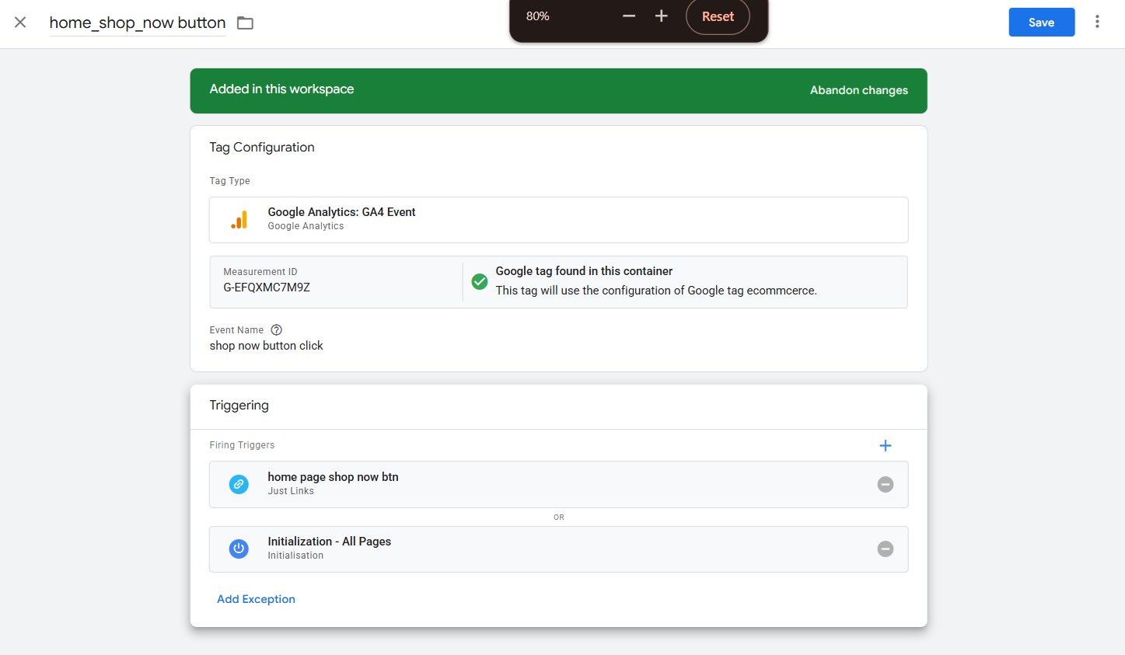

Once we done with tag and trigger creation and then preview and submit

It asked for our website link once we connect it we will redirect to our website and it will show like this “Tag assistant connected”
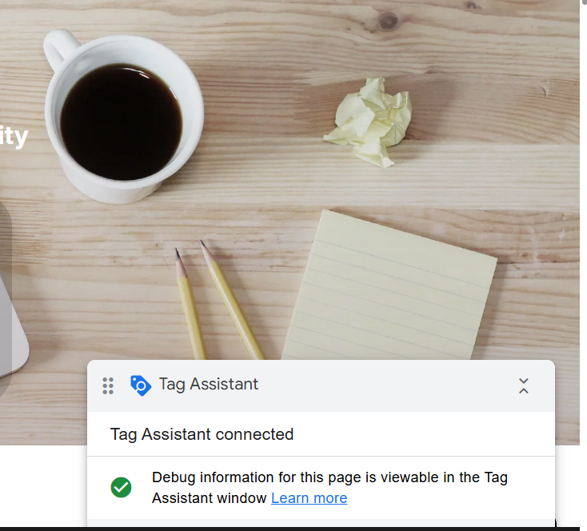

Once we click the shop now button in our web page

Then we can see our tag is triggered and also it reflect in google analytics.

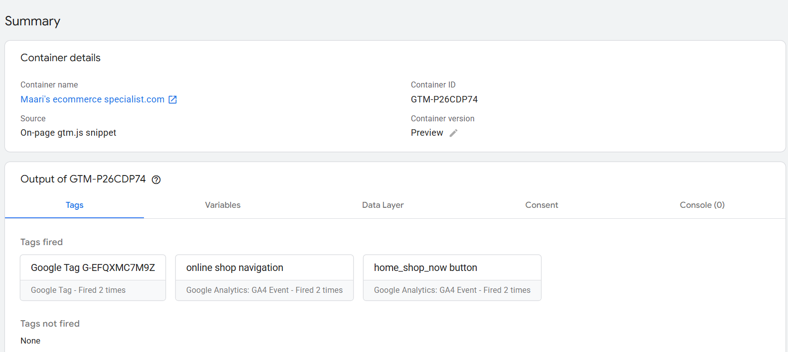

Here in google analytics it will show in reports>realtime overview>event count by event name we can see that

