- Introducing VIEWS

Views are stored queries invoked produce a result set. A view act asa a virtual table.

Views are some query that we give a name to and we can store. So we don’t have to write that query over and over.

CODE:

- -- INSTEAD OF TYPING THIS QUERY ALL THE TIME...
- SELECT
- title, released_year, genre, rating, first_name, last_name
- FROM
- reviews
- JOIN
- series ON series.id = reviews.series_id
- JOIN
- reviewers ON reviewers.id = reviews.reviewer_id;

- -- WE CAN CREATE A VIEW:
- CREATE VIEW full_reviews AS
- SELECT title, released_year, genre, rating, first_name, last_name FROM reviews
- JOIN series ON series.id = reviews.series_id
- JOIN reviewers ON reviewers.id = reviews.reviewer_id;

- -- NOW WE CAN TREAT THAT VIEW AS A VIRTUAL TABLE
- -- (AT LEAST WHEN IT COMES TO SELECTING)
- SELECT * FROM full_reviews;

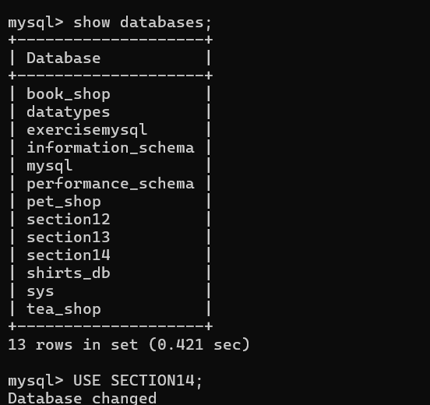

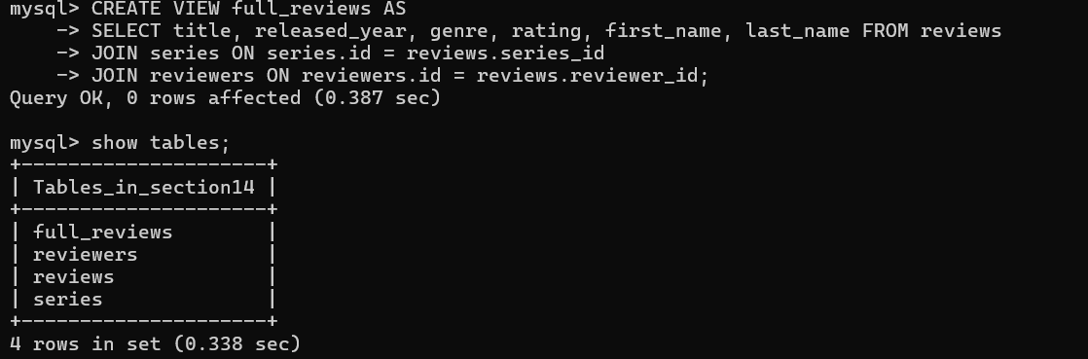

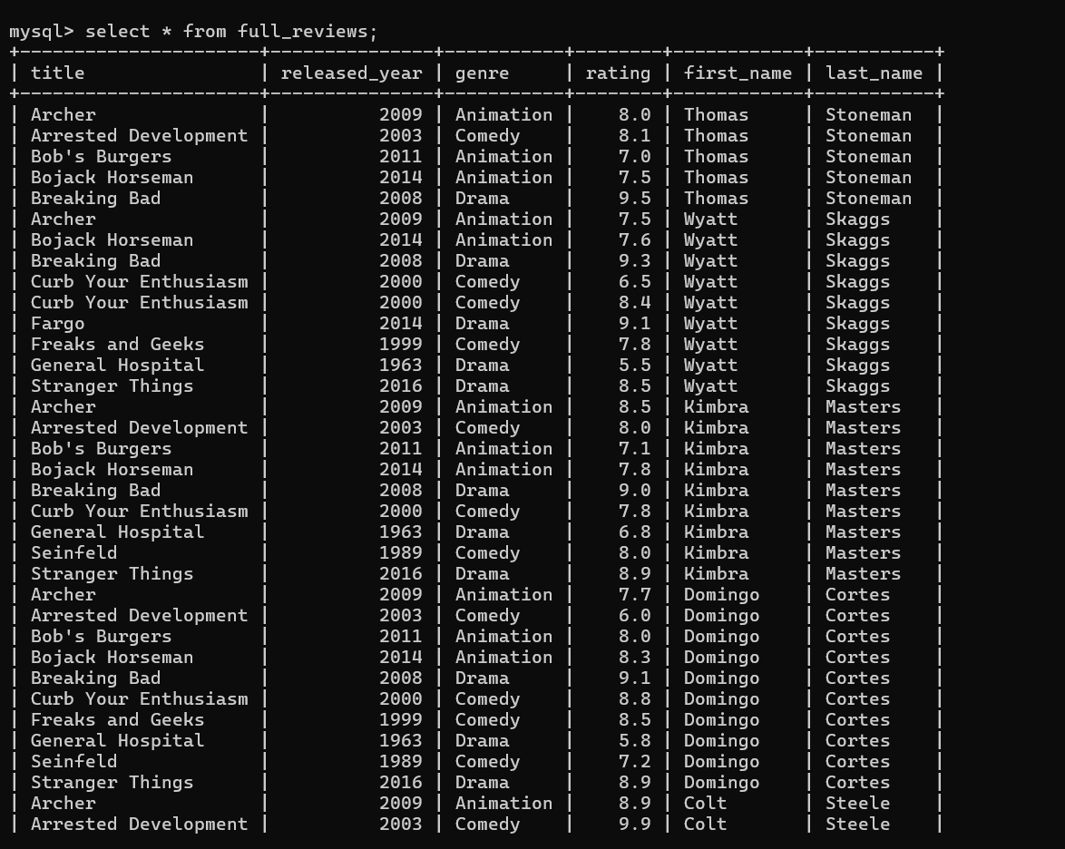

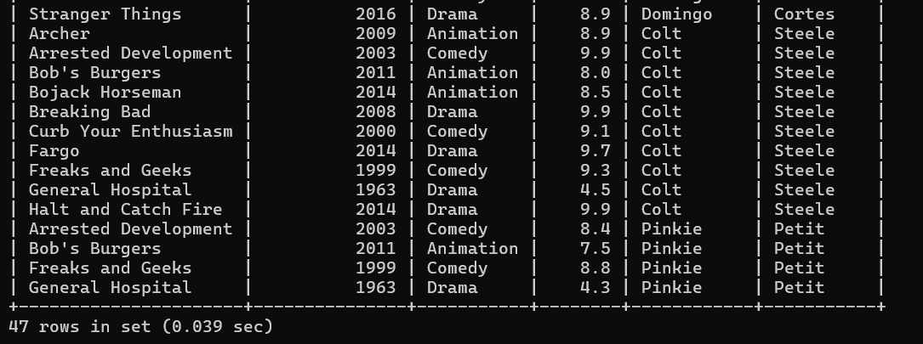

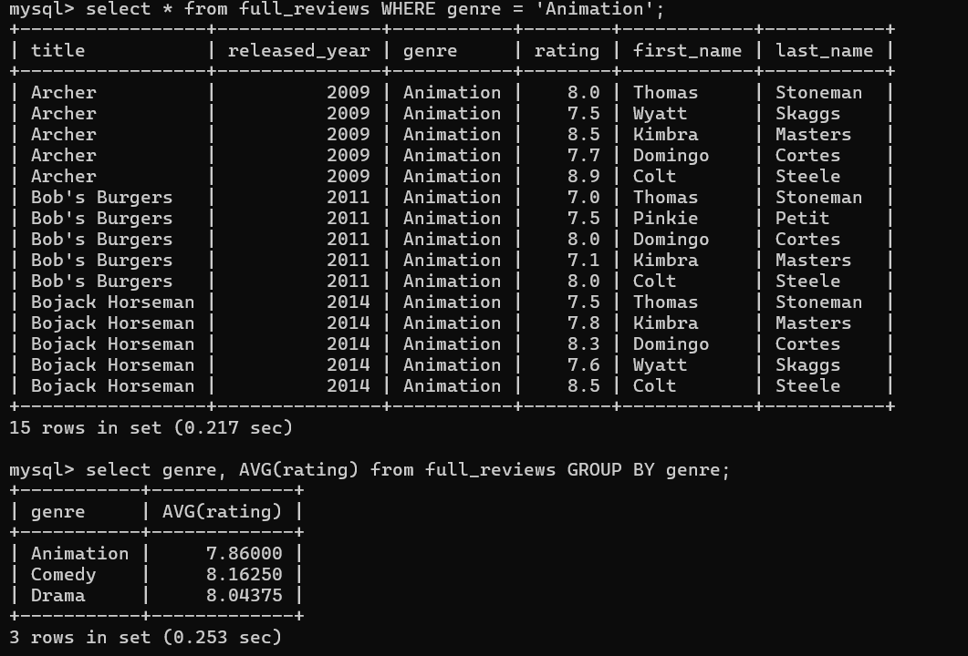

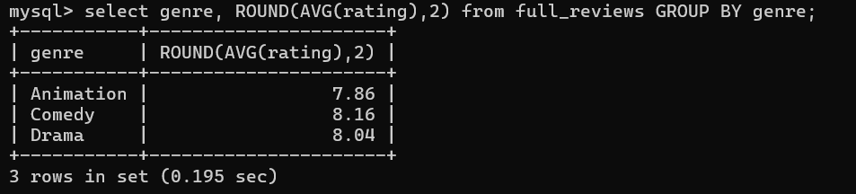

- Updateable Views

DELETE FROM full_reviews WHERE released_year = 2010;
ERROR 1395 (HY000): Can not delete from join view 'section14.full_reviews'

mysql> select * from series ORDER BY released_year;

CREATE VIEW ordered_series AS
SELECT * FROM series ORDER BY released_year;
INSERT INTO ordered_series(title, released_year, genre)
VALUES ('The Great', 2020, 'Comedy');

select * from series;

DELETE FROM ordered_series WHERE title = 'The Great';
Query OK, 1 row affected (0.281 sec)

select * from ordered_series;
select * from series;

OUTCOME

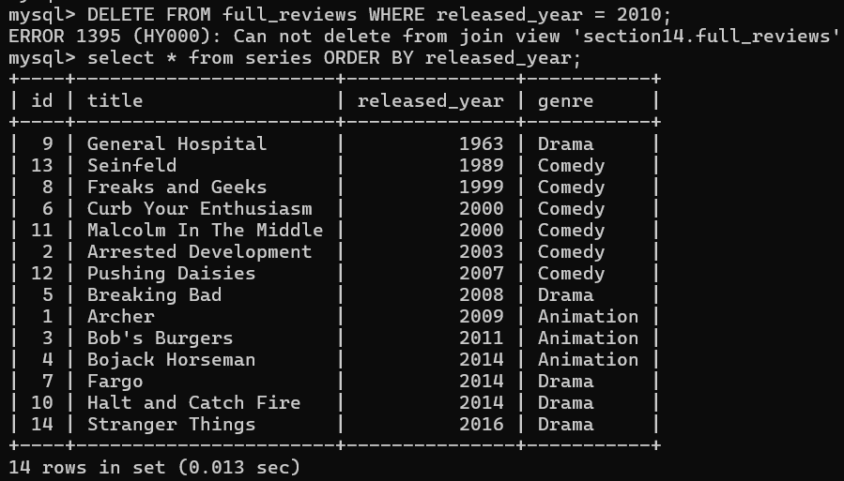

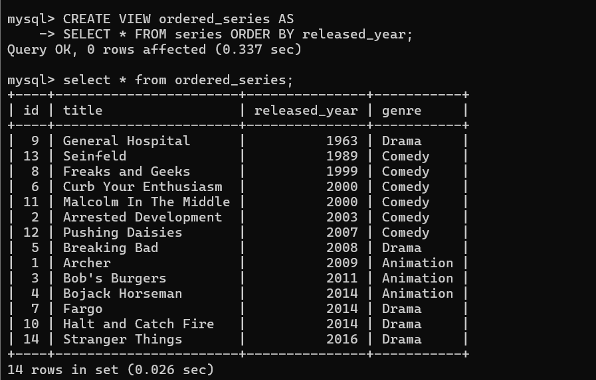

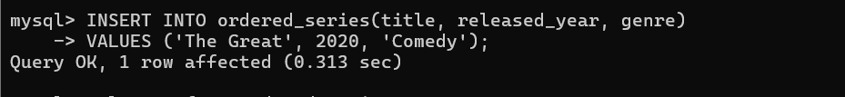

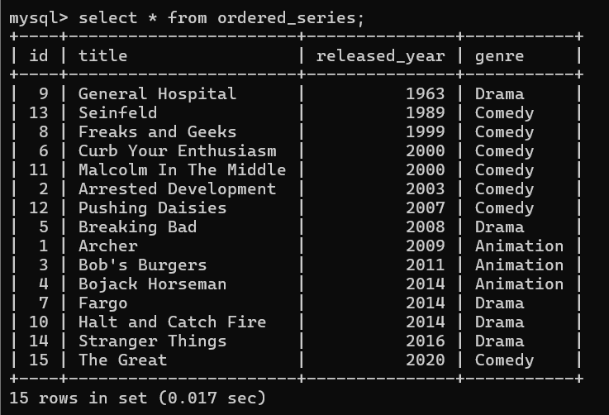

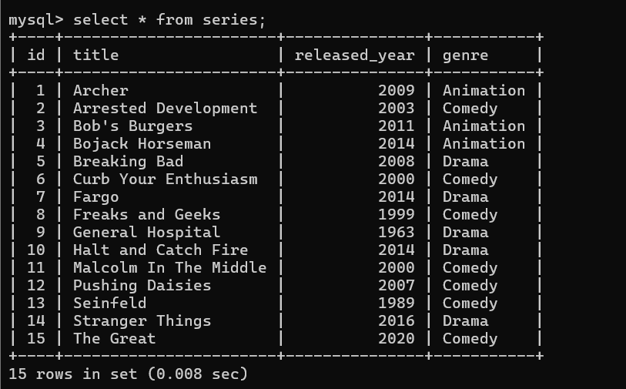

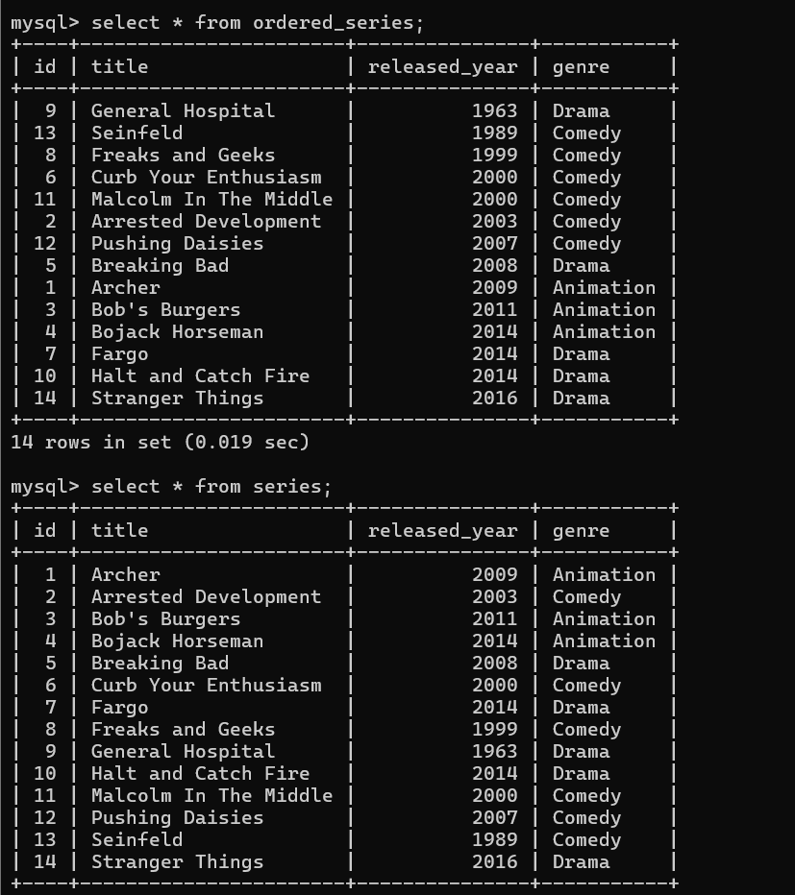

- Replacing / Altering Views

CODE:

- CREATE VIEW ordered_series AS
- SELECT * FROM series ORDER BY released_year;

- CREATE OR REPLACE VIEW ordered_series AS
- SELECT * FROM series ORDER BY released_year DESC;

- ALTER VIEW ordered_series AS
- SELECT * FROM series ORDER BY released_year;

- DROP VIEW ordered_series;

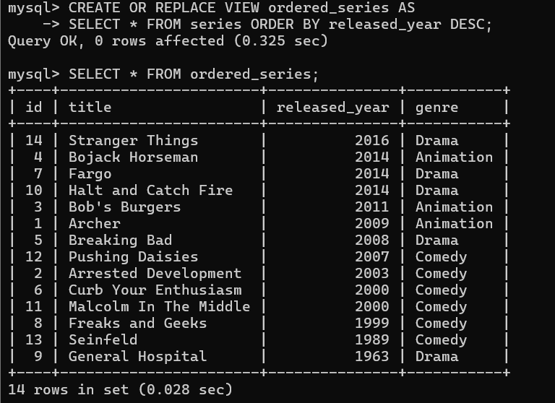

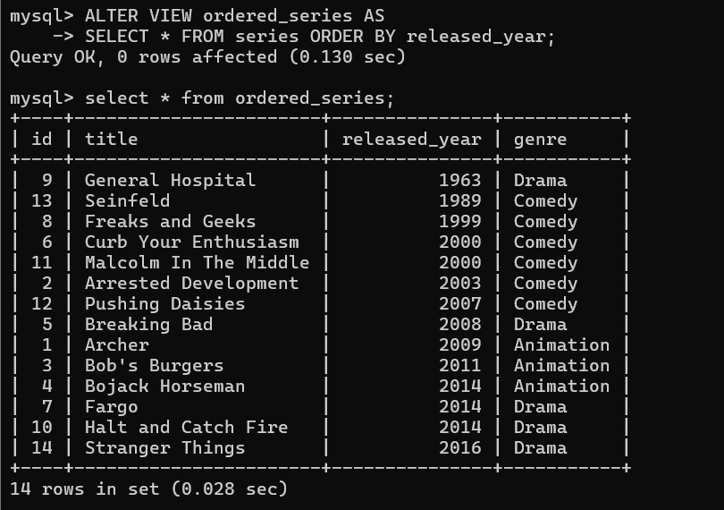

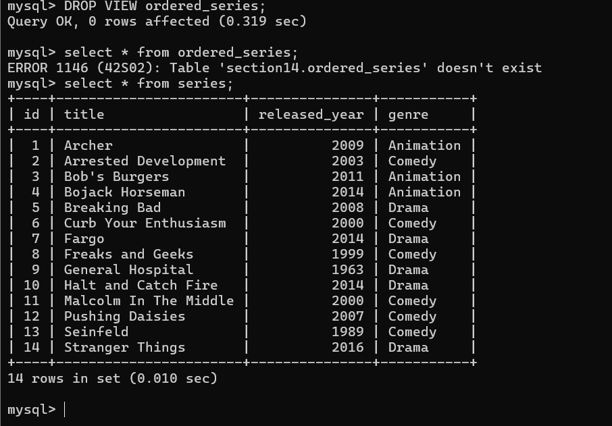

3. HAVING clause

Having clause is used to filter the groups. From GROUP BY

Having clause specifies conditions on groups, typically formed by the Group By Clause.

CODE

- SELECT
- title,
- AVG(rating),
- COUNT(rating) AS review_count
- FROM full_reviews
- GROUP BY title HAVING COUNT(rating) > 1;

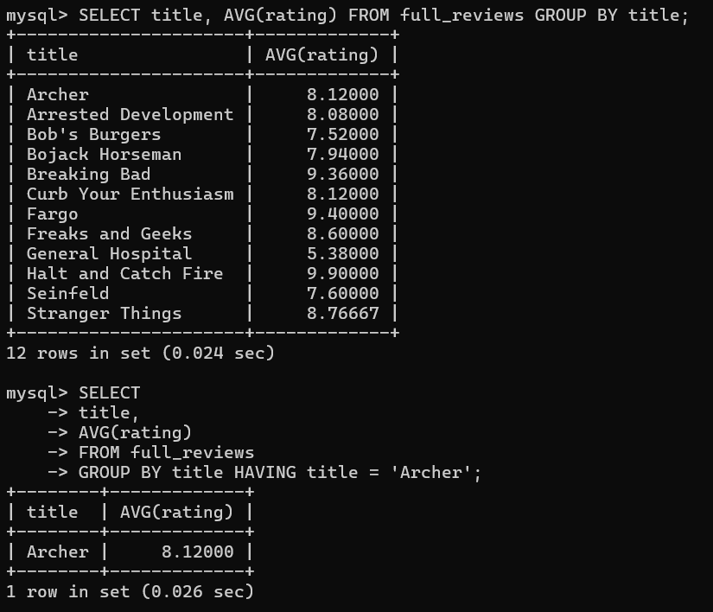

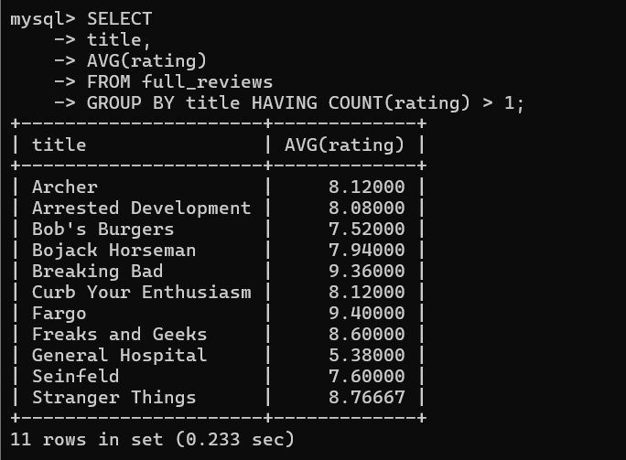

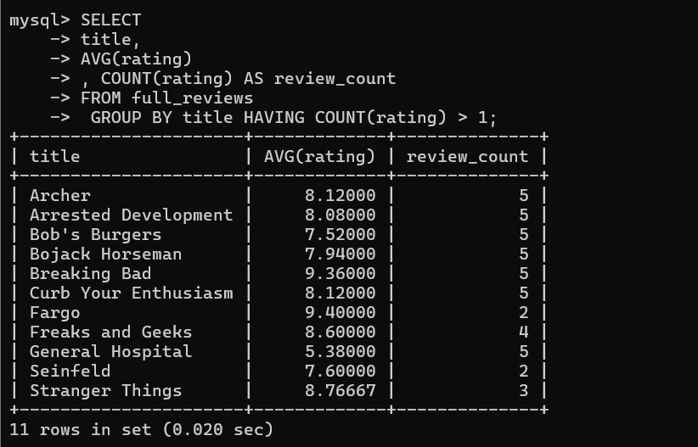

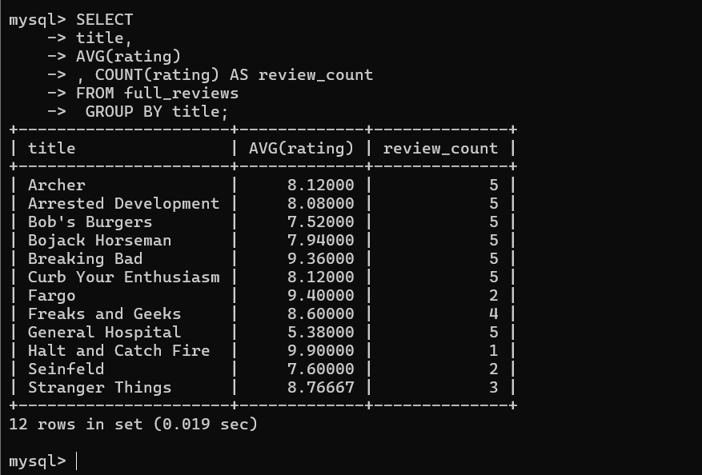

- WITH ROLLUP

WITH ROLLUP modifier that causes summary output to include extra rows that represent higher-level (that is super-aggregate)

CODE:

- SELECT
- title, AVG(rating)
- FROM
- full_reviews
- GROUP BY title WITH ROLLUP;

- SELECT
- title, COUNT(rating)
- FROM
- full_reviews
- GROUP BY title WITH ROLLUP;

- SELECT
- first_name, released_year, genre, AVG(rating)
- FROM
- full_reviews
- GROUP BY released_year , genre , first_name WITH ROLLUP;

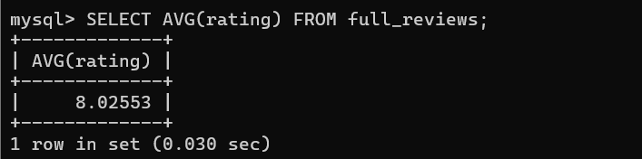

All of the rows for the whole table.

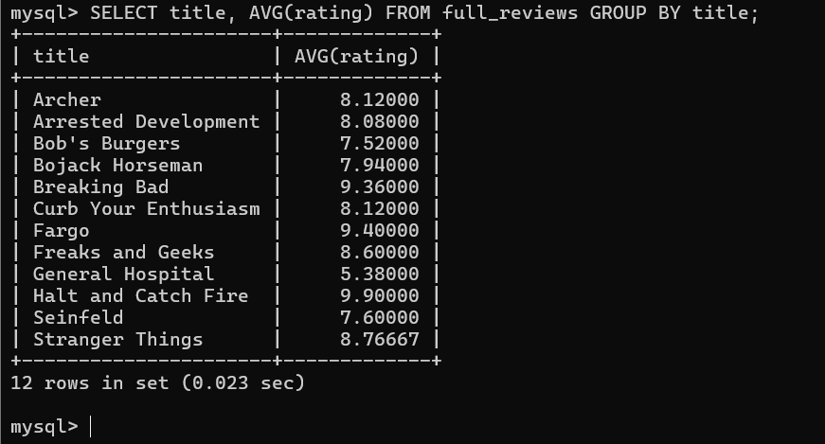
It’s operating on groups of rows, grouped by title.

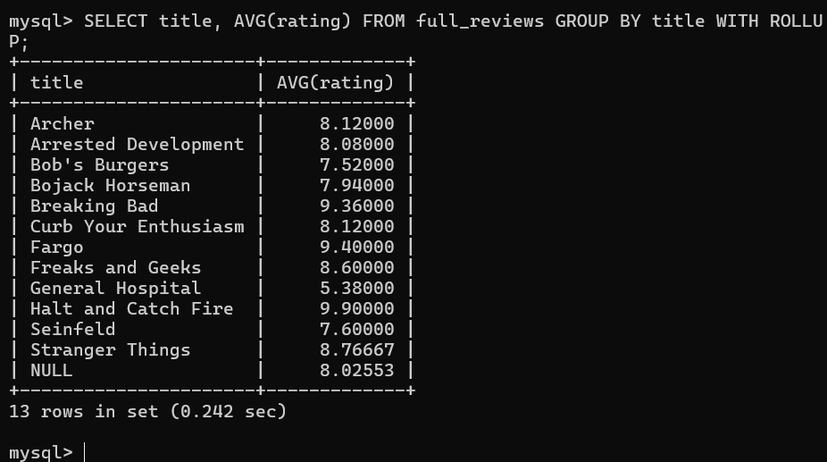

The result look very similar except for this last row. That NULL represent the it is the average for the entire table.

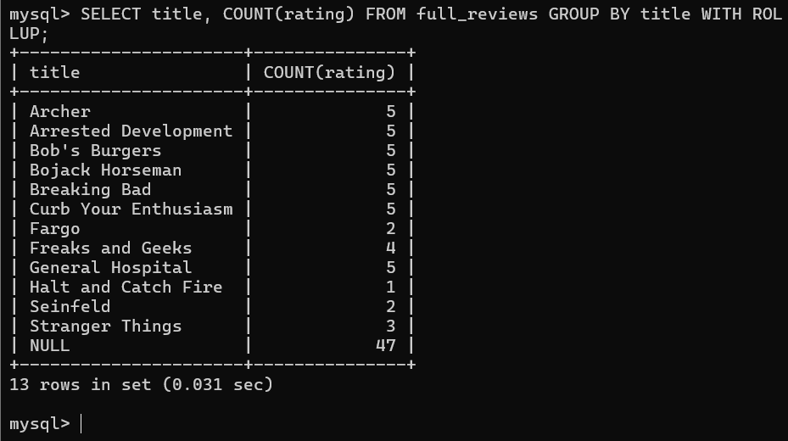

The count of all of the ratings in the table.

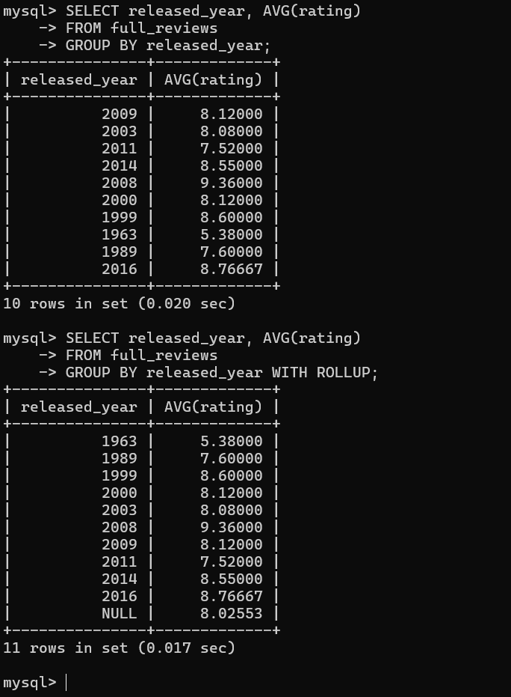
NULL -> overall average for all ratings.

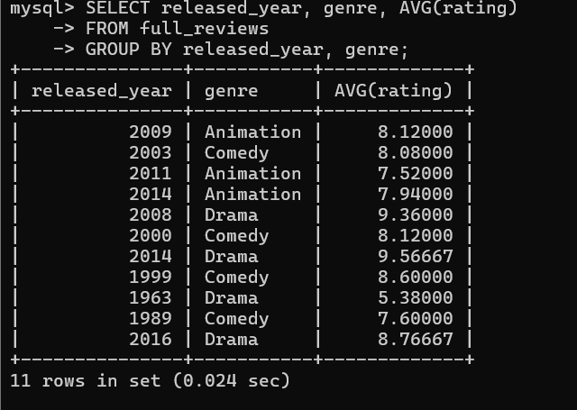

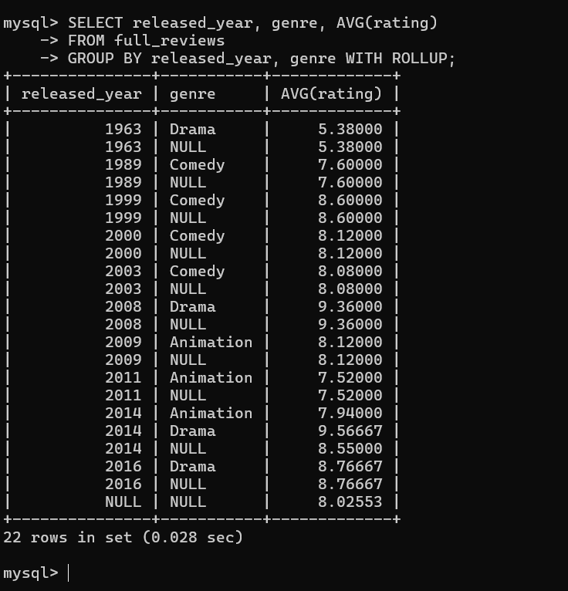
Average for the entire dataset, all of the ratings are 8.02553. This output is 1963 -> drama after 1963’s drama average. 2014 Animation avg is 7.94000 and drama avg is 9.56667 and then we have the summary for all of 2014 is 8.55.

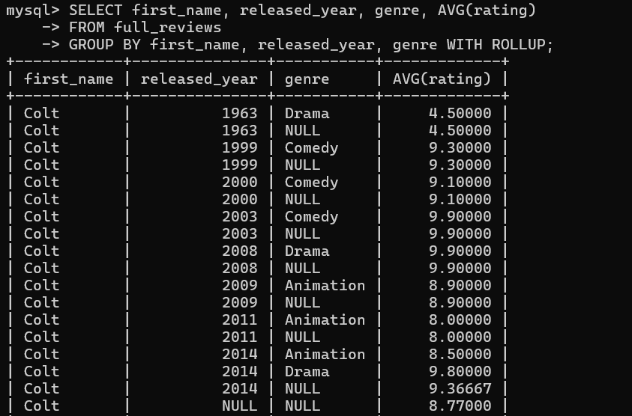

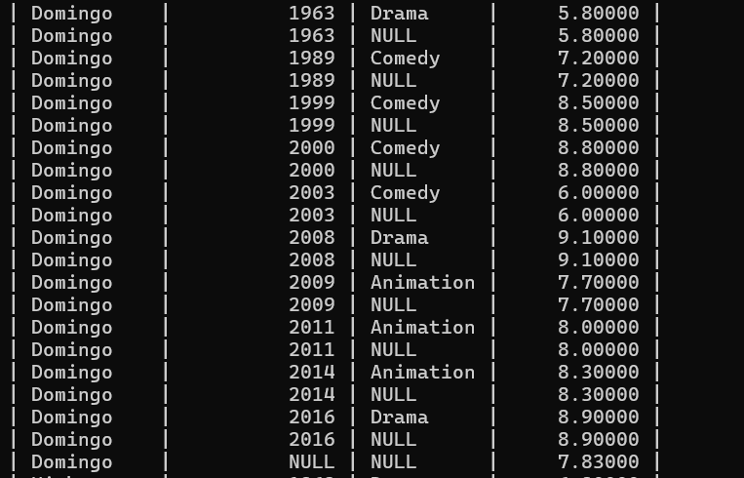

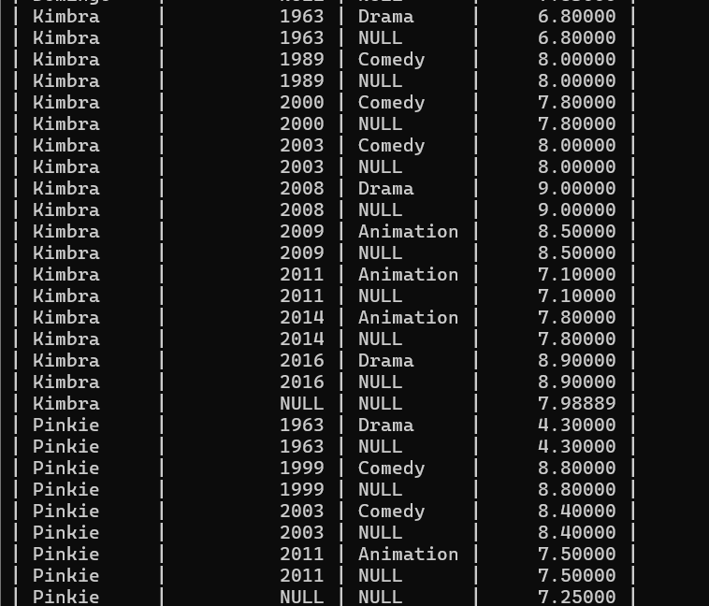

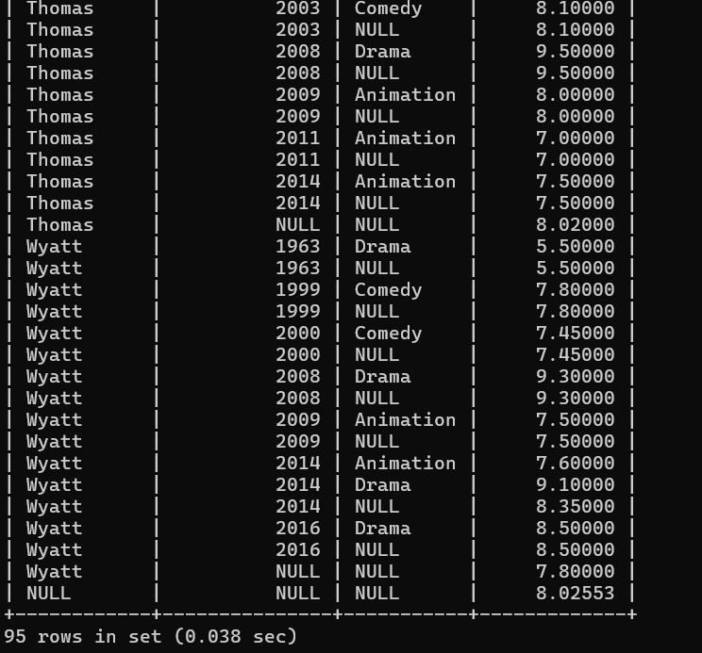

- SQL MODES BASIC
CODE:

- -- To View Modes:
- SELECT @@GLOBAL.sql_mode;
- SELECT @@SESSION.sql_mode;

- -- To Set Them:
- SET GLOBAL sql_mode = 'modes';
- SET SESSION sql_mode = 'modes';
VIEW MODES

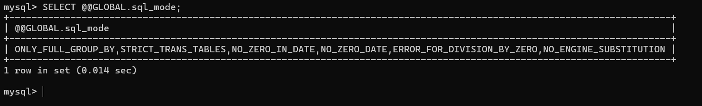

|->Bunch of different settings separated by commas.

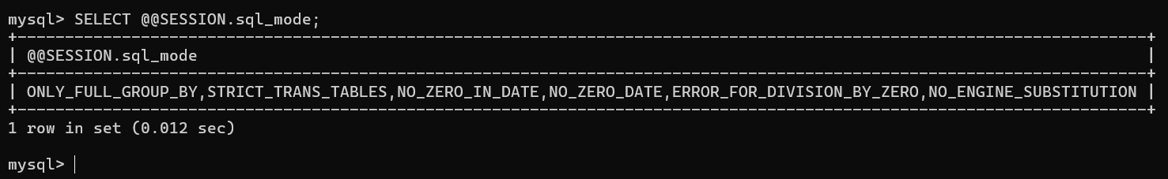

SETTING MODES

Changed the behavior by altering the moats.

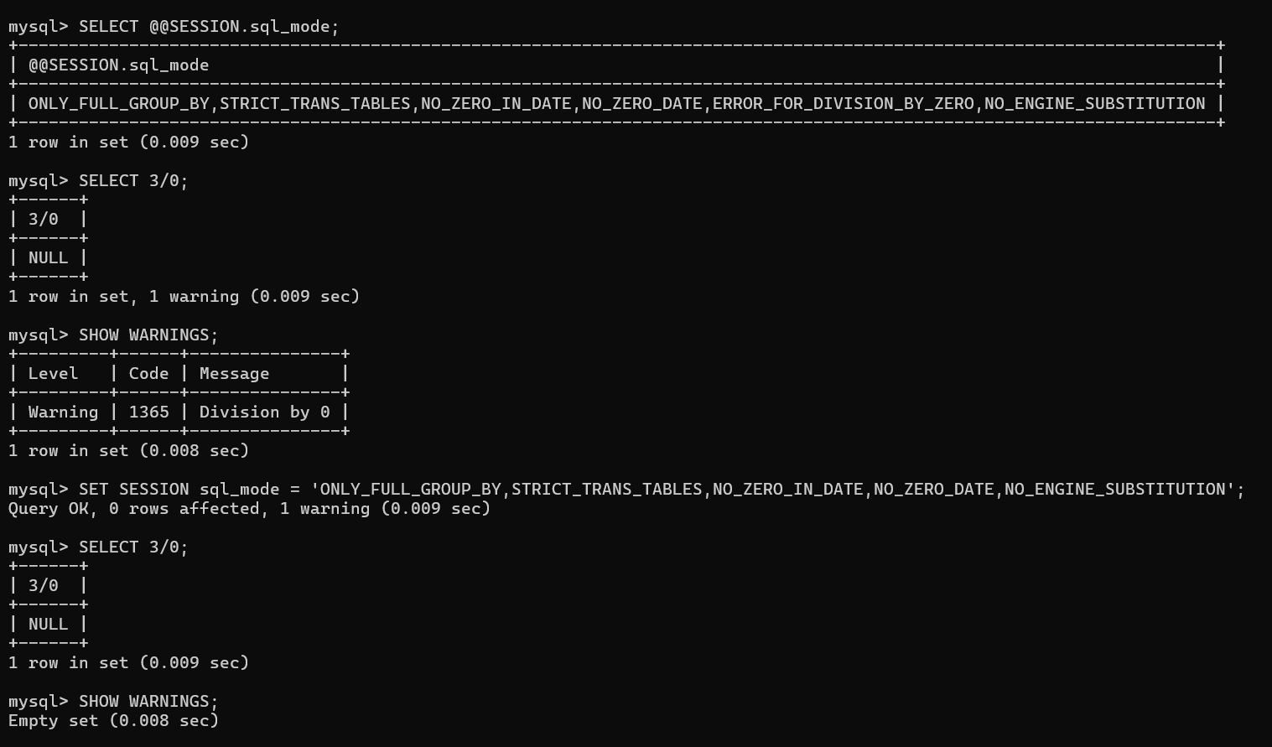

- STRICT_TRANS_TABLE

Strict mode controls how MySQL handles invalid or missing values in data-changes statements such as INSERT OR UPDATE.

Trans means transactional.

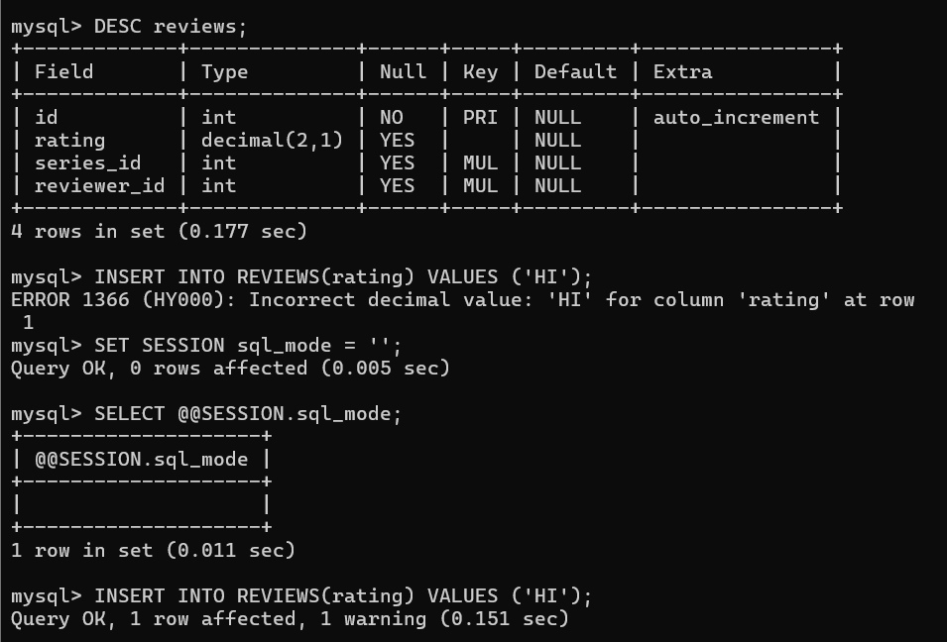

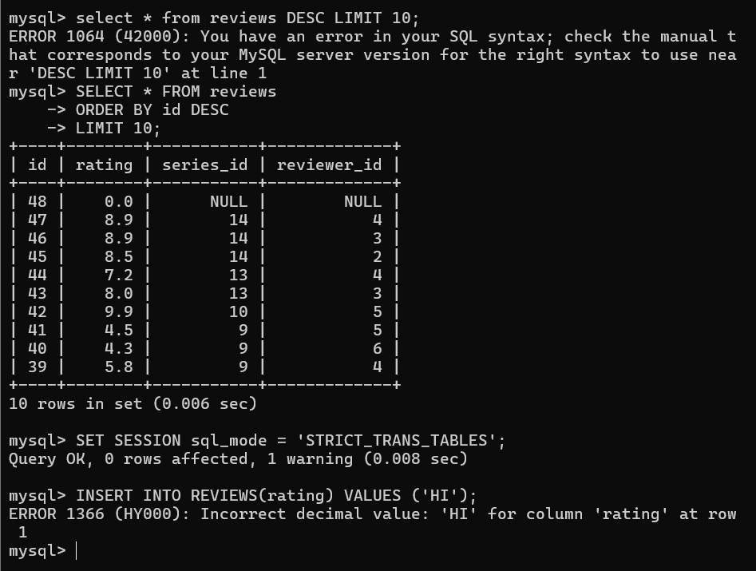

First insert ‘hi’ message in the reviews table. That column has a decimal type so get an error. After changing, the mode is empty. Inserted “hi” message did not get an error message. Change the mode ‘STRICT_TRANS_TABLES’. Mode was changed and it has a mode rules.

- MORE MODES



