- What are database triggers?

They are just SQL statements, bits of code that are automatically run when something happens, when an event triggers them. So when a specific table is changed.

SQL statements that are AUTOMATICALLY RUN when a specific table is changed.

The Syntax

CREATE TRIGGER trigger_name
Trigger_time trigger_event ON table_name FOR EACH ROW
BEGIN
…
END;

_____________________________________________________

Trigger_time trigger_event ON table_name

BEFORE INSERT photos
AFTER UPDATE users
DELETE

_______________________________________________________
- Writing Triggers part-1

CODE:

CREATE TABLE users (
username VARCHAR(100),
age INT
);

INSERT INTO users(username, age) VALUES ("Bobby", 23);
INSERT INTO users(username, age) VALUES ("Sally", 16);
INSERT INTO users(username, age) VALUES ("Sue", 54);
INSERT INTO users(username, age) VALUES ("Yang", 14);

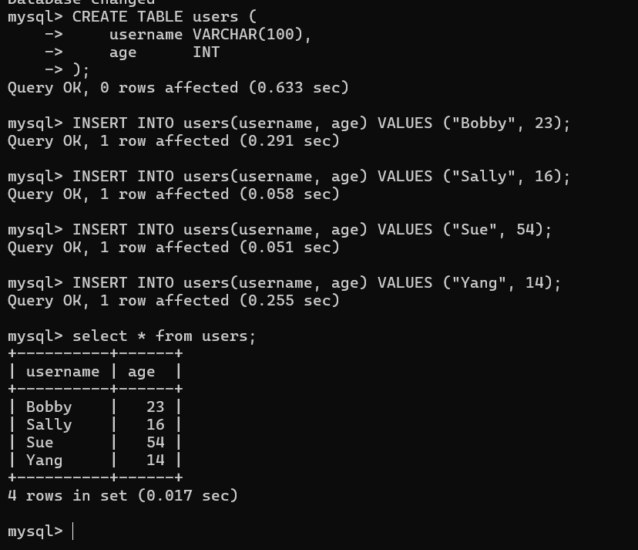
___________________________________________________________
- Writing Triggers part-2

That’s are multiple lines statements so use semicolons(;)

DELIMITER $$

CREATE TRIGGER must_be_adult
BEFORE INSERT ON users
FOR EACH ROW
BEGIN
IF NEW.age < 18 THEN
SIGNAL SQLSTATE '45000'
SET MESSAGE_TEXT = 'Must be an adult!';
END IF;
END$$
DELIMITER ;

INSERT INTO users (username, age)
VALUES ('Blue', 10);

Output is “ERROR 1644 (45000): Must be an adult!”

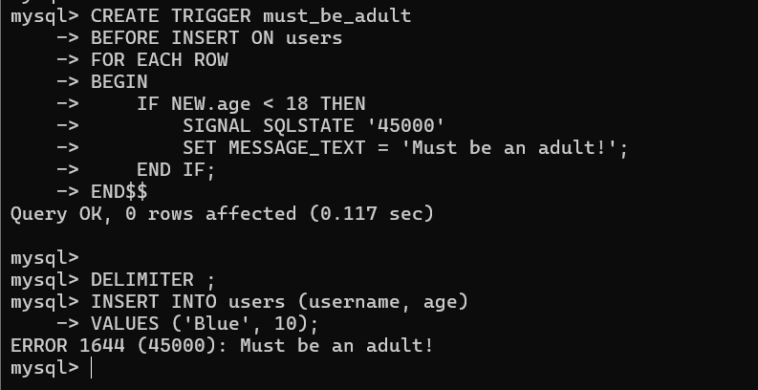

Output explanation

A BEFORE INSERT trigger on users is exactly what you use when you want to stop invalid data and show an error message before the row is inserted.

___________________________________________________________

This code in Instagram Clone

Where it says:
IF NEW.follower_id = NEW.following_id
It should actually be:
IF NEW.follower_id = NEW.followee_id

- CODE

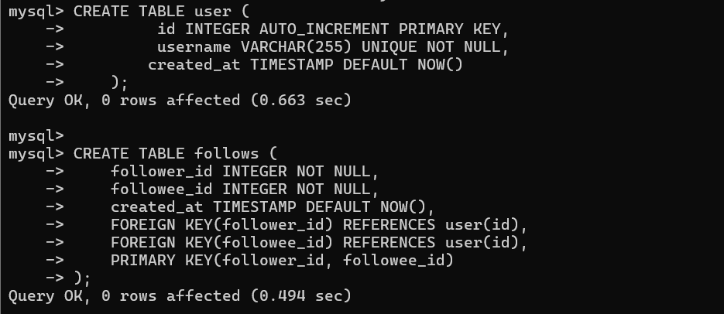

DELIMITER $$

CREATE TRIGGER prevent_self_follow
BEFORE INSERT ON follows
FOR EACH ROW
BEGIN
IF NEW.follower_id = NEW.followee_id THEN
SIGNAL SQLSTATE '45000'
SET MESSAGE_TEXT = 'Users cannot follow themselves';
END IF;
END$$
DELIMITER ;

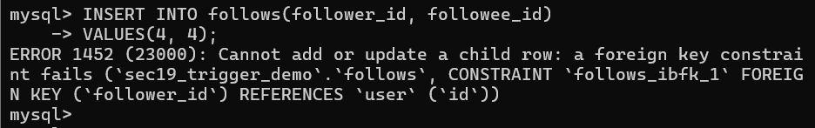

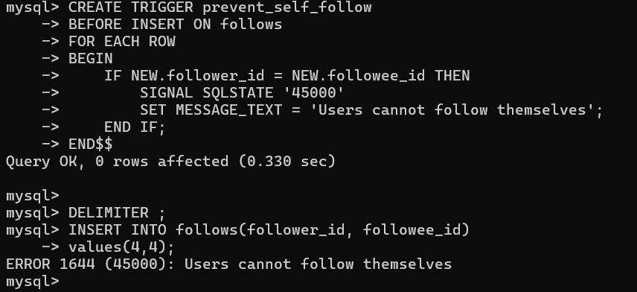

Output error message is ‘Users cannot follow themselves’

___________________________________________________________

- Creating logging triggers

Code:

CREATE TABLE user (
-> id INTEGER AUTO_INCREMENT PRIMARY KEY,
-> username VARCHAR(255) UNIQUE NOT NULL,
-> created_at TIMESTAMP DEFAULT NOW()
-> );

mysql>
mysql> CREATE TABLE follows (
-> follower_id INTEGER NOT NULL,
-> followee_id INTEGER NOT NULL,
-> created_at TIMESTAMP DEFAULT NOW(),
-> FOREIGN KEY(follower_id) REFERENCES user(id),
-> FOREIGN KEY(followee_id) REFERENCES user(id),
-> PRIMARY KEY(follower_id, followee_id)
-> );

mysql> CREATE TABLE unfollows (
-> follower_id INTEGER NOT NULL,
-> followee_id INTEGER NOT NULL,
-> created_at TIMESTAMP DEFAULT NOW(),
-> FOREIGN KEY(follower_id) REFERENCES user(id),
-> FOREIGN KEY(followee_id) REFERENCES user(id),
-> PRIMARY KEY(follower_id, followee_id)
-> );

mysql> INSERT INTO user (id, username) VALUES
-> (1, 'alice'),
-> (2, 'bob'),
-> (3, 'charlie'),
-> (4, 'david'),
-> (5, 'emma'),
-> (6, 'frank'),
-> (7, 'grace');

mysql> INSERT INTO follows (follower_id, followee_id) VALUES
-> (2, 3),
-> (2, 4),
-> (2, 5),
-> (2, 6),
-> (2, 7);

DELIMITER $$

CREATE TRIGGER capture_unfollow
AFTER DELETE ON follows
FOR EACH ROW
BEGIN
INSERT INTO unfollows (follower_id, followee_id)
VALUES (OLD.follower_id, OLD.followee_id);
END$$

DELIMITER ;
__
DELETE FROM follows
WHERE follower_id = 2 AND followee_id = 3;

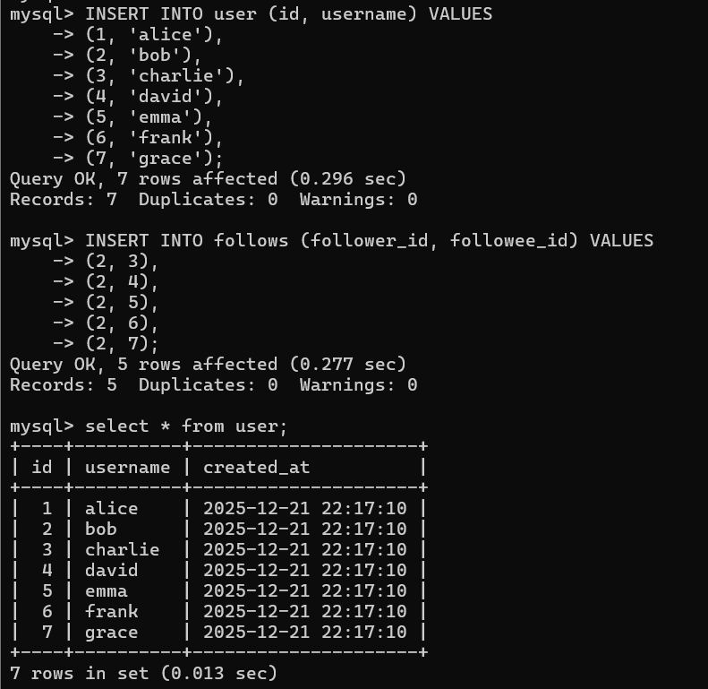

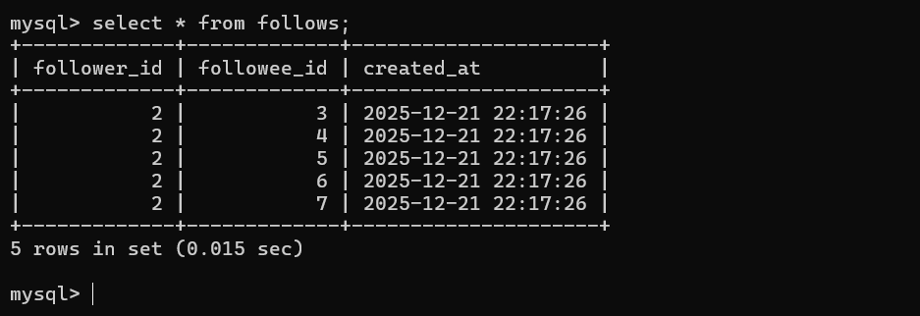

|-> Delete trigger.

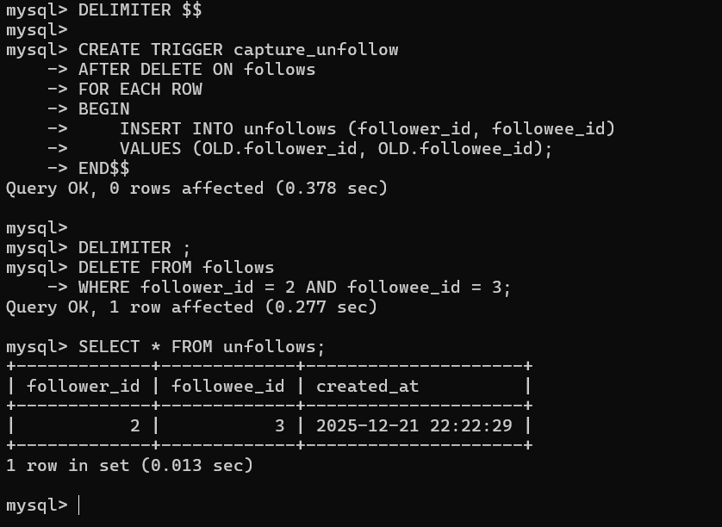

Followers delete one follower that deletes followers stored in the unfollows table.

____________________________________________________________

- Managing Triggers and A Warning

Code:

Show triggers;

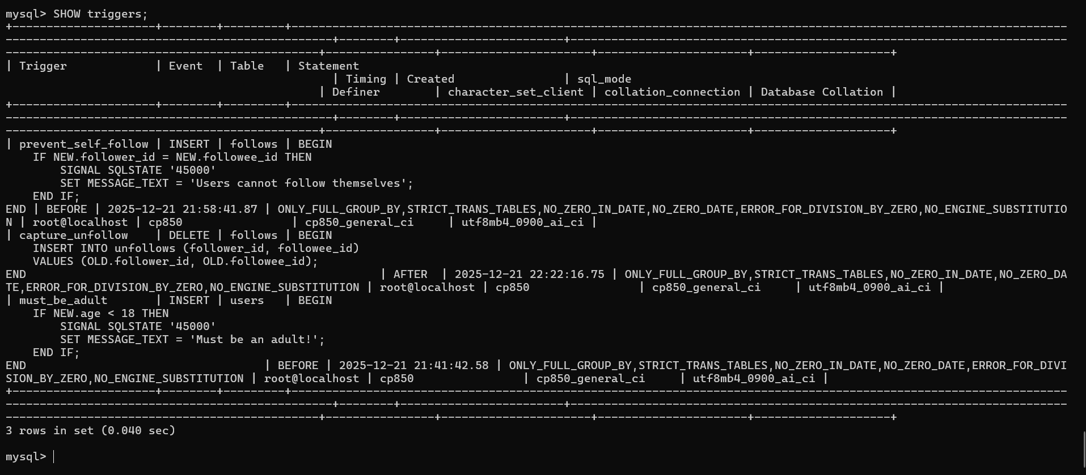

Removing Triggers

DROP TRIGGER trigger_name;

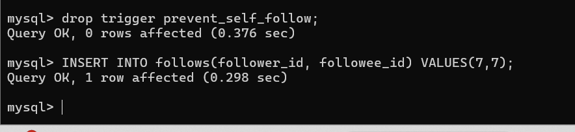
Delete a trigger and it does not show the error message.
“Triggers can make debugging hard!”
