Data Types

- CHAR VS VARCHAR

CHAR is a fixed length and VARCHAR does not care about the size but it cares about the maximum size.

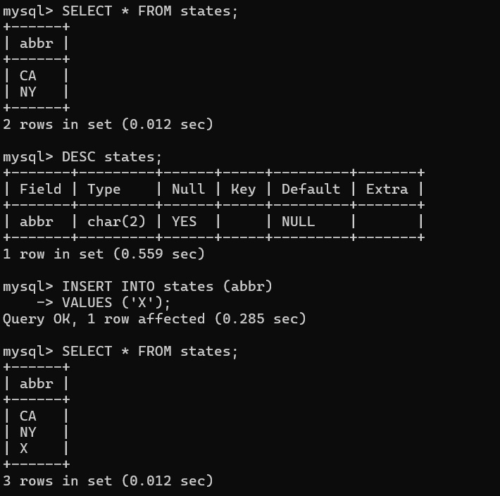

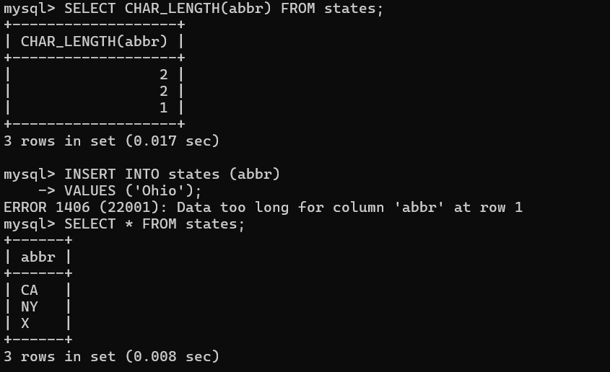

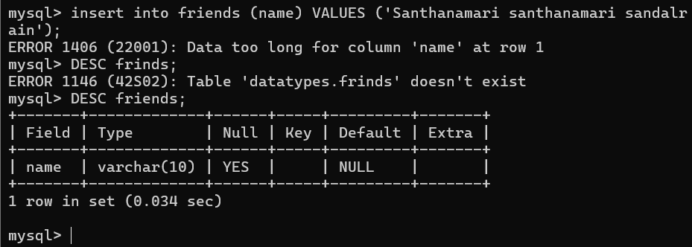

- Numbers

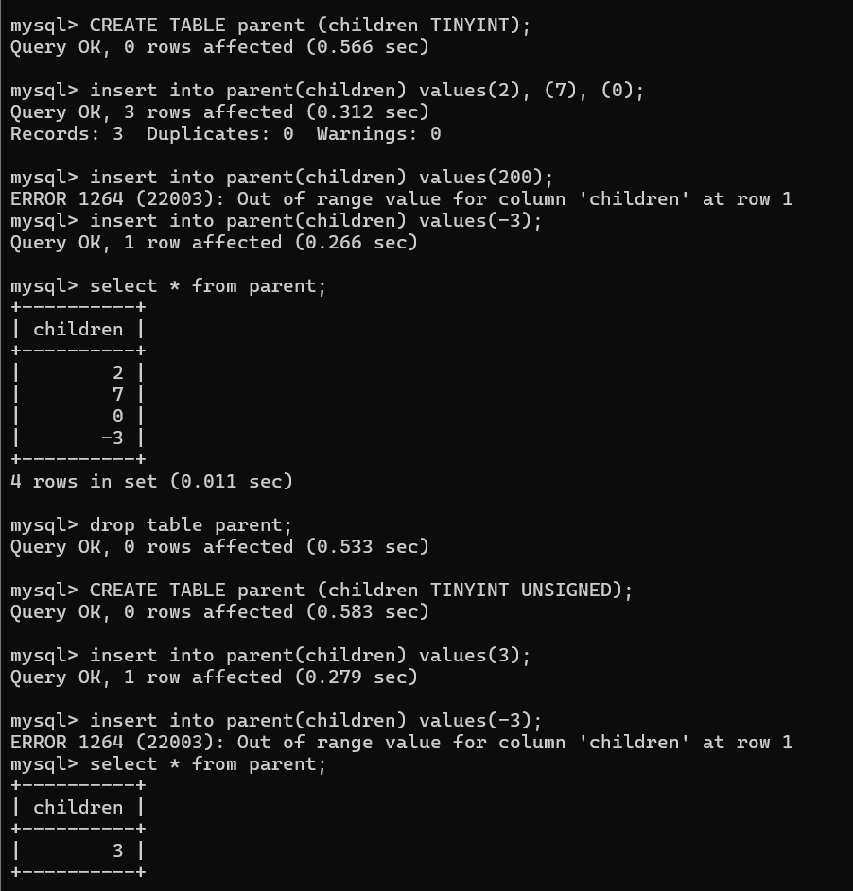

- Decimal

Decimal allows us to store precise or accurate decimals might be small or large.

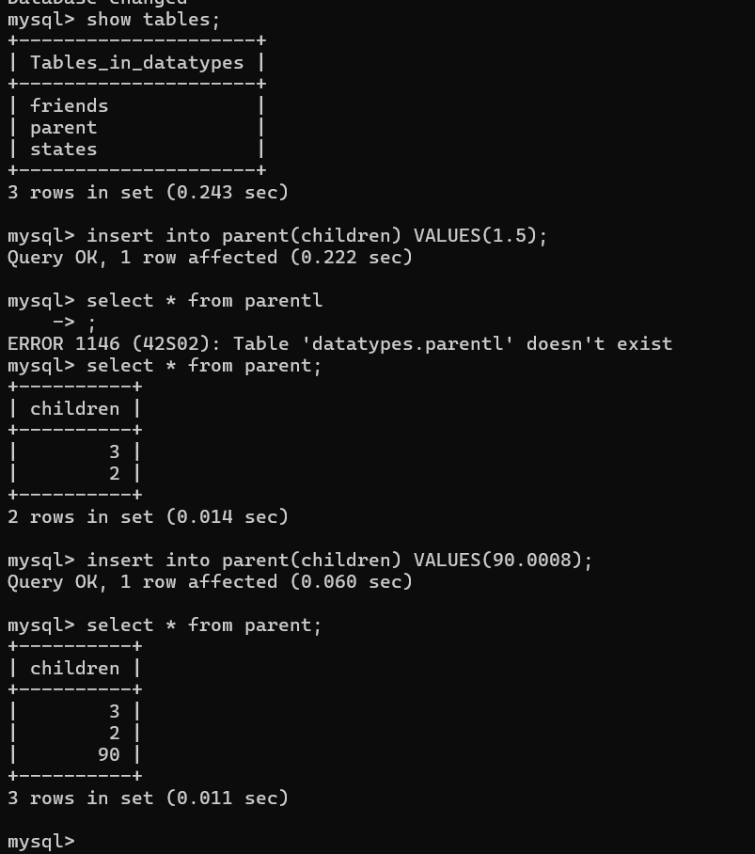

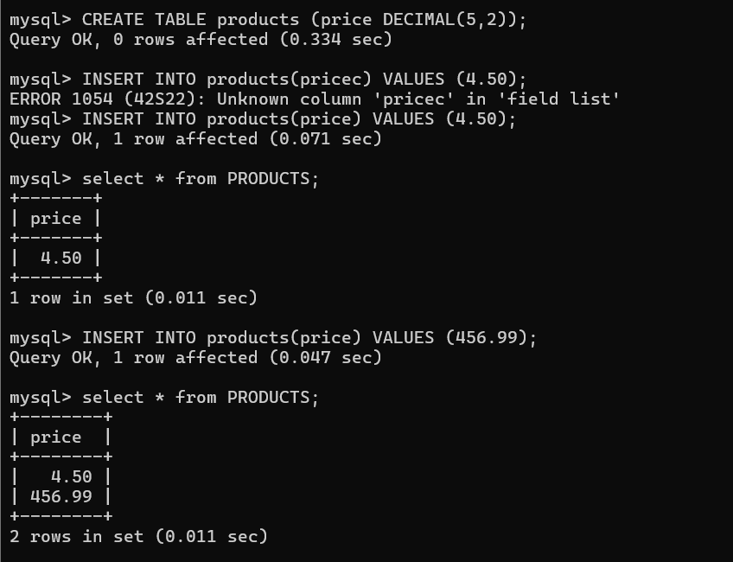

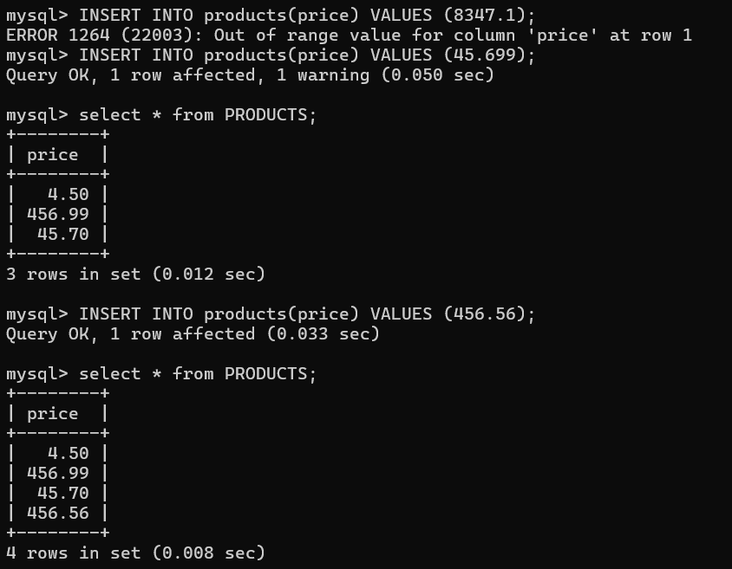

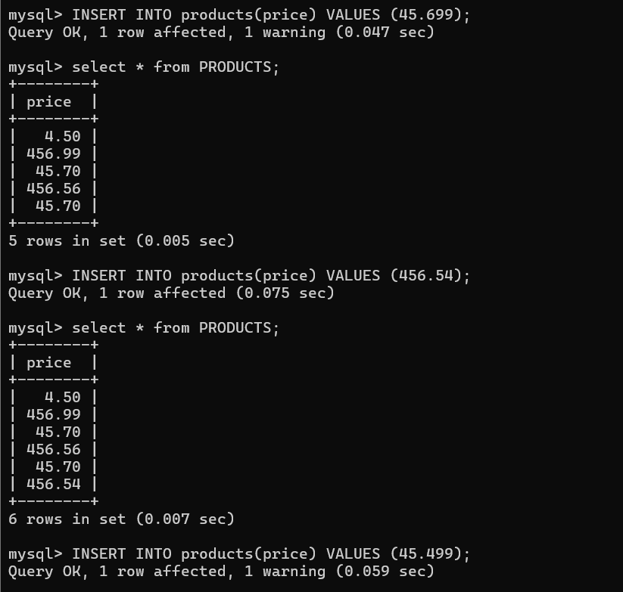

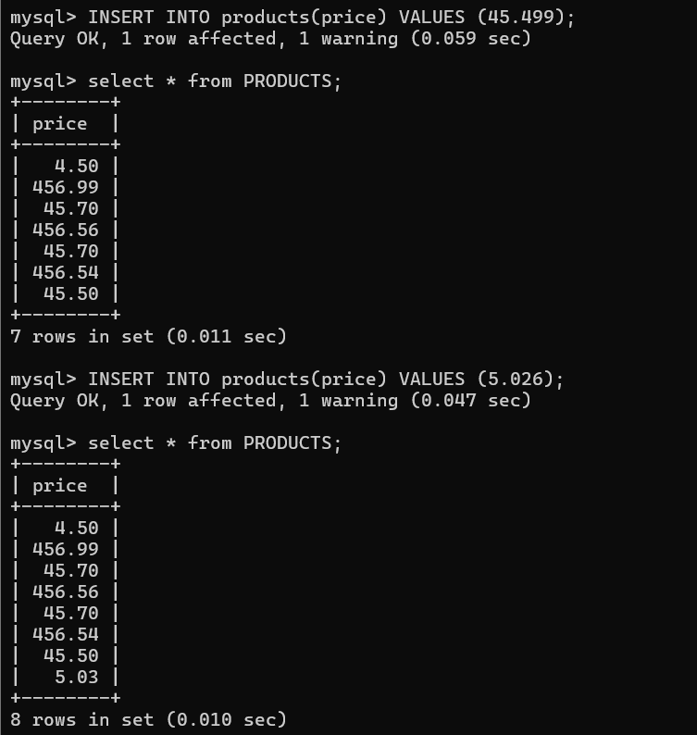
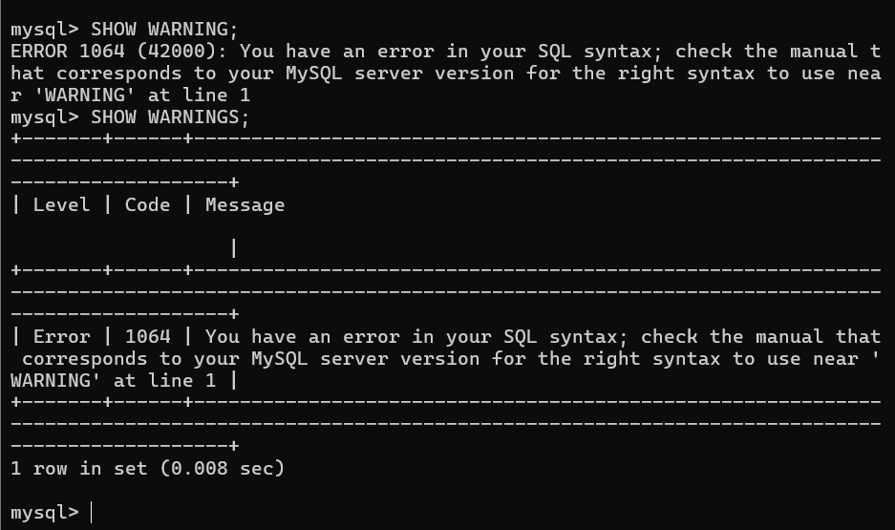

- FLOAT AND DOUBLE

Store large numbers or larger decimal points using less space.

Decimal stores numbers as decimals in memory but Float numbers don’t.

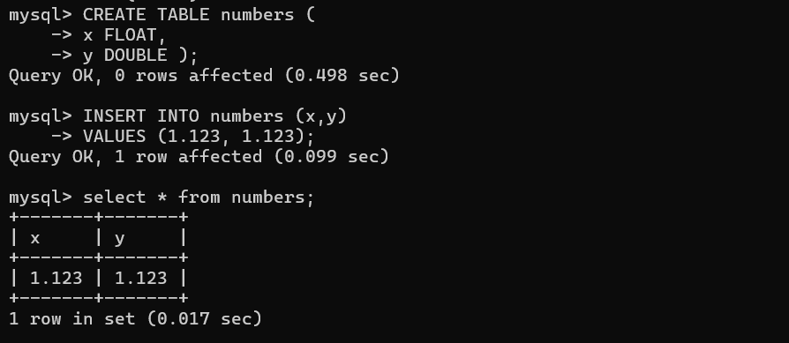

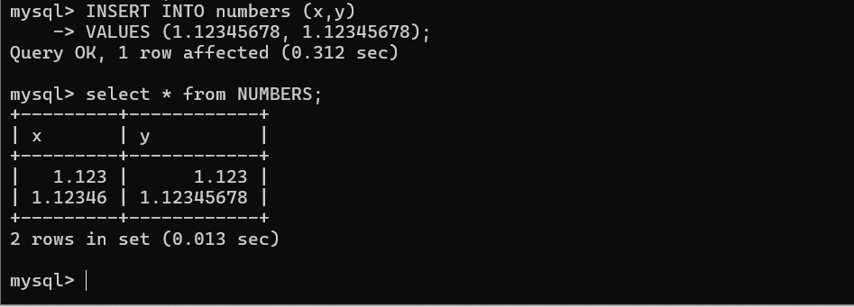
ABOVE screenshot is x is float it takes a fewer range number but float it takes larger number.
Table:
____________________________________________________________
Datatype memory needed precision issues
_____________________________________________________________

Float 4 bytes ~ 7digits
Double 8 bytes ~ 15 digits
_____________________________________________________________

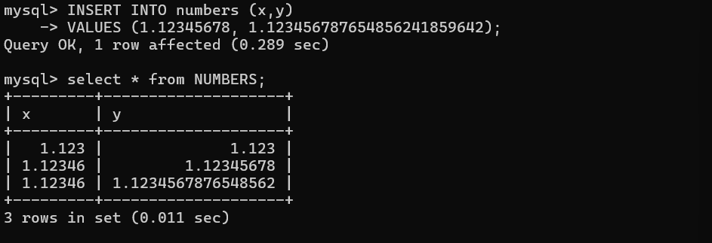

- DATE AND TIME

DATE -> Values with a Date But no Time. => YYYY-MM-DD
TIME -> Values with a Time But no Date. => HH:MM:SS
DateTime -> Values with a Date and Time. => YYYY-MM-DD HH:MM:SS

- Working with Dates

CODE:

- CREATE TABLE people (
- name VARCHAR(100),
- birthdate DATE,
- birthtime TIME,
- birthdt DATETIME
- );

- INSERT INTO people (name, birthdate, birthtime, birthdt)
- VALUES ('Elton', '2000-12-25', '11:00:00', '2000-12-25 11:00:00');

- INSERT INTO people (name, birthdate, birthtime, birthdt)
- VALUES ('Lulu', '1985-04-11', '9:45:10', '1985-04-11 9:45:10');

- INSERT INTO people (name, birthdate, birthtime, birthdt)
- VALUES ('Juan', '2020-08-15', '23:59:00', '2020-08-15 23:59:00');

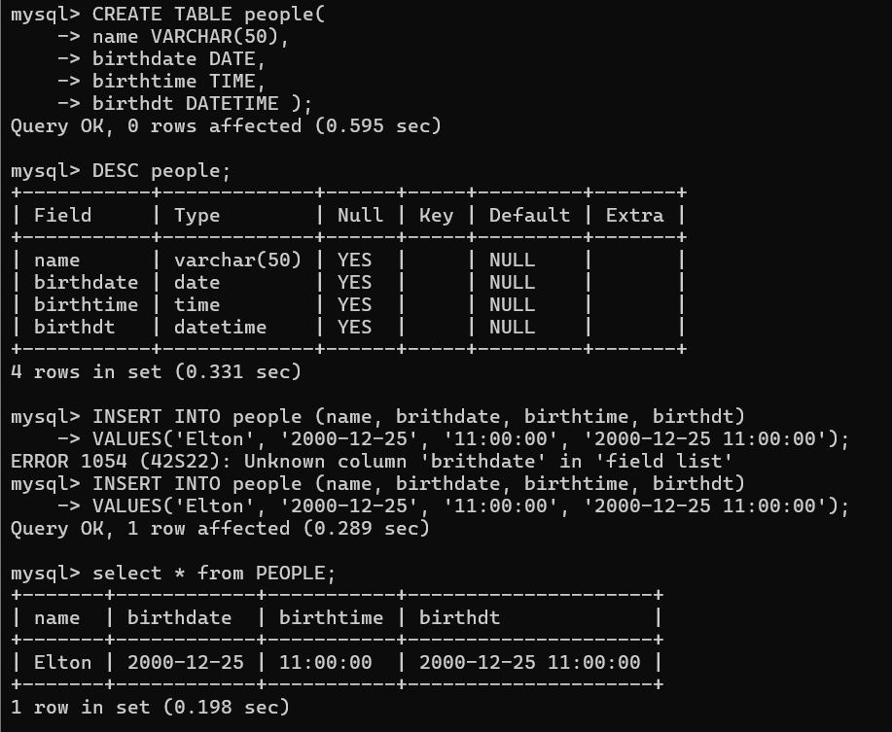

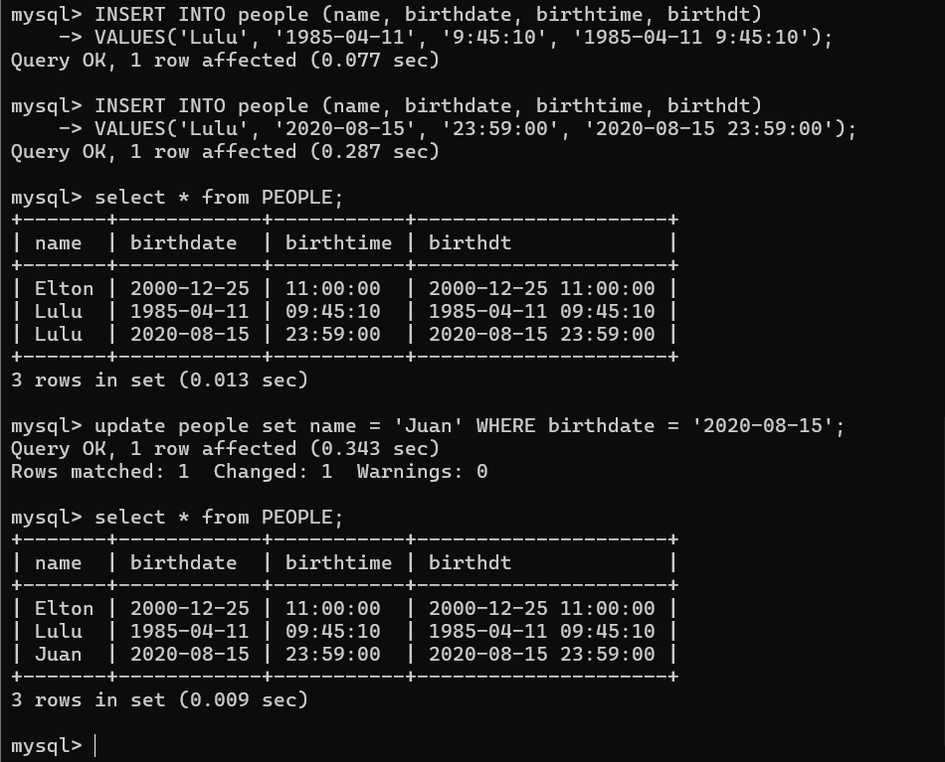

- CURRENT_DATE, CURRENT_TIME AND NOW

CODE:

- SELECT CURTIME();

- SELECT CURDATE();

- SELECT NOW();

- INSERT INTO people (name, birthdate, birthtime, birthdt)
- VALUES ('Hazel', CURDATE(), CURTIME(), NOW());

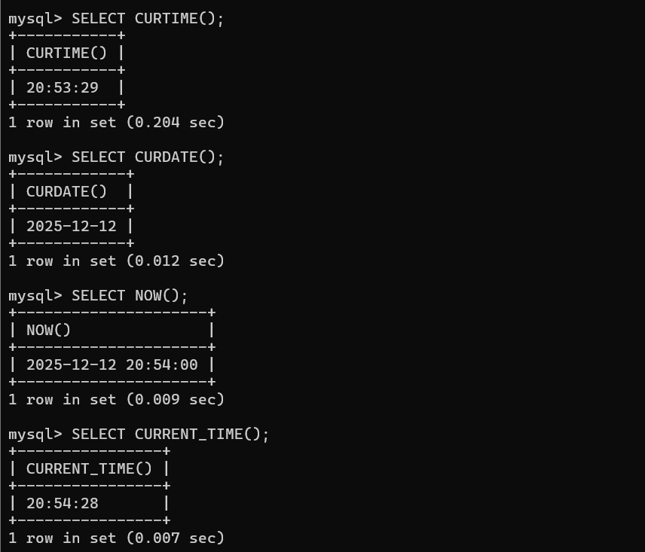

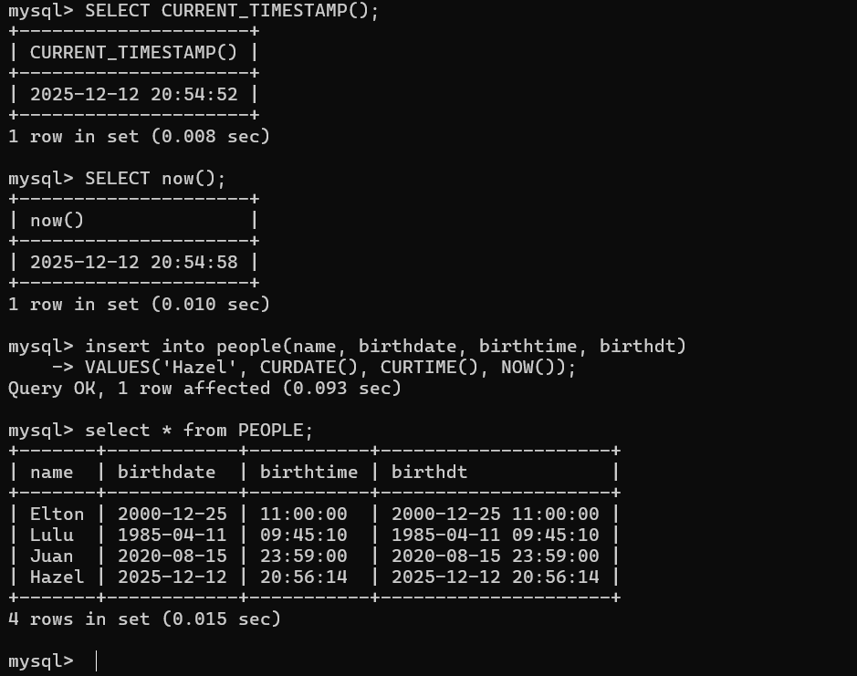

- DATE FUNCTIONS

CODE:

SELECT
birthdate,
DAY(birthdate),
DAYOFWEEK(birthdate),
DAYOFYEAR(birthdate)
FROM people;

SELECT
birthdate,
MONTHNAME(birthdate),
YEAR(birthdate)
FROM people;

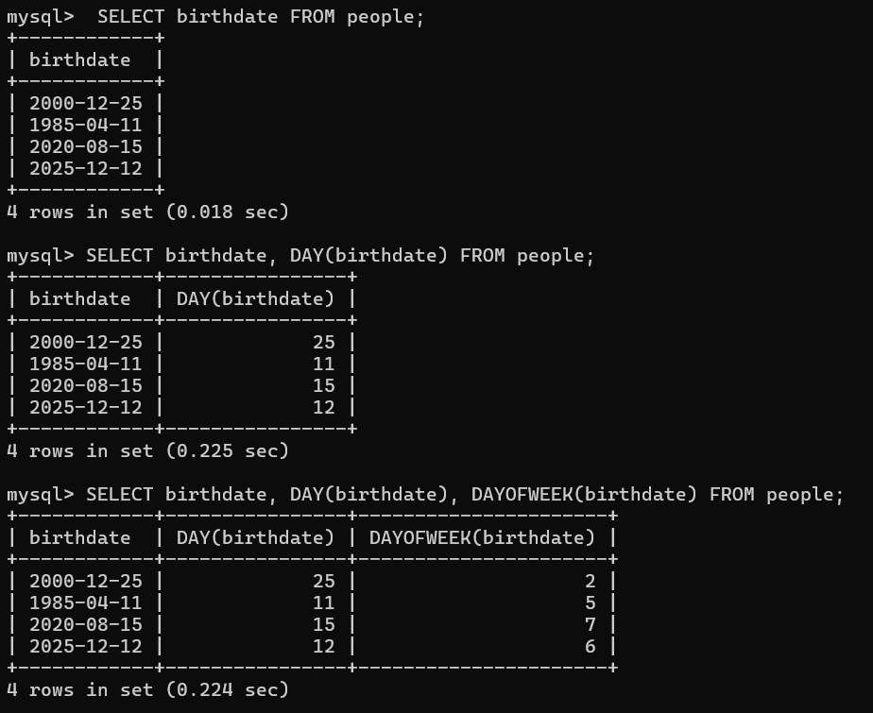

SELECT birthdate, DAY(birthdate), DAYOFWEEK(birthdate) FROM people;

2 5 7 6 these outcome for week for example 7 is a “saturday”.

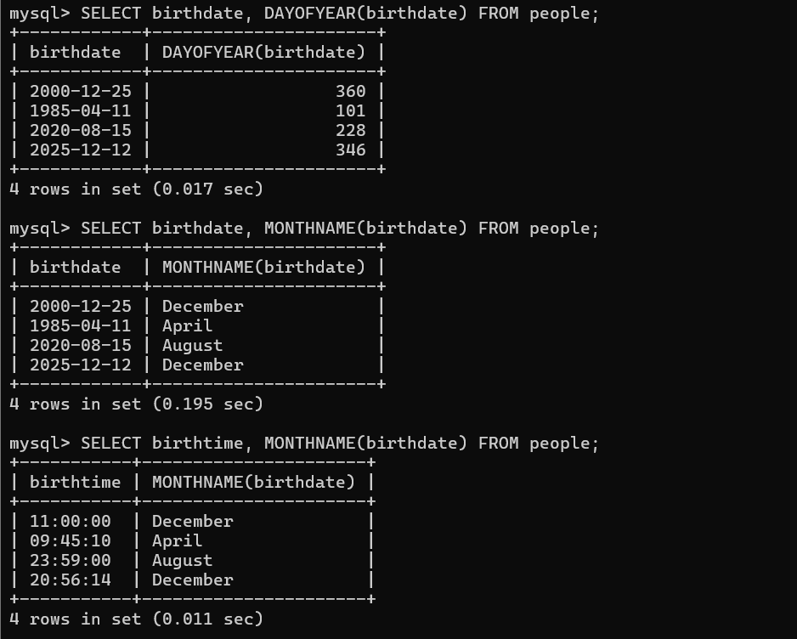

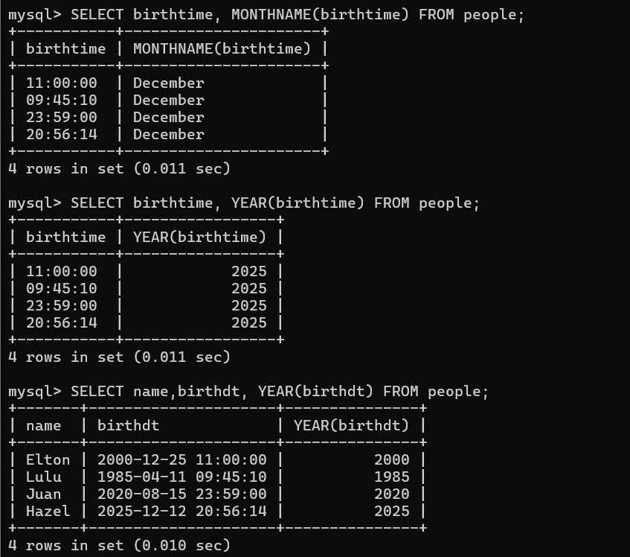

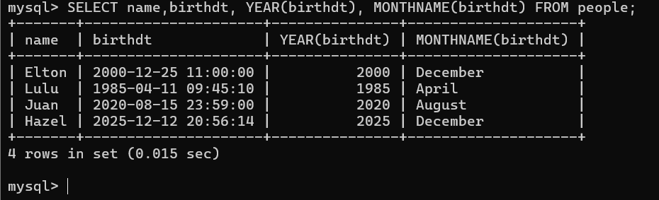

- TIME FUNCTIONS

- SELECT
- birthtime,
- HOUR(birthtime),
- MINUTE(birthtime)
- FROM people;

- SELECT
- birthdt,
- MONTH(birthdt),
- DAY(birthdt),
- HOUR(birthdt),
- MINUTE(birthdt)
- FROM people;

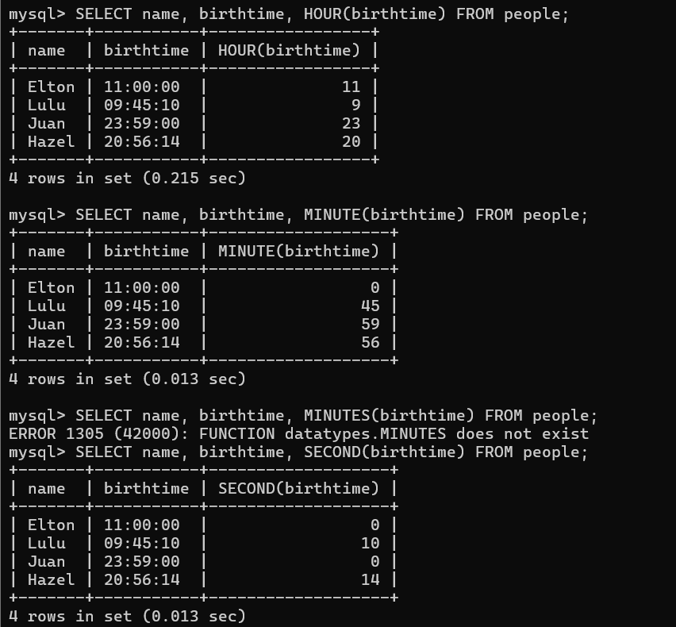

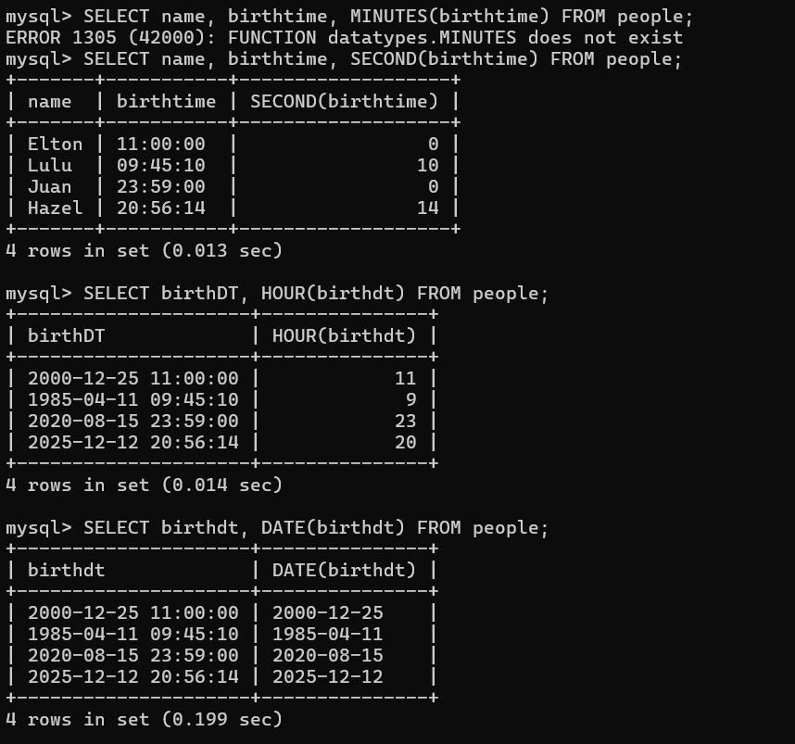

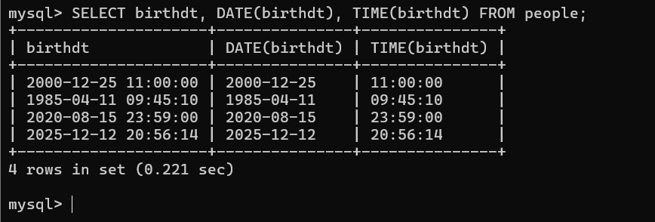

- Formatting Dates

Code:

- SELECT birthdate, DATE_FORMAT(birthdate, '%a %b %D') FROM people;

- SELECT birthdt, DATE_FORMAT(birthdt, '%H:%i') FROM people;

- SELECT birthdt, DATE_FORMAT(birthdt, 'BORN ON: %r') FROM people;

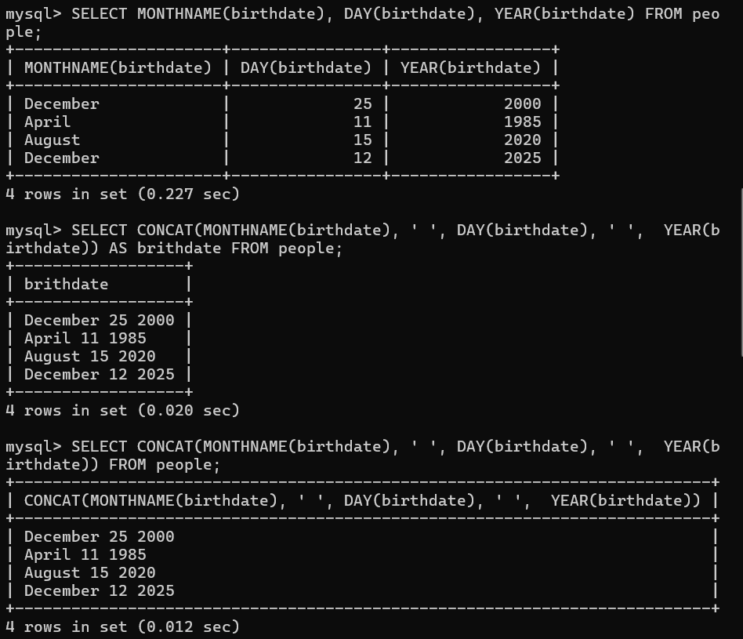

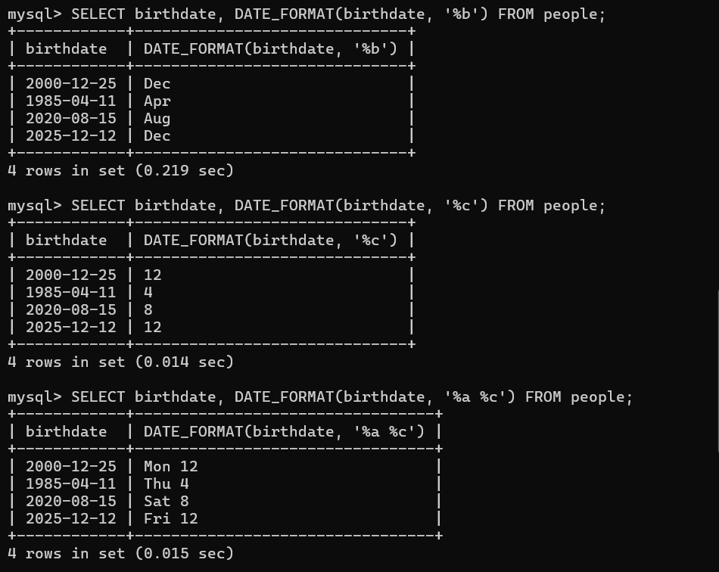

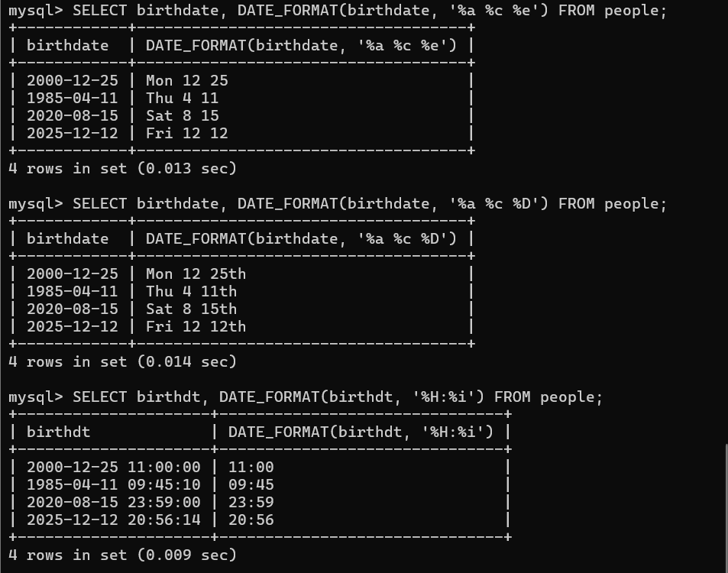

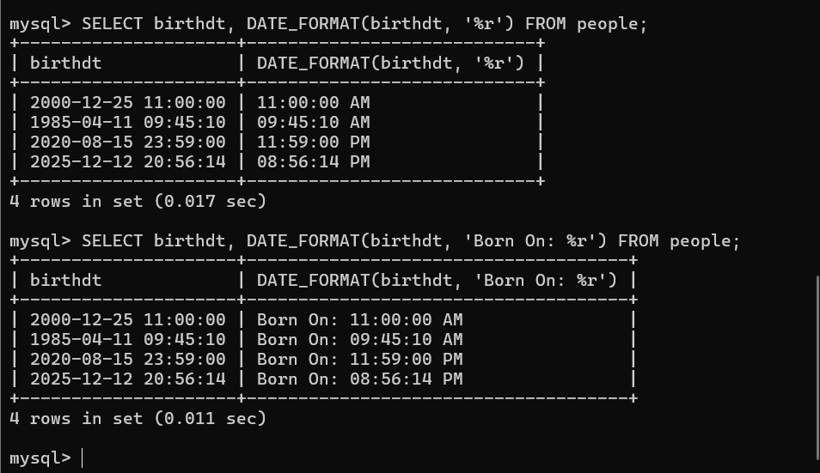

- Date Math

ADD AND SUB

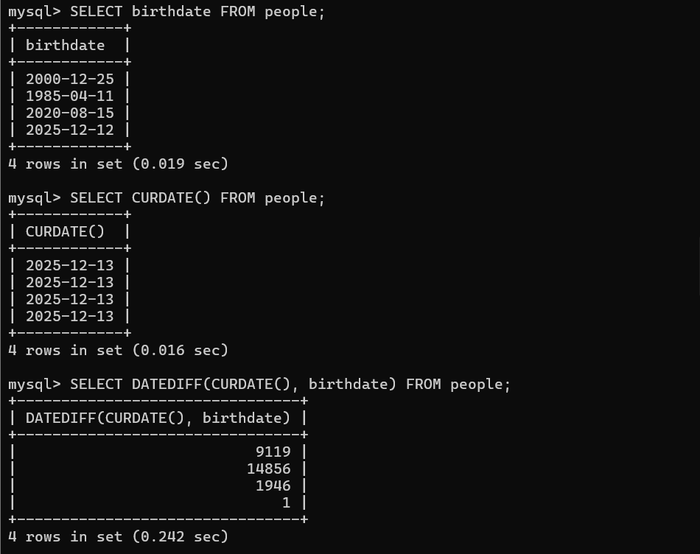

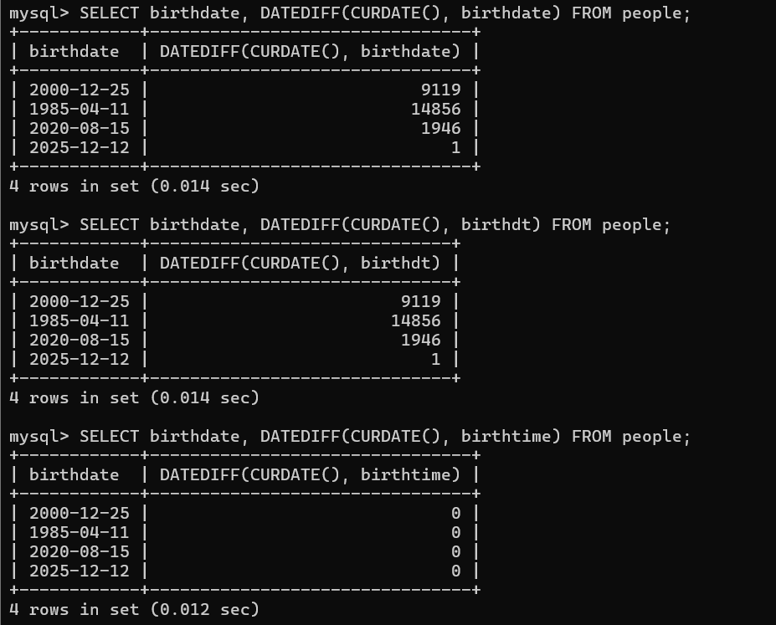

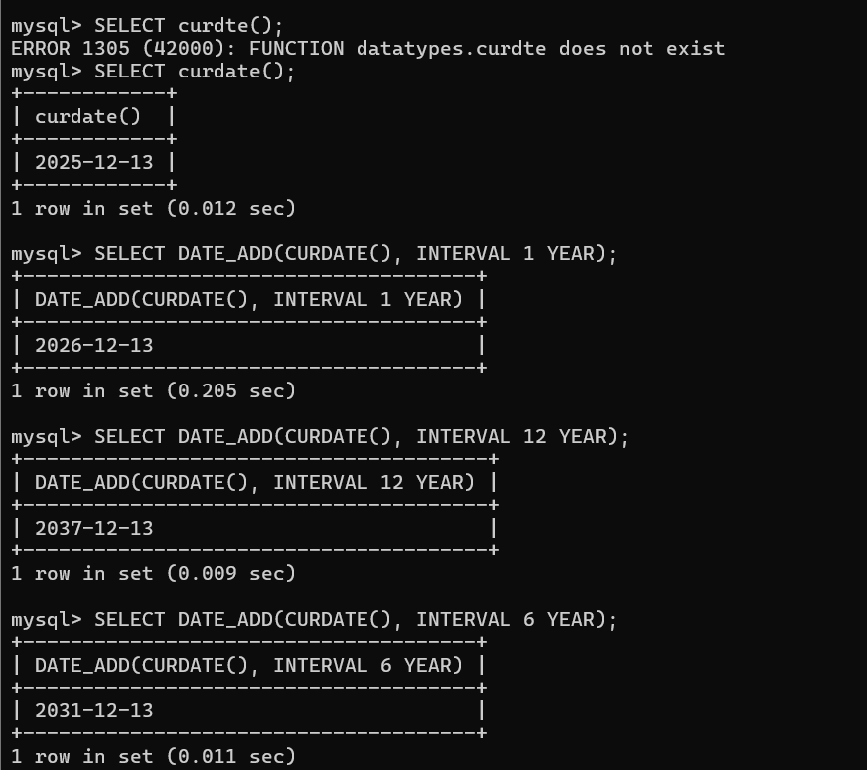

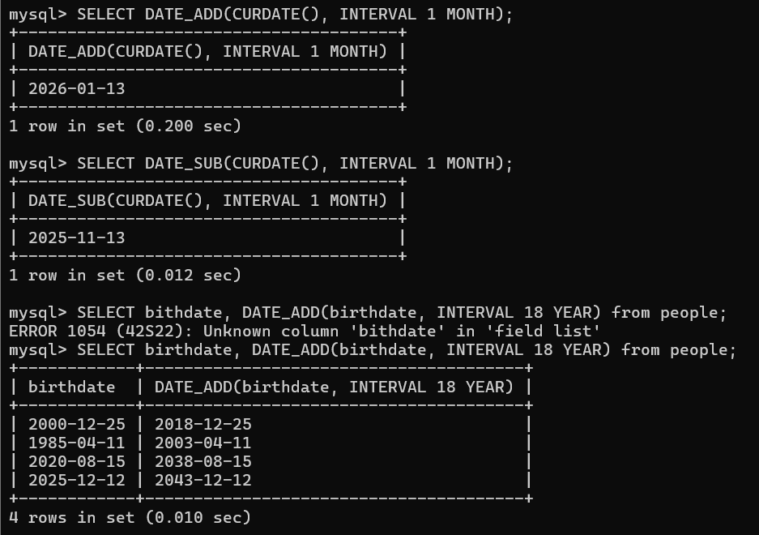

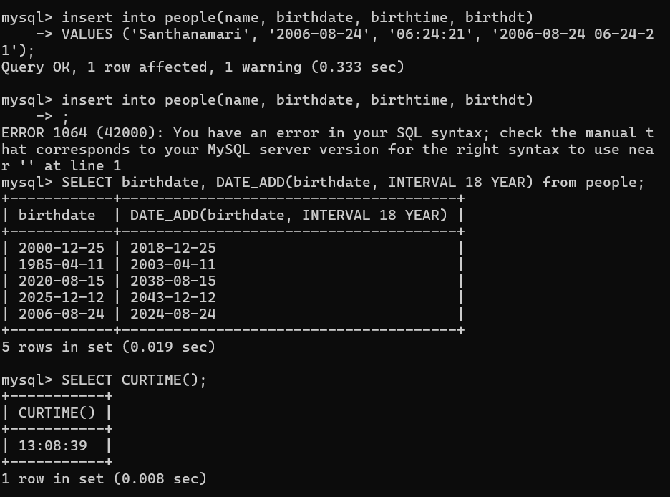

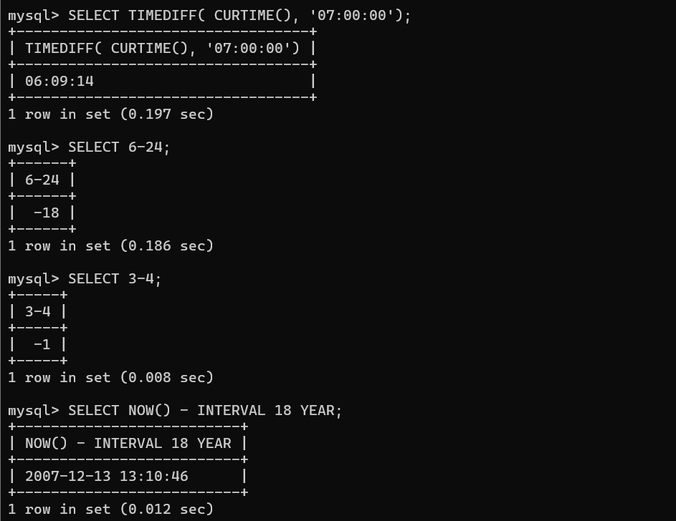

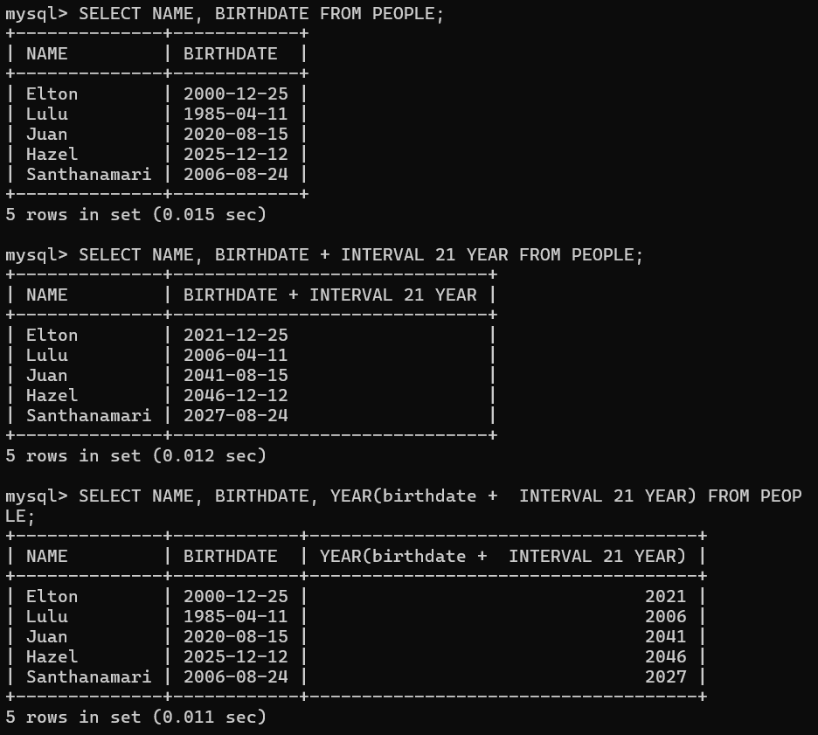

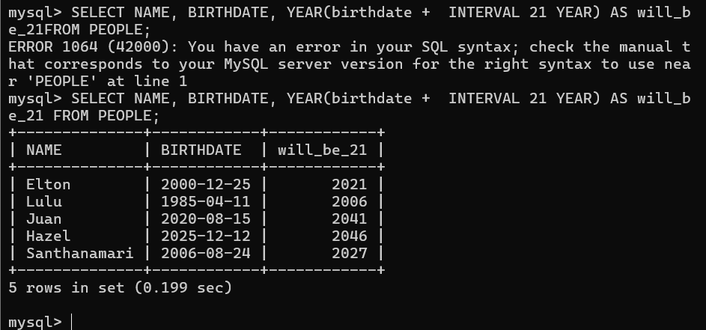

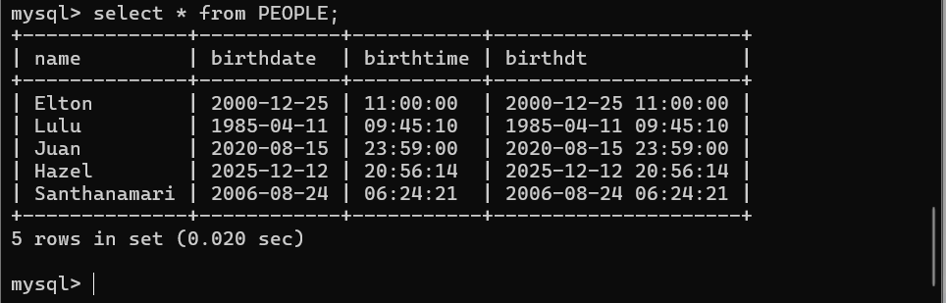

- TIMESTAMPS

Timestamps combine a date and a time.

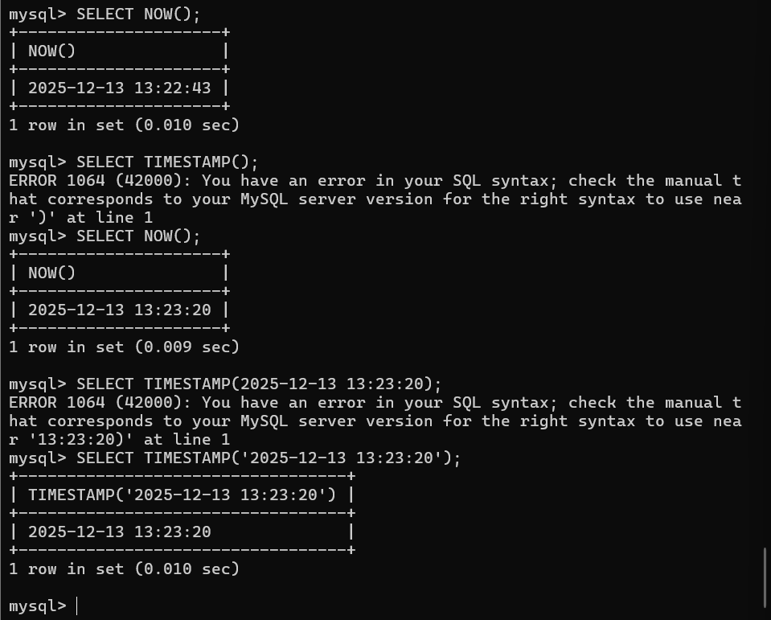

- DEFAULT AND ON UPDATE TIMESTAMPS

- CREATE TABLE captions (
- text VARCHAR(150),
- created_at TIMESTAMP default CURRENT_TIMESTAMP
- );

- CREATE TABLE captions2 (
- text VARCHAR(150),
- created_at TIMESTAMP default CURRENT_TIMESTAMP,
- updated_at TIMESTAMP ON UPDATE CURRENT_TIMESTAMP
- );

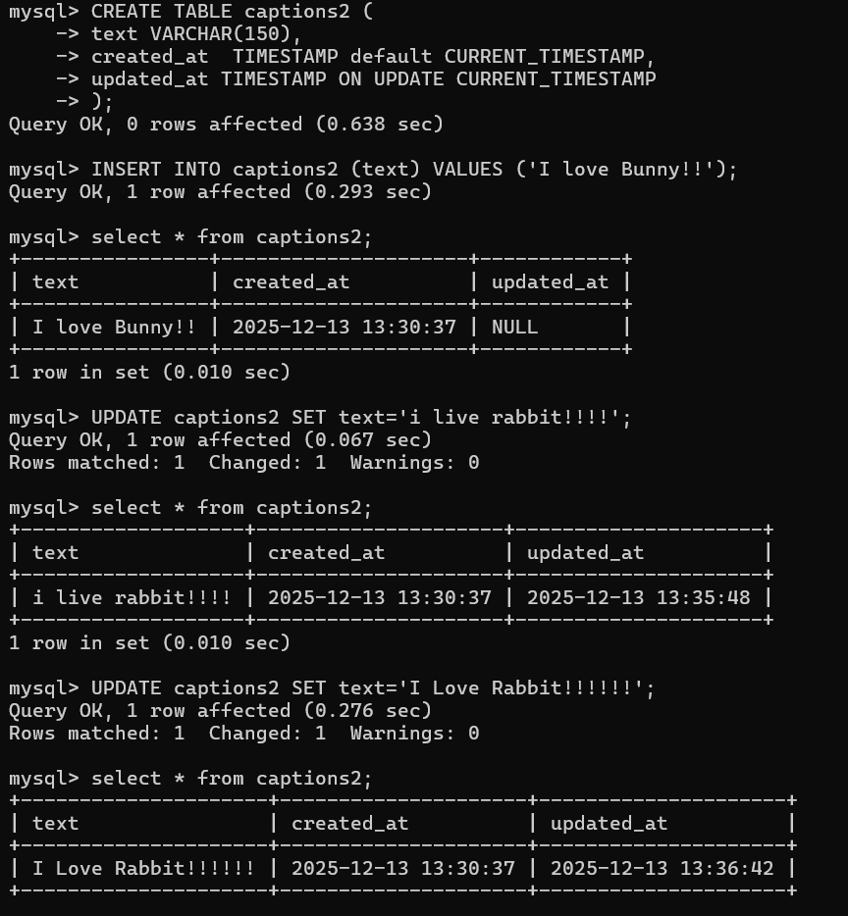

- Exercise

- -- What's a good use case for CHAR?

Used for text that we know has a fixed length, e.g., State abbreviations,
abbreviated company names, etc.

- CREATE TABLE inventory (
item_name VARCHAR(100),
price DECIMAL(8,2),
quantity INT
);

- -- What's the difference between DATETIME and TIMESTAMP?

-- They both store datetime information, but there's a difference in the range,
-- TIMESTAMP has a smaller range. TIMESTAMP also takes up less space.
-- TIMESTAMP is used for things like meta-data about when something is created
-- or updated.

- 4. SELECT CURTIME();

- 5. SELECT CURDATE();

- 6. SELECT DAYOFWEEK(CURDATE());

- SELECT DAYOFWEEK(NOW());
- SELECT DATE_FORMAT(NOW(), '%w') + 1;

- SELECT DAYNAME(NOW());
- SELECT DATE_FORMAT(NOW(), '%W');

- SELECT DATE_FORMAT(CURDATE(), '%m/%d/%Y');

- SELECT DATE_FORMAT(NOW(), '%M %D at %k:%i');

- CREATE TABLE tweets(
- content VARCHAR(140),
- username VARCHAR(20),
- created_at TIMESTAMP DEFAULT NOW()
- );

- INSERT INTO tweets (content, username) VALUES('this is my first tweet', 'coltscat');
- SELECT * FROM tweets;

- INSERT INTO tweets (content, username) VALUES('this is my second tweet', 'coltscat');
- SELECT * FROM tweets;

