Śrī Sūrya Śatanāmāvalī
(Branimir’s version)

gāyatrī mantra
ṛgvedasaṁhitā 3.62.10.
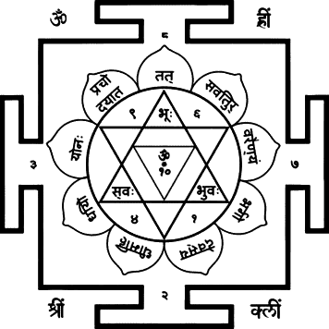
oṁ | bhūr bhuva̱s s^{u}va̍ḥ । required as per taittirīya āraṇyaka 2.11.
ṚV 3.62.10. - gāthino viśvāmitraḥ ṛṣiḥ, savitā devatā, gāyatrī chandaḥ
tat sa̍vi̱tur vare̎ṇya̱m |
bhargo̍ de̱vasya̍ dhīmahi |
dhiyo̱ yo na̍ḥ^{f} praco̱dayā̎tˎ॥
May the transcendental sound om fil the planet earth, the atmosphere, and the heavenly region,
may we meditate on the radiance of that excellent vitalising (Sun) Deva,
may he inspire anyone of us with focused mind.

śrī sūrya gāyatrī
oṁ | bhā̱ska̱rāya̍ vi̱dmahe̍ |
mahāte̱jāya̍ dhīmahi |
tanna̍s sūryaḥ^{f} praco̱dayā̎tˎ॥
We contemplate Bhāskara, the radiant source of light.
We meditate on the One of great luminous strength.
May that Sun God inspire and illumine our intellects and awaken our understanding.

(śrī sāyī sūrya gāyatrī)
oṁ | śrī̱ bhā̱ska̱rāya̍ vi̱dmahe̍ |
sāyī de̱vāya̍ dhīmahi |
tanna̍s sūryaḥ^{f} praco̱dayā̎tˎ॥
We meditate on Śrī Bhāskara, the radiant embodiment of divine light.
We focus our hearts upon Sāyī Devā.
May that Sun, the source of wisdom and spiritual energy, inspire and illumine our minds.

oṁ | atha branimir kṛtā śrī sūryaśatanāmāvalīḥ ॥

oṁ | sūryāya namaḥ ।
oṁ | aryamṇe namaḥ ।
oṁ | bhāskarāya namaḥ ।
oṁ | ravaye namaḥ ।
oṁ | ādityāya namaḥ ।
oṁ | savitre namaḥ ।
oṁ | mārtaṇḍāya namaḥ ।
oṁ | divākarāya namaḥ ।
oṁ | prabhākarāya namaḥ ।
oṁ | sahasrāṁśave namaḥ ॥ 10॥
oṁ | tejase namaḥ ।
oṁ | dinakṛte namaḥ ।
oṁ | bhānave namaḥ ।
oṁ | j^{g}ñānapradāya namaḥ ।
oṁ | tapane namaḥ ।
oṁ | haraye namaḥ ।
oṁ | viśvabhānave namaḥ ।
oṁ | marīcaye namaḥ ।
oṁ | ināya namaḥ ।
oṁ | viśvacakṣase namaḥ ॥ 20॥
oṁ | saptāśvarathārūḍhāya namaḥ ।
oṁ | uṣṇāya namaḥ ।
oṁ | bhānumate namaḥ ।
oṁ | sūryanārāyaṇāya namaḥ ।
oṁ | adhidevatāya namaḥ ।
oṁ | lokapūjitāya namaḥ ।
oṁ | lokanāthāya namaḥ ।
oṁ | lokasākṣiṇe namaḥ ।
oṁ | lokakartre namaḥ ।
oṁ | lokabhāvāya namaḥ ॥ 30॥
oṁ | kamalākṣāya namaḥ ।
oṁ | sahasranetrāya namaḥ ।
oṁ | mahātejase namaḥ ।
oṁ | vṛṣākapaye namaḥ ।
oṁ | mitrāya namaḥ ।
oṁ | pūṣṇe namaḥ ।
oṁ | dhātre namaḥ ।
oṁ | vidhātre namaḥ ।
oṁ | prabhaviṣṇave namaḥ ।
oṁ | timirāndhakāntakāya namaḥ ॥ 40॥
oṁ | ārogyadāya namaḥ ।
oṁ | balapradāya namaḥ ।
oṁ | jīvanāthāya namaḥ ।
oṁ | prāṇadāya namaḥ ।
oṁ | viśvadhāriṇe namaḥ ।
oṁ | kālaprakāśakāya namaḥ ।
oṁ | kālarūpiṇe namaḥ ।
oṁ | mahākālāya namaḥ ।
oṁ | graharājāya namaḥ ।
oṁ | nakṣatranāthāya namaḥ ॥ 50॥
oṁ | dharmabhṛte namaḥ ।
oṁ | karmasākṣiṇe namaḥ ।
oṁ | satyātmane namaḥ ।
oṁ | satyapriyāya namaḥ ।
oṁ | bhūtātmane namaḥ ।
oṁ | paramātmane namaḥ ।
oṁ | brahmaṇe namaḥ ।
oṁ | viṣṇave namaḥ ।
oṁ | śivāya namaḥ ।
oṁ | hiraṇyagarbhāya namaḥ ॥ 60॥

oṁ | bhūtādhipāya namaḥ ।
oṁ | mahādevāya namaḥ ।
oṁ | arcirūpiṇe namaḥ ।
oṁ | bhāsvarāya namaḥ ।
oṁ | śubhapradāya namaḥ ।
oṁ | śāntidāya namaḥ ।
oṁ | puṇyāya namaḥ ।
oṁ | puṇyakṛte namaḥ ।
oṁ | pavitrāya namaḥ ।
oṁ | maṅgalāya namaḥ ॥ 70॥
oṁ | śaraṇyāya namaḥ ।
oṁ | varadāya namaḥ ।
oṁ | kāruṇyāya namaḥ ।
oṁ | bhaktavatsalāya namaḥ ।
oṁ | dayālave namaḥ ।
oṁ | viśvavedase namaḥ ।
oṁ | vedātmane namaḥ ।
oṁ | vedavidāya namaḥ ।
oṁ | yaj^{g}ñāya namaḥ ।
oṁ | yaj^{g}ñabhoktre namaḥ ॥ 80॥
oṁ | hotre namaḥ ।
oṁ | mantrātmane namaḥ ।
oṁ | brahmatejase namaḥ ।
oṁ | viśvasṛje namaḥ ।
oṁ | viśvapālane namaḥ ।
oṁ | viśvanāśāya namaḥ ।
oṁ | sarvātmake namaḥ ।
oṁ | sarvagāya namaḥ ।
oṁ | sarvabhāvāya namaḥ ।
oṁ | sarvapradāya namaḥ ॥ 90॥
oṁ | ekāya namaḥ ।
oṁ | anekāya namaḥ ।
oṁ | avyaktāya namaḥ ।
oṁ | vyaktāya namaḥ ।
oṁ | sākṣiṇe namaḥ ।
oṁ | citrabhānave namaḥ ।
oṁ | bhāsvatāvatāraya namaḥ ।
oṁ | jyotiṣāṁ pataye namaḥ ।
oṁ | tejomayāya namaḥ ।
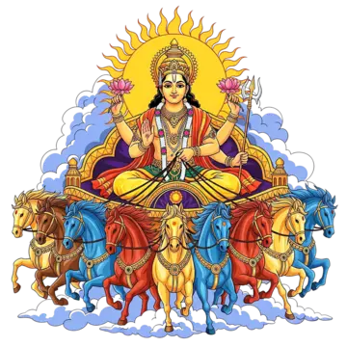
oṁ | śrī sūryanārāyaṇāya namaḥ ॥ 100॥

