Oblikovanje podataka

*Predmet: Informacijski sustavi*

*2022*

**UVOD**

U dokumentu se nalazi slike konceptualnog modela- ER dijagrama i model baze podataka. U nastvku su navedeni kod za kreiranje i punjenje baze podatka.Ako nije vidljivo u dokumentu u prilogu će se nalaziti slike navedenih dijagrama. Korištena baza podataka je PosgreSQL.

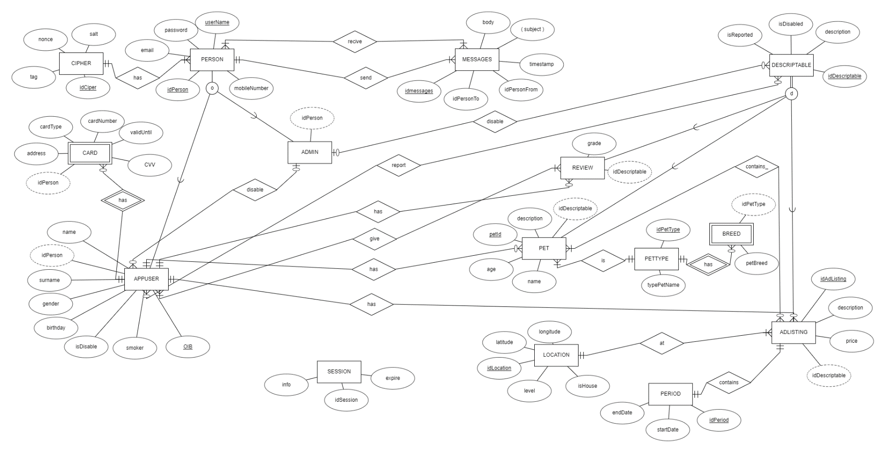

Slika ER dijagram

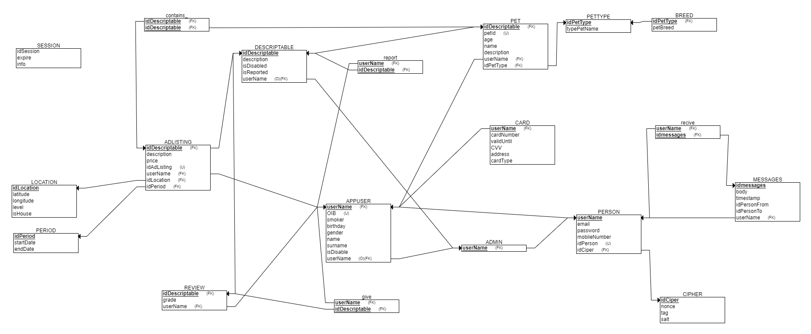

Slika Relacijski dijagrama

**SQL za kreiranje baze podataka**

CREATE TABLE LOCATION

(

idLocation SERIAL NOT NULL,

latitude FLOAT NOT NULL,

longitude FLOAT NOT NULL,

level INT NOT NULL,

isHouse boolean NOT NULL,

PRIMARY KEY (idLocation)

);

CREATE TABLE SESSION

(

idSession VARCHAR(500) NOT NULL,

expire VARCHAR(500) NOT NULL,

info VARCHAR(10000) NOT NULL

);

CREATE TABLE PERIOD

(

startDate DATE NOT NULL,

endDate DATE NOT NULL,

idPeriod SERIAL NOT NULL,

PRIMARY KEY (idPeriod)

);

CREATE TABLE PETTYPE

(

idPetType SERIAL NOT NULL,

typePetName VARCHAR(1000) NOT NULL,

PRIMARY KEY (idPetType)

);

CREATE TABLE BREED

(

petBreed VARCHAR(1000) NOT NULL,

idPetType SERIAL NOT NULL,

PRIMARY KEY (idPetType),

FOREIGN KEY (idPetType) REFERENCES PETTYPE(idPetType)

);

CREATE TABLE CIPHER

(

nonce VARCHAR(65000) NOT NULL,

tag VARCHAR(65000) NOT NULL,

salt VARCHAR(65000) NOT NULL,

idCiper VARCHAR(65000) NOT NULL,

PRIMARY KEY (idCiper)

);

CREATE TABLE PERSON

(

userName VARCHAR(5000) NOT NULL,

email VARCHAR(2000) NOT NULL,

password VARCHAR(4000) NOT NULL,

mobileNumber VARCHAR(400) NOT NULL,

idPerson SERIAL NOT NULL,

idCiper VARCHAR(65000) NOT NULL,

PRIMARY KEY (userName),

FOREIGN KEY (idCiper) REFERENCES CIPHER(idCiper),

UNIQUE (idPerson)

);

CREATE TABLE ADMIN

(

userName VARCHAR(5000) NOT NULL,

PRIMARY KEY (userName),

FOREIGN KEY (userName) REFERENCES PERSON(userName)

);

CREATE TABLE APPUSER

(

OIB VARCHAR(500) NOT NULL,

smoker boolean NOT NULL,

birthday VARCHAR(500) NOT NULL,

gender VARCHAR(100) NOT NULL,

name VARCHAR(500) NOT NULL,

surname VARCHAR(500) NOT NULL,

isDisable boolean NOT NULL,

userName VARCHAR(5000) NOT NULL,

PRIMARY KEY (userName),

FOREIGN KEY (userName) REFERENCES PERSON(userName),

UNIQUE (OIB)

);

CREATE TABLE DESCRIPTABLE

(

description VARCHAR(10000) NOT NULL,

isDisabled boolean NOT NULL,

idDescriptable SERIAL NOT NULL,

isReported boolean NOT NULL,

userName VARCHAR(5000),

PRIMARY KEY (idDescriptable),

FOREIGN KEY (userName) REFERENCES ADMIN(userName)

);

CREATE TABLE REVIEW

(

grade INT NOT NULL,

idDescriptable SERIAL NOT NULL,

userName VARCHAR(5000) NOT NULL,

PRIMARY KEY (idDescriptable),

FOREIGN KEY (idDescriptable) REFERENCES DESCRIPTABLE(idDescriptable),

FOREIGN KEY (userName) REFERENCES APPUSER(userName)

);

CREATE TABLE ADLISTING

(

description VARCHAR(60000) NOT NULL,

price FLOAT NOT NULL,

idAdListing SERIAL NOT NULL,

idDescriptable SERIAL NOT NULL,

userName VARCHAR(5000) NOT NULL,

idLocation SERIAL NOT NULL,

idPeriod SERIAL NOT NULL,

PRIMARY KEY (idDescriptable),

FOREIGN KEY (idDescriptable) REFERENCES DESCRIPTABLE(idDescriptable),

FOREIGN KEY (userName) REFERENCES APPUSER(userName),

FOREIGN KEY (idLocation) REFERENCES LOCATION(idLocation),

FOREIGN KEY (idPeriod) REFERENCES PERIOD(idPeriod),

UNIQUE (idAdListing)

);

CREATE TABLE PET

(

petId SERIAL NOT NULL,

age INT NOT NULL,

name VARCHAR(1000) NOT NULL,

description VARCHAR(10000) NOT NULL,

idDescriptable SERIAL NOT NULL,

userName VARCHAR(5000) NOT NULL,

idPetType SERIAL NOT NULL,

PRIMARY KEY (idDescriptable),

FOREIGN KEY (idDescriptable) REFERENCES DESCRIPTABLE(idDescriptable),

FOREIGN KEY (userName) REFERENCES APPUSER(userName),

FOREIGN KEY (idPetType) REFERENCES PETTYPE(idPetType),

UNIQUE (petId)

);

CREATE TABLE MESSAGES

(

idmessages SERIAL NOT NULL,

body VARCHAR(65000) NOT NULL,

timestamp DATE NOT NULL,

idPersonFrom SERIAL NOT NULL,

idPersonTo SERIAL NOT NULL,

userName VARCHAR(5000) NOT NULL,

PRIMARY KEY (idmessages),

FOREIGN KEY (userName) REFERENCES PERSON(userName)

);

CREATE TABLE CARD

(

cardNumber VARCHAR(160) NOT NULL,

validUntil VARCHAR(200) NOT NULL,

CVV VARCHAR(30) NOT NULL,

address VARCHAR(2000) NOT NULL,

cardType VARCHAR(200) NOT NULL,

userName VARCHAR(5000) NOT NULL,

PRIMARY KEY (userName),

FOREIGN KEY (userName) REFERENCES APPUSER(userName)

);

CREATE TABLE give

(

userName VARCHAR(5000) NOT NULL,

idDescriptable SERIAL NOT NULL,

PRIMARY KEY (userName, idDescriptable),

FOREIGN KEY (userName) REFERENCES APPUSER(userName),

FOREIGN KEY (idDescriptable) REFERENCES REVIEW(idDescriptable)

);

CREATE TABLE contains

(

idDescriptable SERIAL NOT NULL,

PRIMARY KEY (idDescriptable),

FOREIGN KEY (idDescriptable) REFERENCES ADLISTING(idDescriptable),

FOREIGN KEY (idDescriptable) REFERENCES PET(idDescriptable)

);

CREATE TABLE report

(

userName VARCHAR(5000) NOT NULL,

idDescriptable SERIAL NOT NULL,

PRIMARY KEY (userName, idDescriptable),

FOREIGN KEY (userName) REFERENCES APPUSER(userName),

FOREIGN KEY (idDescriptable) REFERENCES DESCRIPTABLE(idDescriptable)

);

CREATE TABLE recive

(

userName VARCHAR(5000) NOT NULL,

idmessages SERIAL NOT NULL,

PRIMARY KEY (userName, idmessages),

FOREIGN KEY (userName) REFERENCES PERSON(userName),

FOREIGN KEY (idmessages) REFERENCES MESSAGES(idmessages)

);

**SQL za punjenje baze podataka**

INSERT INTO location ( idlocation,latitude , longitude, level, isHouse) VALUES

(1,45.3132,13.232, 0, true),

(2,45.3132,14.232, 2, true),

(3,45.3132,16.232, 3, true),

(4,45.3132,15.232, 0, true);

INSERT INTO SESSION (idSession, expire , info ) VALUES

('afkliajhflia', '2013-06-01','ajhfkliajhflia'),

('ahfjadfw', '2022-06-01','ajhfkliajhgada'),

('ahfjadfq', '2022-06-01','ajhfkliaadfadf'),

('ahafjadfq', '2022-06-01','ajhsfkliaadfadf');

INSERT INTO PERIOD(idPeriod,startdate, enddate) VALUES

(0, '2022-04-01','2022-06-01'),

( 1,'2022-04-01','2022-08-01'),

( 2,'2022-04-01','2022-07-01'),

( 3, '2022-04-01','2022-07-01');

INSERT INTO PETTYPE (typePetName ,idpettype ) VALUES

('Ribe',1),

('Mačke',2),

('Psi',3),

('Zmije',4),

('Majmun',5),

('Glodavci',6);

INSERT INTO BREED(petBreed ,idPetType) VALUES

('Šaran', 1),

('Perzijska', 2),

('Njemački ovčar',3);

INSERT INTO CIPHER (nonce,tag , salt, idciper) VALUES

('adfhasgjdfghkasjibhfa','adsghfausgdf','agfdgfuasdofauu', 'adfhasgjdfghkasjibhfa'),

('adfhasgjdfghkasjibhfadaa','adsghfausgdfada','agfdgfuasdofdfasdf','adfhasgjdfghkasjibhfadaa'),

('adfhasgjdfghkasjibhadfa','adsghfausgdadf','agfdgfuasdofauadsu','adfhasgjdfghkasjibhadfa'),

('adfhasgj22dfghkasjibhfa','adsghfaus12gdf','agfdgfuas12dofauu', 'adfhasgj22dfghkasjibhfa');

INSERT INTO PERSON( userName , email , password , mobileNumber , idCiper) VALUES

('userName','blabla@gmail.com','jasamZakon','+095553434', 'adfhasgjdfghkasjibhfa'),

('PeroPeric','PeroPeric@gmail.com','jasamZakon','+0934553434', 'adfhasgjdfghkasjibhfadaa'),

('Pero','Pero@gmail.com','jasamZakon','+093455388434', 'adfhasgj22dfghkasjibhfa');

INSERT INTO public.admin(

username)

VALUES ('Pero'),('PeroPeric'),('userName');

INSERT INTO APPUSER (OIB, smoker, birthday, gender, name, surname, isDisable, userName ) VALUES

('029309818832',FALSE,'22.02.2000','men','Pero','Peric',FALSE,'PeroPeric'),

('029309238832',FALSE,'25.05.2000','men','Pero','Peric',FALSE,'Pero'),

('239309238832',FALSE,'25.05.2000','women','Petra','Peric',FALSE,'userName');

INSERT INTO DESCRIPTABLE (description, isDisabled, idDescriptable, isReported, userName )VALUES

('Some description ',FALSE, 0 ,FALSE,'PeroPeric'),

('Some description za oglase',FALSE, 1 ,FALSE,'Pero'),

('Some description za oglase za psa',FALSE, 2 ,FALSE,'userName');

INSERT INTO REVIEW (grade, idDescriptable, userName ) VALUES

( 5,0,'Pero'),

( 5,1,'PeroPeric'),

( 5,2,'Pero');

INSERT INTO ADLISTING( description, price, idAdListing, idDescriptable, userName, idLocation, idPeriod )

VALUES ( 'Description12 ',100.10,0,0,'userName',1,0),

( 'Description',100.10,2,1,'userName',1,1);

INSERT INTO PET (age, name, description, idDescriptable, userName, idPetType ) VALUES

(12, 'Puslica', 'Traim oglas za čuvanje stare mačke potrebna koja treba cijelo vrijeme nadzor',0,'PeroPeric',1),

(12, 'Hund', 'Traim oglas za čuvanje psapotrebna koja treba cijelo vrijeme nadzor',1,'Pero',2);

INSERT INTO MESSAGES( idmessages, body,timestamp, idPersonFrom, idPersonTo, userName)VALUES

(0,'Pozdrav moj pas je spreman na lokaciji.','2021-12-12',0, 1 ,'PeroPeric'),

(1,'Pozdrav moj pas je spreman na lokaciji.','2021-12-12',0, 1 ,'PeroPeric');

INSERT INTO CARD(

cardNumber,

validUntil,

CVV,

address,

cardType,

userName

)VALUES ('hasVrijednost','hashvrijednost','ajhdgfiad','Ive loleRibara 21','VISA','PeroPeric'),

('hasVrijednost','hashvrijednost1','ajhdgfiad','Ive loleRibara 26','VISA','Pero');

INSERT INTO give(userName, idDescriptable)VALUES

('PeroPeric',0),

('Pero', 1);

INSERT INTO contains

(

idDescriptable

)VALUES(1),(0);

INSERT INTO report

(

userName,

idDescriptable

) VALUES ('PeroPeric', 0),

('Pero',1);

INSERT INTO recive

( userName,

idmessages

) VALUES ('PeroPeric', 0),

('Pero', 1);