**Warm-up**: Discovery of the topic

**expected outcome 1**: understand & describe how a website works

**expected outcome 2**: Give a presentation of a website or mobile app

Where is the information I need? & 

Work with partners! Name items and comment on the extracts below using the following terms!

At the top

In the middle

On the right

Above

Next to

Below

between

On the left

At the bottom

In the upper part

In the lower part

Pic 1

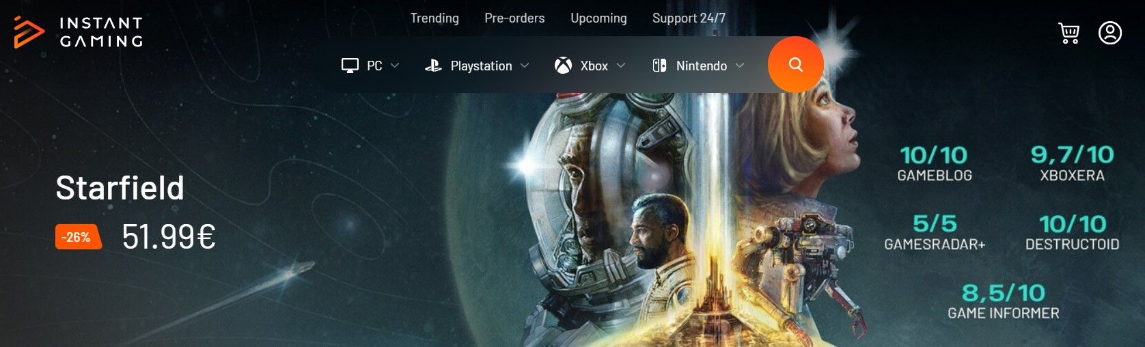

*Source :* [*https://www.instant-gaming.com/en/*](https://www.instant-gaming.com/en/)

Pic 2

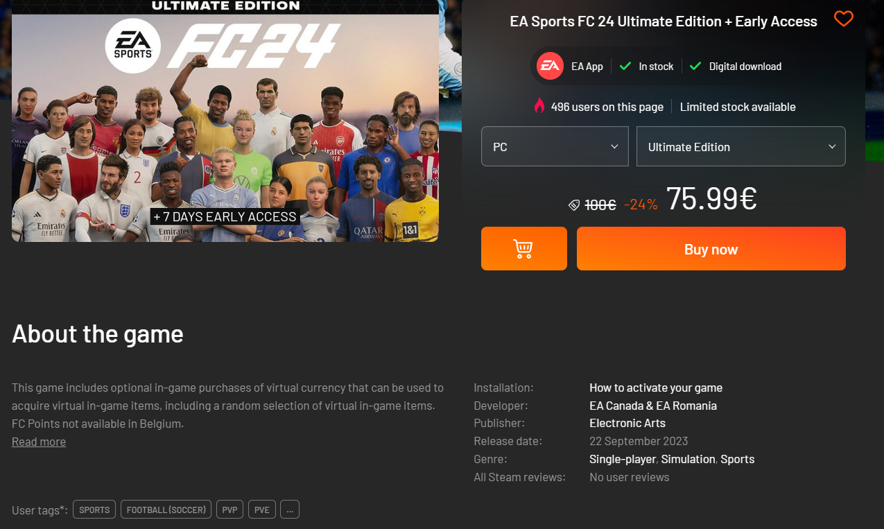

*Source :* [*https://www.instant-gaming.com/en/*](https://www.instant-gaming.com/en/)

Pic 3

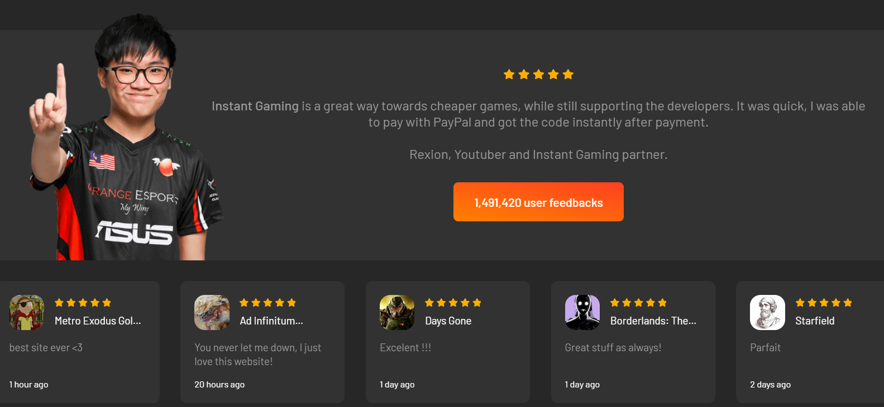

At the top, we see stars rating images

In the middle, thers is button who links to the users feedbacks

Below, there is the comment from this e-sport player about his used of the website

*Source :* [*https://www.instant-gaming.com/en/*](https://www.instant-gaming.com/en/)

In the lower part, we see datetime of the feedbacks

On the left, there is a link to a videogame

Pic 4

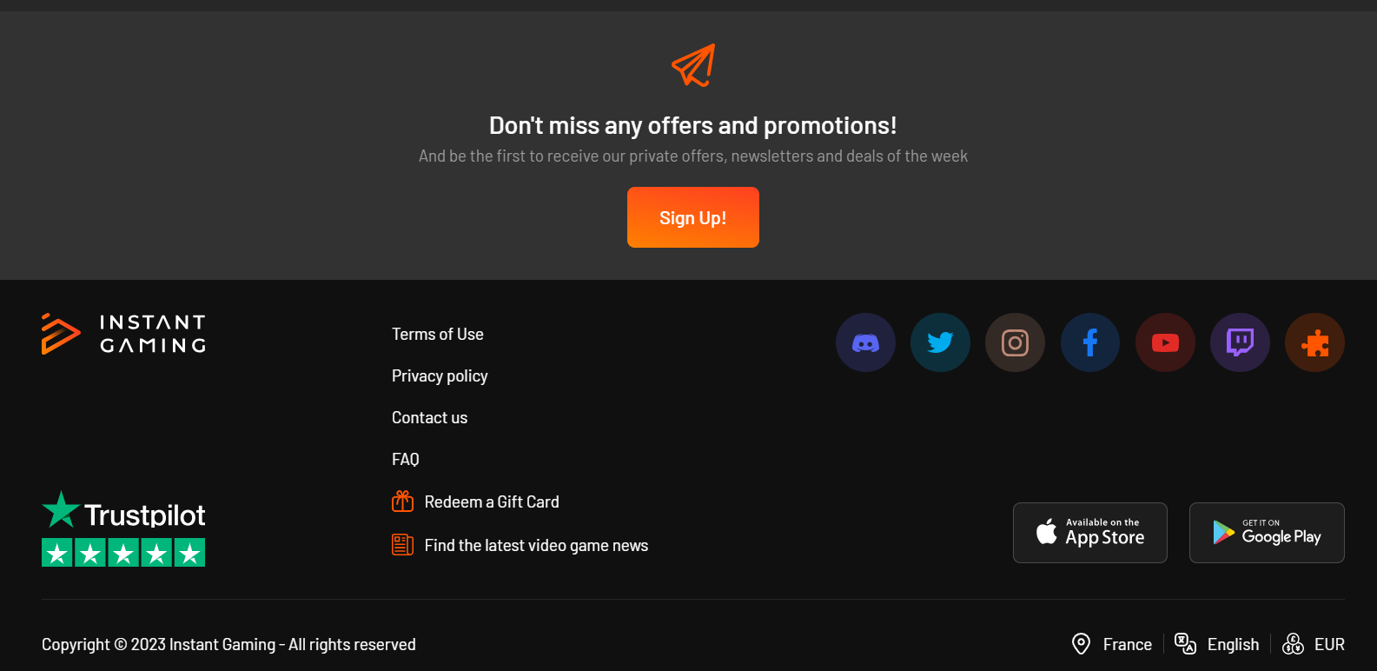

*Source :* [*https://www.instant-gaming.com/en/*](https://www.instant-gaming.com/en/)*◦◦*

 Now Present your website, web app or mobile app of your choice & describe it to the class! 3 mn max

Introduce yourself

Introduce the website or app

The target

The layout & The main features (where things are located)

The buttons, menus, links, info, etc…. Focus on A more detailed description of a relevant feature!

We are the Kevin’s brothers Company, based in Dublin. Kevin M is the CEO, Kevin.s the deputy CEO, Kevin-Dimitri the marketing manager

and Kevin-Florian the accountant.

We are owners of a social network who regroup all people named Kevin in the world.

Our target is all people named Kevin. Old people, young, weird, junkie, fat, skinny, blind, ugly etc.

The age is under 0 and 100 years old.

At the top, there is the logo with a picture of Kevin Costner smiling

There is a search bar below the logo.

In the lower part, there are the different profile of users.

In the profile, there are information on the users.

Above the profile, there are a button for discuss with the user.