GROUP REPORT - WEEK 6
Project: Website Development
Group Name: The EcoCoders
1. Website Title
SmartCity: A Guide to Sustainable Living
2. Short Description & Target Audience
- Subject Content: An educational website dedicated to sustainable living in an urban environment. It features 5 core modules: Energy, Waste, Water, Transport, and Lifestyle, offering practical tips for eco-friendly habits.
- Target Audience: Urban residents, students, and homeowners aged 18-45 who are interested in reducing their carbon footprint but need guided, practical advice.
3. Group Composition & Roles
- Marina Chatziefraimidou (Leader): Repository Management, Global CSS/Styling, Landing Page (index.html), Integration, Module: Transport.
- Dimitris Terpos: Developer - Module: Energy.
- Mary Varzakakou: Developer - Module: Lifestyle.
- Konstantinos Chatzimichail: Developer - Module: Water.
- Georgia Charari: Developer - Module: Waste.
4. Identified Sources
- Text Content: Original content generated with the assistance of GenAI (ChatGPT/Gemini) for educational articles, verified by group members.
- Images: Royalty-free images sourced from Pexels and Unsplash.
- Code: Written entirely by the team (HTML5/CSS3) without the use of AI code generators, using VS Code.
5. Site Map
https://www.gloomaps.com/cosP3ZhwAo
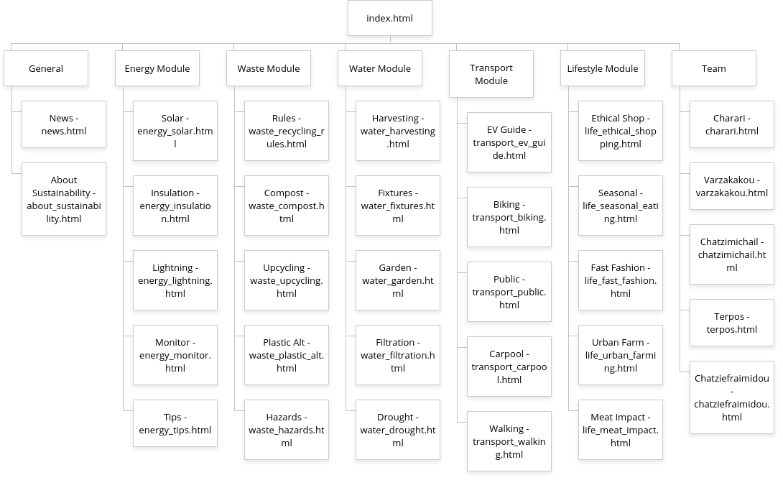
6. Content Descriptions
- Home Page: Introduction to the SmartCity concept and navigation hub to all modules.
- Energy Pages: Guides on solar power, LED lighting, and insulation techniques.
- Waste Pages: Instructions on composting, recycling codes, and hazardous waste.
- Water Pages: Detailed guides on rainwater harvesting systems, installing low-flow fixtures, drought-resistant gardening (xeriscaping), home filtration, and calculating water footprints.
- Transport Pages: Articles covering electric vehicle types (BEV/PHEV), cycling safety gear, the environmental benefits of public transit, carpooling tips, and the "15-minute city" walkability concept.
- Lifestyle Pages: Practical advice on seasonal eating calendars, the environmental impact of fast fashion, small-space urban farming, avoiding "greenwashing" in shopping, and reducing the carbon footprint of food.

7. Plan of Action (Gantt Chart)

Task | Responsible | Start Date | End Date
Project Setup & Repo | Chatziefraimidou | Week 4 | Week 4
Content Gathering (Text/Img) | All Developers | Week 4 | Week 6
HTML Structure Development | All Developers | Week 6 | Week 8
CSS Styling & Layout & JS Functionalities | Chatziefraimidou & All Developers | Week 7 | Week 9
Integration & Linking | Chatziefraimidou | Week 10 | Week 11
Final Review & Testing | All Team | Week 11 | Week 12

