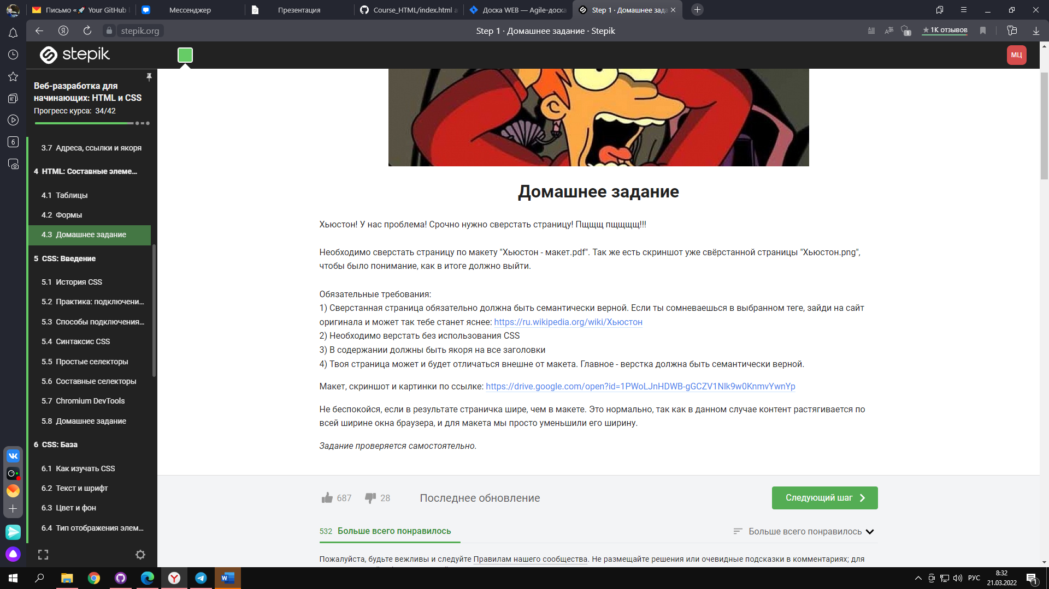

<https://drive.google.com/open?id=1PWoLJnHDWB-gGCZV1Nlk9w0KnmvYwnYp>