

**OpenSim: Hip in Motion**

Python package for biomedical modeling, simulation, and analysis.

**Run-Code-Repeat: Marina Espinosa, Eric Hu, and Kaleigh Renninger**

**Our OpenSim** [**GitHub**](https://github.com/marina378/Run-Code-Repeat_OpenSim)

**OBJECTIVE:**

To create and analyze a human musculoskeletal model walking within OpenSim and calculate the right hip flexion moment within the sagittal plane.

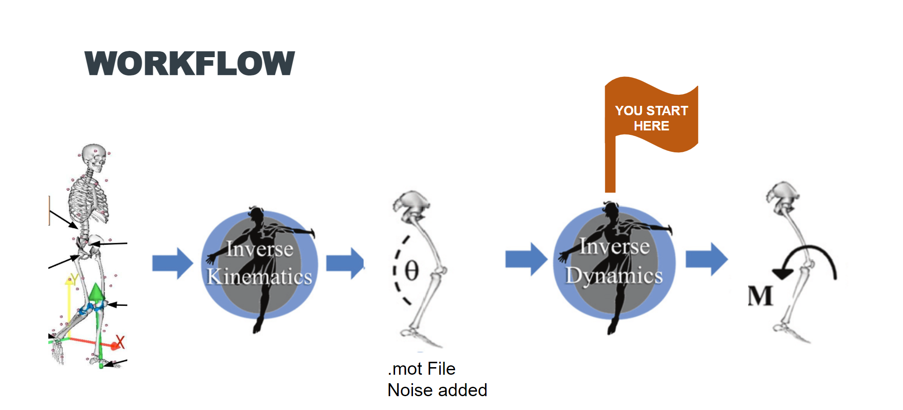

**DOWNLOADS:**

**You MUST download all** [**required files**](https://github.com/marina378/Run-Code-Repeat_OpenSim/tree/main/Sensitivity%20Analysis%20Of%20Hip%20Flexion) **in order to:**

1. Run our [code](https://github.com/marina378/Run-Code-Repeat_OpenSim/blob/main/Sensitivity%20Analysis%20Of%20Hip%20Flexion/SensitivityAnalysisOfHipFlexion.py) and output the Hip Flexion Moment vs. % Gait Cycle Plots
2. Create the different musculoskeletal models

**To run our** [**code**](https://github.com/marina378/Run-Code-Repeat_OpenSim/blob/main/Sensitivity%20Analysis%20Of%20Hip%20Flexion/SensitivityAnalysisOfHipFlexion.py) **to get desired outputs (Hip Flexion Moment vs. % Gait Cycle Plots):**

1. Navigate to [OpenSim](https://simtk-confluence.stanford.edu:8443/display/OpenSim/Scripting+in+Python#ScriptinginPython-AccessingelementsofVecXandVectorusingbrackets)
   1. Follow the instructions for your specific environment to import the OpenSim Package

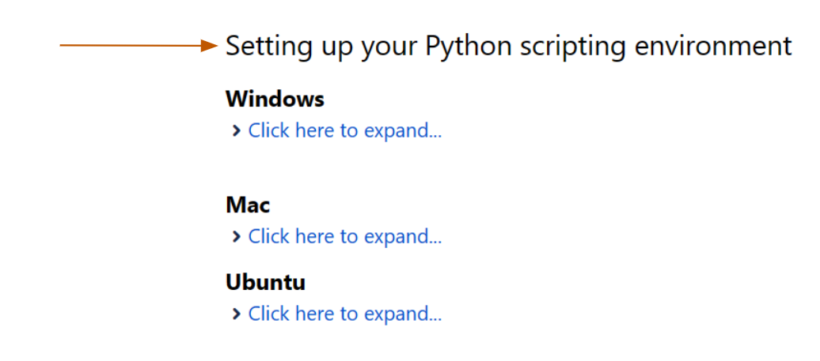

1. Run our [code](https://github.com/marina378/Run-Code-Repeat_OpenSim/blob/main/Sensitivity%20Analysis%20Of%20Hip%20Flexion/SensitivityAnalysisOfHipFlexion.py)
   1. Check [results](https://github.com/marina378/Run-Code-Repeat_OpenSim/tree/main/OurResults/Plots) of plots

**To Create the Musculoskeletal Models:**

1. Download the [OpenSim GUI](https://simtk.org/frs/?group_id=91)
   1. Navigate to the model ("[gait2392_simbody_scaled.osim](https://github.com/marina378/Run-Code-Repeat_OpenSim/blob/main/Sensitivity%20Analysis%20Of%20Hip%20Flexion/gait2392_simbody_scaled.osim)")
2. Open the OpenSim GUI
   1. Click on File
      1. Open Model
         1. Import the "[gait2392_simbody_scaled.osim](https://github.com/marina378/Run-Code-Repeat_OpenSim/blob/main/Sensitivity%20Analysis%20Of%20Hip%20Flexion/gait2392_simbody_scaled.osim)" model
3. Once the model has appeared in the visual window…
   1. Click on File
      1. Load Motion
         1. Select Original Data: "[subject01_walk1_ik.mot](https://github.com/marina378/Run-Code-Repeat_OpenSim/blob/main/Sensitivity%20Analysis%20Of%20Hip%20Flexion/subject01_walk1_ik.mot)" or Noisy Data: "[noisedata0.5.mot](https://github.com/marina378/Run-Code-Repeat_OpenSim/blob/main/Sensitivity%20Analysis%20Of%20Hip%20Flexion/noisedata0.5.mot)", "[noisedata1.m](https://github.com/marina378/Run-Code-Repeat_OpenSim/blob/main/Sensitivity%20Analysis%20Of%20Hip%20Flexion/noisedata0.5.mot)[ot](https://github.com/marina378/Run-Code-Repeat_OpenSim/blob/main/Sensitivity%20Analysis%20Of%20Hip%20Flexion/noisedata2.mot)", or "[noisedata2.mot](https://github.com/marina378/Run-Code-Repeat_OpenSim/blob/main/Sensitivity%20Analysis%20Of%20Hip%20Flexion/noisedata5.mot)"
4. Once the desired motion file is loaded…
   1. Press play on the top of the screen
      1. Check [results](https://github.com/marina378/Run-Code-Repeat_OpenSim/tree/main/OurResults/Models) of simulations

**BREAKDOWN OF OUR** [**CODE**](https://github.com/marina378/Run-Code-Repeat_OpenSim/blob/main/Sensitivity%20Analysis%20Of%20Hip%20Flexion/SensitivityAnalysisOfHipFlexion.py)**:**

Part 1: Retrieve Data & Add Noise

1. Import motion data (“[subject01_walk1_ik.mot](https://github.com/marina378/Run-Code-Repeat_OpenSim/blob/main/Sensitivity%20Analysis%20Of%20Hip%20Flexion/subject01_walk1_ik.mot)”)
2. Convert to CSV file using pandas and numpy
3. Add normal Gaussian noise to the inverse kinematics results at different standard deviations
4. Convert CSV back to motion file:
   1. Original Data: "[subject01_walk1_ik.mot](https://github.com/marina378/Run-Code-Repeat_OpenSim/blob/main/Sensitivity%20Analysis%20Of%20Hip%20Flexion/subject01_walk1_ik.mot)"
   2. Noisy Data: "[noisedata0.5.mot](https://github.com/marina378/Run-Code-Repeat_OpenSim/blob/main/Sensitivity%20Analysis%20Of%20Hip%20Flexion/noisedata0.5.mot)", "[noisedata1.m](https://github.com/marina378/Run-Code-Repeat_OpenSim/blob/main/Sensitivity%20Analysis%20Of%20Hip%20Flexion/noisedata0.5.mot)[ot](https://github.com/marina378/Run-Code-Repeat_OpenSim/blob/main/Sensitivity%20Analysis%20Of%20Hip%20Flexion/noisedata2.mot)", "[noisedata2.mot](https://github.com/marina378/Run-Code-Repeat_OpenSim/blob/main/Sensitivity%20Analysis%20Of%20Hip%20Flexion/noisedata5.mot)"

Part 2: Hip Flexion Moment Calculation

1. To calculate the hip flexion moment using the inverse dynamics module from the OpenSim package make sure the following is downloaded:
   1. The inverse kinematics motion file (“[subject01_walk1_ik.mot](https://github.com/marina378/Run-Code-Repeat_OpenSim/blob/main/Sensitivity%20Analysis%20Of%20Hip%20Flexion/subject01_walk1_ik.mot)”)
   2. The experimental ground reaction force data file (“[subject01_walk1_grf.xml](https://github.com/marina378/Run-Code-Repeat_OpenSim/blob/main/Sensitivity%20Analysis%20Of%20Hip%20Flexion/subject01_walk1_grf.xml)”)
   3. The scaled OpenSim file (“[gait2392_simbody_scaled.osim](https://github.com/marina378/Run-Code-Repeat_OpenSim/blob/main/Sensitivity%20Analysis%20Of%20Hip%20Flexion/gait2392_simbody_scaled.osim)”)

Part 3: Hip Flexion Moment vs. % Gait Cycle Plots

1. Plot the Hip Flexion Moment vs. % Gait Cycle with the original data using matplotlib
2. Plot the individual Hip Flexion Moment vs. % Gait Cycle with the added standard deviations of noise using matplotlib (created within the Inverse Dynamics function (ID(...)))
3. Plot a combined plot of all the individual plots from the step above (created within the plots(...) function)

**USER BEWARE:**

Below is the plot that combines all of our Hip Flexion Moments vs. % Gait Cycle with increasing noise levels. **Note:** the hip flexion moment values on the y-axis do not match measured hip flexion moments found in research. We plan to investigate and troubleshoot the code to resolve for future use in our research.

