Mapping a lost community: Tracing Jewish Life, Absence and Memory in the Urban Landscape of Ioannina

A Community within the City

The Jewish presence in Ioannina can be documented at least as far back as the early fourteenth century. A chrysobull issued by the Byzantine emperor Andronikos II Palaiologos in 1319 explicitly refers to the “Jews of the city”, providing evidence of a Jewish community in Ioannina at that time. Over the following centuries, Jewish settlement developed both within the Castle and beyond its walls, including the Sarava and Tsoukala neighborhoods and areas around the city’s commercial center. Today, much of this historical geography is difficult to recognize. By tracing selected sites that have survived, disappeared or changed, this project explores how Jewish presence and absence remain embedded in the contemporary city.

The Jewish Neighborhoods: Spaces of Everyday Life

The Jewish neighborhoods were spaces where domestic, religious and economic life intersected. Jewish residents lived around the Castle and in neighborhoods connected with the commercial center, while Romaniote Jews participated in occupations ranging from small-scale trade to larger mercantile activities, including the textile and silk trades. Their everyday life also reflected close interaction with the wider cultural environment of Ioannina. The Romaniote Jews were Greek-speaking and elements of local Epirote culture became part of their distinctive communal traditions. The Jewish neighborhoods were therefore identifiable spaces of communal life while remaining closely connected to the wider social and economic landscape of the city.

Synagogue, School and Community Life

Religious life was closely connected to the urban presence of the Jewish community of Ioannina. The Old Synagogue, Kahal Kadosh Yashan, was a place of worship for the city’s Jewish community. At the beginning of the twentieth century, Jewish education in Ioannina was increasingly connected with the Alliance Israélite Universelle. The Alliance school stood next to the New Synagogue (Kahal Kadosh Hadash), in the Jewish neighborhood of Megali Rouga, along present-day Yosef Eliya Street. These institutions formed important spaces of communal life, linking religious tradition with new forms of education and embedding both worship and learning within the Jewish geography of the city.

March 1944: The Rupture

On 25 March 1944, the centuries-long Jewish presence in Ioannina was violently disrupted. German forces, with the cooperation of the Greek Gendarmerie, carried out an operation to surround the areas inhabited by the city’s Jewish population and assemble them for deportation. Jews were gathered in the lakeside area of Mavili Square, where families were separated and the Jewish population was loaded onto German military trucks. They were transported out of Ioannina and subsequently deported to Auschwitz-Birkenau.

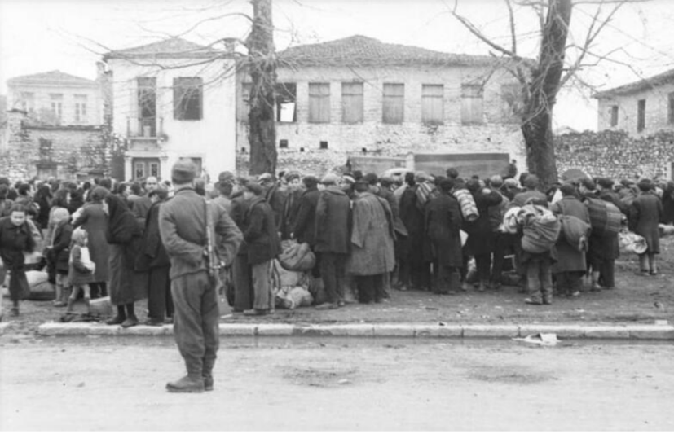
The deportation devastated the Jewish community and radically altered the human geography of Ioannina, leaving behind neighborhoods, buildings and places from which much of the community that had given them meaning was now absent.
Figure 1. Members of the Jewish community of Ioannina gathered during the deportation operation on 25 March 1944. A German soldier stands in the foreground.
Photograph: Wetzel. Bundesarchiv, Bild 101I-179-1575-03. CC BY-SA 3.0 DE.

What Remains? Reading Jewish History in the Present-Day City

The destruction of the Jewish community in 1944 profoundly changed the human landscape of Ioannina, but it did not erase every trace of its presence. Today, the Old Synagogue, Kahal Kadosh Yashan, still stands inside the Castle and remains an active place of worship and memory. The Jewish cemetery is also maintained by the community, while several houses associated with Jewish residents survive within the modern city. Other important sites can no longer be encountered in their original form. The New Synagogue and the Alliance Boys’ School were destroyed and apartment buildings belonging to the Jewish Community now stand on their former sites.
The interactive map brings together the surviving, lost and transformed sites discussed in this project, alongside the approximate spatial boundaries of the historical Jewish neighborhoods of Ioannina. It allows the historical geography of the community to be read in relation to the present-day urban landscape.
Explore the interactive map: Mapping a Lost Community: Jewish Ioannina
These different forms of survival, disappearance and transformation make the contemporary city itself a historical source. A visitor moving through Ioannina may encounter a surviving synagogue, a cemetery, an ordinary apartment building or a public square without immediately recognizing the histories connected to them. Mavili Square is particularly significant in this respect: today an open public space beside the lake, it was one of the places where the Jewish population was assembled for deportation on 25 March 1944.
Mapping these locations therefore does more than reconstruct the former geography of a Jewish community. It brings different layers of the city into relation with one another, connecting places of everyday life, worship and education with sites of persecution and with the transformed urban landscape of the present. The history of Jewish Ioannina can thus be read not only through what has survived, but also through what has disappeared or changed. The map makes these absences visible, allowing the contemporary city to be read alongside the community that once inhabited it.

Βιβλιογραφία
Papaioannou, A. (2007). Οι Εβραϊκές Συνοικίες των Ιωαννίνων: Ιστορία – Πολεοδομία – Αρχιτεκτονική. Athens: Central Board of Jewish Communities in Greece.
Battinou, J. (2014). Η Εβραϊκή Κοινότητα των Ιωαννίνων: Διαδρομή στο χρόνο. Athens: Jewish Museum of Greece.
Central Board of Jewish Communities in Greece. (χ.χ.). Jewish Community of Ioannina: History. Ανάκτηση September 29, 2026, από Central Board of Jewish Communities in Greece: https://www.kis.gr/en/communities/active-communities/ioannina/history
Fleischer, H. (1995). Στέμμα και Σβάστικα: Η Ελλάδα της Κατοχής και της Αντίστασης 1941–1944. Athens: Papazisis Publishers.
Schminck, C.-G. U. (2008). Μνήμες Κατοχής: Ιταλοί και Γερμανοί στα Γιάννενα και η καταστροφή της Εβραϊκής κοινότητας. Ioannina: Isnafi.
Zampakolas, C. (2013). Η ιστορική παρουσία των Γιαννιωτών Εβραίων μέσα από την εμπορική τους δραστηριότητα: Ιωάννινα–Βενετία, 16ος–18ος αιώνας. Ioannina: Ίδρυμα Ιωσήφ και Εσθήρ Γκανή.

Apostolos Papaioannou, Οι Εβραϊκές Συνοικίες των Ιωαννίνων: Ιστορία – Πολεοδομία – Αρχιτεκτονική (Athens: Central Board of Jewish Communities in Greece, 2007), 17.
Papaioannou, Οι Εβραϊκές Συνοικίες των Ιωαννίνων, 33–34, 44.
Ch. Zampakolas, Η ιστορική παρουσία των Γιαννιωτών Εβραίων μέσα από την εμπορική τους δραστηριότητα (Ioannina: Idrima Iosif kai Esther Gani, 2013), 53.
Apostolos Papaioannou, Οι Εβραϊκές Συνοικίες των Ιωαννίνων: Ιστορία – Πολεοδομία – Αρχιτεκτονική (Athens: Central Board of Jewish Communities in Greece, 2007), 23.
Janet Battinou, Η Εβραϊκή Κοινότητα Ιωαννίνων: Διαδρομή στο χρόνο (Athens: Jewish Museum of Greece, 2014).
Apostolos Papaioannou, Οι Εβραϊκές Συνοικίες των Ιωαννίνων: Ιστορία – Πολεοδομία – Αρχιτεκτονική (Athens: Central Board of Jewish Communities in Greece, 2007), 42, 65.
Christoph U. Schminck-Gustavus, Μνήμες Κατοχής: Ιταλοί και Γερμανοί στα Γιάννενα και η καταστροφή της εβραϊκής κοινότητας, trans. Alkiviadis Netas, Anna Pantidis, Thanasis Pantidis, and Sofia Georgallidi, ed. Eleni Torosi, vol. 2 (Ioannina: Isnafi, 2008), 236, 248.
Hagen Fleischer, Στέμμα και Σβάστικα: Η Ελλάδα της Κατοχής και της Αντίστασης 1941–1944, vol. 2 (Athens: Papazisis, 1995), 335.
Central Board of Jewish Communities in Greece, “Jewish Community of Ioannina: History,” accessed September 29, 2026.
Central Board of Jewish Communities in Greece, “Jewish Community of Ioannina: History,” accessed September 29, 2026.

