Comparative Genomics 2018
Practical 6: Orthology prediction

Group 9
Martinez Hernandez, Marina
Perez Gomez, Fernando

Summary
(100-200 words)

Key questions to answer
Topic
1.
2.

Attachments
For example
Activity 1.1: practical1_group9_scriptname1.py
Activity 2.1: practical1_group9_scriptname2.py

Exercise 1
Choose 3 genes: you want to compare the orthology predictions from one database with the prediction of other databases for three of your genes. Since you want that the genes are present in at least two databases (i.e TreeFam and InParanoid) you should restrict your gene selection to a species that is present in the selected databases. Some databases provide files with trees reporting of the species that were used.

Selected genomes:
04.fa.txt: Bradyrhizobium japonicum strain E109
16.fa.txt: Rhodopirellula baltica SH 1
18.fa.txt: Synechocystis sp. PCC 6714

Databases: InParanoid, OMAbrowser and Hieranoid.

Exercise 2
Get the protein identifier (gene symbol): to search for orthologs you first need the correct protein identifiers for your predicted genes (instead of orf1234..):

a) One way to find correct identifiers is to do a local blast search with the sequence of your protein against the source files of the InParanoid database. The source files can be found in http://inparanoid.sbc.su.se/download/current/sequences/processed/
You can even try to find a gene that occurs in two of your genomes to find orthologs for (you will need to adapt the blast search pipeline: makeblastdb.. | blastp .. | ); make sure that both organisms are present in at least two databases to get more interesting results.
By using http://inparanoid.sbc.su.se/download/current/sequences/species.mapping.inparanoid8 we could find the corresponding FASTA files to these organisms included in Inparanoid8 website:
04.fa.txt: Bradyrhizobium japonicum - 224911.fasta
16.fa.txt: Rhodopirellula baltica - 243090.fasta
18.fa.txt: Synechocystis sp. - 1111708.fasta

Command:
makeblastdb -in 224911.fasta -dbtype prot -out db04organism
makeblastdb -in 243090.fasta -dbtype prot -out db16organism
makeblastdb -in 1111708.fasta -dbtype prot -out db18organism

lastp -outfmt 7 -query 04.fa.txt.pfa -db db04organism -max_hsps 1 -evalue 0.0001 -out hits04againstinparanoid
lastp -outfmt 7 -query 16.fa.txt.pfa -db db16organism -max_hsps 1 -evalue 0.0001 -out hits16againstinparanoid
lastp -outfmt 7 -query 18.fa.txt.pfa -db db18organism -max_hsps 1 -evalue 0.0001 -out hits18againstinparanoid

b) You can also do an online blast search to find the identifiers (gene symbol)
c) Once you have the correct identifiers you need to find three genes which are also present in other databases

Search number | Genome ID | Organism | Gene ID
1 | 04.fa.txt | B. japonicum | Q89P52
2 | 04.fa.txt | B. japonicum | Q89UV1
3 | 04.fa.txt | B. japonicum | Q89QT2

Exercise 3
Search for orthologs and compare the results: for each of the three genes pick at least 3 species for your comparison
1

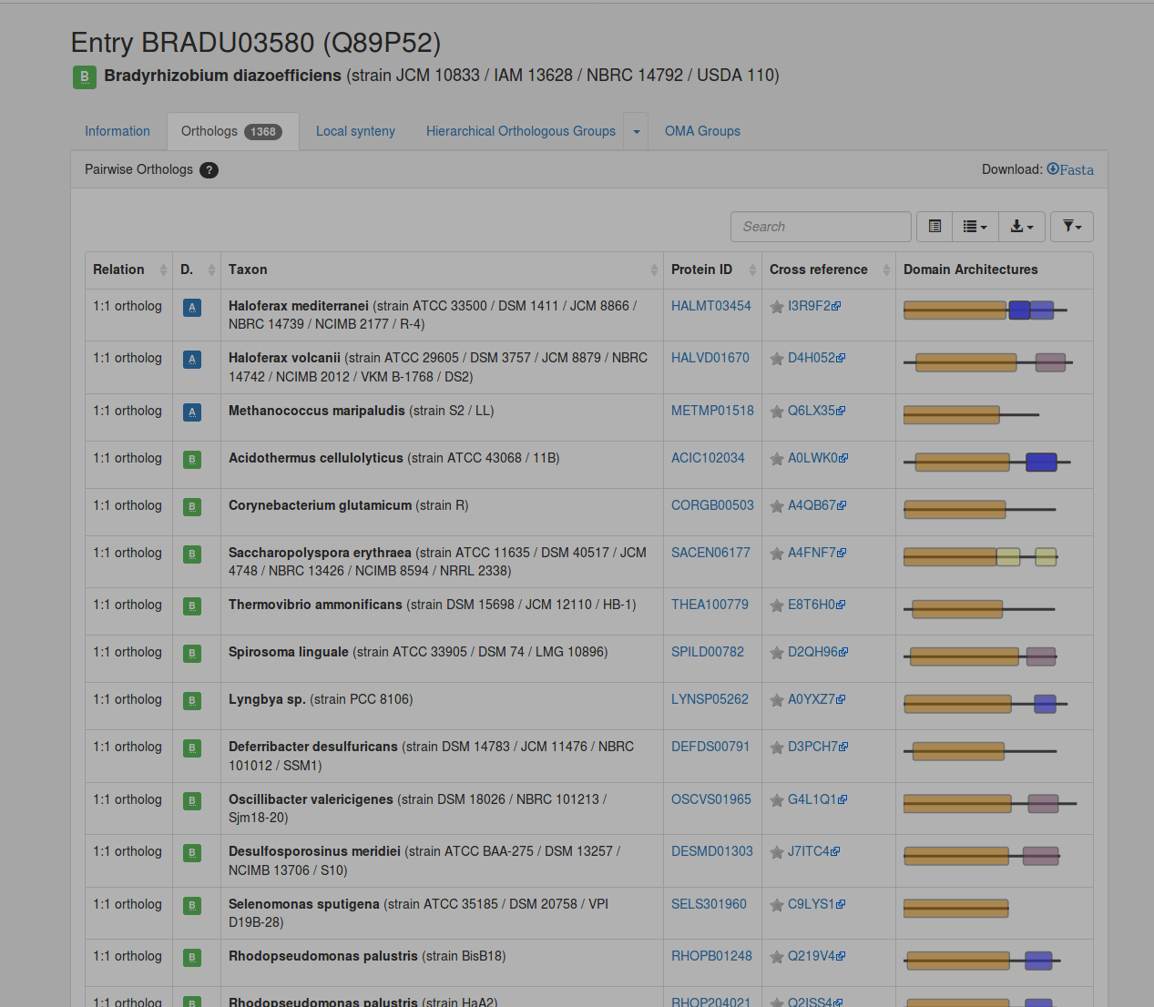
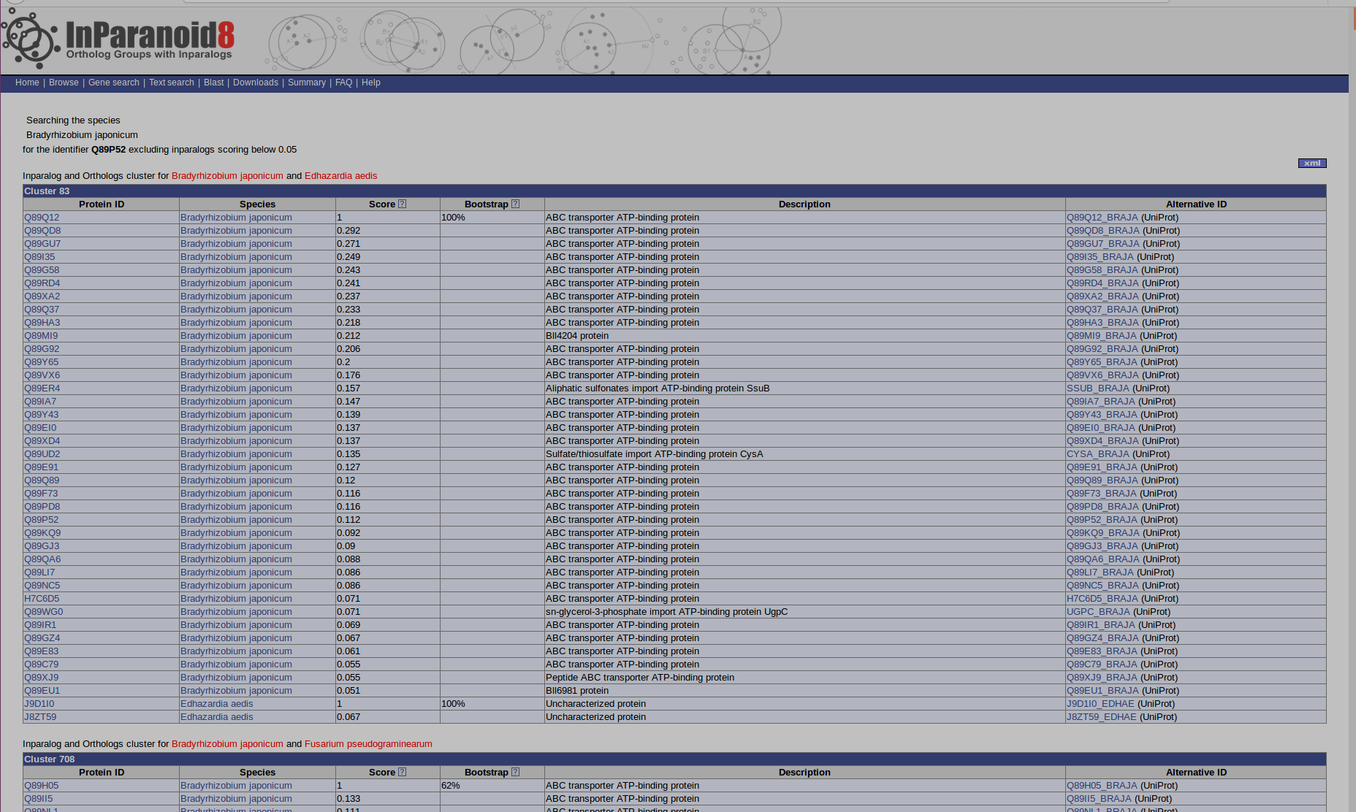

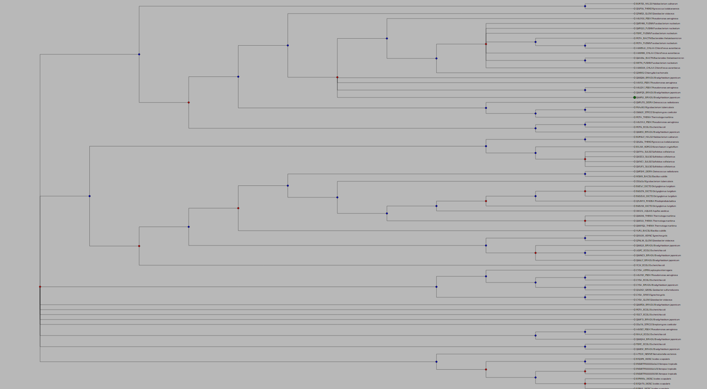

2

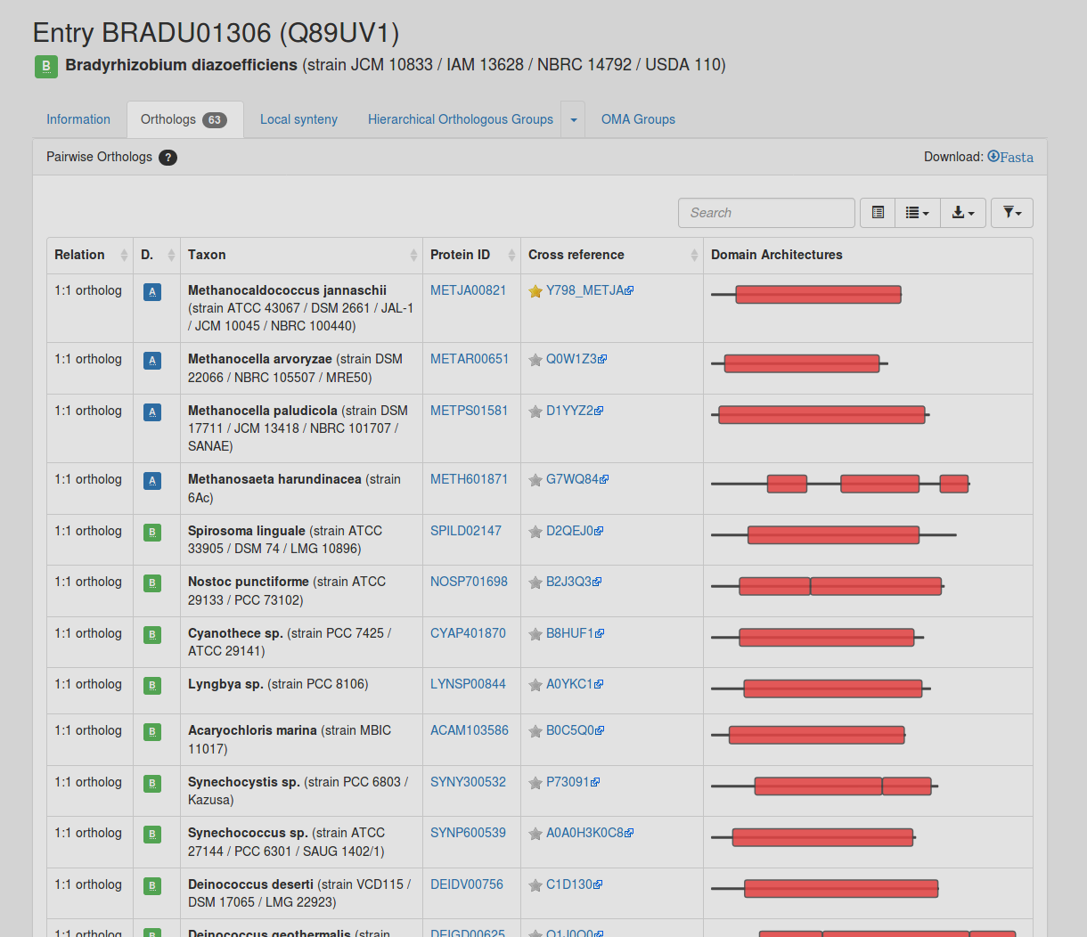

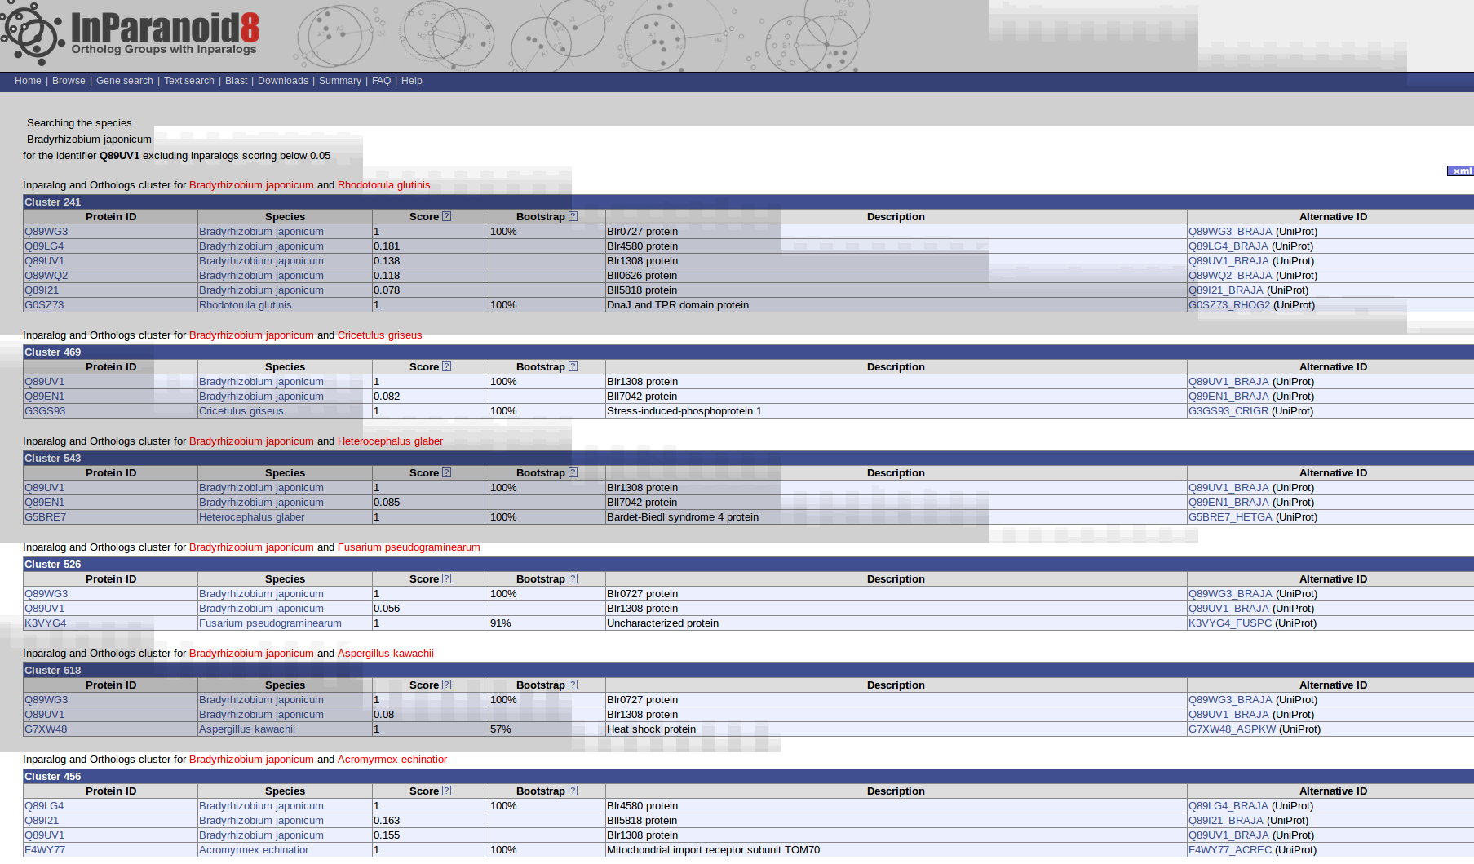
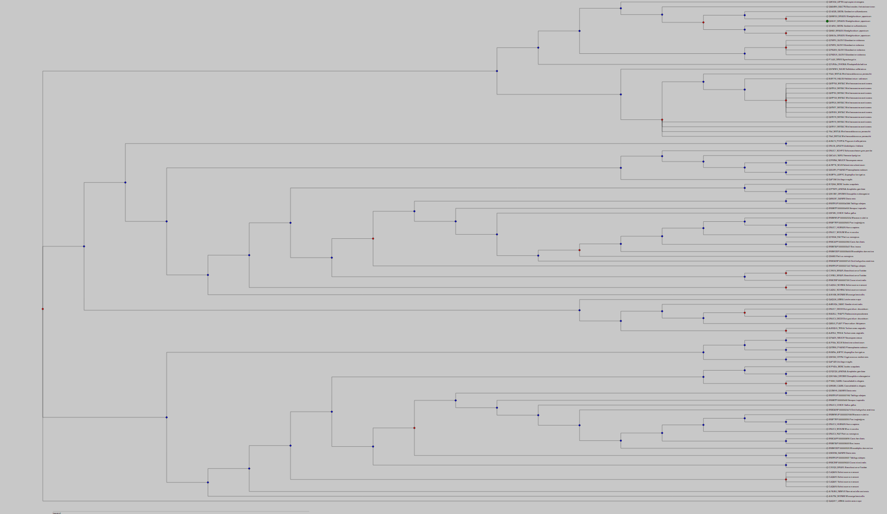
3
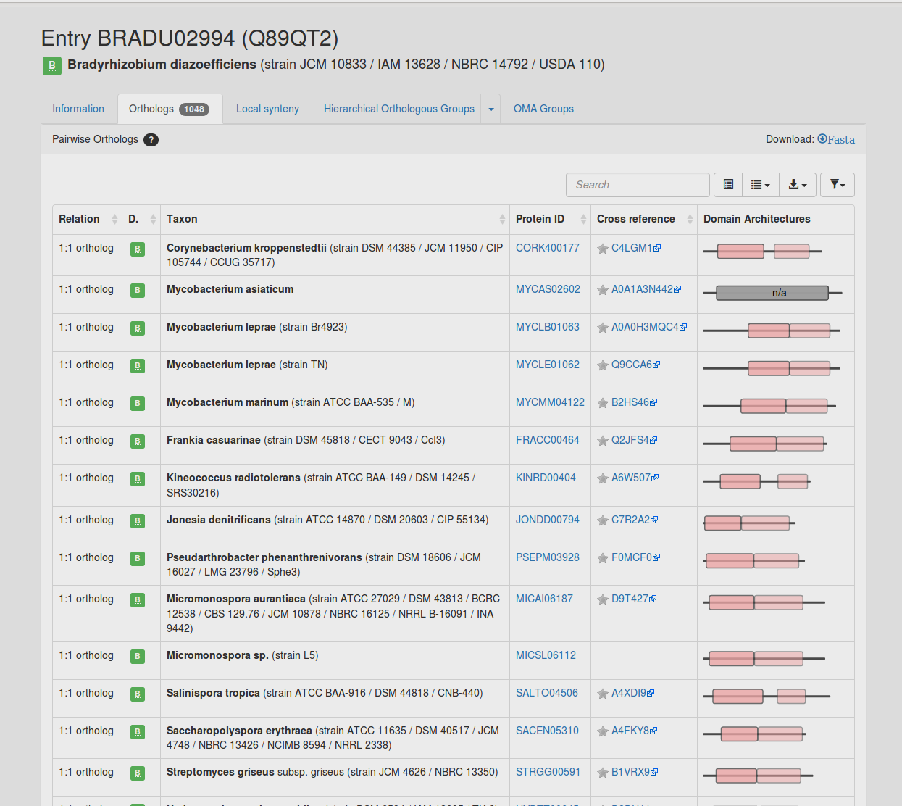
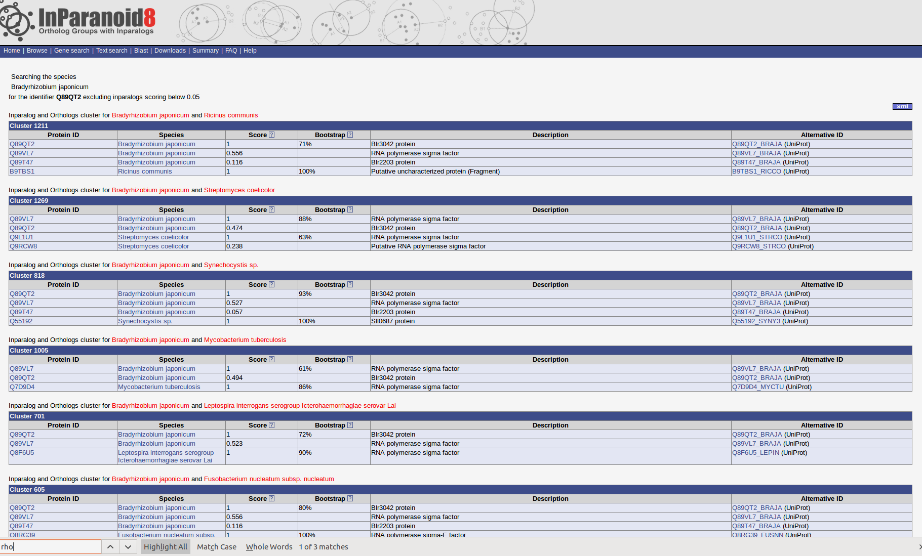
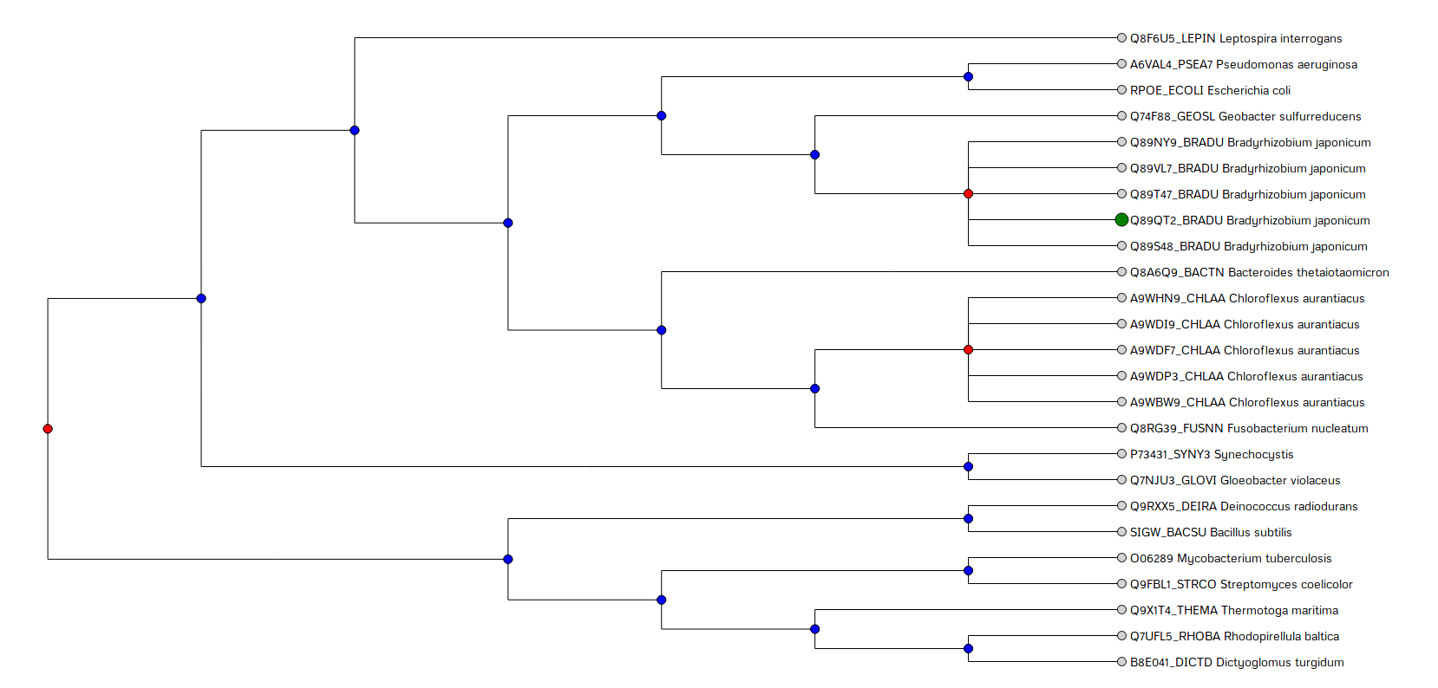

Key questions
1. Summarise shortly this practical
HACER

2. Pick at least three databases that store orthologs for three of your selected genes (links provided under Material & Tools); describe the used algorithms of the databases you are comparing and motivate your choice of databases
OMAbrowser:
HACER
OMA’s algorithm distinguishes three different stages. In the first stage, Smith-Waterman alignments are carried out to obtain homologous sequences with a common ancestry (“all-against-all pairwise alignments). After this, during the second stage, the subset of these homologs that are related by speciation (orthologs) are found. This is done based on evolutionary distances on the significant pairwise alignments found in stage 1. During this step differential gene losses and distance inference uncertainty are considered. Finally, during stage 3, the orthologs that have been obtained throughout the previous processes are clustered in 2 distinct manners: hierarchical orthologous groups (HOGs) and cliques of orthologous pairs (OMA groups). HOGs are useful for finding genes that have a common ancestral gene in a particular taxonomic range, while OMA groups are used as marker genes for phylogenetic reconstruction (Schneider et al., 2007).

POR QUE ? The distinctive features of OMA are its broad scope and size, high quality of inferences, feature-rich web interface, availability of data in a wide range of formats and interfaces, and frequent update schedule of two releases per year.

InParanoid8:
HACER

HieranoiDB:
FERNANDO

3. Discuss the achieved results with the different algorithms, especially the differences between their predictions (pairs, ortholog groups):
a. How do the predicted orthologs differ? Which are missing or are the same?

Q89P52 (B. japonicum)

 | R. baltica | Synechocystis sp. | Number of otrhologs
OMAbrowser
InParanoid8
HieranoiDB

Q89UV1 (B. japonicum)

Q89QT2 (B. japonicum)

b. Can you find orthologs in one database that are either missing or appear as out-paralogs in another database? Why do you think this happens?
Yes

c. How big are the ortholog groups for your selected genes in the databases you compare?

d. What can you say about the quality of orthology predictions with the databases you compare?

