Comparative Genomics 2018
Practical 8: Interaction Networks

Group 9
Martinez Hernandez, Marina
Perez Gomez, Fernando

Summary
(100-200 words)

Key questions to answer
Topic
1.
2.

Attachments
For example
Activity 1.1: practical1_group9_scriptname1.py
Activity 2.1: practical1_group9_scriptname2.py

Key questions
Summarise shortly this practical
TO DO

Comparative network analysis using STRING

You will investigate the topology of your interactomes (i.e., the known and predicted networks of your genomes)

1. Write a Python script to calculate the average connectivity (i.e, number of links/interactions vs number of proteins) for each extracted interactome for your genomes, and present the results.
Done! Script name: Connectivity.py

The average connectivity for Bradyrhizobium japonicum interactome is 312.06
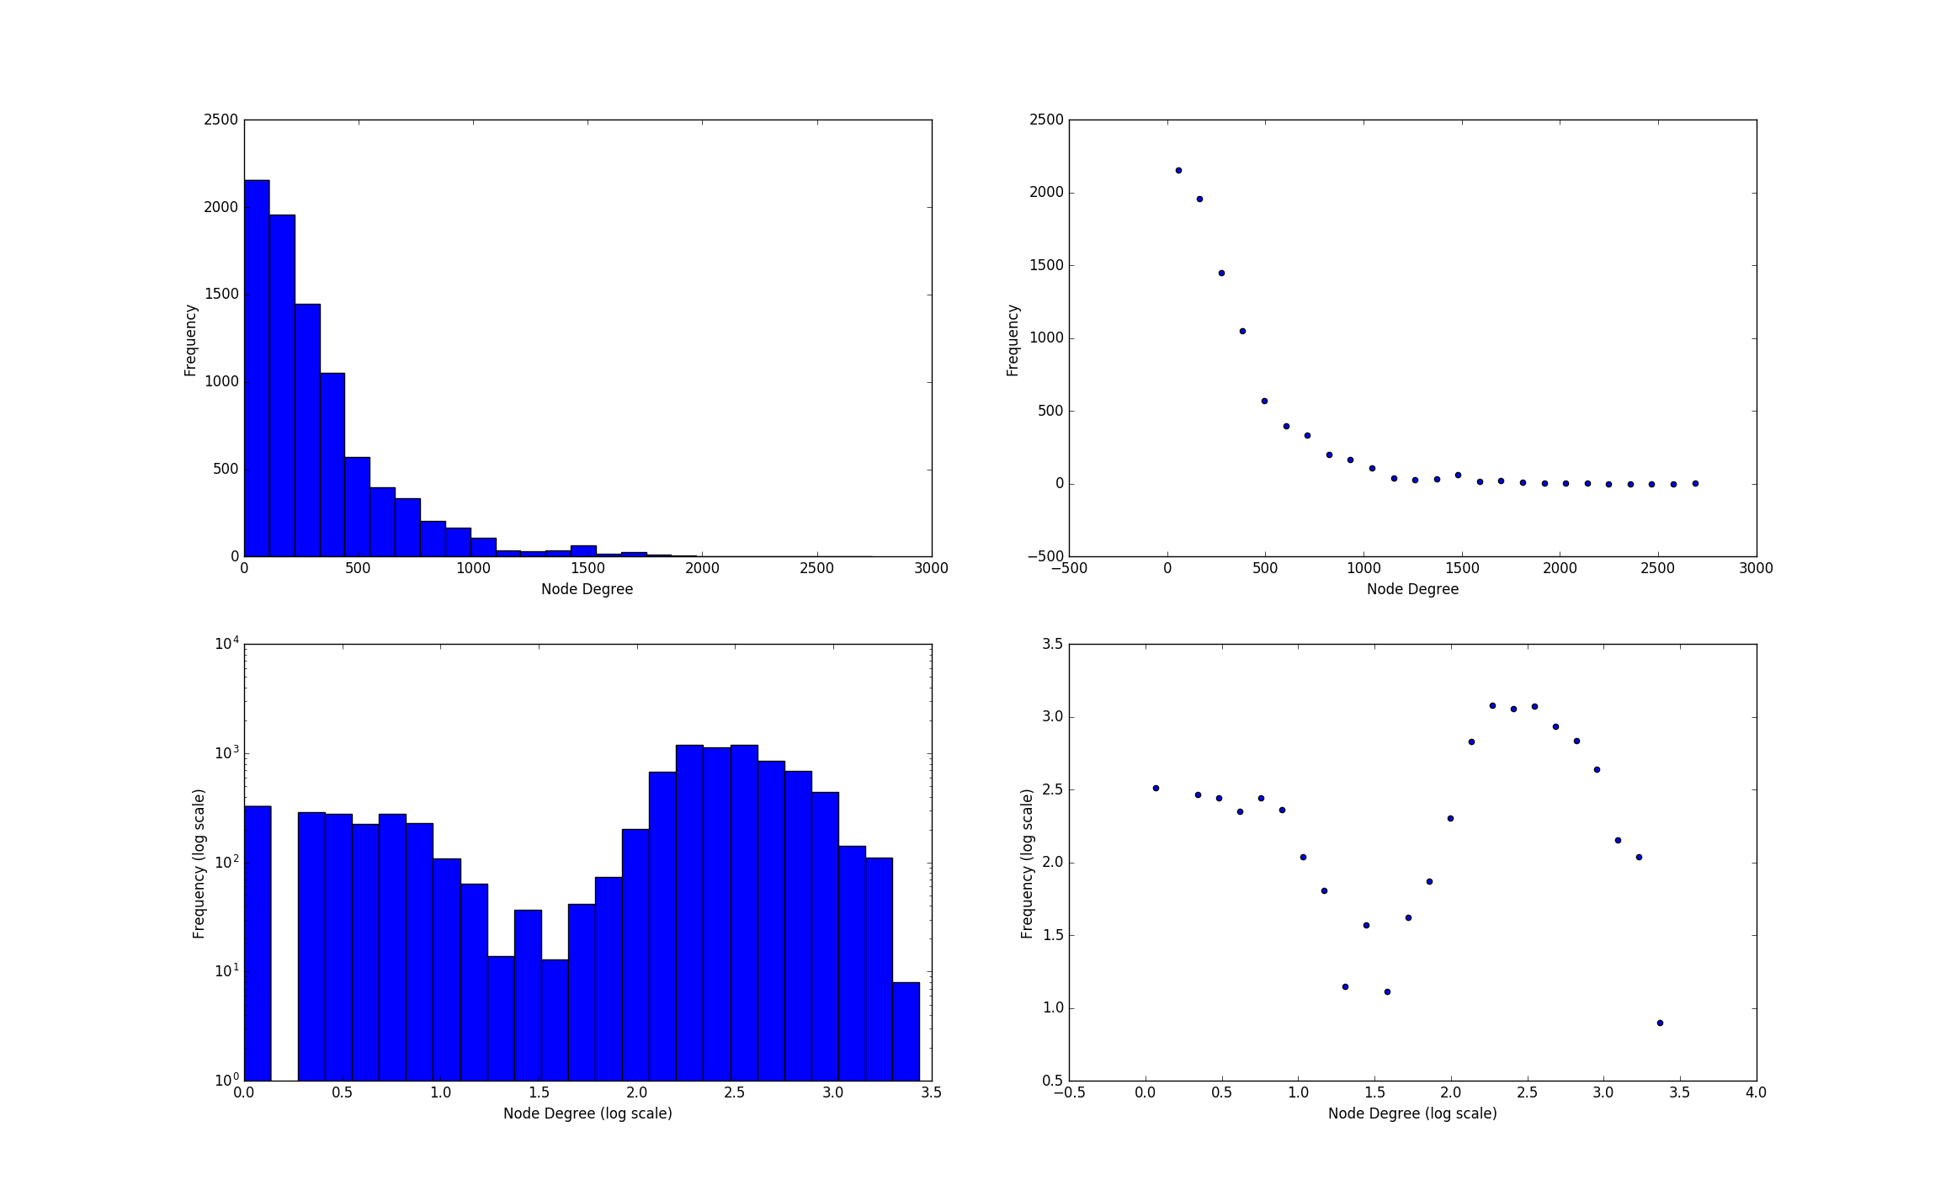

The average connectivity for Rhodopirellula baltica SH1 interactome is 134.17
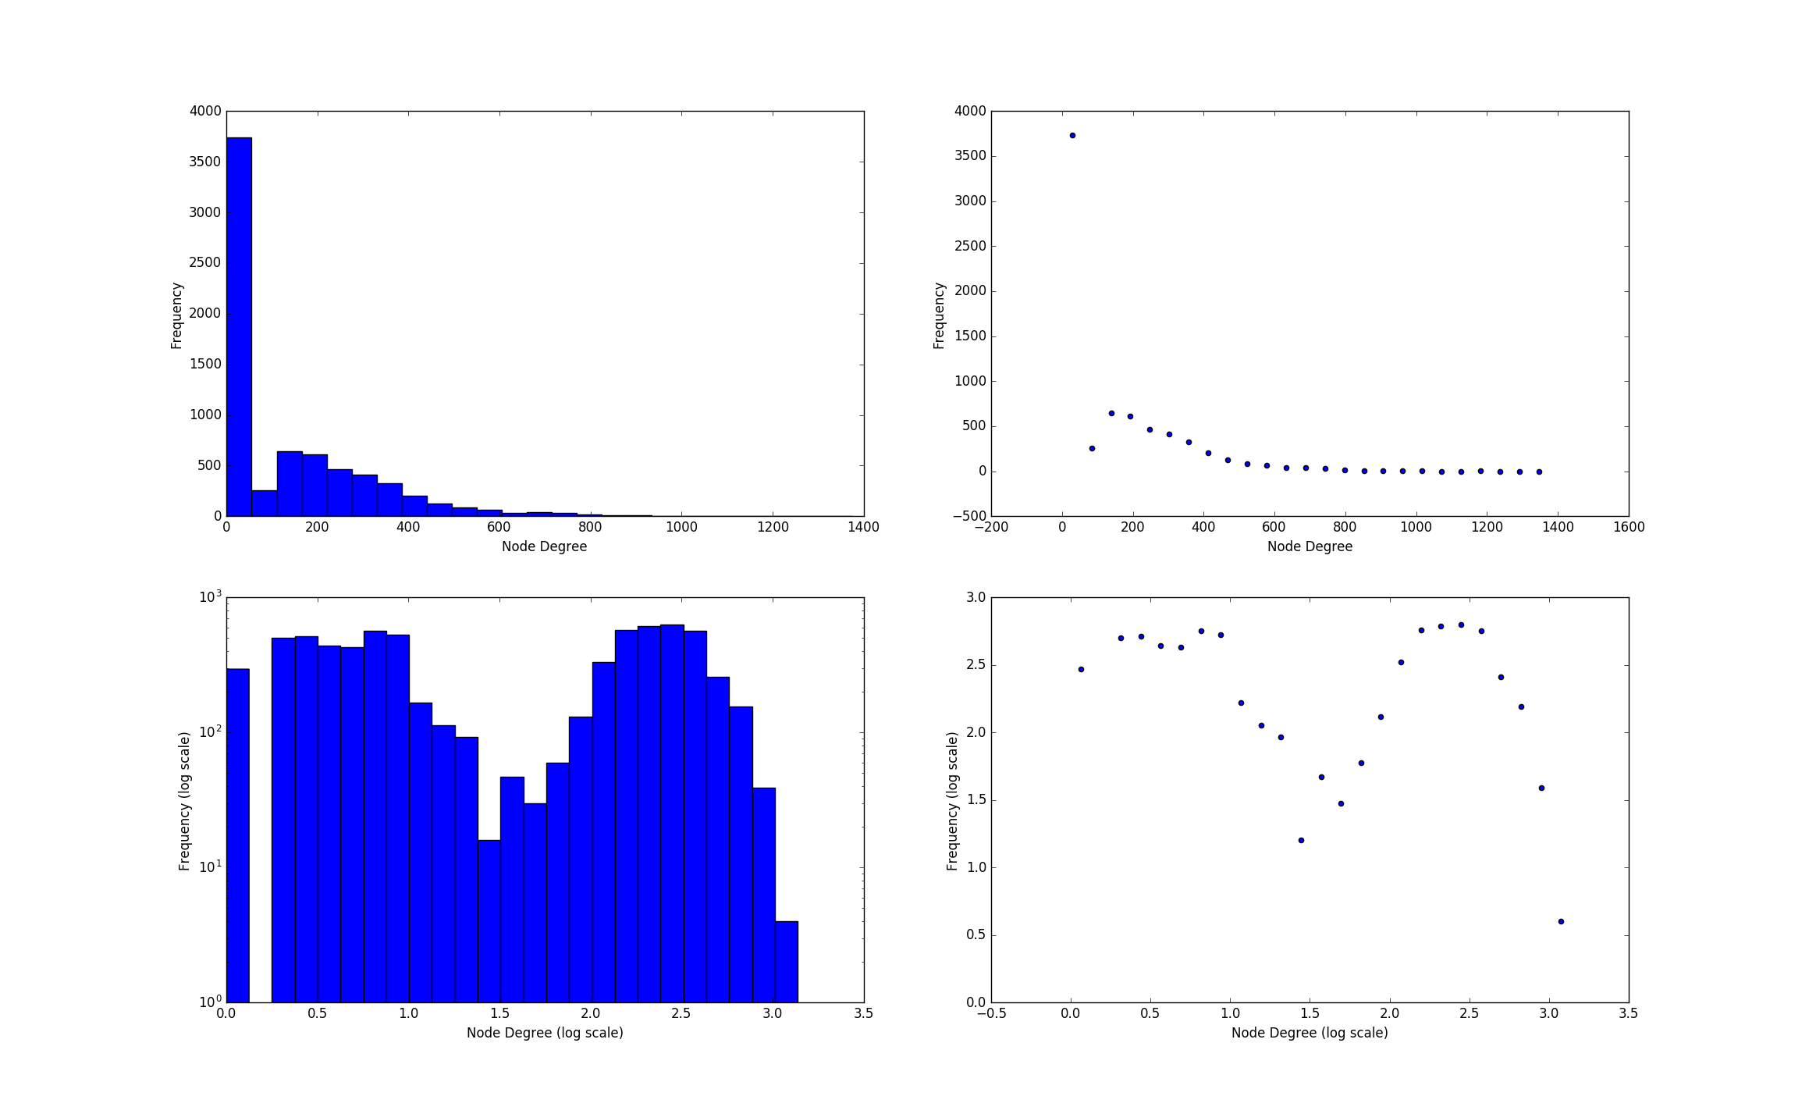
The average connectivity for Synechocystis sp. interactome is 262.60
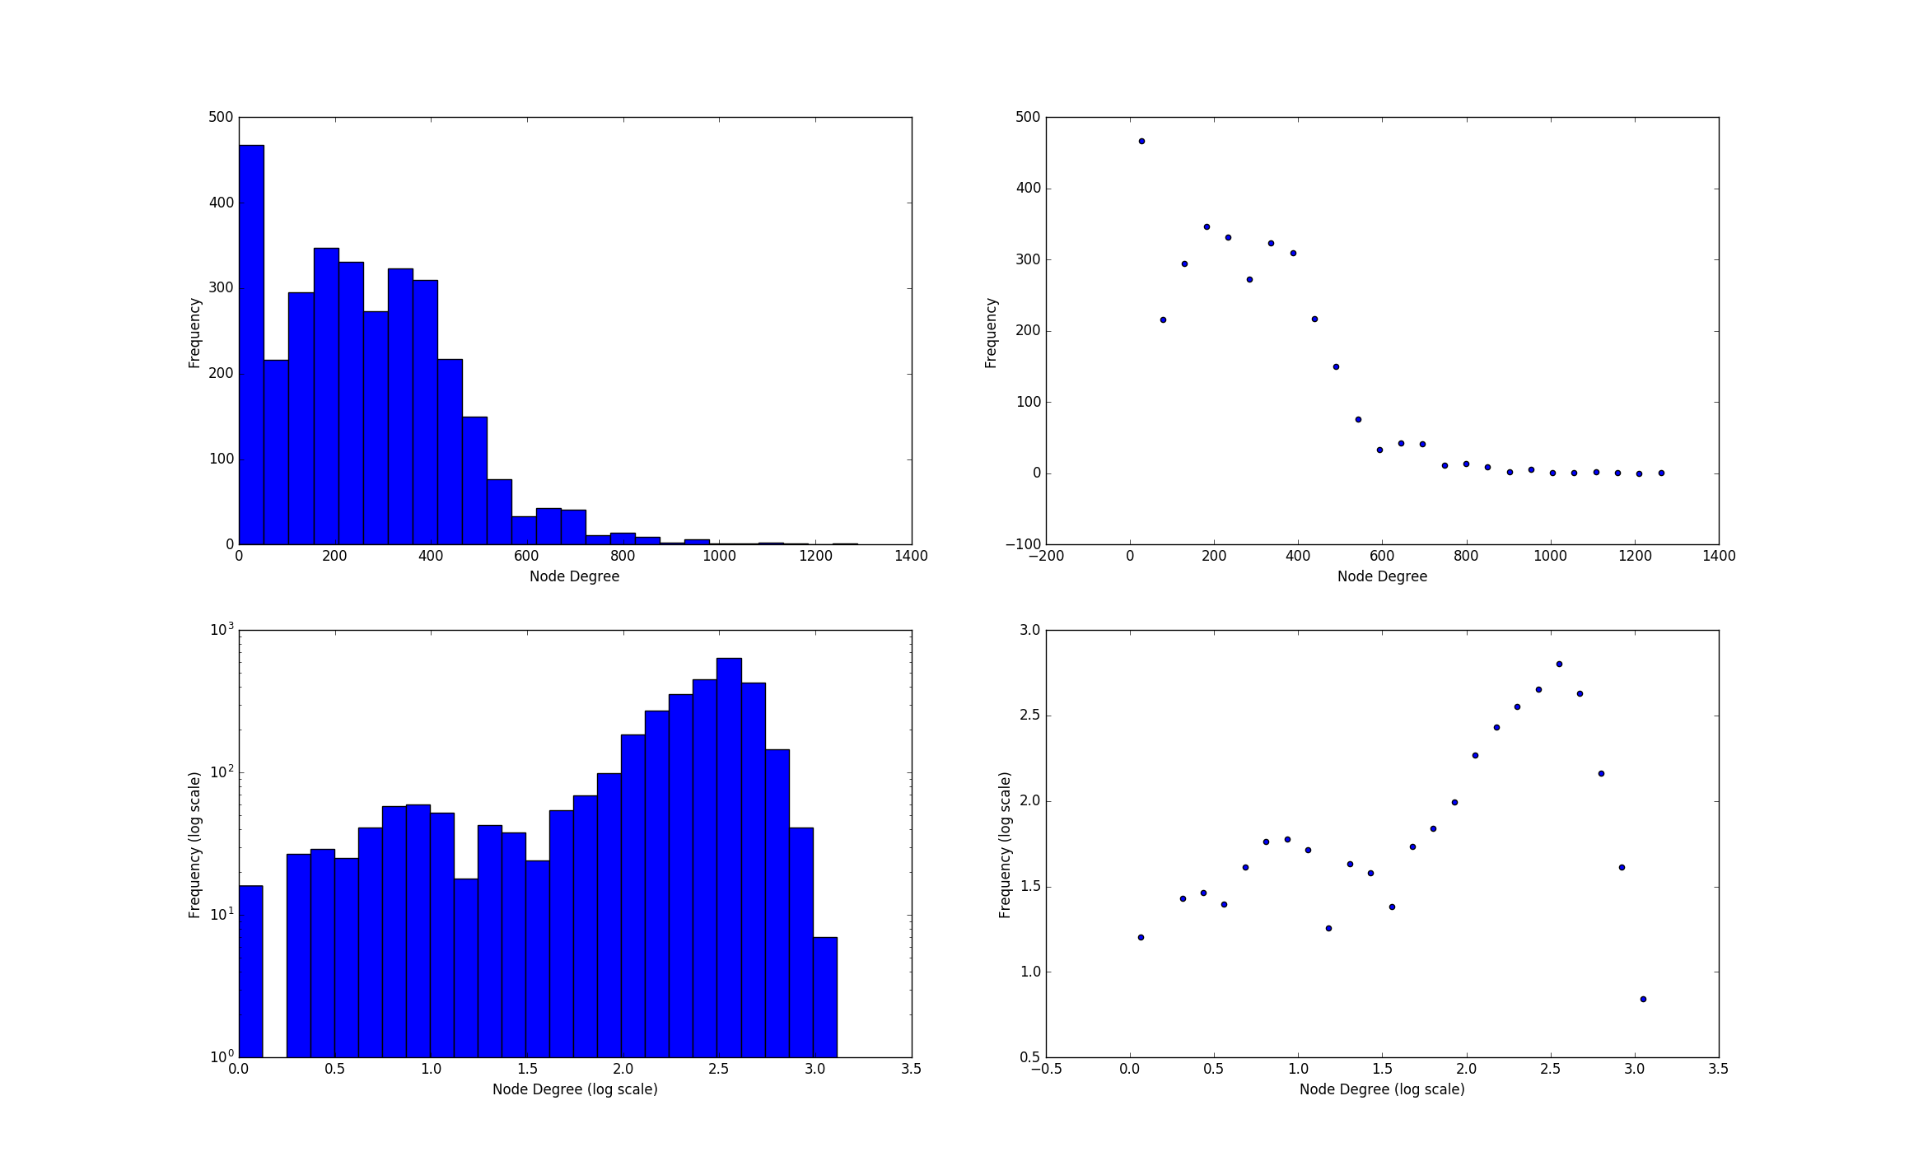
The average connectivity for Saccharomyces cerevisiae interactome is 314.06
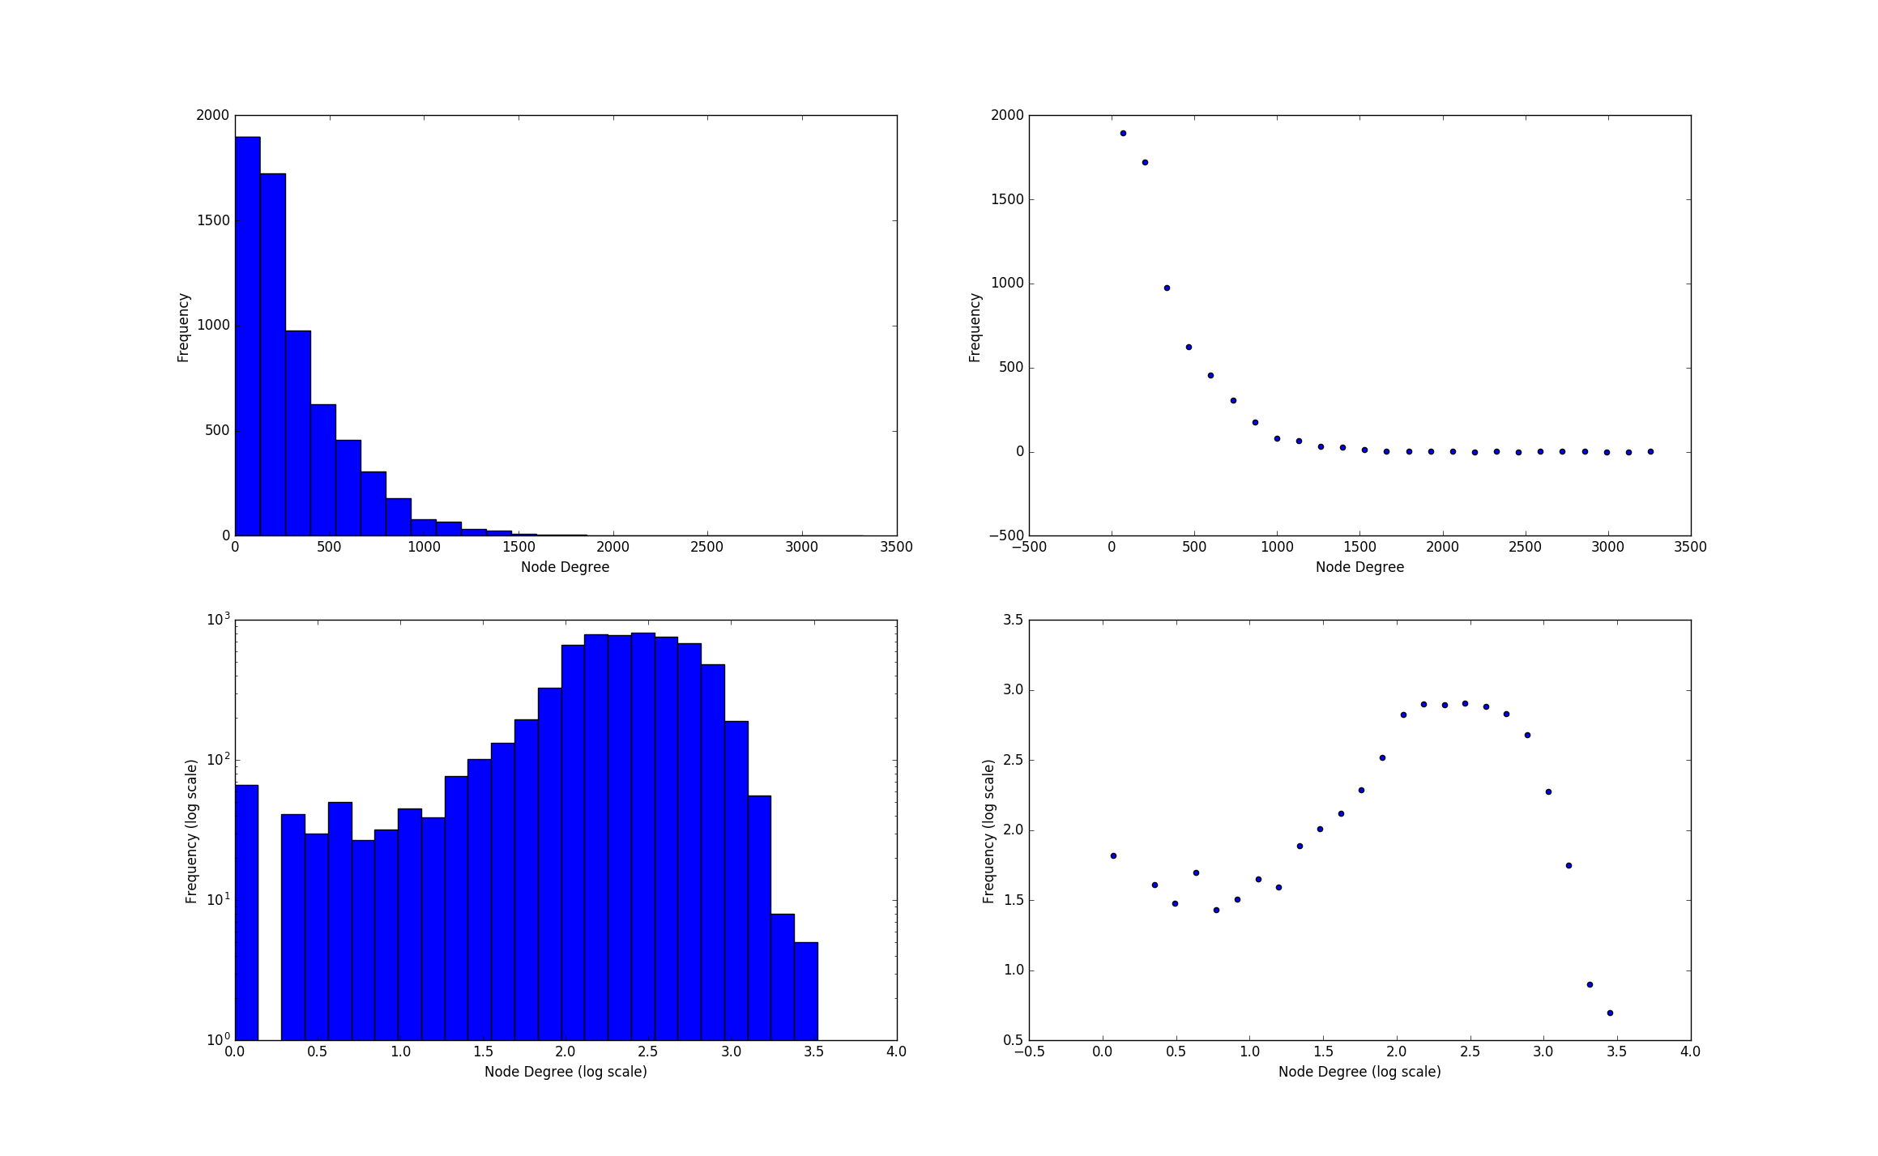
The average connectivity for Rubrobacter xylanophilus interactome is 203.62
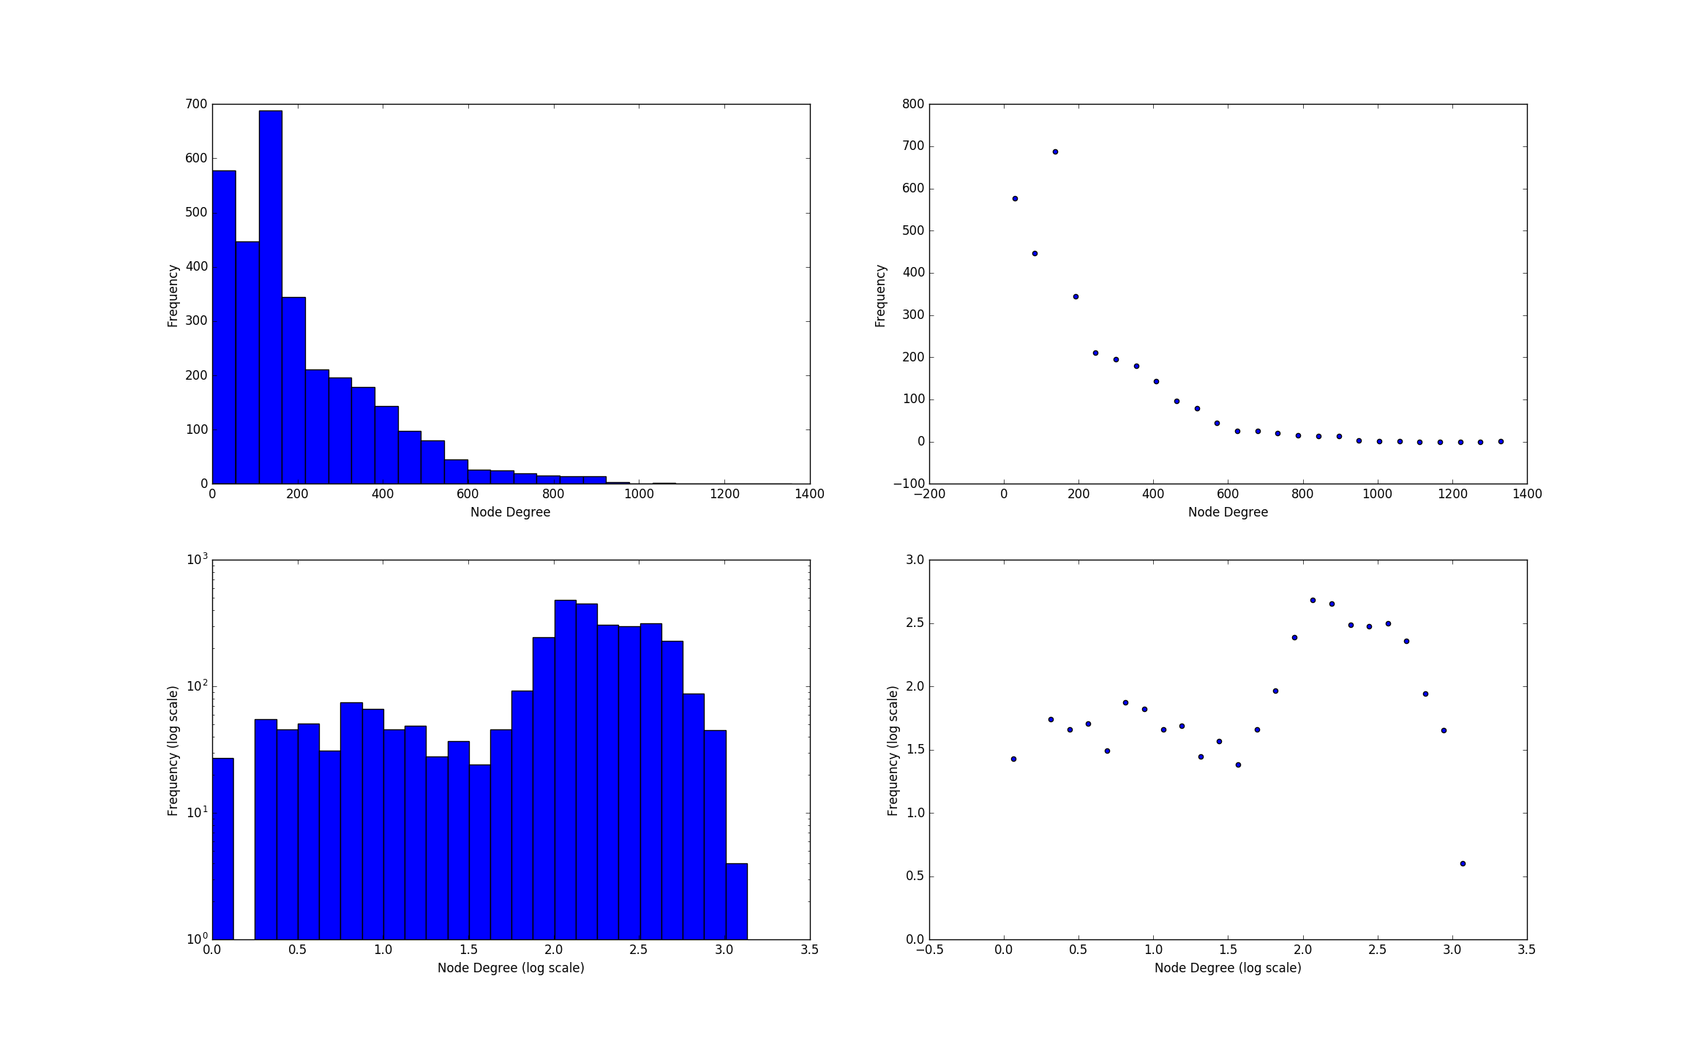

2. Further, plot the degree distribution as a scatter plot with log10-scaled axes for each interactome separately. The x-axis of each plot presents the node degree for each node protein in the network and the other axis the frequency of each node degree. Do you observe a power-law distribution in any of the interactomes? If yes, in which?
Done! See pllots attached to the previous exercise. FALTA EXPLICACION http://www.physics.pomona.edu/sixideas/old/labs/LRM/LR05.pdf
not power law, scale free, check lecture.

Experimental gene sets

3. Present the two gene sets with most overlap; for each, report how many genes of the set size overlap with the genes in your eukaryote

Y

Comparative network analysis using FunCoup and STRING

4. Compare your results gained with both tools based on the same input data (your two genes sets).
a. How do these networks differ in terms of nodes, links, and hubs (the three nodes with the highest degree) for both of your gene sets?
b. Which is the most common evidence type with a high confidence (>0.9)?
c. What are the differences in terms of underlying data sources in the two databases? Explain them!

Enrichment analysis using PathwAX and DAVID

5. Which pathways are enriched ?
6. What differences do you observe in the results from PathwAX and DAVID?
7. Does the number of (input) genes matter for the results? If so, explain why!

Activities
1. Download known and predicted protein-protein interaction (PPI) networks from STRING
Command:
wget https://stringdb-static.org/download/protein.links.v10.5.txt.gz

The entries of that file are: protein1 protein2 combined_score
Example: 394.NGR_c00010 394.NGR_c33930 255
(394 stands for the NCBI taxonomy identifier; NGR_c00010 & NGR_c33930 are the gene symbols)

The file is very large so do not copy or decompress it; however, you can check the first 100 lines in the terminal with:
gzip -cd protein.links.v10.5.txt.gz | head -100

2. You will need to extract the network belonging to all of your prokaryotic and eukaryotic organisms from this file protein.links.v10.5.txt.gz

Filename | Organism | STRING Taxon-ID | NCBI Taxon-ID
04.fa.txt | Bradyrhizobium japonicum USDA 6 | 1037409 | 1037409
16.fa.txt | Rhodopirellula baltica SH1 | 243090 | 243090
18.fa.txt | Synechocystis sp. | 1148 | 1148
34.fa.txt | Saccharomyces cerevisiae | 4932 | 4932
49.fa.txt | Rubrobacter xylanophilus DSM 9941 | 266117 | 266117

Python code: ExtractNetworks.py
+ fernando command

Creation of two experimental gene sets containing differentially expressed genes (DEGs)

Let us say experiments on S.cerevisiae S228C has been performed to investigate certain diseases, each comparing two conditions; significantly differentially expressed genes have been detected (one gene set per experiment). If any of these DEGs are present in your yeast chromosome, you want to extract and study the corresponding gene sets from S.cerevisiae S228C that overlap the most with genes in your eukaryotic chromosome.

1. Download the S.cerevisiae S228C yeast proteome from Uniprot (http://www.uniprot.org/proteomes/) and use BLAST to match your predicted genes against the S.cerevisiae S228C proteome.

2. Parse the blast results to extract the gene symbols (of only best hits) of genes present on your yeast chromosome

3. Using the provided file experiments.txt containing gene sets (one set per row) of DEGs from the experiments in S.cerevisiae S228C, find two experimental gene sets that overlap the most with the genes in your eukaryotic chromosome. Save the two gene sets (from experiments.txt) with most overlap for further analysis.

Comparative network analysis using FunCoup and STRING

1. Using your two experimental gene sets from the previous task, query FunCoup and STRING for sub-networks containing these genes.

2. Use the same expansion depth or max number of interactors for searching both databases to get comparable results.

b) You can also do an online blast search to find the identifiers (gene symbol)

Pathway enrichment analysis using PathwAX and DAVID

Analyze your two experimental gene sets for an enrichment of pathways with both, PathwAX and DAVID (both using KEGG).

GENESET53:
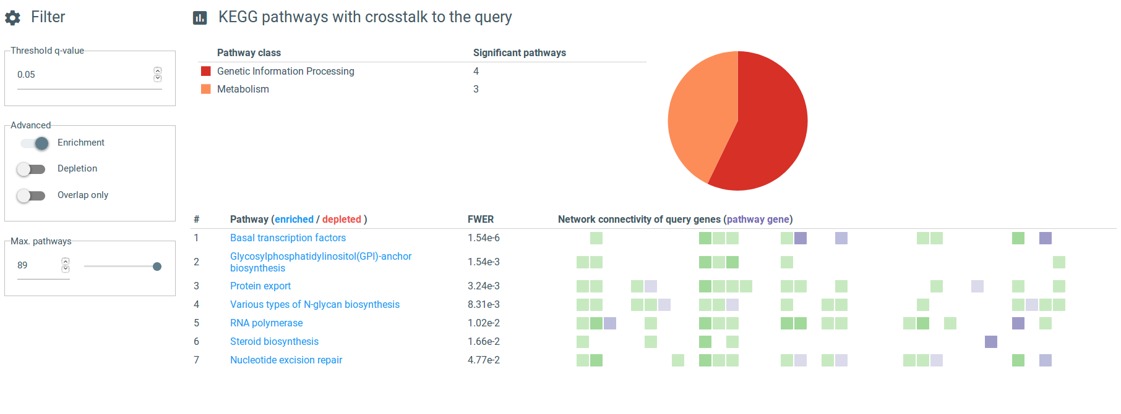
Mirar papers, no tiene ni idea si aparece depletion o no.

