Comparative Genomics 2018
Practical 3: Phylogenetic Reconstruction

Group 9
Martinez Hernandez, Marina
Perez Gomez, Fernando

Summary
(100-200 words)

Key questions to answer
Topic
1.
2.

Attachments
For example
Activity 1.1: practical1_group9_scriptname1.py
Activity 2.1: practical1_group9_scriptname2.py

Exercise 1 – Finding homologs
1. In order to be able to search locally, format a BLAST database for your genomes.

1.1. Explain the parameters. What do they mean?

1.2. Run the program for each nucleotide dataset
Done!

Command:
makeblastdb -in /afs/pdc.kth.se/misc/pdc/volumes/sbc/prj.sbc.dmessina.5/Comparative_Genomics/data/genomes2018/Grp9/04.fa.txt -dbtype nucl -out db04

And so one with the rest of the files… (16.fa.txt, 18.fa.txt, 49.fa.txt, 34.fa.txt is an eucaryotic genome, so it was not neccesary to do it with that one).

2. Gather all your genomes in one file in order to have a single database.
Done!

Command:
cat /afs/pdc.kth.se/misc/pdc/volumes/sbc/prj.sbc.dmessina.5/Comparative_Genomics/data/genomes2018/Grp9/04.fa.txt /afs/pdc.kth.se/misc/pdc/volumes/sbc/prj.sbc.dmessina.5/Comparative_Genomics/data/genomes2018/Grp9/16.fa.txt /afs/pdc.kth.se/misc/pdc/volumes/sbc/prj.sbc.dmessina.5/Comparative_Genomics/data/genomes2018/Grp9/18.fa.txt /afs/pdc.kth.se/misc/pdc/volumes/sbc/prj.sbc.dmessina.5/Comparative_Genomics/data/genomes2018/Grp9/49.fa.txt > genomes_all

makeblastdb -in genomes_all -dbtype nucl -out dbALL

3. Use BLAST to query the database for the 16S rRNA file.

3.1. Find the best hit in each genome as “actual” 16S rRNA, and gather them as entries in a FASTA file.
Done!

Command:
blastn -outfmt 5 -query /afs/pdc.kth.se/misc/pdc/volumes/sbc/prj.sbc.dmessina.5/Comparative_Genomics/data/16S_ecoli.fasta -db db04 -out blast04result
And so one with the rest of the files… (16.fa.txt, 18.fa.txt, 49.fa.txt).

3.2. Extract 16S sequence from BLAST results that you run against the whole genome.
Done!

Command:
blastn -outfmt 5 -query /afs/pdc.kth.se/misc/pdc/volumes/sbc/prj.sbc.dmessina.5/Comparative_Genomics/data/16S_ecoli.fasta -db dbALL -out blastALLresult

3.2.1. What other parameters do you need? Explain their meanings.

3.2.2. Where do you find the output? What do you expect to see in it?
In my home directory, as I did not specify any other route to place it. I expect to see in it a summary with the best hits. The number of hits expected to be obtained are the sum of the individual hits done in the 4 genomes in exercise 3.1. I compared them and, as expected, all previously obtained individual hits appear in the BLAST results run against the whole genome. Also, the score of each hit appears, which is very useful for comparison between the different hits. Other relevant information is also contained in the report of the BLAST output: gaps, length of the alignment, etc.

Exercise 2 - Parsing
B. A ready script (blastResultParser.py) is provided to you in order to parse the BLAST output in this option. You will discuss the following questions in detail:
a. How does the script choose the single best BLAST hit in each genome in the database?
First, the sys module is imported for using the sys.argv tool, which enters to any command line arguments. Thus, sys.argv=list of command line arguments, being sys.argv[0] the name of the script. Looking at the length of sys.argv (len(sys.argv)) we can get the number of command line arguments.

Then, the script proceeds to open the BLAST report in XML format. NCBIXML.parse() returns an iterator. This tool let us go through the BLAST output, getting back individual BLAST records: it screens them one by one for each result given by BLAST. This is done by means of a for loop in the script (for aSingleBlastRecord in listOfBlastRecords:). This program screens the BLAST records contained in the report one, thus for each record it shows (prints) the information that we are interested in.

At the end, it compiles the needed information and displays the alignment that is stored in the first position of the hsp argument, which corresponds to the single best BLAST hit.

b. What does a BLAST record correspond to?
It corresponds to a BLAST output search in which all the information that has been obtained is contained within different classes according to their nature. There are different classes, and depending on them different information will be stored. For example, the alignment class stores information about one alignment hit, meanwhile the HSP class contains information about one hsp in an alignment hit and so one with the different group of classes.

c. What is assumed about the BLAST XML output?

d. What does this script output?

Command:
python3 ./Desktop/Comparative_genomics/Practical3/blastResultParser.py blast04result > parsed04hit

Exercise 3 - KALIGN
1. Use KALIGN on the resulting sequence file to make a multiple alignment of the homologs identified in the previous step

1.1. What are the gap penalties?
1.2. Does any of the gap penalties make any sense to apply? Discuss why.

Exercise 4 – Tree building
1. Investigate the various options of Belvu and how to create a tree from an alignment.
Command for doing the exercise with the latest belvu version:
ssh -X u2351@stud29.dbb.su.se
module add belvu
NOTE: then type belvu and double check that it is version 4.44.1

1.1. Which distance correction methods does Belvu use?

There are different correction methods in Belvu. The default distance correction method is Scoredist. On the other hand, it is possible to use 3 different distance correction methods: Jukes-Cantor, Kimura and Storm & Sonnhammer.

1.2. Use two different distance corrections in combination with two tree building methods. How does this affect the tree?
NOTE: First, the Kalign output file was modified and the headers contained the name of each alignment was modified: ./ removed, otherwise it did not work! Eg: >./04.fa.txt → >04.fa.txt
Commands:
belvu -T u -o tree Kalign_nonames
belvu -T u -T s -o tree Kalign_nonames
belvu -T u -T k -o tree Kalign_nonames
belvu -T n -o tree Kalign_nonames
belvu -T n -T s -o tree Kalign_nonames
belvu -T n -T k -o tree Kalign_nonames
And then visualize with ETE tree viewer

UPGMA, Scoredist (default)

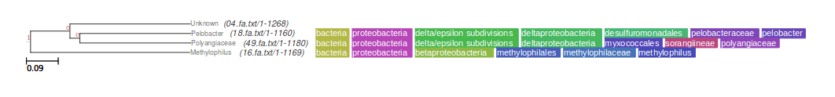
UPGMA, Storm & Sonnhammer distance correction

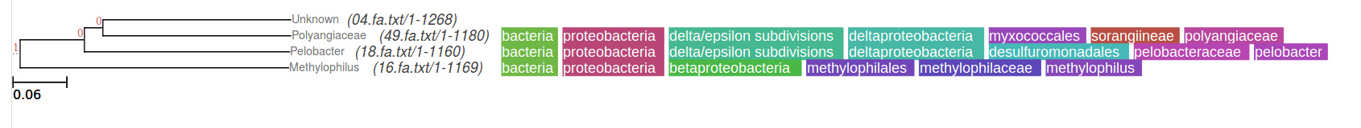
UPGMA, Kimura distance correction
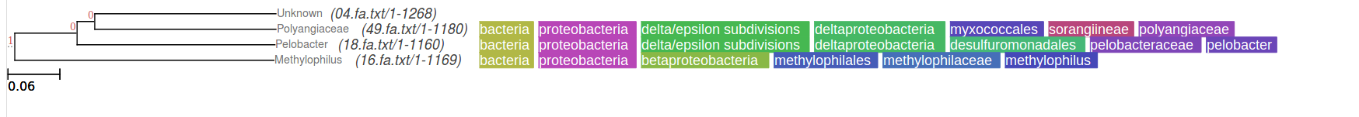

Neighbor-joining, Scoredist
FOTO FERNANDO

Neighbor-joining, Storm & Sonnhammer distance correction
FOTO FERNANDO

Neighbor-joining, Kimura
FOTO FERNANDO

2. Build a maximum likelihood tree with RaxML
2.1. First make sure all gaps in the alignment are denoted with “-”
Done!
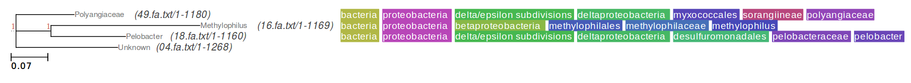
2.2. Run e.g. raxmlHPC-PTHREADS-AVX -f a -x 54321 -N 100 -T 4 -p 12345 -m PROTCATBLOSUM62 -s input -n output
Tree results viewed through ETE tree viewer.

Command:
raxmlHPC-PTHREADS-AVX -f a -x 54321 -N 100 -T 4 -p 12345 -m PROTCATBLOSUM62 -s Kalign_nonames -n RaxmlHPC_outputnonames

2.3. Explain what the options do.

2.4. Explain briefly what the main difference is between distance-based and maximum likelihood methods. What are their advantages/disadvantages?

Exercise 5 - Sequence Bootstrapping
1. What is bootstrapping? What is the reason to apply bootstrapping?
It is an analysis described in: Efron and Gong, 1983; Felsenstein, 1985; Swofford et al., 1996. It consists on sampling again your estimated data with replacements so that you can construct a series of bootstrap fragments that are the same size as the initial data. Here, the data that is sampled again is the amino acids contained in the sequence and the statistical significance corresponding to a cluster is derived from the amount of portions in the tree that contain that encompass that cluster.

The reason to use bootstrapping is because it is like a statistical analysis that is used to examine the trustworthiness of specific branches that are included in an evolutionary tree under study. It gives us a measure of reliability!

2. Construct a tree with bootstrap support values with Belvu from your alignment.
Command:
belvu -b 100 -o tree ./Desktop/Comparative_genomics/Practical3/Kalign_nonames

2.1. What does the option N mean?
N is the number of bootstrap samples.

2.2. What value of N do you choose and what consequences does that choice have?

With N=100000
(
16.fa.txt/1-1169:0.206,
(
(
04.fa.txt/1-1268:0.178,
49.fa.txt/1-1180:0.125)
87:0.024,
18.fa.txt/1-1160:0.145)
93:0.046)
;

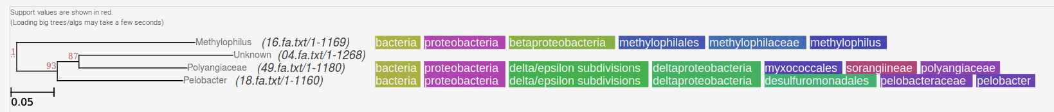

With N=100
(
16.fa.txt/1-1169:0.206,
(
(
04.fa.txt/1-1268:0.178,
49.fa.txt/1-1180:0.125)
90:0.024,
18.fa.txt/1-1160:0.145)
92:0.046)
;
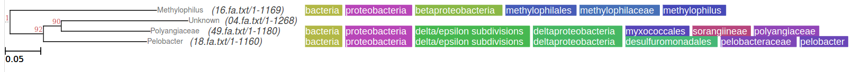

With N=10 & n=1000
FERNANDO FOTO Y VALUES

Same lengths, bootstrap support change.
Bootstrap values increase as N decreases.
The higher the N the more accurate results, but slower process.

