Juice Shop

Documentation

**What is Juice Shop?** **2**

**How to create an account on Juice Shop?** **2**

Create an account 2

What to do if you have trouble logging in? 6

Check if you are using wrong email 6

Check if you forgot your password 6

**How to purchase products on Juice Shop?** **7**

Purchase a product 7

Paying using credit or debit card 11

Paying using wallet 12

Coupon 12

Other payment options 12

**How to leave feedback on Juice Shop?** **13**

Customer Feedback 13

Review on a product 15

Complaint 16

# What is Juice Shop?

Juice Shop is an online system which works as an online shop. Using Juice Shop you could easily purchase products, write reviews of the product and the shop. Also you could write a complaint. Juice Shop is easy to work with.

The site is on [https://juice-shop.herokuapp.com/](https://juice-shop.herokuapp.com/?fbclid=IwAR3lDkztLNLwL1Q-FPT_gZH8GgAyzg64UpjXenHlb-MoYhFH1Xc5Ths44_I)

To use Juice Shop, the first thing you should do is to create an account.

# How to create an account on Juice Shop?

## Create an account

1. Firstly click on the button named “Account” on the right top of the screen near the search button.



1. Then you should click on “Login”

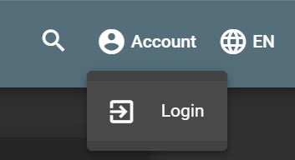

1. After that on your screen will show a Login form, which you should fill in if you already have an account. If you are a new customer you should click on the green link “Not yet a customer?” on the bottom.

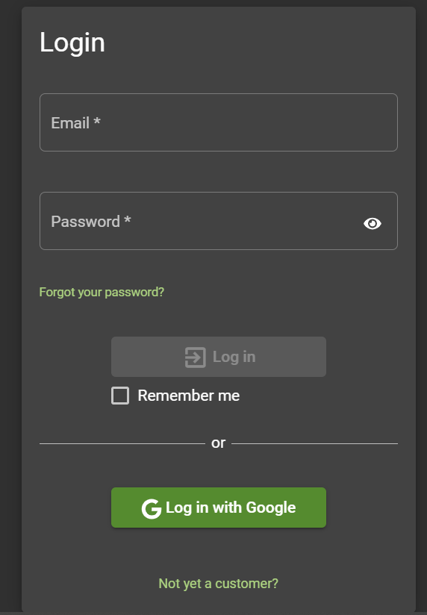

1. Then you can see on your screen the Registration form.

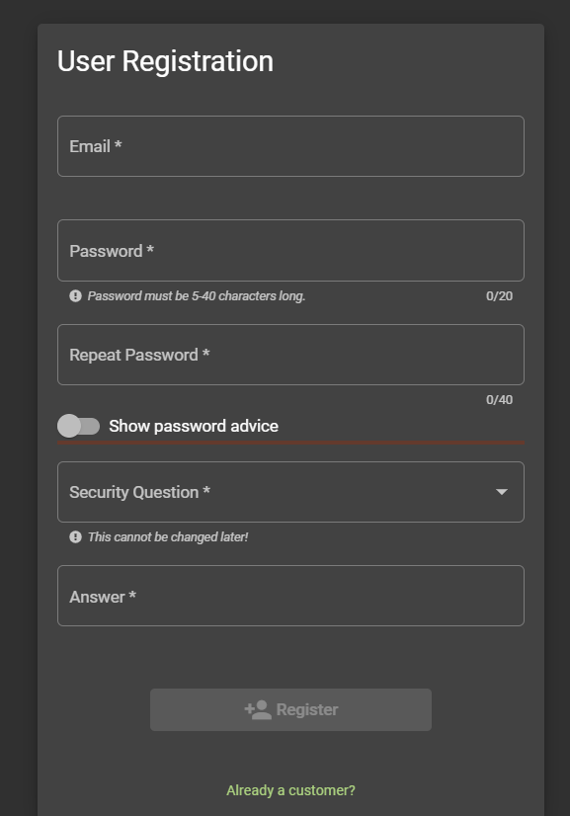

To register in the Juice Shop system you should fill in your email and password, which should be 5-40 characters long. If you have trouble choosing your password, you can click on the button ”Show password advice”. Where the following information appear:

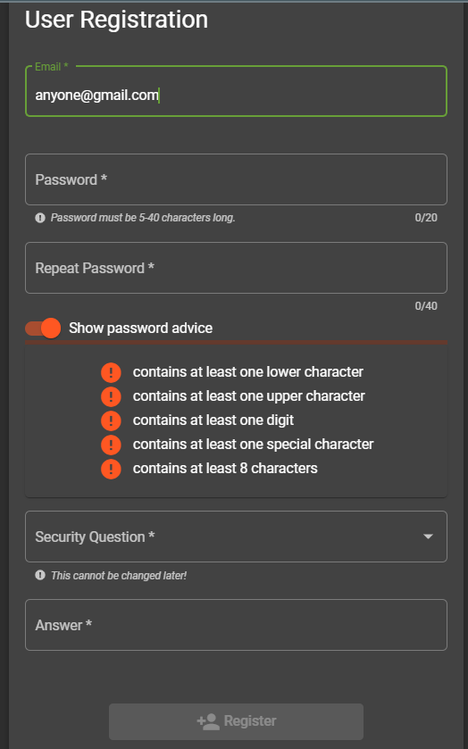

Also you should repeat your password and choose one of the security questions proposed from the system.

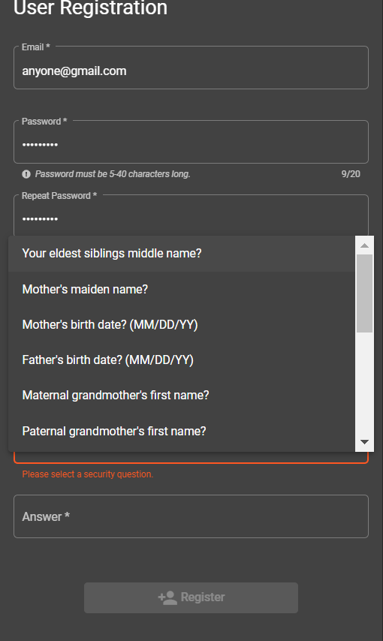

When you choose your security question, you can not change it later, so be aware of your choice. After that you should write an answer to that question. Lastly, to register you should press the “Register” button.

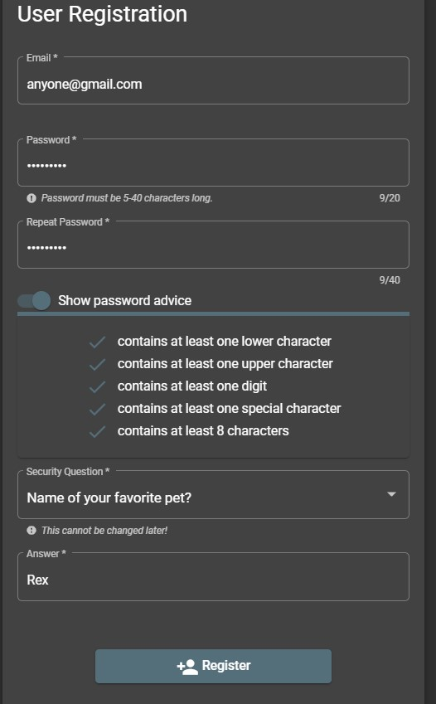

1. After you register, if there are not any problem the following message appear:



And on your screen you see the Login form, which you should fill in. Write down your email and password and click on “Log in”. You also have an option to remember your password- if you want you can click on the square button.

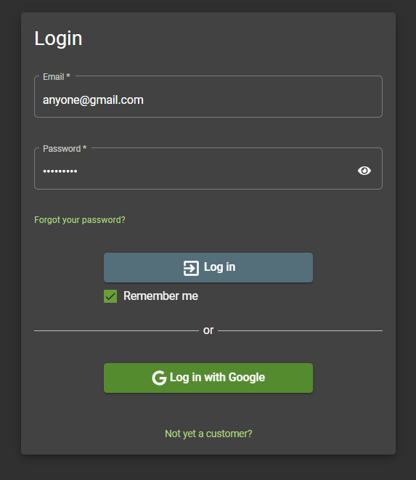

## What to do if you have trouble logging in?

### Check if you are using wrong email

You should enter your valid email with whom you registered the system.

### Check if you forgot your password

If you have forgotten your password click on the green link named “Forgot your password?”

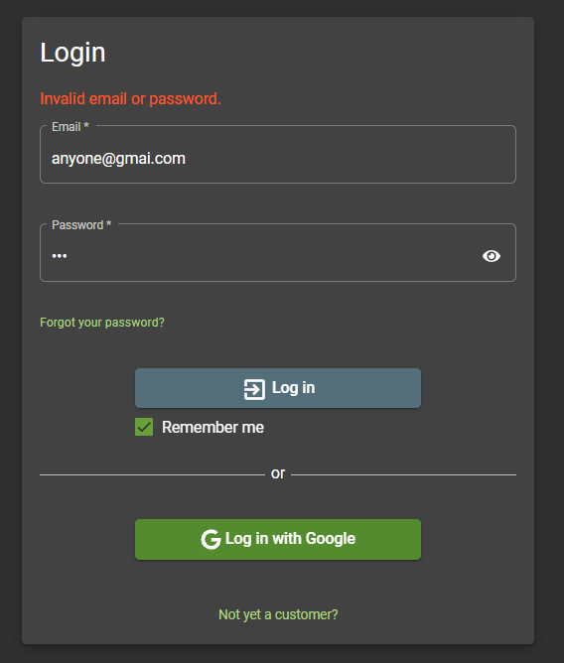

After that you should type your email and the answer to your security question, which you have chosen when registering, and the new password. Then you can change it by clicking on the “Change” button.

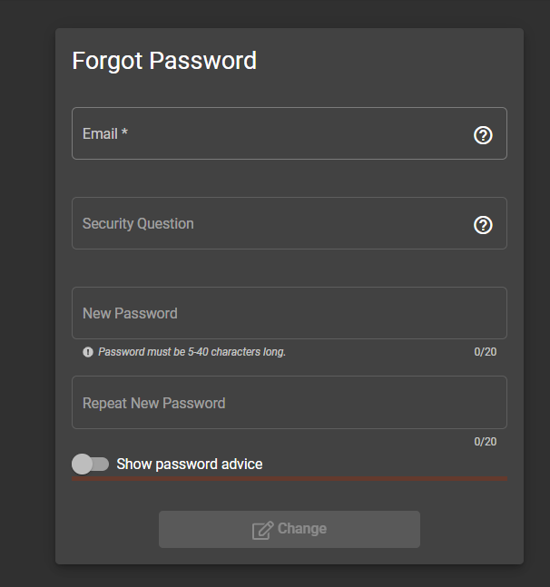

When you registered and logged in the system you should see the following screen:

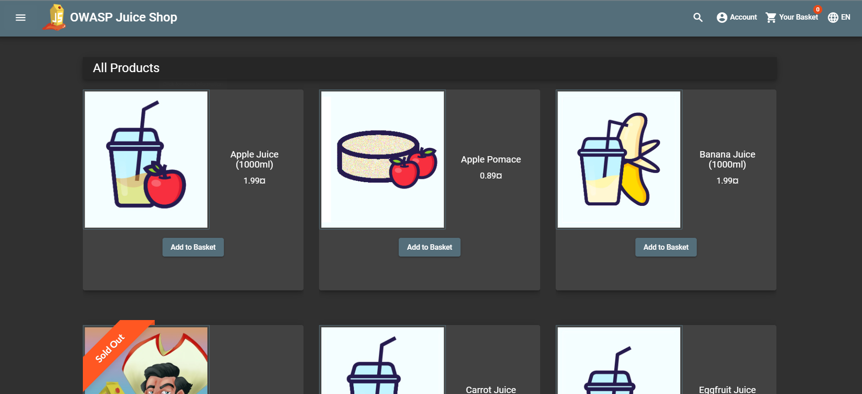

On the left top of your screen you have the menu and to the right are the search button, account information, your basket and the language button, where you can easily change your language according to your preferences.

# How to purchase products on Juice Shop?

## Purchase a product

1. First of all you should be logged in the system.
2. After that you could look around a product you want to purchase
3. You could click on a product for more information

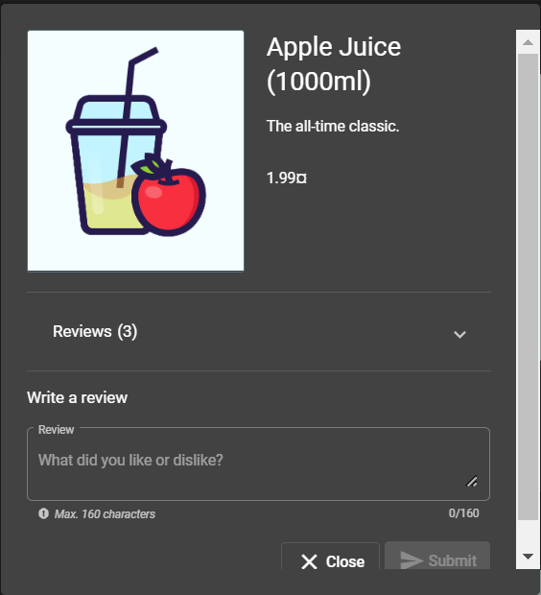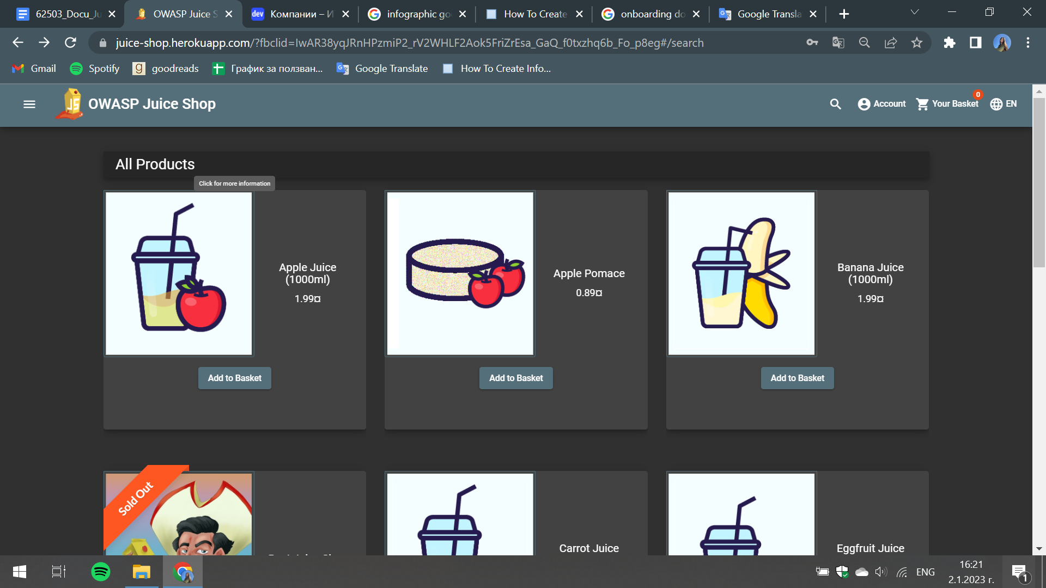

1. If you want to buy a product you could easily click on the button “Add to Basket”

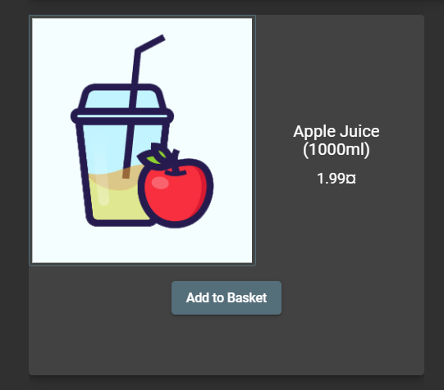

1. After adding one or more products of your wish you should click on “Your Basket” on the top right menu. This would show your items.



1. “Your Basket” would show your items.

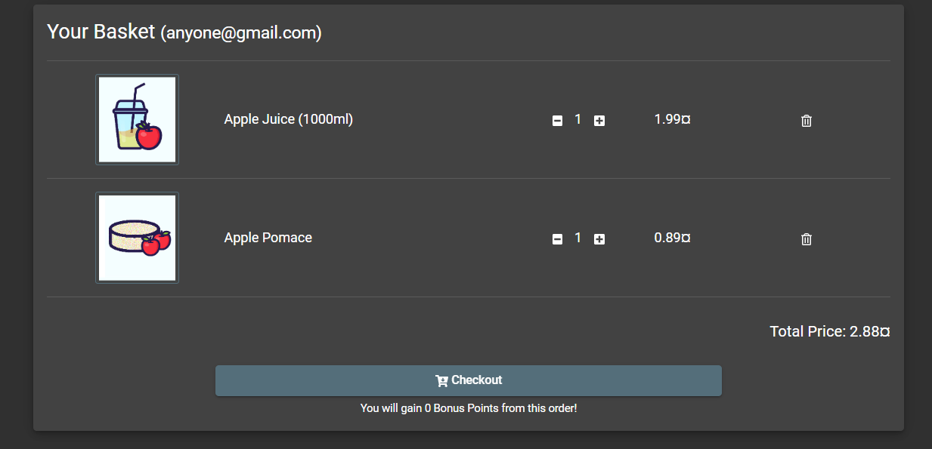

You could easily add more of the selected ones by clicking on the “+” button and you could also delete an item using the “bin” button on the right of your screen. The total price of your product is shown on the right bottom.

1. Click on the “Checkout” button to complete your purchase
2. After that you should select an address

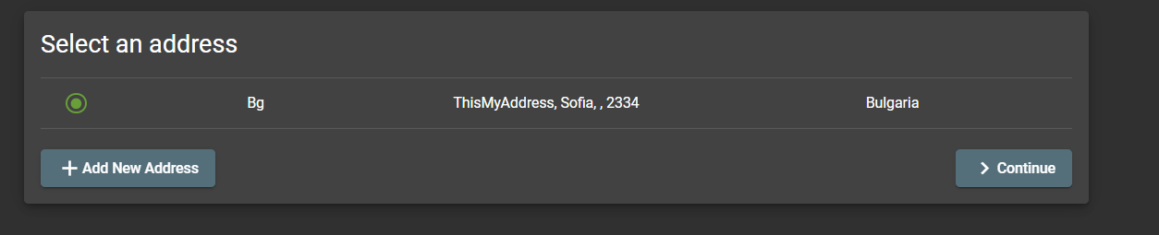

If you have not a filled out address you could add one by choosing the “Add New Address” button. This button would be also helpful if you want to add a new address beside the filled out ones.

1. Adding New Address

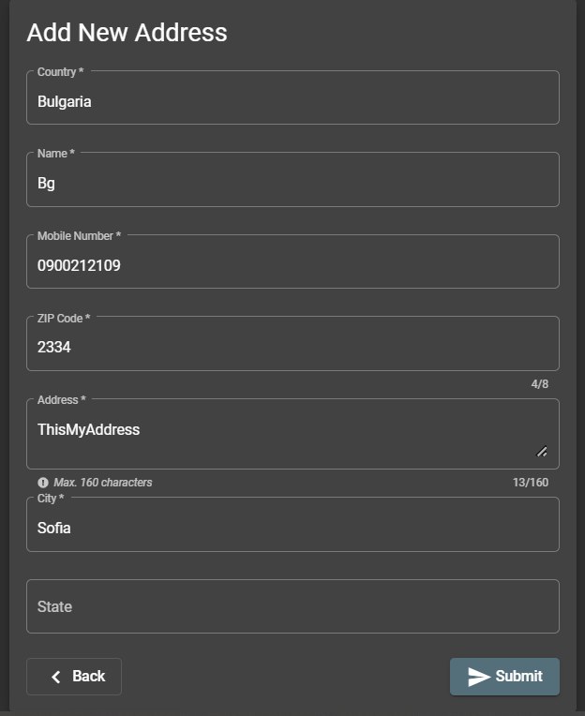

You should enter your country, name, mobile number, ZIP Code, Address, City and optionally your state. After that click on “Submit”.

1. After Selecting an address click on “Continue”.
2. Choose your delivery option. You could pick a “One Day Delivery”, “Fast Delivery” or “Standard Delivery”. The price and the expected days of delivery are shown right of the delivery type. After choosing an option, click on “Continue”.

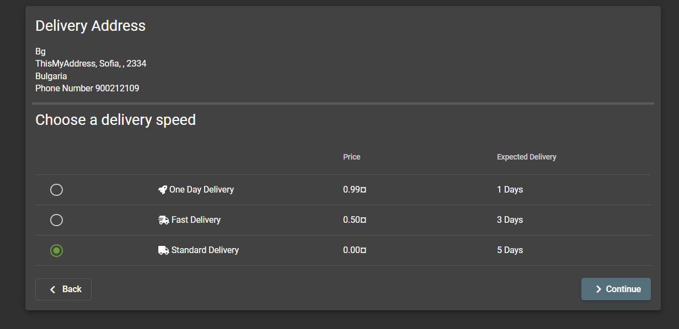

1. After that you could choose a payment option.

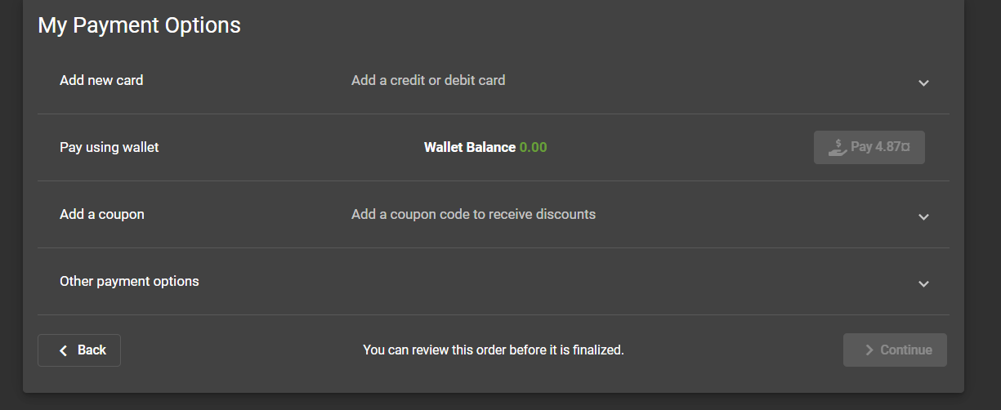

You could pay using credit or debit card or using a wallet.

#### Paying using credit or debit card

You can add your credit or debit card by clicking on it on the drop down menu.

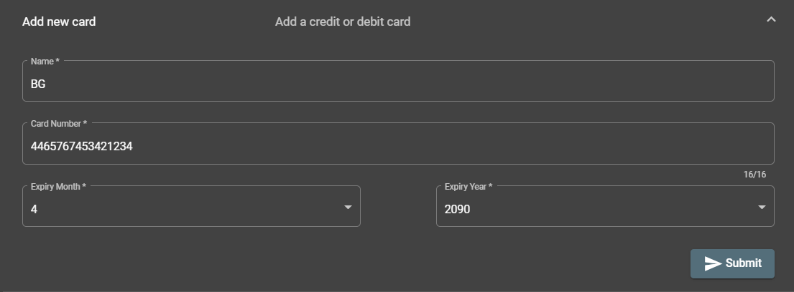

Your cards would appear on the top. Choose your wanted card.

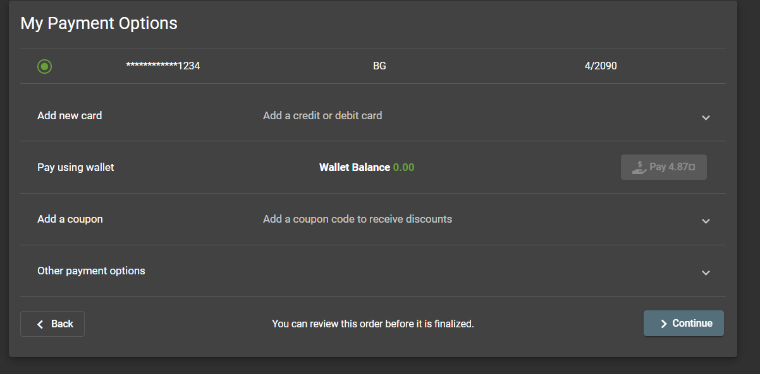

#### Paying using wallet

You can pay using a wallet. Your wallet balance is written on the screen. If you do not have enough money you could not use this payment method



#### Coupon

If you have a coupon for a discount you could easily add it by clicking the drop down menu “Add a coupon” and writing it down on the indicated place. After that you should click on the “Redeem” button.

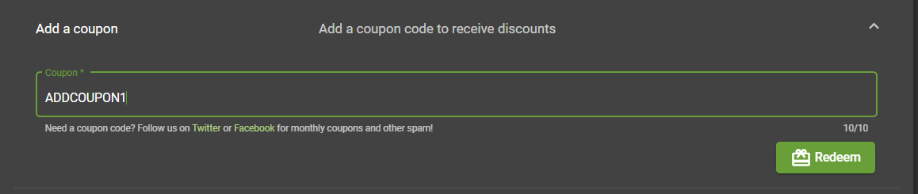

#### Other payment options

In the “Other payment options” drop down menu you could find Donation- where you could donate money to support Juice Shop and Merchandise where you could purchase T-Shirts, stickers and mugs that are part of the Juice Shop Merchandise.

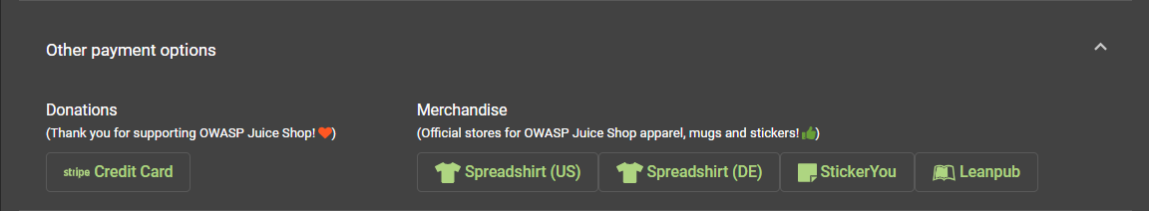

1. After selecting your payment method you could click on “Continue”
2. You could review your purchase before finalizing it and if you are satisfied with your purchase you could click on “Place your order and pay”

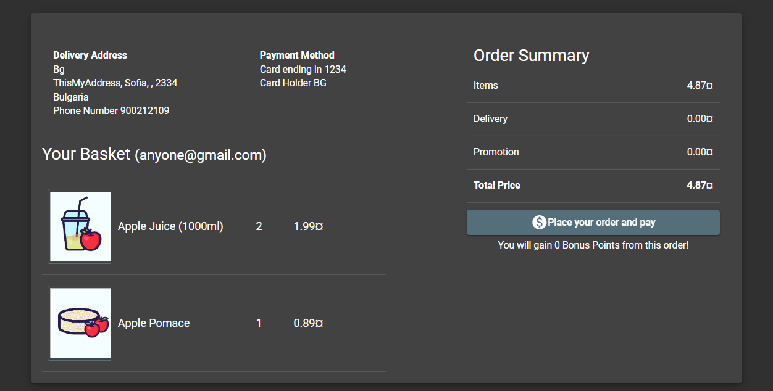

1. After purchasing your products you would have an order summary on your screen

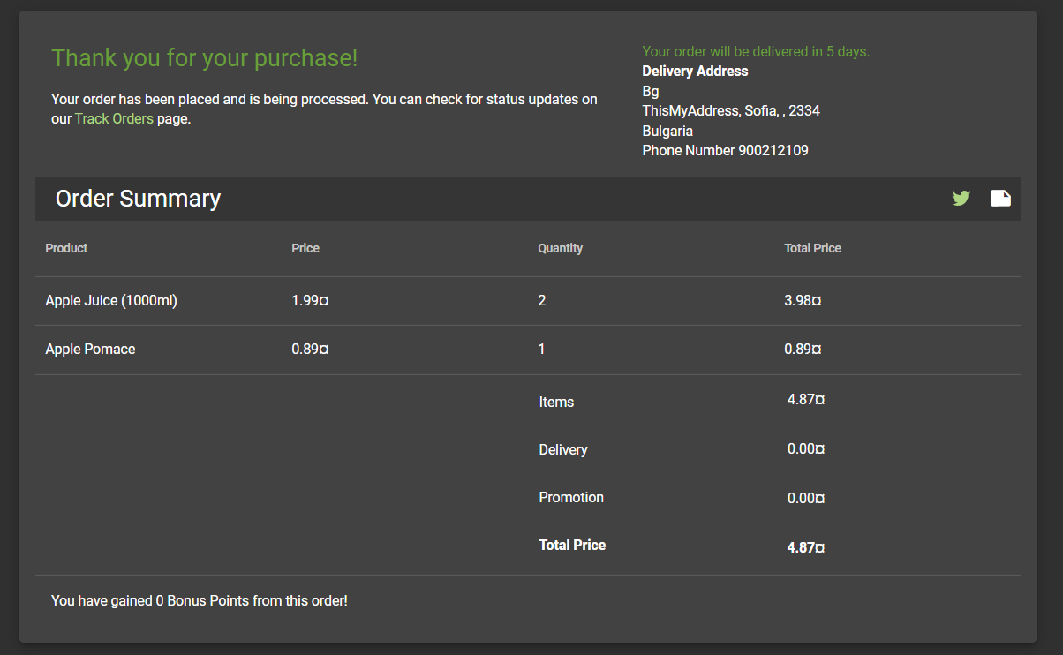

# How to leave feedback on Juice Shop?

## Customer Feedback

1. Firstly you should click on the Menu.

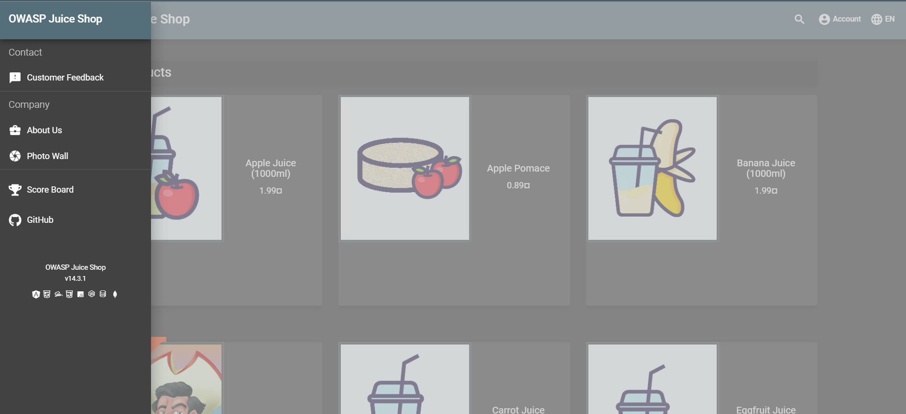

1. After that click on the “Customer Feedback” button at the top.



1. On your screen would appear a Customer Feedback form that you should fill in

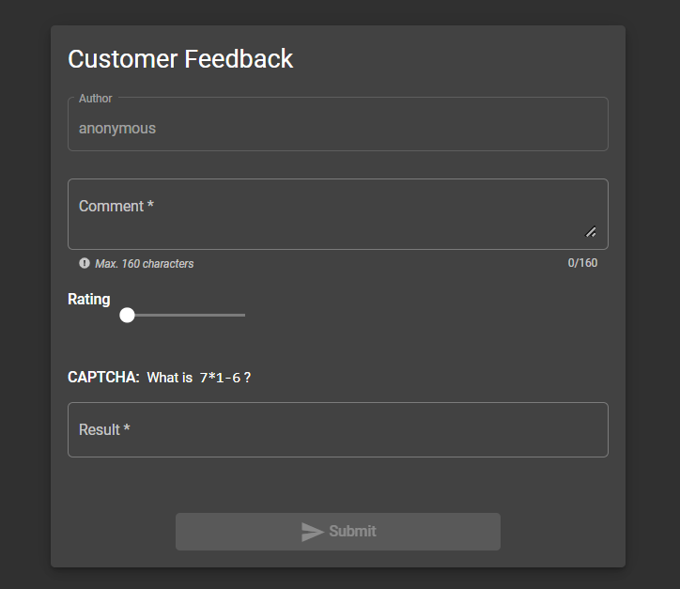

Your feedback would be anonymous. You can write your comment in the box but it should be 160 characters maximum.

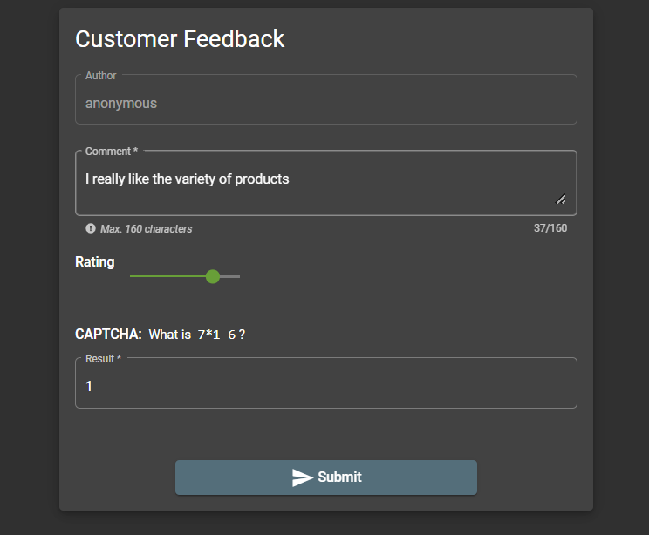

You can give a rating sliding the bar. The rating could be between one to five stars.

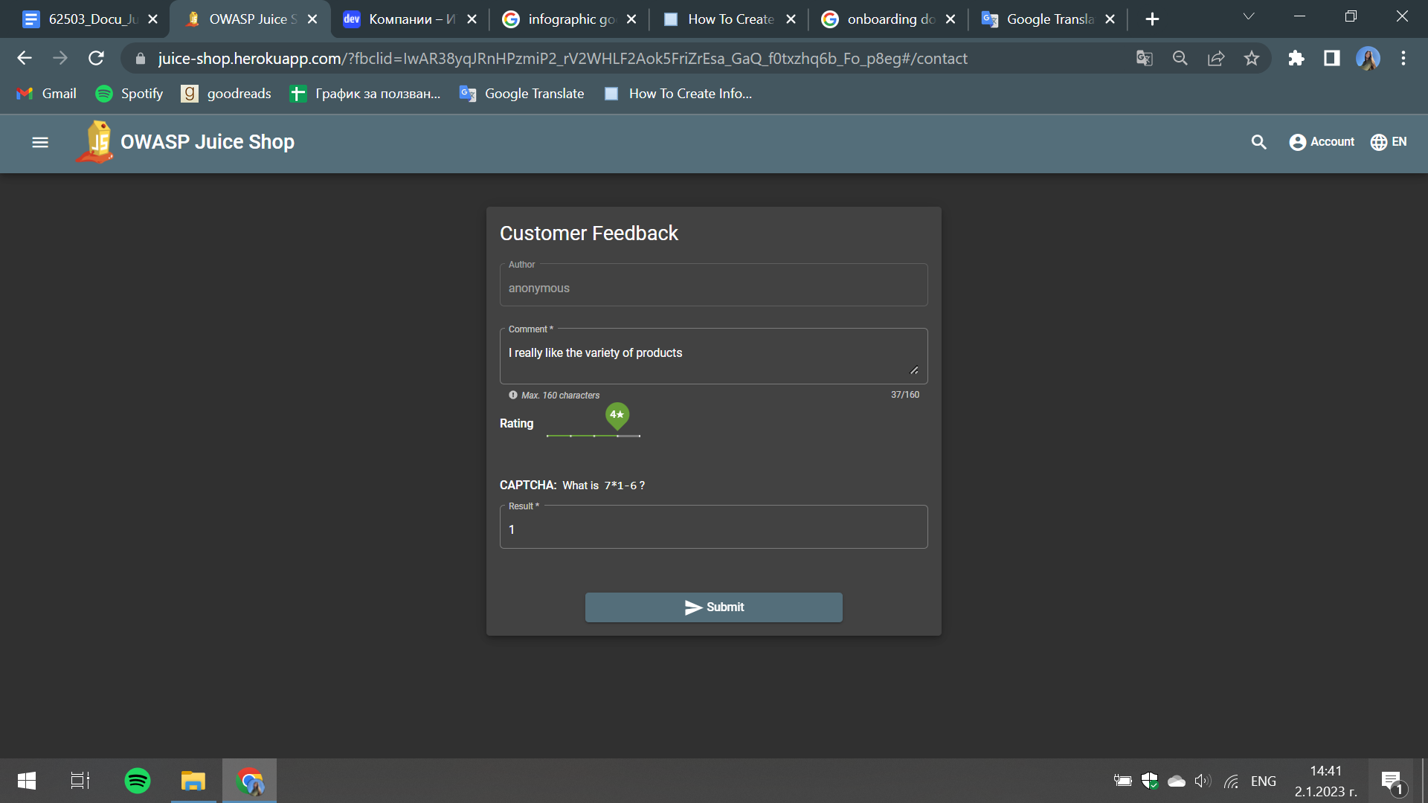

After that you should answer the question below. And lastly click on the button “Submit”.



If you want you can submit another feedback.

## Review on a product

You can write a review on a chosen product by clicking on the product and write your review at the indicated field. After that you could click on “Submit”.

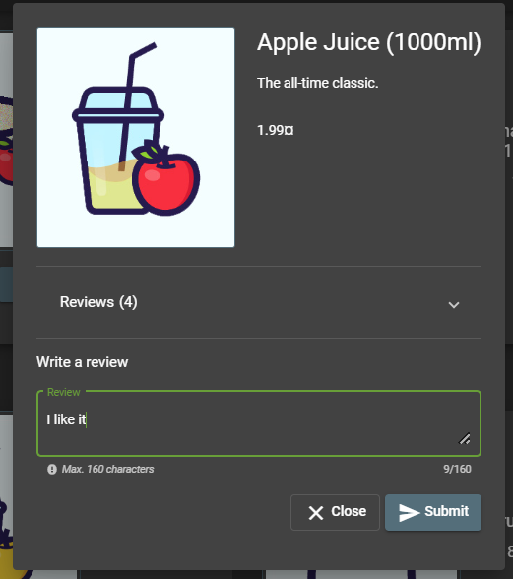

## Complaint

You could also write a complaint if you are not satisfied with something on the system.

1. Firstly you should click on the Menu.



1. After that click on the “Complaint” button at the top.

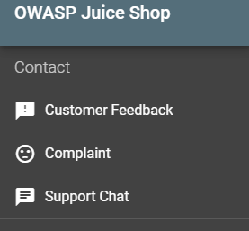

1. On your screen would appear a Complaint form. You could write a message and attach an invoice of your purchase. After you filled the form click on “Submit”.

