How to crop a video or image using Camtasia 2020

Link: <https://youtu.be/NocUs_JW8Ok>

# Who are the target users?

The target users are Camtasia 2020 users, who want to know how to crop a video or image using the application.

# What is their level of competence?

The Camtasia 2020 users should have basic skills of how to use a computer.

# What is the aim of this tutorial?

The aim of this tutorial is to teach the Camtasia 2020 user how to crop media such as video or image.

# Guideline:

1. To remove unwanted parts of a video or image, use crop mode.

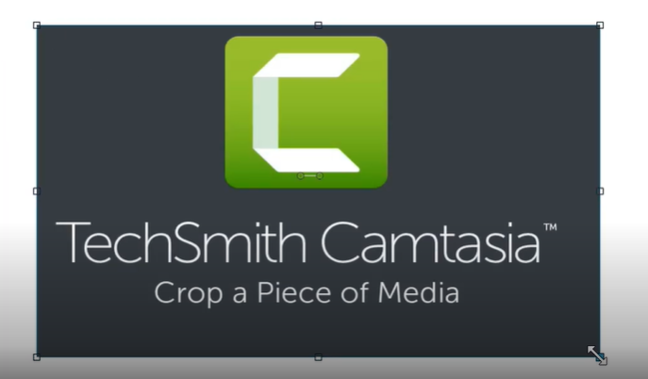

1. To enable crop mode, click Crop on the toolbar above the canvas.



1. A blue border appears around the selected media.

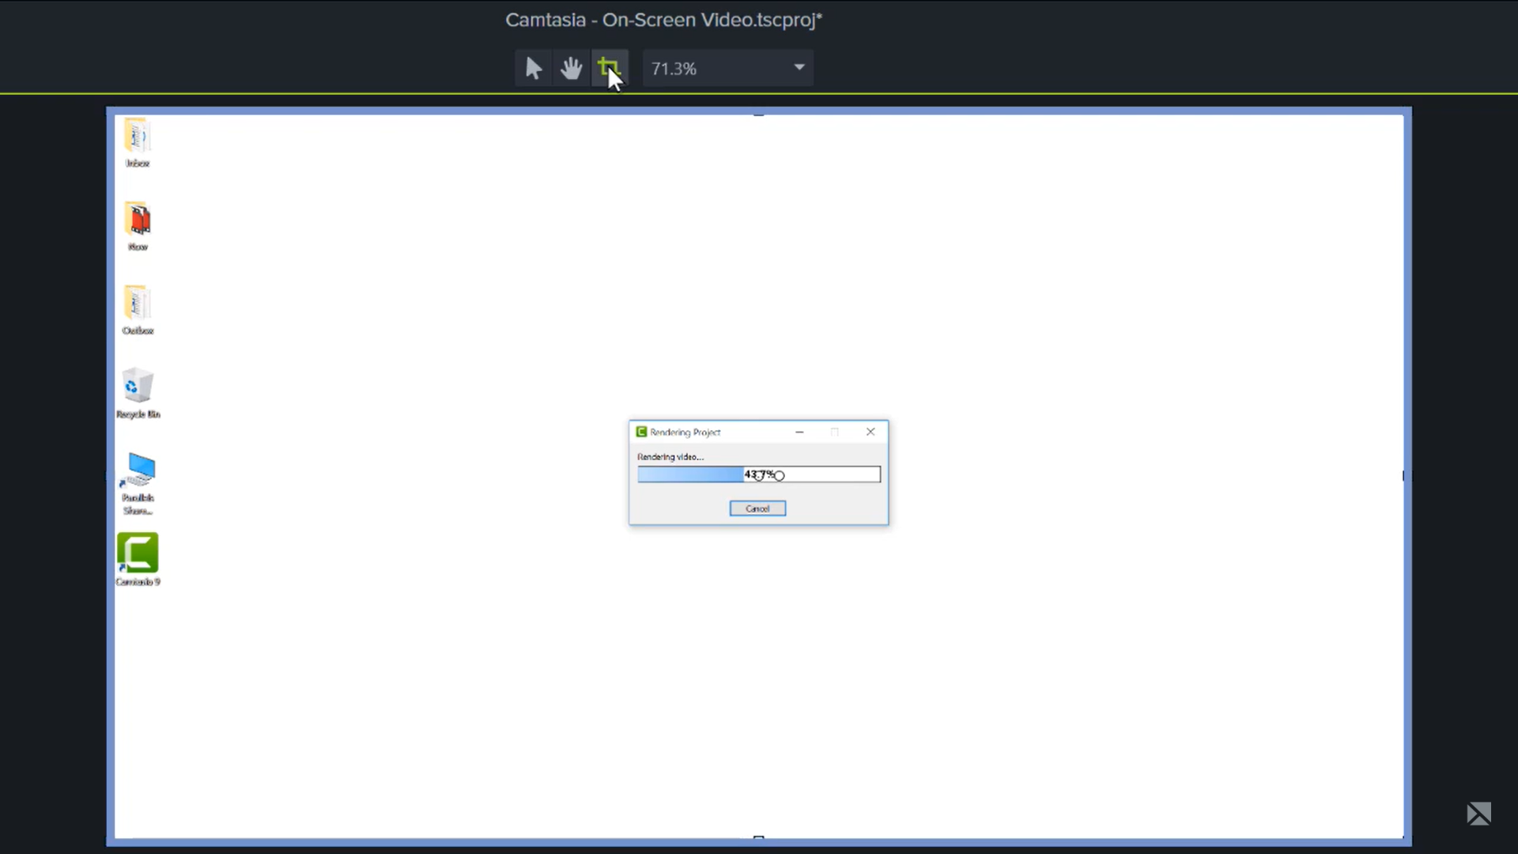

1. To crop the video or image, click and drag the handles.

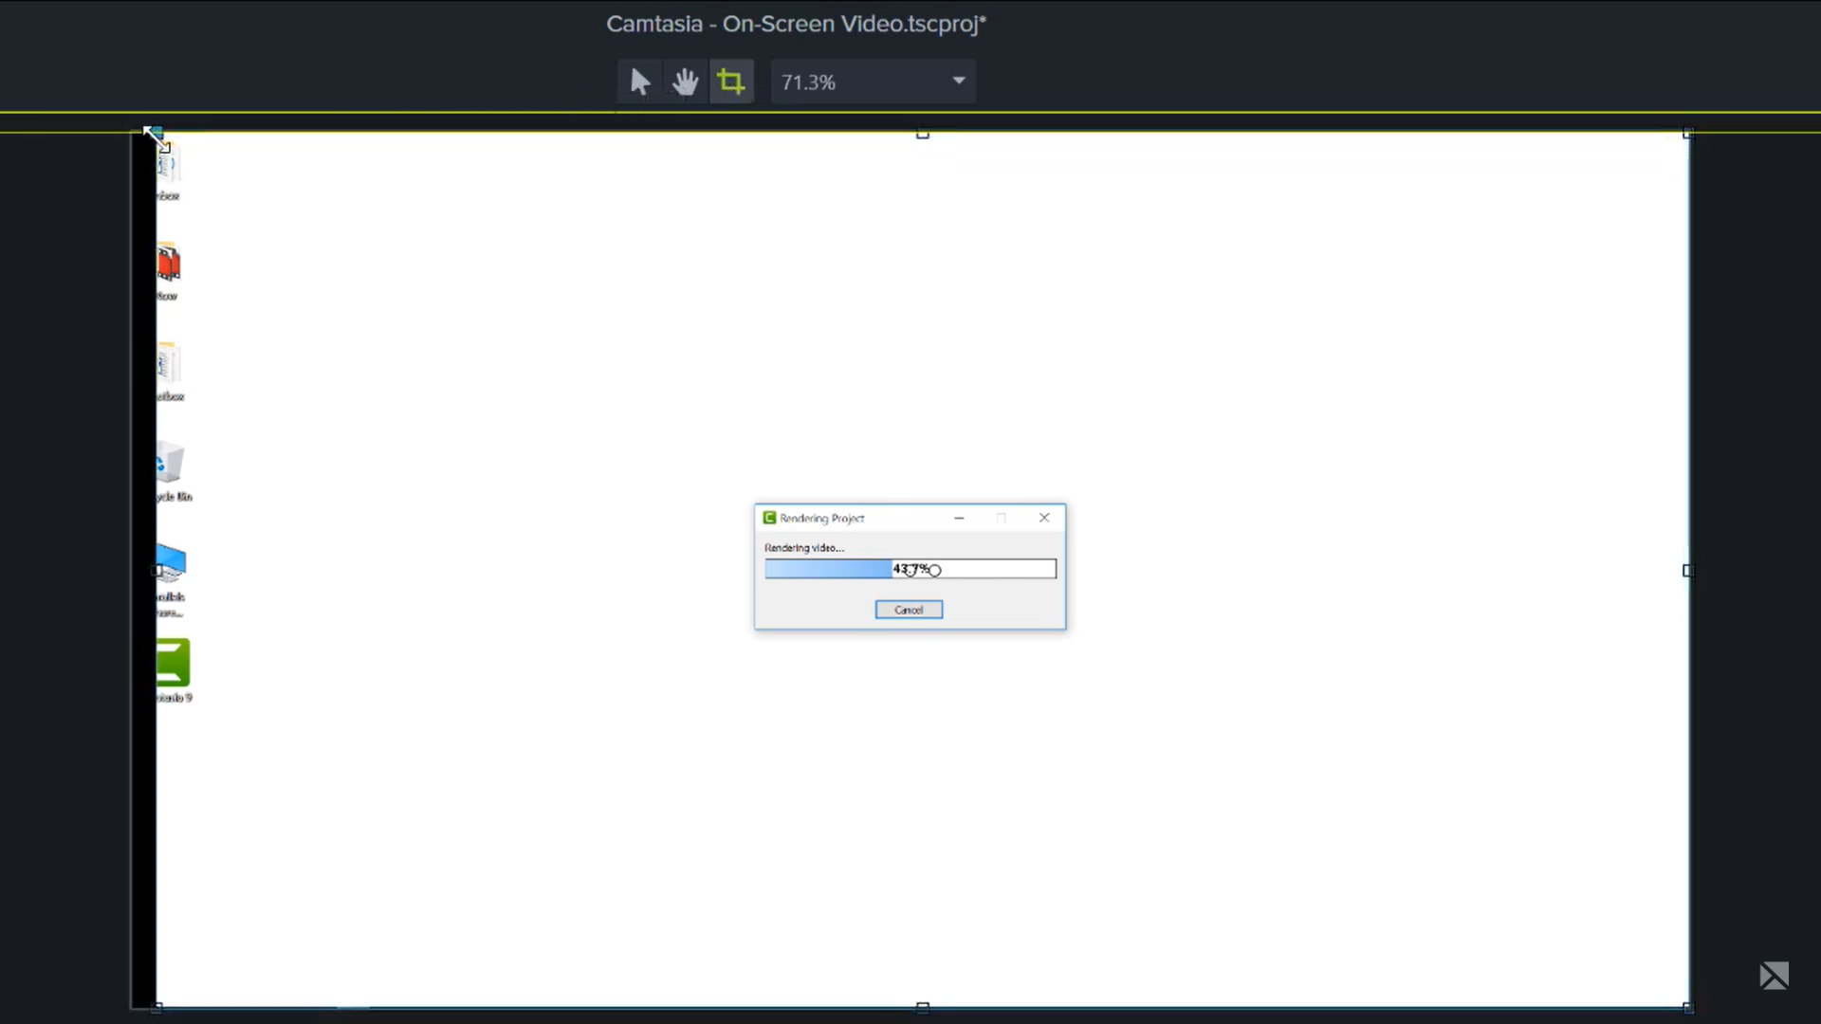

1. To return to normal edit mode, click the arrow button.



1. To isolate a part of the user interface, to fit a clip in a specific space or a frame, or to show actions at the same time in separate areas on your screen, use crop mode.

