Chest of two drawers MALM

Assembly Instructions

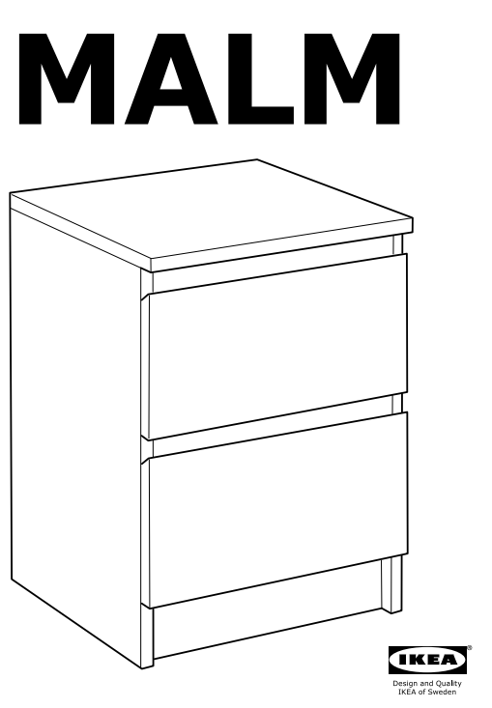

# INTRODUCTION

The following documentation shows the assembly instructions of the MALM chest of two drawers.

Read each of the following steps carefully. It is very important that each step is performed in the correct order. If these steps are not followed in sequence, assembly difficulties will occur.

## Assembly Tools Required (not supplied)

* Flat Head Screwdriver
* Phillips Screwdriver
* A pen
* A hammer

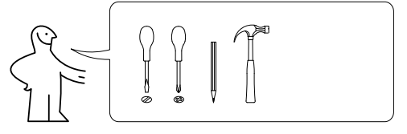

## Tips

It is recommended to not work alone. 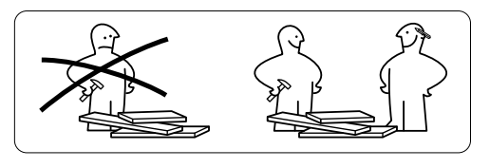

## Product Care and Maintenance

Work in a level area, preferably carpet.

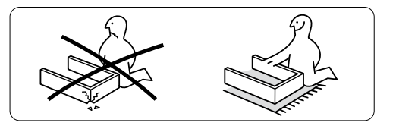

If you are missing any parts or have assembly difficulties, please contact customer service right away before assembly.

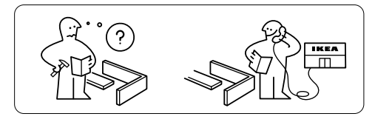

## Your package should include the following parts:

* 8 parts of item 110519
* 20 parts of item 118331
* 20 parts of item 101345
* 20 parts of item 120076 119030
* 12 parts of item 100365
* 4 parts of item 115339
* A bag of nails 101221
* 4 parts of item 102372
* 2 parts of item 118790

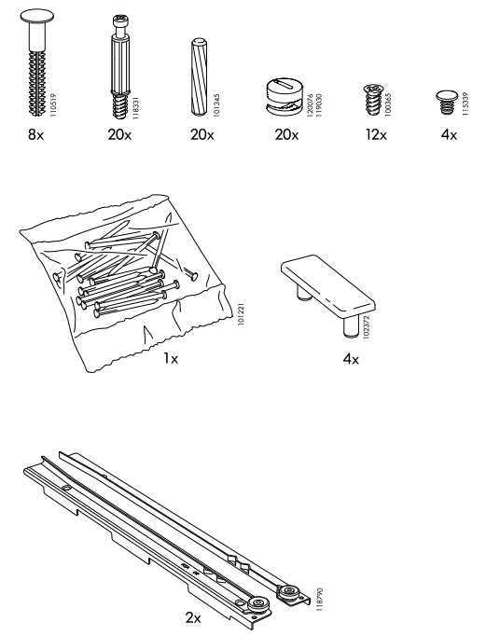

## WARNING

This product contains small and sharp parts, keep away from children.

This product contains plastic bags, keep away from children

## Used vocabulary

* ***screwdriver*** - a tool for turning screws
* ***bolt*** - a screw-like metal object without a point, used with a nut to fasten things together
* ***chest of drawers*** - a piece of furniture with drawers in which you keep things such as clothes
* ***drawer*** - a box-shaped container, without a top, that is part of a piece of furniture. It slides in and out to open and close and is used for keeping things in

# LET’S GET STARTED…

## Step 1

Place the drawer sides down. Grab eight of the 118331 bolts and a phillips screwdriver. Put each bolt in the shown holes and screw them.

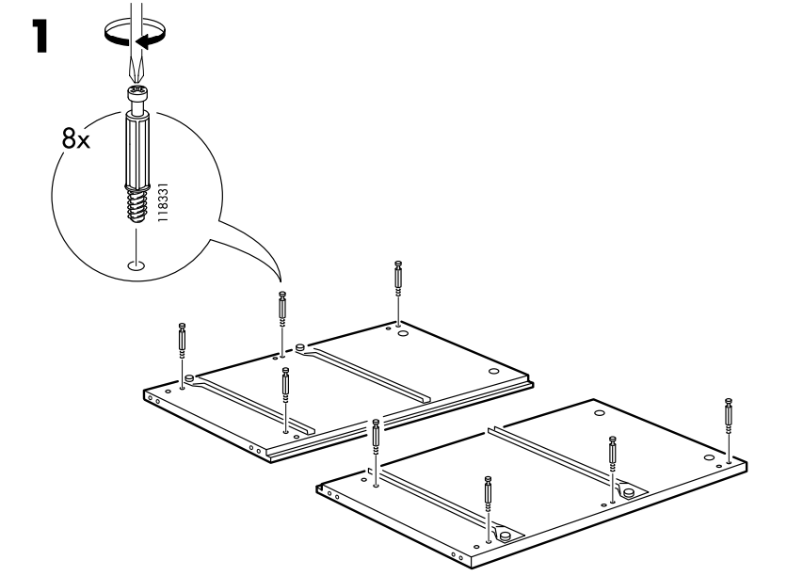

## Step 2

Grab four of item 102372. Place them in the double holes on top of each one of the drawer sides as shown.

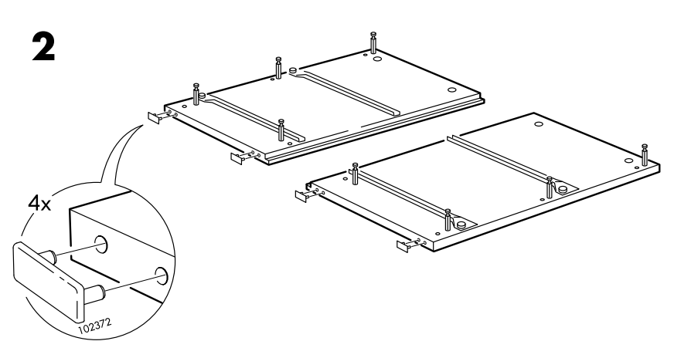

## Step 3

Take four of the long wooden boards. Place eight of item 101345 in the designated holes. You can gently use a hammer to put them. Do that step for the both drawer sides.

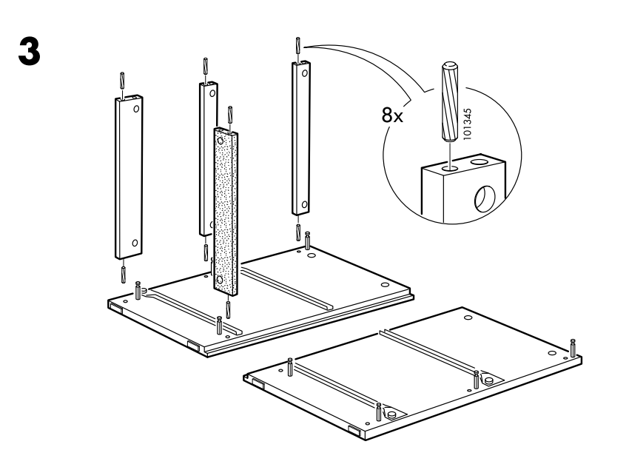

## Step 4

Take four items 120076 119030. Using a flat head screwdriver screw them in the shown holes in one of the drawer sides.

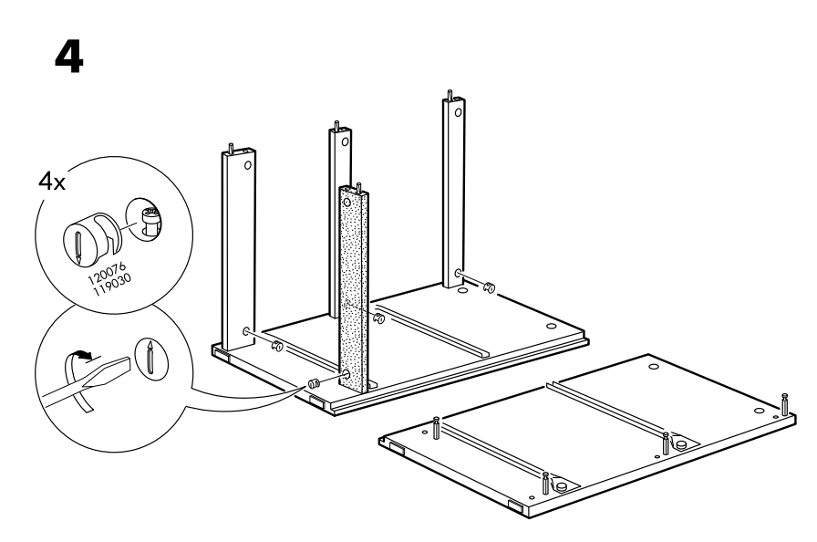

## Step 5

Take the second drawer side and put it on top of the first one. Beware which side of the drawer you put.

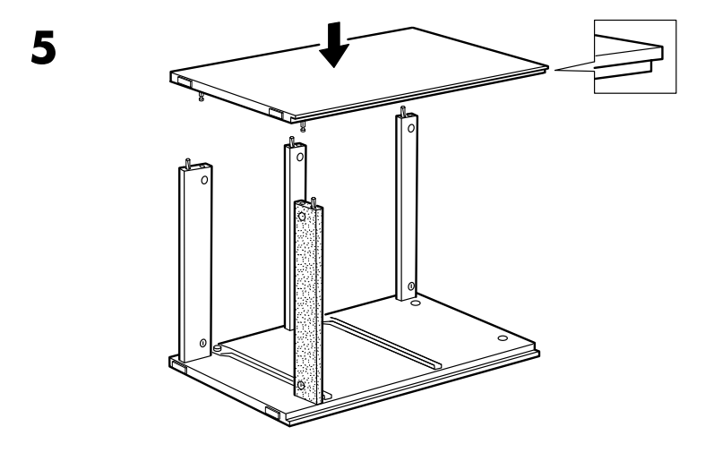

## Step 6

Rotate the drawer to the other side as shown. Take four of the items 120076 119030. Using a flat head screwdriver screw them in the shown places.

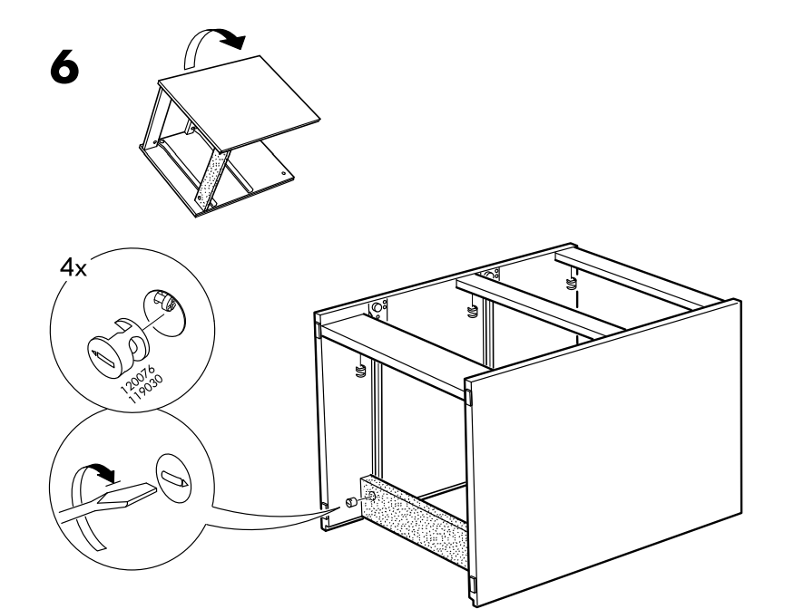

## Step 7

Grab four items with number 118331. As it is shown, put them in the right places on the board.

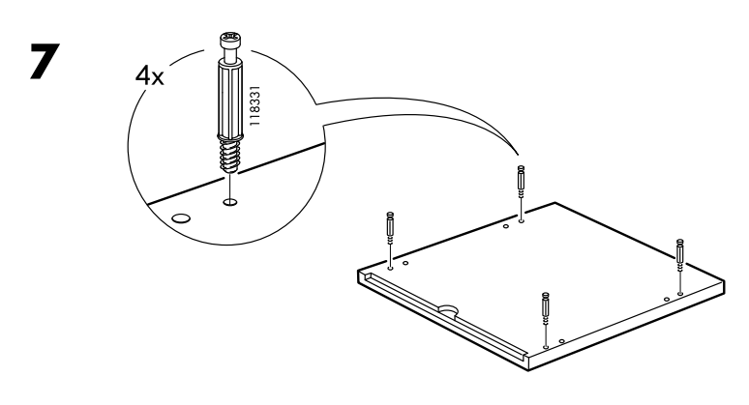

## Step 8

Take four of the parts 101345 and put them as shown. Grab the board from the previous step and put it on top of the drawer. Pay attention to the side of the board you put on top.

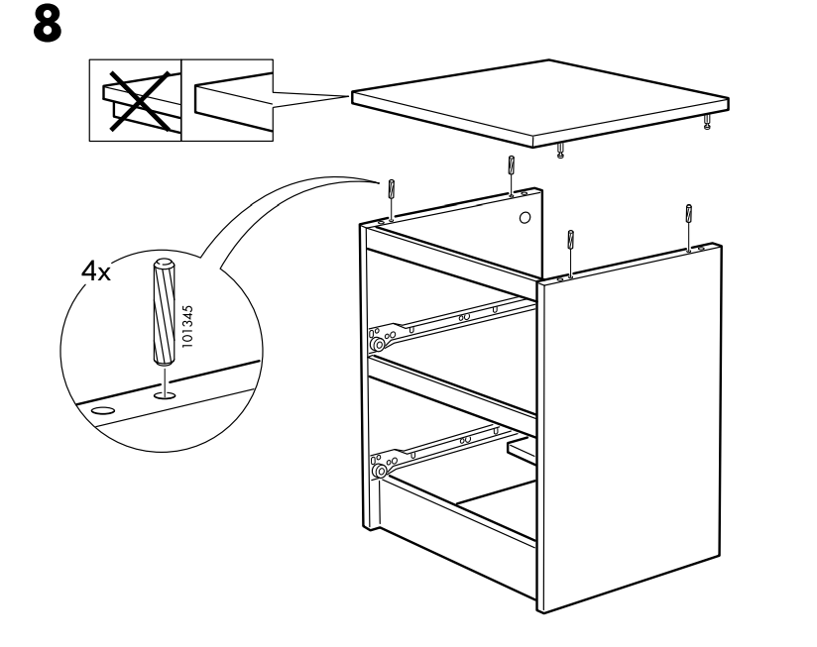

## Step 9

Take four of the 120076 119030 items and screw them in the shown places using a flat head screwdriver.

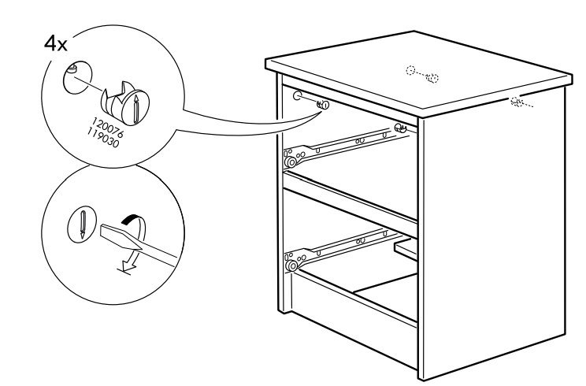

## Step 10

Take the back of the drawer and put it as shown. Grab one of the bolts with number 101221. Using a hammer, fix it at the top right place as it is shown while someone holds the back of the drawer.

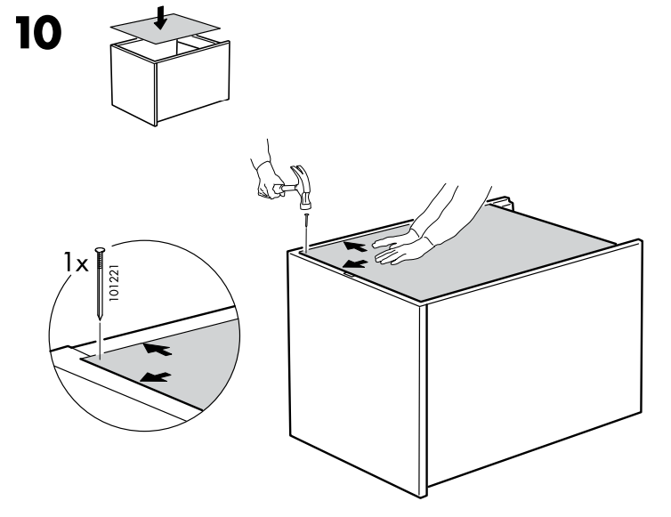

## Step 11

Grab another of the bolts with number 101221. Using a hammer, fix it at the bottom right as it is shown while someone holds the back of the drawer.

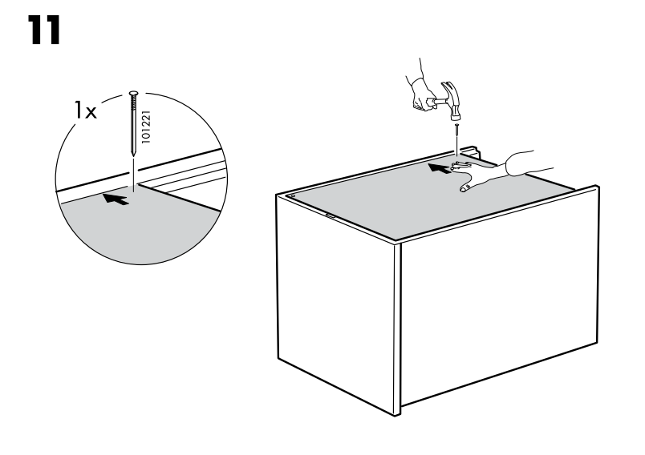

## Step 12

Grab a bolt with the number 101221. Using a hammer, fix it at the top left as it is shown while someone holds the back of the drawer.

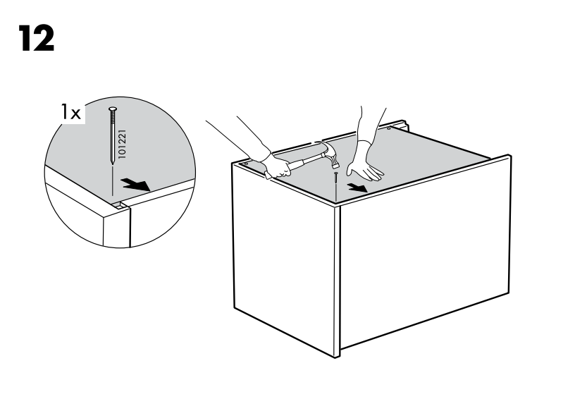

## Step 13

Put the rest of the 101221 bolts as it is shown using a hammer.

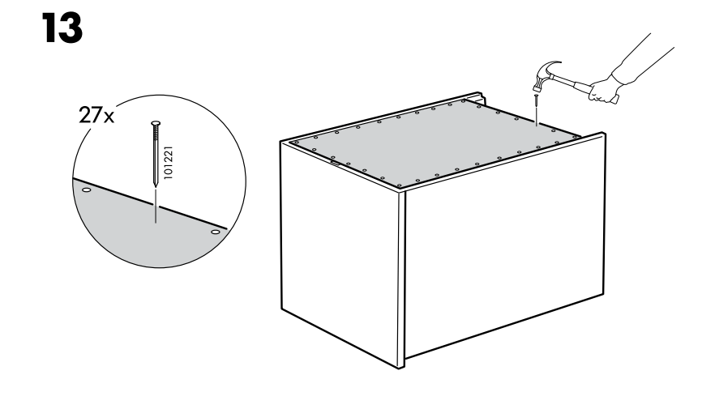

## Step 14

Grab four of the 118331 bolts and put them in the holes of the front board of the drawer as shown.

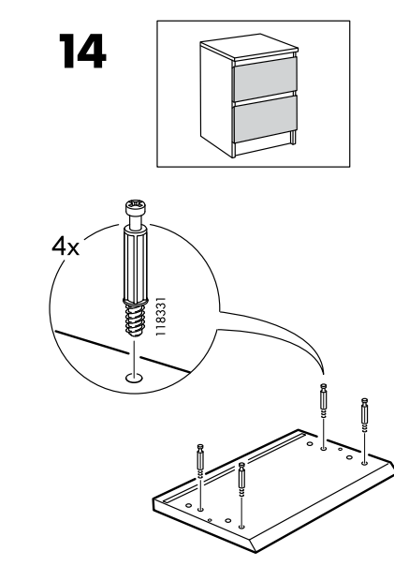

## Step 15

Grab four of the 101345 bolts. Put two of them at the bottom of one of the boards and another two at the bottom of the other board. Secure the two boards with the front piece as shown. Do this step for the second drawer.

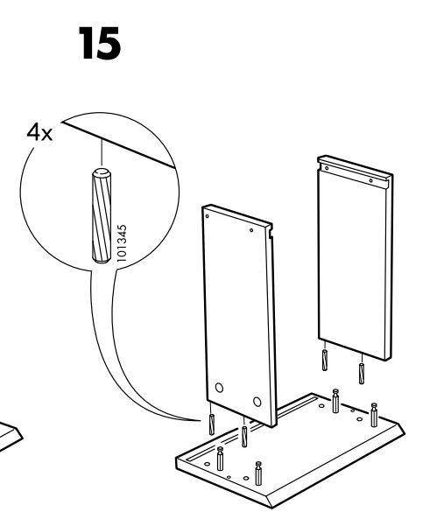

## Step 16

Grab four of the 120076 119030 bolts and using a flat head screwdriver screw them at the designated places. Do this step for the second drawer.

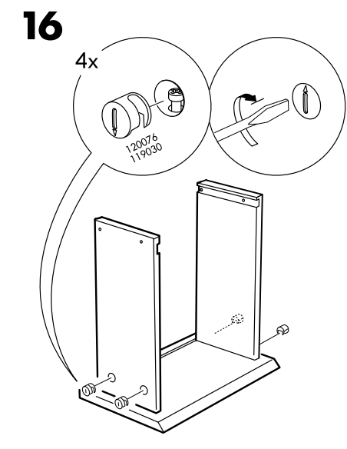

## Step 17

Grab the bottom of the drawer and place it at its place. Do this step for the second drawer.

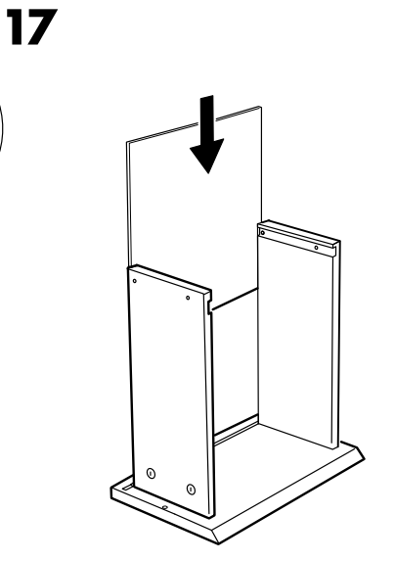

## Step 18

Grab the fifth board of the drawer and place it in its place. Beware of the right place. Do this step for the second drawer.

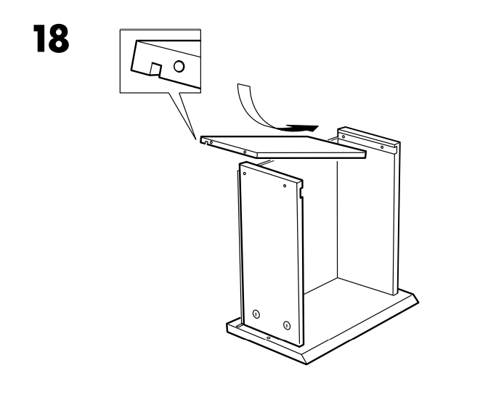

## Step 19

Take four bolts with number 110519 and a hammer. Secure the bolts at the holes with the hammer. Grab two 115339 bolts and put them as shown. Rotate the drawer. Do this step for the second drawer.

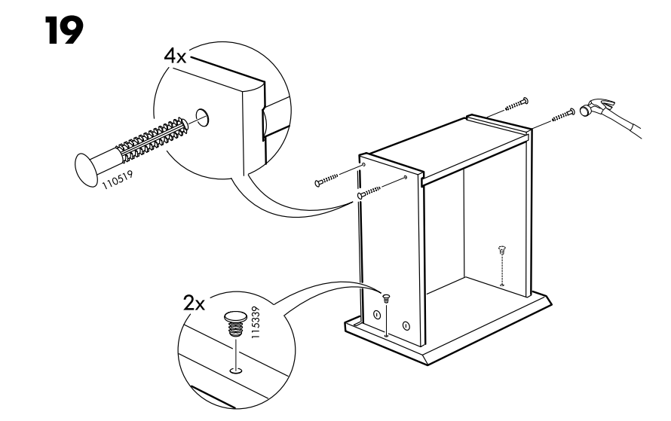

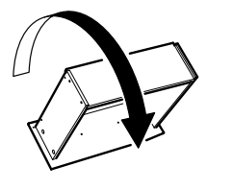

## Step 20

Take two of the items with number 118790 and six of 100365 and secure them as shown with the other part of the drawer. Do this step for the second drawer.

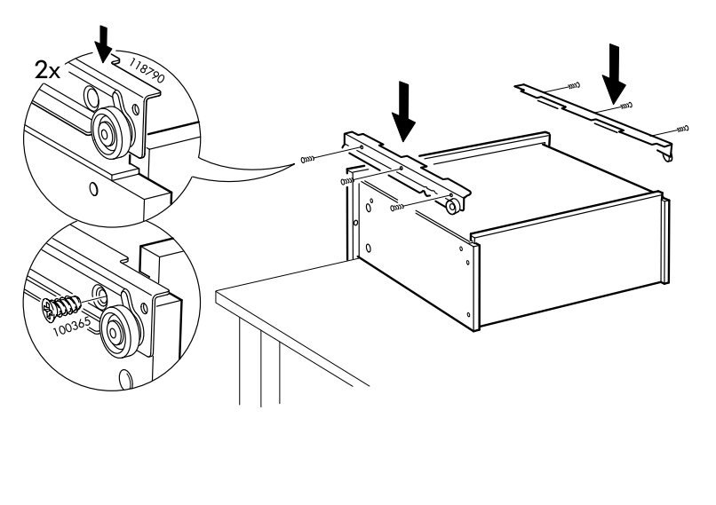

## Step 21

Put the drawers at their place and the chest of two drawers is ready to use.

