Министерство науки и высшего образования Российской Федерации
Федеральное государственное автономное образовательное учреждение высшего образования
«НАЦИОНАЛЬНЫЙ ИССЛЕДОВАТЕЛЬСКИЙ УНИВЕРСИТЕТ ИТМО»
Факультет инфокоммуникационных технологий
ОТЧЕТ
О ЛАБОРАТОРНОЙ РАБОТЕ № 3
по теме: Создание таблиц базы данных POSTGRESQL. Заполнение таблиц рабочими данными.
по дисциплине: Проектирование и реализация баз данных

Специальность:
09.03.03 Мобильные и сетевые технологии

Проверила:  Говорова М.М. __________  Дата: «__» _______ 20__г.  Оценка ______________ | Выполнил:  студент группы К3240  Легин Д.А.
Санкт-Петербург 2021
цель работы
овладеть практическими навыками создания таблиц базы данных PostgreSQL 1Х, заполнения их рабочими данными, резервного копирования и восстановления БД.
практическое задание
Наименование БД: LR_3.
Схема логической модели базы данных: рисунок 1.
Dump, содержащий скрипты работы с бд:
--
-- PostgreSQL database dump
--

-- Dumped from database version 13.2
-- Dumped by pg_dump version 13.2

-- Started on 2021-05-25 20:35:08
SET statement_timeout = 0;
SET lock_timeout = 0;
SET idle_in_transaction_session_timeout = 0;
SET client_encoding = 'UTF8';
SET standard_conforming_strings = on;
SELECT pg_catalog.set_config('search_path', '', false);
SET check_function_bodies = false;
SET xmloption = content;
SET client_min_messages = warning;
SET row_security = off;
SET default_tablespace = '';
SET default_table_access_method = heap;

--
-- TOC entry 205 (class 1259 OID 16442)
-- Name: auditory; Type: TABLE; Schema: public; Owner: postgres
--
CREATE TABLE public.auditory (
id_aud integer NOT NULL,
type text NOT NULL,
aud_no text NOT NULL,
aud_st integer NOT NULL,
adress text NOT NULL,
subdivision integer DEFAULT 1 NOT NULL
);
ALTER TABLE public.auditory OWNER TO postgres;
--
-- TOC entry 201 (class 1259 OID 16410)
-- Name: direction; Type: TABLE; Schema: public; Owner: postgres
--
CREATE TABLE public.direction (
id_of_direction integer NOT NULL,
name_of_direction text NOT NULL,
discipline integer NOT NULL,
subdivision integer NOT NULL
);
ALTER TABLE ONLY public.direction ALTER COLUMN discipline SET (n_distinct=1);

ALTER TABLE public.direction OWNER TO postgres;

--
-- TOC entry 200 (class 1259 OID 16402)
-- Name: discipline; Type: TABLE; Schema: public; Owner: postgres
--
CREATE TABLE public.discipline (
id_dis integer NOT NULL,
name_of_dis text NOT NULL
);
ALTER TABLE public.discipline OWNER TO postgres;
--
-- TOC entry 204 (class 1259 OID 16434)
-- Name: group; Type: TABLE; Schema: public; Owner: postgres
--
CREATE TABLE public."group" (
id_g integer NOT NULL,
group_no text NOT NULL,
group_year text NOT NULL,
direction integer DEFAULT 1 NOT NULL
);
ALTER TABLE public."group" OWNER TO postgres;
--
-- TOC entry 206 (class 1259 OID 16450)
-- Name: schedule; Type: TABLE; Schema: public; Owner: postgres
--
CREATE TABLE public.schedule (
teacher integer NOT NULL,
discipline integer NOT NULL,
auditory integer NOT NULL,
"group" integer NOT NULL,
day_of_week integer NOT NULL,
les_begin time without time zone NOT NULL,
les_ending time without time zone NOT NULL,
les_type text NOT NULL,
id integer NOT NULL
);
ALTER TABLE public.schedule OWNER TO postgres;
--
-- TOC entry 203 (class 1259 OID 16426)
-- Name: subdivision; Type: TABLE; Schema: public; Owner: postgres
--

CREATE TABLE public.subdivision (
is_sub integer NOT NULL,
name_sub text NOT NULL
);
ALTER TABLE public.subdivision OWNER TO postgres;
--
-- TOC entry 202 (class 1259 OID 16418)
-- Name: teacher; Type: TABLE; Schema: public; Owner: postgres
--
CREATE TABLE public.teacher (
id_t integer NOT NULL,
surname text NOT NULL,
name text NOT NULL,
patronymic text,
discipline integer NOT NULL,
"position" text
);
ALTER TABLE public.teacher OWNER TO postgres;
--
-- TOC entry 3039 (class 0 OID 16442)
-- Dependencies: 205
-- Data for Name: auditory; Type: TABLE DATA; Schema: public; Owner: postgres
--
COPY public.auditory (id_aud, type, aud_no, aud_st, adress, subdivision) FROM stdin;
1 type 202 23 ad 1
\.
--
-- TOC entry 3035 (class 0 OID 16410)
-- Dependencies: 201
-- Data for Name: direction; Type: TABLE DATA; Schema: public; Owner: postgres
--

COPY public.direction (id_of_direction, name_of_direction, discipline, subdivision) FROM stdin;
1 2021 22 21
\.
--
-- TOC entry 3034 (class 0 OID 16402)
-- Dependencies: 200
-- Data for Name: discipline; Type: TABLE DATA; Schema: public; Owner: postgres
--

COPY public.discipline (id_dis, name_of_dis) FROM stdin;
\.
--
-- TOC entry 3038 (class 0 OID 16434)
-- Dependencies: 204
-- Data for Name: group; Type: TABLE DATA; Schema: public; Owner: postgres
--
COPY public."group" (id_g, group_no, group_year, direction) FROM stdin;
1 23 2021 1
\.
--
-- TOC entry 3040 (class 0 OID 16450)
-- Dependencies: 206
-- Data for Name: schedule; Type: TABLE DATA; Schema: public; Owner: postgres
--
COPY public.schedule (teacher, discipline, auditory, "group", day_of_week, les_begin, les_ending, les_type, id) FROM stdin;
\.
--
-- TOC entry 3037 (class 0 OID 16426)
-- Dependencies: 203
-- Data for Name: subdivision; Type: TABLE DATA; Schema: public; Owner: postgres
--
COPY public.subdivision (is_sub, name_sub) FROM stdin;
1 vh
4 fds
\.
--
-- TOC entry 3036 (class 0 OID 16418)
-- Dependencies: 202
-- Data for Name: teacher; Type: TABLE DATA; Schema: public; Owner: postgres
--
COPY public.teacher (id_t, surname, name, patronymic, discipline, "position") FROM stdin;
--
-- TOC entry 2892 (class 2606 OID 16446)
-- Name: auditory auditory_pkey; Type: CONSTRAINT; Schema: public; Owner: postgres
--

ALTER TABLE ONLY public.auditory
ADD CONSTRAINT auditory_pkey PRIMARY KEY (id_aud);

--
-- TOC entry 2884 (class 2606 OID 16417)
-- Name: direction direction_pkey; Type: CONSTRAINT; Schema: public; Owner: postgres
--

ALTER TABLE ONLY public.direction
ADD CONSTRAINT direction_pkey PRIMARY KEY (id_of_direction);
--
-- TOC entry 2882 (class 2606 OID 16409)
-- Name: discipline discipline_pkey; Type: CONSTRAINT; Schema: public; Owner: postgres
--
ALTER TABLE ONLY public.discipline
ADD CONSTRAINT discipline_pkey PRIMARY KEY (id_dis);
--
-- TOC entry 2890 (class 2606 OID 16441)
-- Name: group group_pkey; Type: CONSTRAINT; Schema: public; Owner: postgres
--
ALTER TABLE ONLY public."group"
ADD CONSTRAINT group_pkey PRIMARY KEY (id_g);

--
-- TOC entry 2894 (class 2606 OID 16457)
-- Name: schedule schedule_pkey; Type: CONSTRAINT; Schema: public; Owner: postgres
--
ALTER TABLE ONLY public.schedule
ADD CONSTRAINT schedule_pkey PRIMARY KEY (id);
--
-- TOC entry 2888 (class 2606 OID 16433)
-- Name: subdivision subdivision_pkey; Type: CONSTRAINT; Schema: public; Owner: postgres
--
ALTER TABLE ONLY public.subdivision
ADD CONSTRAINT subdivision_pkey PRIMARY KEY (is_sub);
--
-- TOC entry 2886 (class 2606 OID 16425)
-- Name: teacher teacher_pkey; Type: CONSTRAINT; Schema: public; Owner: postgres
--
ALTER TABLE ONLY public.teacher
ADD CONSTRAINT teacher_pkey PRIMARY KEY (id_t);
--
-- TOC entry 2898 (class 2606 OID 16458)
-- Name: group id_of_direction; Type: FK CONSTRAINT; Schema: public; Owner: postgres
--
ALTER TABLE ONLY public."group"
ADD CONSTRAINT id_of_direction FOREIGN KEY (direction) REFERENCES public."group"(id_g) NOT VALID;
--
-- TOC entry 2899 (class 2606 OID 16489)
-- Name: auditory is_aud; Type: FK CONSTRAINT; Schema: public; Owner: postgres
--
ALTER TABLE ONLY public.auditory
ADD CONSTRAINT is_aud FOREIGN KEY (id_aud) REFERENCES public.subdivision(is_sub) NOT VALID;
--
-- TOC entry 2903 (class 2606 OID 16524)
-- Name: schedule is_audi; Type: FK CONSTRAINT; Schema: public; Owner: postgres
--
ALTER TABLE ONLY public.schedule
ADD CONSTRAINT is_audi FOREIGN KEY (auditory) REFERENCES public.auditory(id_aud) NOT VALID;
--
-- TOC entry 2896 (class 2606 OID 16499)
-- Name: direction is_disc; Type: FK CONSTRAINT; Schema: public; Owner: postgres
--
ALTER TABLE ONLY public.direction
ADD CONSTRAINT is_disc FOREIGN KEY (id_of_direction) REFERENCES public.discipline(id_dis) NOT VALID;
--
-- TOC entry 2897 (class 2606 OID 16504)
-- Name: teacher is_disci; Type: FK CONSTRAINT; Schema: public; Owner: postgres
--
ALTER TABLE ONLY public.teacher
ADD CONSTRAINT is_disci FOREIGN KEY (id_t) REFERENCES public.discipline(id_dis) NOT VALID;
--
-- TOC entry 2901 (class 2606 OID 16514)
-- Name: schedule is_discis; Type: FK CONSTRAINT; Schema: public; Owner: postgres
--
ALTER TABLE ONLY public.schedule
ADD CONSTRAINT is_discis FOREIGN KEY (discipline) REFERENCES public.discipline(id_dis) NOT VALID;
--
-- TOC entry 2902 (class 2606 OID 16519)
-- Name: schedule is_groups; Type: FK CONSTRAINT; Schema: public; Owner: postgres
--
ALTER TABLE ONLY public.schedule
ADD CONSTRAINT is_groups FOREIGN KEY ("group") REFERENCES public."group"(id_g) NOT VALID;
--
-- TOC entry 2895 (class 2606 OID 16494)
-- Name: direction is_sbb; Type: FK CONSTRAINT; Schema: public; Owner: postgres
--
ALTER TABLE ONLY public.direction
ADD CONSTRAINT is_sbb FOREIGN KEY (id_of_direction) REFERENCES public.subdivision(is_sub) NOT VALID;
--
-- TOC entry 2900 (class 2606 OID 16509)
-- Name: schedule is_teach; Type: FK CONSTRAINT; Schema: public; Owner: postgres
--
ALTER TABLE ONLY public.schedule
ADD CONSTRAINT is_teach FOREIGN KEY (teacher) REFERENCES public.teacher(id_t) NOT VALID;

-- Completed on 2021-05-25 20:35:10
--
-- PostgreSQL database dump complete
--
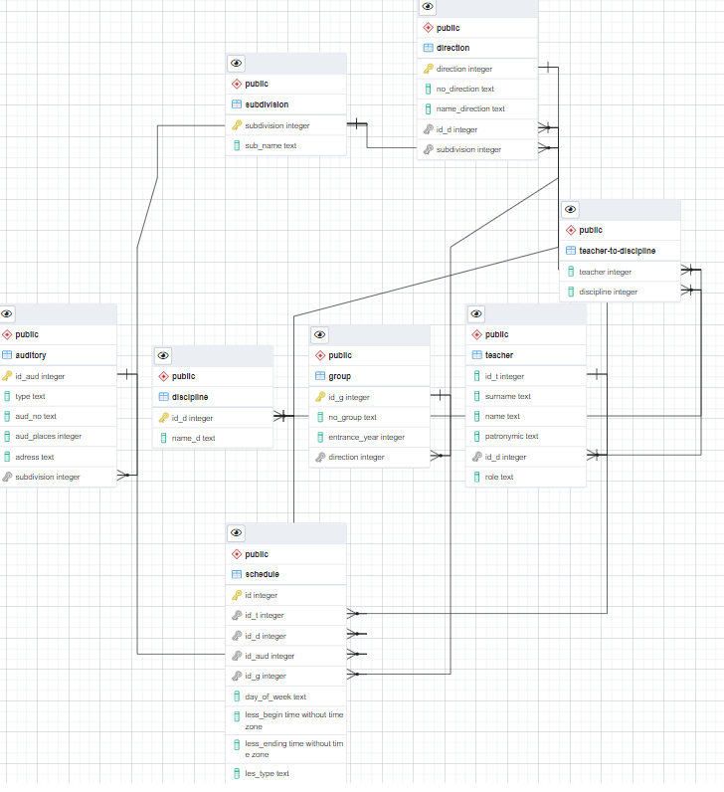
Рисунок 1 – логическая модель базы данных
Вывод: в ходе выполнения работы была создана база данных в Postgresql, созданы
таблицы и ограничения на значения столбцов, в базу данных были занесены рабочие
данные, а также была создана логическая модель базы данных и dump.

