Министерство науки и высшего образования Российской Федерации

Федеральное государственное автономное образовательное учреждение высшего образования

«НАЦИОНАЛЬНЫЙ ИССЛЕДОВАТЕЛЬСКИЙ УНИВЕРСИТЕТ ИТМО»

Факультет инфокоммуникационных технологий

**ОТЧЕТ**

**О ЛАБОРАТОРНОЙ РАБОТЕ № 3**

по теме: Создание таблиц базы данных POSTGRESQL. Заполнение таблиц рабочими данными.

по дисциплине: Проектирование и реализация баз данных

Специальность:

09.03.03 Мобильные и сетевые технологии

|  |  |
| --- | --- |
| Проверила:  Говорова М.М. __________  Дата: «__» _______ 20__г.  Оценка ______________ | Выполнил:  студент группы К3240  Легин Д.А. |

Санкт-Петербург 2021

цель работы

овладеть практическими навыками создания таблиц базы данных PostgreSQL 1Х, заполнения их рабочими данными, резервного копирования и восстановления БД.

практическое задание

Наименование БД: LR_3.  
Схема логической модели базы данных: рисунок 1.   
Dump, содержащий скрипты работы с бд:

--

-- PostgreSQL database dump

--

-- Dumped from database version 13.2

-- Dumped by pg_dump version 13.2

-- Started on 2021-05-25 20:35:08

SET statement_timeout = 0;

SET lock_timeout = 0;

SET idle_in_transaction_session_timeout = 0;

SET client_encoding = 'UTF8';

SET standard_conforming_strings = on;

SELECT pg_catalog.set_config('search_path', '', false);

SET check_function_bodies = false;

SET xmloption = content;

SET client_min_messages = warning;

SET row_security = off;

SET default_tablespace = '';

SET default_table_access_method = heap;

--

-- TOC entry 205 (class 1259 OID 16442)

-- Name: auditory; Type: TABLE; Schema: public; Owner: postgres

--

CREATE TABLE public.auditory (

id_aud integer NOT NULL,

type text NOT NULL,

aud_no text NOT NULL,

aud_st integer NOT NULL,

adress text NOT NULL,

subdivision integer DEFAULT 1 NOT NULL

);

ALTER TABLE public.auditory OWNER TO postgres;

--

-- TOC entry 201 (class 1259 OID 16410)

-- Name: direction; Type: TABLE; Schema: public; Owner: postgres

--

CREATE TABLE public.direction (

id_of_direction integer NOT NULL,

name_of_direction text NOT NULL,

discipline integer NOT NULL,

subdivision integer NOT NULL

);

ALTER TABLE ONLY public.direction ALTER COLUMN discipline SET (n_distinct=1);

ALTER TABLE public.direction OWNER TO postgres;

--

-- TOC entry 200 (class 1259 OID 16402)

-- Name: discipline; Type: TABLE; Schema: public; Owner: postgres

--

CREATE TABLE public.discipline (

id_dis integer NOT NULL,

name_of_dis text NOT NULL

);

ALTER TABLE public.discipline OWNER TO postgres;

--

-- TOC entry 204 (class 1259 OID 16434)

-- Name: group; Type: TABLE; Schema: public; Owner: postgres

--

CREATE TABLE public."group" (

id_g integer NOT NULL,

group_no text NOT NULL,

group_year text NOT NULL,

direction integer DEFAULT 1 NOT NULL

);

ALTER TABLE public."group" OWNER TO postgres;

--

-- TOC entry 206 (class 1259 OID 16450)

-- Name: schedule; Type: TABLE; Schema: public; Owner: postgres

--

CREATE TABLE public.schedule (

teacher integer NOT NULL,

discipline integer NOT NULL,

auditory integer NOT NULL,

"group" integer NOT NULL,

day_of_week integer NOT NULL,

les_begin time without time zone NOT NULL,

les_ending time without time zone NOT NULL,

les_type text NOT NULL,

id integer NOT NULL

);

ALTER TABLE public.schedule OWNER TO postgres;

--

-- TOC entry 203 (class 1259 OID 16426)

-- Name: subdivision; Type: TABLE; Schema: public; Owner: postgres

--

CREATE TABLE public.subdivision (

is_sub integer NOT NULL,

name_sub text NOT NULL

);

ALTER TABLE public.subdivision OWNER TO postgres;

--

-- TOC entry 202 (class 1259 OID 16418)

-- Name: teacher; Type: TABLE; Schema: public; Owner: postgres

--

CREATE TABLE public.teacher (

id_t integer NOT NULL,

surname text NOT NULL,

name text NOT NULL,

patronymic text,

discipline integer NOT NULL,

"position" text

);

ALTER TABLE public.teacher OWNER TO postgres;

--

-- TOC entry 3039 (class 0 OID 16442)

-- Dependencies: 205

-- Data for Name: auditory; Type: TABLE DATA; Schema: public; Owner: postgres

--

COPY public.auditory (id_aud, type, aud_no, aud_st, adress, subdivision) FROM stdin;

1 type 202 23 ad 1

\.

--

-- TOC entry 3035 (class 0 OID 16410)

-- Dependencies: 201

-- Data for Name: direction; Type: TABLE DATA; Schema: public; Owner: postgres

--

COPY public.direction (id_of_direction, name_of_direction, discipline, subdivision) FROM stdin;

1 2021 22 21

\.

--

-- TOC entry 3034 (class 0 OID 16402)

-- Dependencies: 200

-- Data for Name: discipline; Type: TABLE DATA; Schema: public; Owner: postgres

--

COPY public.discipline (id_dis, name_of_dis) FROM stdin;

\.

--

-- TOC entry 3038 (class 0 OID 16434)

-- Dependencies: 204

-- Data for Name: group; Type: TABLE DATA; Schema: public; Owner: postgres

--

COPY public."group" (id_g, group_no, group_year, direction) FROM stdin;

1 23 2021 1

\.

--

-- TOC entry 3040 (class 0 OID 16450)

-- Dependencies: 206

-- Data for Name: schedule; Type: TABLE DATA; Schema: public; Owner: postgres

--

COPY public.schedule (teacher, discipline, auditory, "group", day_of_week, les_begin, les_ending, les_type, id) FROM stdin;

\.

--

-- TOC entry 3037 (class 0 OID 16426)

-- Dependencies: 203

-- Data for Name: subdivision; Type: TABLE DATA; Schema: public; Owner: postgres

--

COPY public.subdivision (is_sub, name_sub) FROM stdin;

1 vh

4 fds

\.

--

-- TOC entry 3036 (class 0 OID 16418)

-- Dependencies: 202

-- Data for Name: teacher; Type: TABLE DATA; Schema: public; Owner: postgres

--

COPY public.teacher (id_t, surname, name, patronymic, discipline, "position") FROM stdin;

--

-- TOC entry 2892 (class 2606 OID 16446)

-- Name: auditory auditory_pkey; Type: CONSTRAINT; Schema: public; Owner: postgres

--

ALTER TABLE ONLY public.auditory

ADD CONSTRAINT auditory_pkey PRIMARY KEY (id_aud);

--

-- TOC entry 2884 (class 2606 OID 16417)

-- Name: direction direction_pkey; Type: CONSTRAINT; Schema: public; Owner: postgres

--

ALTER TABLE ONLY public.direction

ADD CONSTRAINT direction_pkey PRIMARY KEY (id_of_direction);

--

-- TOC entry 2882 (class 2606 OID 16409)

-- Name: discipline discipline_pkey; Type: CONSTRAINT; Schema: public; Owner: postgres

--

ALTER TABLE ONLY public.discipline

ADD CONSTRAINT discipline_pkey PRIMARY KEY (id_dis);

--

-- TOC entry 2890 (class 2606 OID 16441)

-- Name: group group_pkey; Type: CONSTRAINT; Schema: public; Owner: postgres

--

ALTER TABLE ONLY public."group"

ADD CONSTRAINT group_pkey PRIMARY KEY (id_g);

--

-- TOC entry 2894 (class 2606 OID 16457)

-- Name: schedule schedule_pkey; Type: CONSTRAINT; Schema: public; Owner: postgres

--

ALTER TABLE ONLY public.schedule

ADD CONSTRAINT schedule_pkey PRIMARY KEY (id);

--

-- TOC entry 2888 (class 2606 OID 16433)

-- Name: subdivision subdivision_pkey; Type: CONSTRAINT; Schema: public; Owner: postgres

--

ALTER TABLE ONLY public.subdivision

ADD CONSTRAINT subdivision_pkey PRIMARY KEY (is_sub);

--

-- TOC entry 2886 (class 2606 OID 16425)

-- Name: teacher teacher_pkey; Type: CONSTRAINT; Schema: public; Owner: postgres

--

ALTER TABLE ONLY public.teacher

ADD CONSTRAINT teacher_pkey PRIMARY KEY (id_t);

--

-- TOC entry 2898 (class 2606 OID 16458)

-- Name: group id_of_direction; Type: FK CONSTRAINT; Schema: public; Owner: postgres

--

ALTER TABLE ONLY public."group"

ADD CONSTRAINT id_of_direction FOREIGN KEY (direction) REFERENCES public."group"(id_g) NOT VALID;

--

-- TOC entry 2899 (class 2606 OID 16489)

-- Name: auditory is_aud; Type: FK CONSTRAINT; Schema: public; Owner: postgres

--

ALTER TABLE ONLY public.auditory

ADD CONSTRAINT is_aud FOREIGN KEY (id_aud) REFERENCES public.subdivision(is_sub) NOT VALID;

--

-- TOC entry 2903 (class 2606 OID 16524)

-- Name: schedule is_audi; Type: FK CONSTRAINT; Schema: public; Owner: postgres

--

ALTER TABLE ONLY public.schedule

ADD CONSTRAINT is_audi FOREIGN KEY (auditory) REFERENCES public.auditory(id_aud) NOT VALID;

--

-- TOC entry 2896 (class 2606 OID 16499)

-- Name: direction is_disc; Type: FK CONSTRAINT; Schema: public; Owner: postgres

--

ALTER TABLE ONLY public.direction

ADD CONSTRAINT is_disc FOREIGN KEY (id_of_direction) REFERENCES public.discipline(id_dis) NOT VALID;

--

-- TOC entry 2897 (class 2606 OID 16504)

-- Name: teacher is_disci; Type: FK CONSTRAINT; Schema: public; Owner: postgres

--

ALTER TABLE ONLY public.teacher

ADD CONSTRAINT is_disci FOREIGN KEY (id_t) REFERENCES public.discipline(id_dis) NOT VALID;

--

-- TOC entry 2901 (class 2606 OID 16514)

-- Name: schedule is_discis; Type: FK CONSTRAINT; Schema: public; Owner: postgres

--

ALTER TABLE ONLY public.schedule

ADD CONSTRAINT is_discis FOREIGN KEY (discipline) REFERENCES public.discipline(id_dis) NOT VALID;

--

-- TOC entry 2902 (class 2606 OID 16519)

-- Name: schedule is_groups; Type: FK CONSTRAINT; Schema: public; Owner: postgres

--

ALTER TABLE ONLY public.schedule

ADD CONSTRAINT is_groups FOREIGN KEY ("group") REFERENCES public."group"(id_g) NOT VALID;

--

-- TOC entry 2895 (class 2606 OID 16494)

-- Name: direction is_sbb; Type: FK CONSTRAINT; Schema: public; Owner: postgres

--

ALTER TABLE ONLY public.direction

ADD CONSTRAINT is_sbb FOREIGN KEY (id_of_direction) REFERENCES public.subdivision(is_sub) NOT VALID;

--

-- TOC entry 2900 (class 2606 OID 16509)

-- Name: schedule is_teach; Type: FK CONSTRAINT; Schema: public; Owner: postgres

--

ALTER TABLE ONLY public.schedule

ADD CONSTRAINT is_teach FOREIGN KEY (teacher) REFERENCES public.teacher(id_t) NOT VALID;

-- Completed on 2021-05-25 20:35:10

--

-- PostgreSQL database dump complete

--

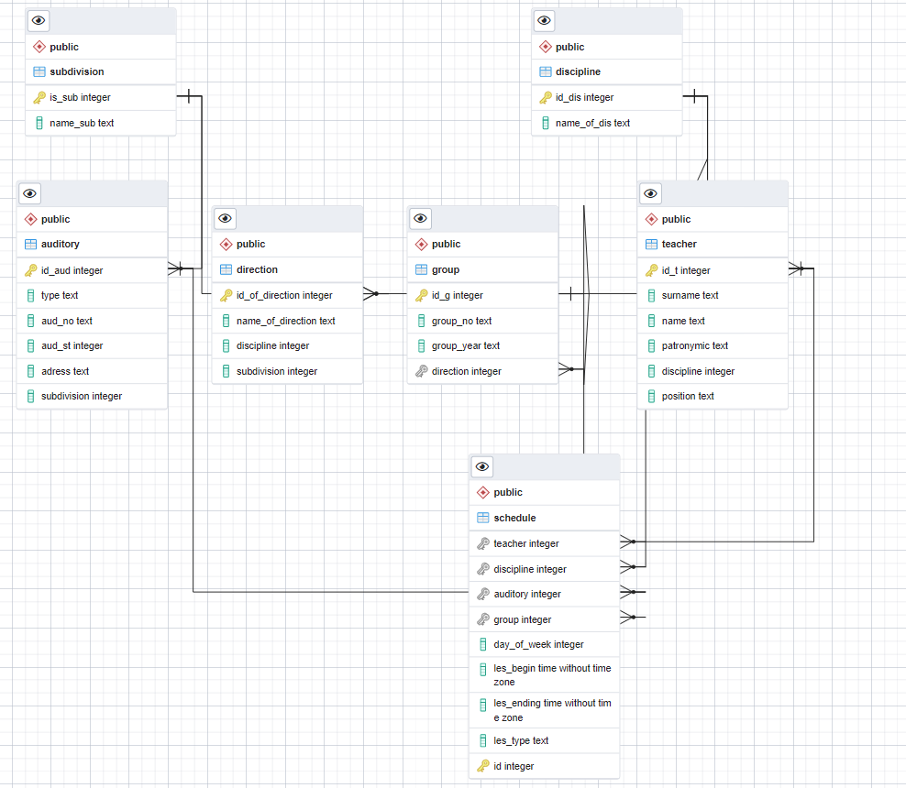

**Рисунок 1 –** логическая модель базы данных

Вывод: в ходе выполнения работы была создана база данных в Postgresql, созданы

таблицы и ограничения на значения столбцов, в базу данных были занесены рабочие

данные, а также была создана логическая модель базы данных и dump.