数学模型-规划模型

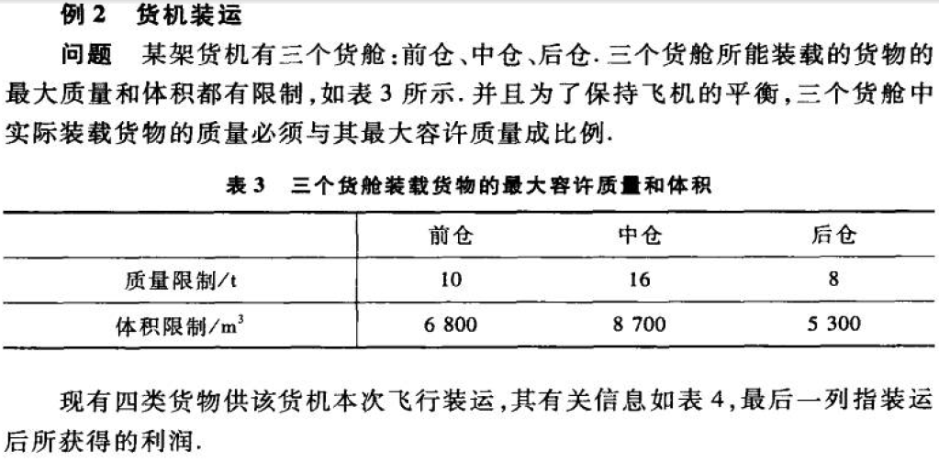

**解析:**根据上述给定的相关描述,设计下面的一个矩阵,从而方便进行后续的进一步分析.

|  |  |  |  |  |  |  |
| --- | --- | --- | --- | --- | --- | --- |
|  | 货1(480) | 货2(650) | 货3(580) | 货4(390) | 质量 | 体积 |
| 前仓 | X11 | X12 | X13 | X14 | 10 | 6800 |
| 中仓 | X21 | X22 | X23 | X24 | 16 | 8700 |
| 后仓 | X31 | X32 | X33 | X34 | 8 | 5300 |
| 合计 | 18 | 15 | 23 | 12 |  |  |

根据定义,目标函数为:

MAX=3100*(X11+X21+X31)+3800*(X12+X22+X32)+3500*(X13+X23+X33)+2850*(X14+X24+X34)

约束条件:

X11+X12+X13+X14<=10;

X21+X22+X23+X24<=16;

X31+X32+X33+X34<=8;

X11+X21+X31<=18;

X12+X22+X32<=15;

X13+X23+X33<=23;

X14+X24+X34<=12;

480*X11+650*X12+580*X13+390*X14<=6800;

480*X21+650*X22+580*X23+390*X24<=8700;

480*X31+650*X32+580*X33+390*X34<=5300;

(X11+X12+X13+X14):(X21+X22+X23+X24):(X31+X32+X33+X34)=10:16:8;

x11>=0;

x12>=0;

x13>=0;

x14>=0;

x21>=0;

x22>=0;

x23>=0;

x24>=0;

x31>=0;

x32>=0;

x33>=0;

x34>=0;

使用LINGO求解,得到的结果为:  
 Global optimal solution found.

Objective value: 121515.8

Infeasibilities: 0.000000

Total solver iterations: 18

Elapsed runtime seconds: 0.54

Model Class: LP

Total variables: 12

Nonlinear variables: 0

Integer variables: 0

Total constraints: 25

Nonlinear constraints: 0

Total nonzeros: 76

Nonlinear nonzeros: 0

Variable Value Reduced Cost

X11 0.000000 400.0000

X21 0.000000 57.89474

X31 0.000000 400.0000

X12 7.000000 0.000000

X22 0.000000 239.4737

X32 8.000000 0.000000

X13 3.000000 0.000000

X23 12.94737 0.000000

X33 0.000000 0.000000

X14 0.000000 650.0000

X24 3.052632 0.000000

X34 0.000000 650.0000

Row Slack or Surplus Dual Price

1 121515.8 1.000000

2 0.000000 3500.000

3 0.000000 1515.789

4 0.000000 3500.000

5 18.00000 0.000000

6 0.000000 300.0000

7 7.052632 0.000000

8 8.947368 0.000000

9 510.0000 0.000000

10 0.000000 3.421053

11 100.0000 0.000000

12 0.000000 0.000000

13 0.000000 0.000000

14 0.000000 0.000000

15 7.000000 0.000000

16 3.000000 0.000000

17 0.000000 0.000000

18 0.000000 0.000000

19 0.000000 0.000000

20 12.94737 0.000000

21 3.052632 0.000000

22 0.000000 0.000000

23 8.000000 0.000000

24 0.000000 0.000000

25 0.000000 0.000000

分析上面的结果,得到的数据是:

X12=7;

X32=8;

X13=3;

X23=12.94737;

X24=3.052632;