Watering Experiment Protocol Spring 2017

1. 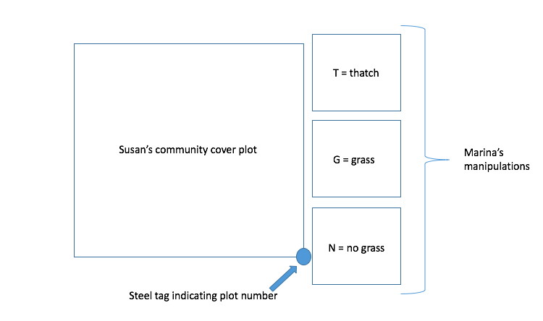Data columns
   1. t.in – total tagged inside the quadrant in which that species was planted
   2. t.out – total tagged outside the quadrant in which that species was planted
   3. G.in – number germinated and tagged (up to 15) inside the quadrant in which that species was planted (only CETR)
   4. G.out - number germinated and tagged (up to 15, including G.in) outside the quadrant in which that species was planted (only CETR)
   5. d.in - number dead inside the quadrant in which that species was planted
   6. d.out - number dead outside the quadrant in which that species was planted
   7. T.in – number germinated above 15 inside the quadrant (only CETR)
   8. flo.A – number of tagged individuals with buds
   9. flo.B – number of tagged individuals with open flowers
   10. flo.C – number of tagged individuals with flowers that have gone to seed
   11. flo.1, flo.2, flo.3, flo.4, flo.5 – number of flowers on 5 randomly chosen individuals
   12. Notes – anything that needs to be recorded, visual damage to plot, herbivory etc
2. Getting situated
   1. All of the plots I am using are marked with a pink flag. In general flag colors correspond to the treatment
      1. All red flags: watering control plot
      2. 3 red + 1 blue flag: watered plot
      3. White flags: rain-out shelter or shelter control plots
   2. Within each plot are three competition treatments subplots
      1. T = grass thatch (green nails)
      2. G = grass presence (orange nails)
      3. N = no grass (purple nails)
   3. Plots are numbered with a steel tag on the lower right rebar of the main community plot, when you arrive at a plot, check this number to record
   4. 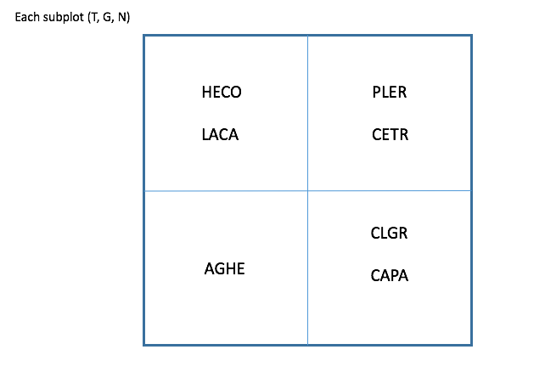Species are seeded into quadrants **within each subplot** to make it a little easier to identify
3. Upon arriving at a plot and after checking the plot number
   1. Remove grass and extraneous species from T and N subplots
   2. Remove extraneous species from G subplot
   3. For each species
      1. Only tag/record new germs for CETR
      2. Check for mortality by counting off toothpicks and seeing if there is a living individual of that species near the toothpick; if there isn’t, remove the toothpick and record total number that died under “n.died”
      3. Record flowering (go by whatever flower is in the latest stage)
         1. Flo.A – number of individuals with buds
         2. Flo.B – number of individuals with open flowers
         3. Flo.C – number of individuals setting seed
      4. Record flower number (flo.1-flo.5)
         1. For 5 random individuals, record the number of flowers per individual

|  |  |  |
| --- | --- | --- |
| **Species** | **Toothpick color** | **Flowering?** |
| Agoseris heterophylla (AGHE) | White | Yes |
| Clarkia purpurea (CLPU) | Green | No |
| Hemizonia congesta (HECO) | Yellow | No |
| Lasthenia californica (LACA) | Red | Yes |
| Centaurium trichanthum (CETR) | Pink | No |
| Plantago erecta (PLER) | Orange | Yes |
| Calycadenia pauciflora (CAPA) | Blue | No |

Species Info:

