Invasive species reduce the relative success of drought-avoiding plant species under a variable climate
Marina L LaForgia¹*, Susan P. Harrison² & Andrew M. Latimer³

¹Dept. of Plant Sciences, University of California, Davis, One Shields Drive, Davis, CA 95616; Tel: (805) 279-8803; marina.laforgia@gmail.com
²Dept. of Environmental Science and Policy, University of California, Davis; spharrison@ucdavis.edu
³Dept. of Plant Sciences, University of California, Davis; amlatimer@ucdavis.edu
*Corresponding author

Running title: Invaders reduce success in a variable climate

Key words: functional traits, competition, invasive species, climate change, drought tolerance, water use efficiency, relative growth rate, grassland

Type of article: Letter
Word Numbers: Abstract (); Main text (); Text box (NA)
Number of References:
Number of figures, tables, and text boxes:

Statement of Authorship: MLL conceived of, designed, and carried out the study. MLL performed analyses in collaboration with AML. MLL wrote the manuscript, AML and SPH contributed to manuscript content and revisions.
Abstract
Plants in climatically variable environments have evolved drought tolerance and drought avoidance strategies to deal with inconsistent rainfall, but interactions with novel competitors can undermine the success of these strategies. To investigate how competition with invaders affects these strategies, we manipulated rainfall and invader presence and followed demographic rates of six species that varied in drought tolerance. We found that invader competition had a more negative effect on avoiders than on tolerators and this impact was strongest under drought, acting through increased mortality and lower seed set. Additionally, the interaction between watering and competition had a relatively stronger effect on tolerators by increasing mortality. Competition with invaders can thus make bad years worse and good years less good, harming the ability of some species to recover from climatic events, especially avoiders. This is the first study to examine how invasions might synergize with climatic fluctuations to create extinction debts.

Introduction
Competition between species can cause changes in the composition, relative abundance, and diversity of species within a community by altering responses to the abiotic environment (Goldberg & Barton 1992; Gremer et al. 2013; Thompson et al. 2018). In the absence of competition, all species benefit from a resource rich environment, but competition selects for species with certain traits that allow them to outcompete neighbors (Tilman 1977, Grime 1977). While interactions between coexisting species are typically weak (Adler et al. 2018), competition from novel invaders impose stronger biotic pressures on native species (Levine et al. 2003). Further, precipitation variability is expected to increase with climate change (IPCC 2013; Berg & Hall 2015; Yoon et al. 2015; Swain et al. 2016) and although plants have evolved strategies to deal with inconsistent rainfall in variable environments, interactions with novel competitors have the ability to magnify the effects of climate and undermine the success of those strategies (Bruno 2005; Tylianakis et al. 2008). These novel interactions can make previously inhabitable environments less suitable for native plants as they try to cope with the multiple stressors of invasive dominance and climate change (Rinnan 2018). Thus invasive species may be contributing to a mounting “extinction debt” (Gilbert & Levine 2013), leading to extinction in the long-term by weakening the ability of these species to deal with a fluctuating climate.
Annual plants in temporally fluctuating environments have two main strategies (Brown & Venable 1986; Angert et al. 2007), trading off between resource acquisition and resource conservation (Volaire 2017). Drought intolerant species, or drought avoiders, grow quickly and reproduce before resources become too scarce to avoid seasonal drought, or remain dormant belowground to avoid longer, multi-year periods of drought. Conversely, Drought tolerators grow more slowly to develop deeper root systems and hardier leaves that help to increase their survival during harsh drought periods. While drought avoiders typically have traits associated with faster-growing species such as high specific leaf area (SLA; leaf area/mass), low water use efficiency (WUE), high relative growth rate (RGR), smaller seeds, and shallower rooting depth, drought tolerators tend towards the opposite traits (Angert et al. 2007), caplan et al 2018, others). These contrasting strategies are a precursor for coexistence in temporally variable systems (Angert et al. 2009), as avoiders excel at competing for light in favorably wet years due to their faster growth rates while tolerators are better at surviving during unfavorably dry years due to higher WUE (Angert et al. 2009; Kimball et al. 2012; Gremer et al. 2013). While there is substantial work on linking functional trait to competitive abilities (Grotkopp et al. 2002; Kunstler et al. 2012; Godoy & Levine 2014; Funk & Wolf 2016) and climate (Poorter et al. 2008; Kimball et al. 2016; LaForgia et al. 2018), how novel competitors affect the relative ability of these opposing strategies to withstand changing rainfall patterns remains uncertain.
Interactions with dominant invaders can alter the benefits of these strategies in various ways. For instance, the direct effects of aridification may favor drought tolerators when water is limiting (Penuelas et al. 2007; Báez et al. 2012; Hoover et al. 2014), but in high rainfall years when light becomes limiting, competition from invaders with higher RGRs might outweigh this otherwise favorable climate (Suttle et al. 2007), making this strategy less viable. Likewise, when water is limiting, competition with invaders might intensify the negative effects of drought, harming drought avoiders more than drought alone (ref). In this way, interactions with invaders can make “good years” less good, and “bad years” even worse for species with the fast-growing, drought-avoiding strategy relative to the slow-growing, drought-tolerant strategy.
California annual grasslands are a variable environment where highly diverse but less abundant native annual forbs compete with novel exotic annual grasses, the dominant functional group in this system known for their high relative growth rates and strong competitive abilities. At our annual grassland study site in northern California, we have already observed significant changes in the plant community in response to rainfall. Native annual forb diversity, led by drought avoiding high-SLA forbs, undergone long-term decline as a result of elevated seedling mortality caused by drier winters (Harrison et al. 2015, 2017; Harrison & LaForgia 2019). While it is possible that such declines also occurred in the distant past, it is alternatively possible that the arrival of exotic annual grasses since the early 19th century has reduced the resilience of this community to its fluctuating environment. During the extreme drought of 2012-2014, native annual forb abundance in the seed bank increased while dominant exotic annual grasses decreased substantially both in cover aboveground and seed abundance in the seed bank (Copeland et al. 2016; LaForgia et al. 2018), suggesting that forbs benefitted during the drought from the reduced grass competition. While all forbs increased in abundance in the seed bank, drought tolerant forbs increased more than twice as much as drought avoidant forbs, suggesting that the strength of these interactive effects vary by drought tolerance (LaForgia et al 2018).
We predicted that invasive annual grasses will have differential effects on the relative success of drought avoiding and drought tolerant native annual forbs, and that these differential effects will be most strongly manifested under exacerbated water stress. We tested this using demographic analyses of six native annuals planted into plots where water supply was increased by watering or decreased by shelters and grass competition was either maintained or removed.
Compared with drought tolerators, we expected drought avoiders to be affected more negatively by drought, more positively by watering, and more negatively by grass competition under drought than under watering. Compared with drought avoiders, we expected drought tolerators to be affected less negatively by drought, less positively by watering, and more negatively by grass competition under watering than under drought.
Materials and methods
Field Site
This study took place in an annual-dominated grassland at the University of California McLaughlin Natural Reserve (https://naturalreserves.ucdavis.edu/mclaughlin-reserve) in the Inner North Coast Range (N 38°52’, W 122°26’). The site has a Mediterranean climate with cool, wet winters and dry, hot summers with a 30-yr average annual precipitation of 732 mm. Plant biomass in this community is dominated by exotic (Eurasian) annual grasses with a smaller component of native and exotic annual forbs that germinate in the fall (Oct-Dec) shortly after rains begin, are present as seedlings during the winter (Dec-Feb), and flower in spring (Mar-May) with a few species flowering later in the summer (Jun-Sep).
Watering experiment
The experiment was conducted on a hillside of the reserve with deep, serpentine-derived soils (high Mg, low Ca) over the course of two growing seasons. In spring 2015, 10 watered plots were established along three watering lines emanating from a rainfall catchment system with each plot centered on a sprinkler that cast water over a 3-m radius (Mini Rotor Drip Emitters, Olson Irrigation, Santee, CA, USA). From 1 Dec – 1 Mar 2016 and 2017, at the end of any week in which rainfall fell below its 30-year average for the week, sprinklers operated for enough hours to bring natural plus supplemental rainfall up to the 30-year weekly average. Natural rainfall was reported by the Knoxville Creek weather station of the Western Regional Climate Center (www.wrcc.dri.edu/cgi-bin/rawMAIN.pl?caCKNO), near the center of our study landscape. Supplemental rainfall was estimated by hours of watering times the measured application rate of 25 mm h⁻¹.
Also in spring 2015, 10 sheltered plots were set up interspersed with watered plots. These 3 x 3 m drought shelters were constructed following the design of DroughtNet (wp.natsci.colostate.edu/droughtnet) except that the removable roofs intercepted 100% of rainfall. Roofs were placed on the shelters from approximately 1 December to 1 March 2016 and 2017 to reduce winter rainfall, the period when roughly 60% of annual precipitation occurs. Natural rainfall during the 2015-2016 year was close to average at 701.26 mm while the 2016-2017 year was one the wettest years recorded in California, with rainfall at our site totaling 1297.87 mm. Shelters were not effective in this extremely high rainfall year, so we focus our analysis on drought effects in 2015-2016 and watering effects in both years. Ten control plots with ambient rainfall were interspersed with treatment plots and all plots were > 4 m from each other.
Nested within each plot we placed two 30 x 30 cm subplots in which to track native annual forb vital rates with and without grass removal. Throughout each growing season, one subplot in each plot was weeded monthly of all background species to estimate demographic rates of forbs in the absence of grasses (“no grass” treatment) and the second subplot was weeded monthly to remove only background forb species, allowing the abundant grasses in the area to germinate and grow naturally (“grass” treatment). Dominant exotic grasses in our study site included Avena fatua, Festuca perennis, Bromus hordeaceus, and Elymus caput-medusae.
Demographic data collection
Six common native forbs were chosen based on seed availability and SLA (Table 1). In the fall of 2015 and 2016, just before the first significant rainfall event, aboveground vegetation from both subplots was clipped and 50 - 100 seeds of each species were sown into each subplot. For the 2015-2016 year, species included Agoseris hererophylla, Clarkia purpurea, Lasthenia californica, Plantago erecta, and Hemizonia congesta. During the 2016-2017 year, we added a sixth species, Calycadenia pauciflora.
We counted number of germinants before thinning all subplots to ≤ 20 individuals per species, each marked with a toothpick. Throughout the growing season, plots were visited 1-2 times a month and monitored for further germination and mortality.
To estimate seed set, flowers were counted on 1-5 individuals per species and seeds were counted on 1-30 flowers per species in each subplot; these means were multiplied to obtain a subplot-level estimate of seeds per individual.
To measure belowground seed survival we buried one mesh bag per species, filled with 50-100 seeds mixed with sand, 5-10 cm belowground in each plot prior to the onset of fall rains. We dug up the bags the following summer and counted the number of viable seeds by inspecting embryos under a dissecting scope. Seeds were tested for viability in a growth chamber to adjust number of viable seeds in our estimates of germination rates, seed set, and belowground seed survival.
Functional Strategy Measurement
To characterize the drought strategies of our species we measured relative growth rate (RGR) and water use efficiency (WUE), two, two key performance measures that are correlated with widely studied morphological traits (SLA, seed size, and specific root length) and that have been strongly linked to demographic rate changes in other annual systems (Huxman, Kimball, Angert papers etc). To quantify RGR, we monitored total leaf area accumulation over the 2016-2017 growing season. Two individuals per species were tagged in control plots just after germination. Leaves were counted monthly, their sizes were recorded as small, average, or large, and the length and width of a leaf representative of each size class was measured. From this we calculated total leaf area and parameterized standard models describing leaf area accumulation over time (Paine et al. 2012). To quantify WUE we used leaf carbon isotope discrimination (Dawson et al. 2002). Just before peak flowering, young but fully mature leaves from five individuals per species were collected, dried, ground, and analyzed at the UC Davis Stable Isotope Facility (https://stableisotopefacility.ucdavis.edu/). Carbon isotope delta values were converted to discrimination (∆, ⁰/₀₀) by the equation:
∆ = (δa - δp)/(1 + δp/1000)
(Farquhar et al. 1989) where δa is the carbon isotope ratio of CO2 in the atmosphere (-8 ppm, ⁰/₀₀) and δp is the measured relative delta value of carbon isotope found in leaf tissue. Lower ∆ indicates higher integrated WUE (Farquhar et al. 1989; Seibt et al. 2008).
The six species showed the standard strong tradeoff between these two measures, with L. californica, A. heterophylla, and P. erecta displaying the high RGR and low WUE typical of drought avoiders, and C. pupurea, C. pauciflora, and H. congesta having the low RGR and high WUE of drought tolerators (Fig. 1). As a single index of drought tolerance we used the first axis of a principal components analysis on RGR and WUE, which explained 90% of the variation. This index clearly separated the drought avoiders (negative values) and drought tolerators (positive values), which also differed in SLA in the expected direction (Table 1).
Analyses
To test how annual grass competition interacted with water and drought treatments to affect the relative success of avoiders and tolerators, we estimated per capita growth rates (λ) from individual vital rate models in each treatment combination. To understand the causes of changes in λ , we conducted parallel analyses on individual vital rates.
We first built individual vital rate models for mortality, seed set, and germination. For mortality, we used generalized linear mixed effect models with a binomial response variable reflecting success (number dead) and failures (number survived), and included watering treatment, grass treatment, PC score, and their interactions as our predictors and a random intercept for species nested within plots within years. For seed set, log-transformed values were modeled with watering treatment, grass treatment, PC score, and all two way interactions as predictors. This model was determined through AIC to be better than a model that included the three-way interactions. We also included a random intercept for species nested within plots within years. We did not analyze treatment effects on germination, since grasses were absent and watering treatments not yet initiated at the time of germination. Instead, germination rates were modeled using a binomial model with PC score as the only predictor and a random intercept for each species nested in subplots within plots within years.
We then used individual vital rate models to estimate parameter distributions for each watering/grass/species combination using 1000 simulated bootstraps for each model with the bootMer function in the lme4 library (Bates et al. 2015). We constructed simulated per capita growth rate values by sampling from these bootstrapped distributions of individual rates and calculating per capita growth rate, λ, for each species in each treatment combination using the annual plant model, adapted from Levine et al. (2008):
λ = s(1 – g) + g(1-m)F
where s is the annual seed survival rate, g is the proportion of germinated seeds, m is the mortality rate, and F is the number of viable seeds produced per survived germinant. Seed survival varied strongly among species but not among plots or by drought tolerance (Table 1), so we used species-level seed survival estimates in the calculation of λ. The first term thus describes the contribution of the seed bank to the annual per capita growth rate while the second term is the per-seed production of germinated individuals. Values of λ were log-transformed to meet assumptions of normality and modeled with watering treatment, grass treatment, drought tolerance and their interactions as predictors. All data analyses were done in R version 3.4.4 (R Core Team 2018).
Results
Effects of competition and climate on λ in avoiders and tolerators
In the absence of grass competition, drought avoiders had higher λ values than drought tolerators, although this advantage was substantially diminished under the drought treatment compared to the control or watered treatments (Fig. 2; Table 2). However, grass competition not only reduced λ considerably for all species under all treatments, but as predicted, exerted an especially negative effect on avoiders under the drought treatment. In watered plots, the presence of grass competition largely eliminated the small positive effect of watering on λ, and again as predicted, this interactive effect was marginally stronger on drought tolerators than drought avoiders.
Effects of competition and climate on individual vital rates in avoiders vs. tolerators
Changes in λ were predominantly driven by mortality, which varied by drought strategy and in response to the interacting treatments (Fig. 3; Table 3a). Mortality was significantly higher in tolerators than avoiders except in the drought and grass removal treatment, where avoiders were more negatively affected by drought than tolerators. The drought and grass competition treatment caused the highest mortality in all species, but this effect was also strongest in avoiders. In the watering treatment, mortality was reduced in tolerators but only in the absence of grass, while watering had little effect on mortality in avoiders.
Seed set responded primarily to grass removal, with avoiders responding more than tolerators, and responding more strongly under drought (Fig. 4; Table 3b). Grass removal only affected tolerators when interacting with drought.
Germination was linked to drought tolerance; species with higher drought tolerance had significantly lower germination rates (est = -0.24, z = -3.34, p < 0.001).
Discussion
As predicted, we found that grass competition had a more negative effect on avoiders than on tolerators, and this was strongest in the drought treatment. Though these species are adapted to drought, competition with novel invaders intensified the negative effects of drought stress leading to lower per capita growth rates across species with avoiders suffering the largest declines. These findings underscore that the long-term decline in high SLA species observed in this system (Harrison et al. 2015, 2017) is neither a normal fluctuation nor strictly a consequence of a drier climate, but rather a result of competition with invasive grasses inhibiting these species’ abilities to cope with fluctuating climates, especially drought. While species of both strategies responded less strongly to the watering treatment than to the drought treatment, the watering-grass interaction had a relatively stronger effect on tolerators as predicted. Population growth rates of both tolerators and avoiders were higher in watered plots, but competition with grasses limited growth rates of tolerators more than avoiders. Similarly, in Sonoran Desert annuals, the interaction of competition and water affected slow-growing drought tolerators more than fast-growing drought avoiders (Gremer et al. 2013). Together, our results corroborate that competition with invasive grasses is depressing the population growth rates of all species and it effects are disproportionately strong for avoider species in dry years.
Mortality was the main driver of changes in per capita population growth rates, with smaller changes in seed set reinforcing these responses. Grass competition intensified the negative effects of drought by causing both increased mortality and lower seed set, ultimately leading to lower growth rates in all species, but with the strongest effects on avoiders, again consistent with results in Sonoran Desert annuals (Gremer et al. (2013). Though both drought-induced mortality (Harrison et al 2017, others) and lower seed set in the presence of competitors (MacDougall & Turkington 2005, Goldberg et al. 2001, Latimer and Jacobs 2010) are well-documented, support for competition-induced mortality is less common (Thomson et al. 2018, Goldberg et al. 2001; but see Thomson et al. 2017). The competition-induced mortality that we found may have been driven by good germinating rains creating higher densities of plants (Thomson et al. 2018, Levine et al. 2008), which non-additively intensified drought-induced mortality later in the season. In watered plots, competitive pressure negated the beneficial effects of a higher resource environment for tolerators, while not affecting avoiders. In contrast to mortality, seed set was unaffected by either watering or its interaction with grass. Novel competition and its interaction with climate are thus more significant for avoiders, as they reduce fitness in multiple life stages while only affecting mortality in tolerators.
The responses of tolerators and avoiders to our treatments are qualitatively consistent with observed changes in this community, including the long-term decline in high-SLA (i.e. avoider) forbs (Harrison et al. 2015), and the increase in low-SLA (i.e., tolerator) forbs during the extreme drought of 2014 when grass cover was substantially reduced (Copeland et al. 2016; LaForgia et al. 2018). Our seemingly anomalous finding that tolerators had the highest growth rates in the drought treatment without grass may have resulted from the elevated winter temperatures under drought shelters (see Lucas et al. 2008). Our estimated lambda values were unrealistically high in absolute terms,, which probably reflects that we did not measure rates of seed removal by granivores, which are likely to be high but also extremely variable (Grasslands pg 186, Hobbs 1985) and which we presumed would be little affected by our treatments. Finally, per capita growth rates are likely sensitive to germination rates, which in turn are influenced by temperature after a large rainfall event (Levine) and thatch buildup (Reynolds, Thomson), both of which differentially affect tolerators and avoiders (Huang). The lack of drought early in the season may have induced higher numbers of plants to germinate than in an average drought year, however the pattern of fall rains followed by winter drought is becoming more prevalent (Harrison et al. 2015), and therefore these findings may actually better represent environmental response in future drought years (ref). Even with these high population growth rates, the relative changes in per capita growth rates we found reinforce the large interactive effect rainfall and competition has on the success of these strategies.
While avoiders are strongly negatively impacted by drought and grass, competitively dominant grasses limit tolerators’ abilities to take advantage of a higher water availability. The small but significant effect of grass competition on per capita growth rates in watered plots, driven by increased mortality in tolerators, affirms that competitively dominant grasses limit tolerators’ abilities to take advantage of a higher resource environment. This small negative effect can build up over time through lagged indirect effects that operate predominantly through thatch in this system (Levine and Rees, Dudney). The accumulation of grass thatch, caused by repeated wet years, has been shown to depress native forb germination (Thomson), leading to lower overall abundance, biomass, and seed set (Thomson papers, Suttle, Dudney). Multiple wet years in a row could amplify the negative interaction between grass and watering that we found, decreasing per capita growth rates of competition-intolerant tolerators more than avoiders. The distribution of extreme events across years will therefore influence which strategy is most affected by the interactive effects of climate and competition. When water is the main limiting resource, then the effects of drought, novel competition, and their interaction will be most severe on avoiders, hastening their decline through increased mortality and lower seed set. Alternatively, if invaders are mainly competing for light, then the effects of competition may be worst on the drought tolerators. The predicted aridification combined increased variability (Diffenbaugh 2015) point to avoiders being more harmed than tolerators, especially given avoiders’ strong response to a single year of competition under drought. Interestingly, grasses may actually decline as well under a drier climate, as previously documented in Copeland et al. (2016) and predicted to occur for temperate grasslands (Gherardi and Sala 2019), though whether this occurs before avoiders go extinct remains an active question.
While there are studies of climate-caused extinction debts (refs), and other studies of invasion-caused extinction debts (refs), this is the first study to examine how invasions might synergize with climatic fluctuations to create extinction debts. In this system we show that species previously adapted to variable rainfall might be unable to cope with these fluctuating climates due to competition with invaders. Before invasive grasses dominated these areas, avoiding or tolerating drought were sufficient strategies of dealing the infrequent rainfall, ultimately allowing both types of species to coexist (Angert). The arrival of competitively dominant invasive grasses however has altered the effectiveness of both of these strategies. While much of the research on plant drought-response strategies comes from desert and grassland annuals (Gremer/Venable/Huxman/Angert), the trade-off between fast resource acquisition in avoiders and resource conservation in tolerators is fundamental among plants (Reich et al 2014, Diaz et al 2004), and has been studied in various functional groups including tropical trees (Visser et al. 2018), herbaceous perennials (Adler), and shrubs (West et al 2007). As climate becomes increasingly variable in many regions of the world and species ranges shift, interactions with novel competitors will intensify the negative effects of bad years and reduce the benefits of good years, harming the ability of some species to recover from extreme events (Douda, Rinnan). Competition with invaders thus adds to an increasing extinction debt that interacts with climate change to detrimentally affect the future of these species.

Acknowledgements
We thank C. Koehler, P. Aigner, and J. Garlock for logistical support at the UC McLaughlin Reserve. We also thank countless undergraduates who have helped with prepping, censusing, counting, and processing samples both in the field and in the lab. Finally, we thank members of the Latimer Lab, who provided valuable discussions on several steps of the data analysis and drafts of the manuscript.

References

Table 1. Species used in the study along with their PC score (tradeoff between WUE and RGR), respective drought strategy, SLA (mm²/g), and seed survival rates.
Species | PC Score | Drought strategy | SLA | Seed Survival
Lasthenia californica | -1.63 | Avoider | 240.14 | 46%
Plantago erecta | -1.01 | Avoider | 130.66 | 83%
Agoseris heterophylla | -0.88 | Avoider | 413.55 | 1%
Clarkia purpurea | 0.61 | Tolerator | 87.04 | 56%
Hemizonia congesta | 1.38 | Tolerator | 64.05 | 43%
Calycadenia pauciflora | 1.55 | Tolerator | 54.56 | 54%

Table 2. Model results for treatment effects on per capita population growth rates for species.
 | Estimate | Std. Error | t value | p-value
(Intercept) | 2.07 | 0.01 | 174.59 | < | 0.001 | ***
Drought | 0.38 | 0.02 | 22.49 | < | 0.001 | ***
Watering | 0.21 | 0.02 | 12.35 | < | 0.001 | ***
Grass | -0.38 | 0.02 | -22.95 | < | 0.001 | ***
Tolerance | -0.52 | 0.01 | -54.28 | < | 0.001 | ***
Drought x Grass | -0.56 | 0.02 | -23.79 | < | 0.001 | ***
Watering x Grass | -0.08 | 0.02 | -3.30 |  | 0.003 | **
Drought x Tolerance | 0.37 | 0.01 | 27.05 | < | 0.001 | ***
Watering x Tolerance | 0.04 | 0.01 | 2.97 |  | 0.007 | **
Grass x Tolerance | 0.12 | 0.01 | 8.71 | < | 0.001 | ***
Drought x Grass x Tolerance | -0.07 | 0.02 | -3.67 |  | 0.001 | **
Watering x Grass x Tolerance | -0.04 | 0.02 | -2.22 |  | 0.036 | *

Table 3. Model results for treatment effects on (a) mortality and (b) seed set for each species.
(a) Mortality
 | Estimate | Std. Error | z value | p-value
(Intercept) | -1.02 | 0.13 | -8.17 | < | 0.001 | ***
Drought | 0.27 | 0.23 | 1.18 |  | 0.237
Watering | -0.36 | 0.17 | -2.09 |  | 0.037 | *
Grass | 0.22 | 0.08 | 2.65 |  | 0.008 | **
Tolerance | 0.83 | 0.11 | 7.77 |  | 0.000 | ***
Drought x Grass | 0.40 | 0.13 | 2.97 |  | 0.003 | **
Watering x Grass | 0.02 | 0.11 | 0.20 |  | 0.840
Drought x Tolerance | -0.73 | 0.20 | -3.59 | < | 0.001 | ***
Watering x Tolerance | -0.38 | 0.15 | -2.57 |  | 0.010 | *
Grass x Tolerance | 0.04 | 0.07 | 0.55 |  | 0.584
Drought x Grass x Tolerance | 0.21 | 0.13 | 1.68 |  | 0.093 | .
Watering x Grass x Tolerance | 0.25 | 0.10 | 2.48 |  | 0.013 | *
(b) Seed set
 | Estimate | Std. Error | t value | p-value
(Intercept) | 2.88 | 0.09 | 31.71 | < | 0.001 | ***
Drought | 0.44 | 0.17 | 2.54 |  | 0.012 | *
Watering | 0.10 | 0.13 | 0.81 |  | 0.417
Grass | -0.37 | 0.09 | -4.16 | < | 0.001 | ***
Tolerance | -0.23 | 0.07 | -3.23 |  | 0.001 | **
Drought x Grass | -0.48 | 0.17 | -2.84 |  | 0.005 | **
Watering x Grass | -0.07 | 0.12 | -0.55 |  | 0.584
Drought x Tolerance | 0.25 | 0.13 | 1.89 |  | 0.060 | .
Watering x Tolerance | -0.06 | 0.09 | -0.67 |  | 0.503
Grass x Tolerance | 0.13 | 0.05 | 2.72 |  | 0.007 | **

Figure Legends
- Species displayed a strong negative trade-off between relative growth rate (leaf area accumulation/time; cm⋅cm⁻¹⋅day⁻¹) and intrinsic water use efficiency (carbon isotope discrimination; ∆, ⁰/₀₀). Species abbreviations are the first two letters of the genus and specific epithet as described in Materials and Methods.
- Relationship between estimated per capita population growth rates of each species obtained through bootstrapped vital rates (y-axis) and drought tolerance measured as species’ loadings on PC1 (x-axis; see Table 1). Drought treatments in red, watered treatments in blue, and control treatments in yellow; estimates without grass (left) and with grass (right).
- Relationship between species level mortality rates (y-axis) and drought tolerance as measured by species’ loadings on PC1 (x-axis; see Table 1). (a) Drought treatments in red and (b) watering treatments in blue are split up into two panels for ease of viewing. Controls in yellow are thus the same in both panels. Mortality rates without grass (left) and with grass (right). Shown with bootstrapped 95% confidence intervals.
- Relationship between seed set per species (y-axis) and drought tolerance as measured by species’ loadings on PC1 (x-axis; see Table 1). (a) Drought treatments in red and (b) watering treatments in blue are split up into two panels for ease of viewing. Controls in yellow are thus the same in both panels. Seed set without grass (left) and with grass (right). Shown with bootstrapped 95% confidence intervals.

Figure 1. Trade-off in relative growth rate and water use efficiency
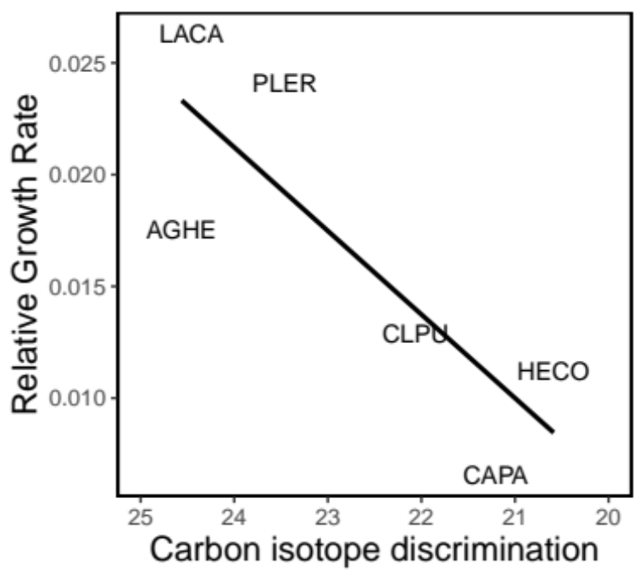

Figure 2. Per capita population growth rate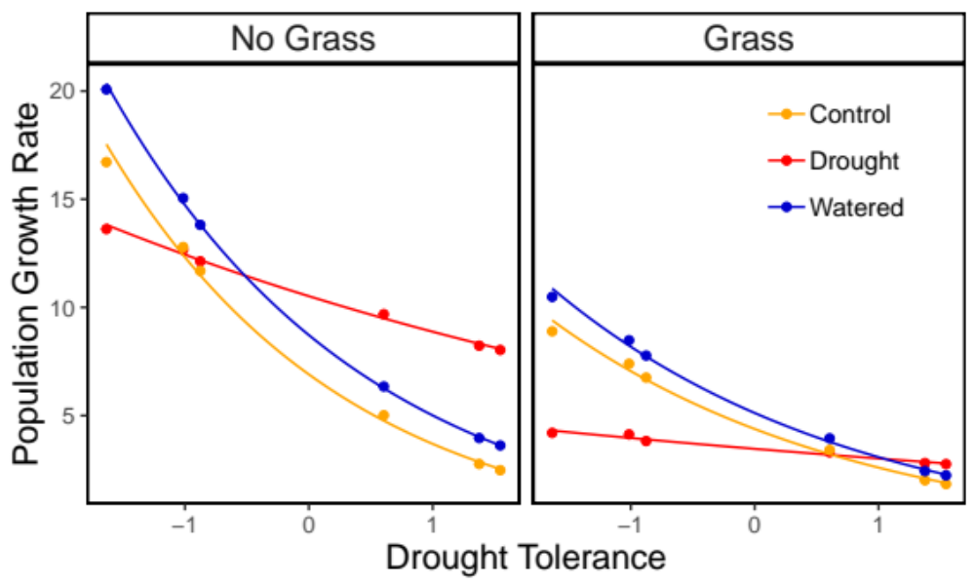

Figure 3. Mortality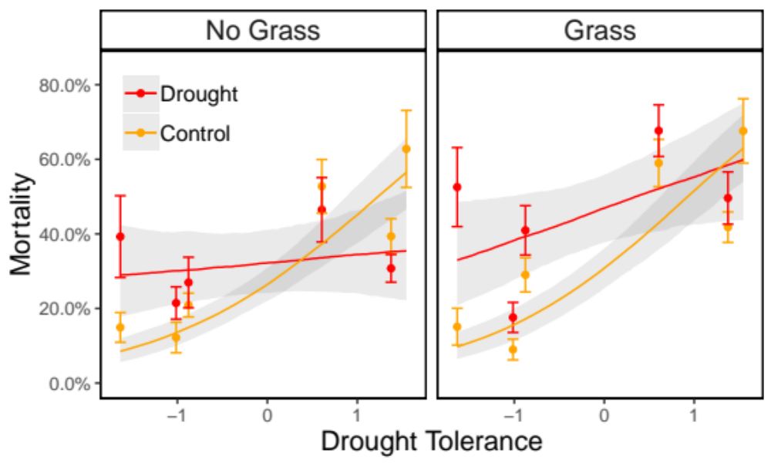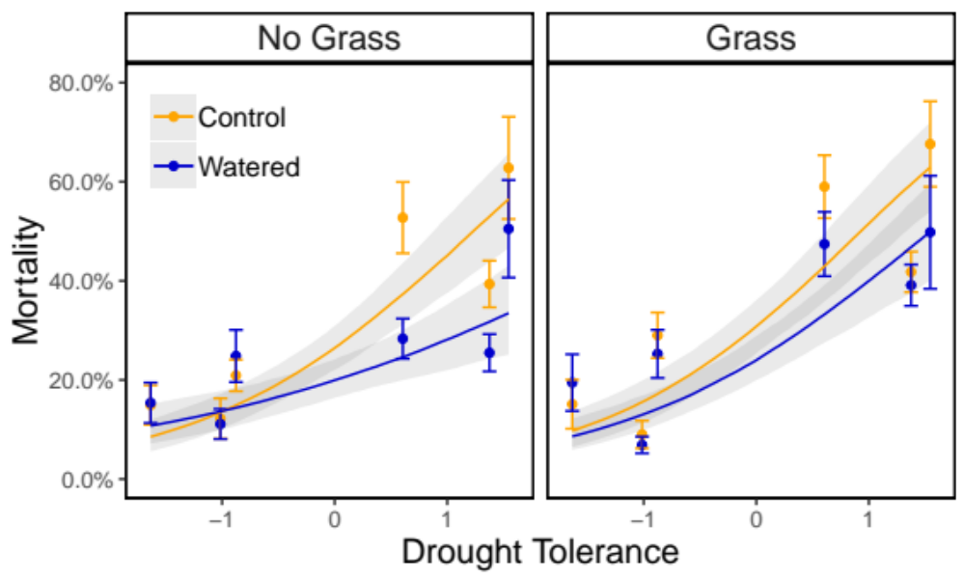

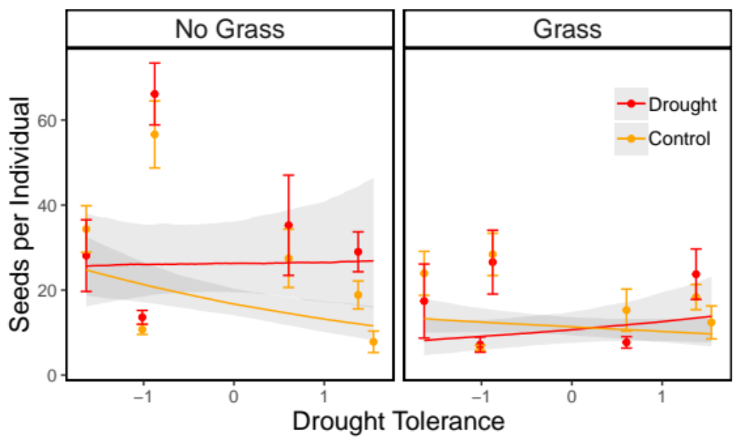
Figure 4. Seed Set

