**Faculty of Computers and Artificial Intelligence**

**Cairo University**

**Final Assessment Project**

**Course Title: Introduction to Database Systems (IS211)**

**Semester: Second Semester Date: May 2020**

**Instructors: Dr. Iman Hassan & Dr. Amani Hassan**

Transportation System Project

**Prepared by:**

|  |  |
| --- | --- |
| Student Name | ID |
| Habiba Amr Mohamed | 20180083 |
| Seif Mosaad Abd EL-Fattah | 20180128 |
| Marina Moheb Nafee | 20180208 |
| Ahmed Nabil Mohamed | 20180413 |



**Contents**

Chapter 1: Introduction …………………………………………………………… 3

1.1 Description of the project idea ………………………………………….. 3

1.2 Technology and tools used ……………………………………………… 3

Chapter 2: Analysis ……………………………………………………………….. 4

2.1 DB Conceptual ERD ……………………………………………………. 4

2.2 DB Physical ERD ……………………………………………………….. 5

2.3 Tables ……………………………………………………………………. 6

Chapter 3: SQL Queries + screenshots of the results ……………………………... 9

References ………………………………………………………………………… 12

# Chapter 1: Introduction

## Description of the project idea

This project idea aims to reduce the transport costs and improve delivery times through effective timetabling. It’s easy and user friendly we adds a lot of features to make it more efficient than others and more attractive , user can order any trip he/she want at any time without having any problem on timing/availability,…etc.

And also, the users can rate the drivers to improve the service and apply promocodes to get a satisfying discount on any trip.

We provide a lot of payment method with a high information security.

The user can request many trips in a day. Each driver has a unique id and may have more than one vehicle on the system. Each Trip has Payment Method, from/to Area Id, Payment Amount and may have a promo code. Each promo code has Expiry Date, Discount Amount, and a code. Each vehicle has license, Manufacturing Model/Date and Type.

## Technology and tools used

We used Microsoft SQL Server as a DBMS to create our project and to run our queries, to draw our Conceptual Model ERD we used Lucidchart website.

# Chapter 2: Analysis

## DB Conceptual ERD

We used a free website called Lucidchart it’s a free website which provides you a great template of a lot of diagrams, and we draw our ERD depends on Martin Style.

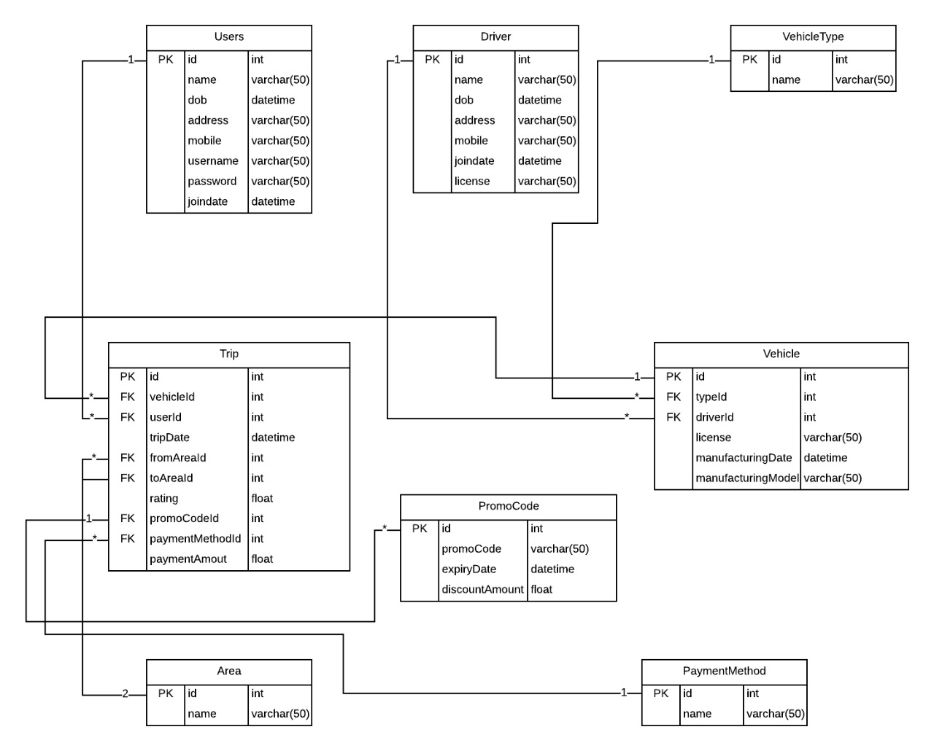

## DB Physical ERD

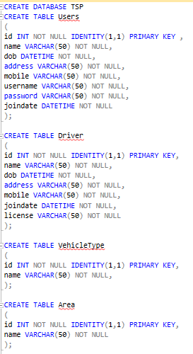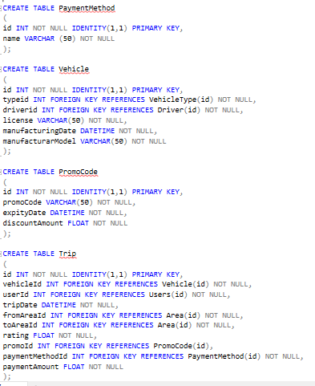

**2.3 Tables**

Drivers table

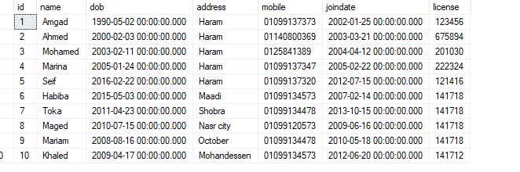

Area table Payment Method Vehicle Type

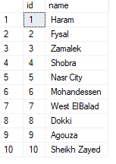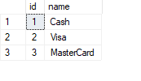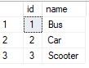

Users table

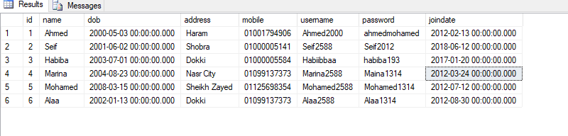

Promo Code Table

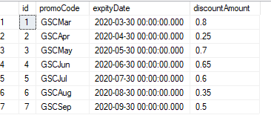

Vehicle Table

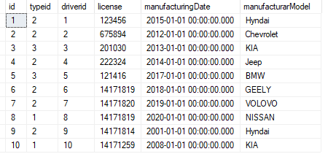

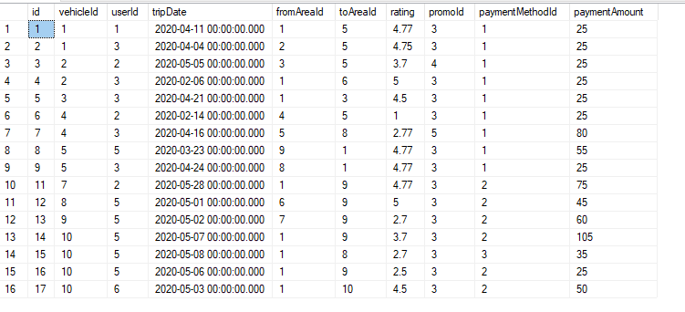Trip Table

# Chapter 3: SQL Queries + screenshots of the results

**Query 1:**

SELECT TOP 1 a.name as MostRideArea, COUNT(*) as NumberOfRides

FROM Trip as t

JOIN Area as a

ON t.toAreaId = a.Id

WHERE DATEPART(m, t.tripDate) = DATEPART(m, DATEADD(m, -1, getdate()))

AND DATEPART(yyyy, t.tripDate) = DATEPART(yyyy, DATEADD(m, -1, getdate()))

GROUP BY a.name

ORDER BY NumberOfRides Desc

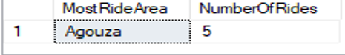

SELECT TOP 1 a.name as LeastRideArea, COUNT(*) as NumberOfRides

FROM Trip as t

JOIN Area as a

ON t.toAreaId = a.Id

WHERE DATEPART(m, t.tripDate) = DATEPART(m, DATEADD(m, -1, getdate()))

AND DATEPART(yyyy, t.tripDate) = DATEPART(yyyy, DATEADD(m, -1, getdate()))

GROUP BY a.name

ORDER BY NumberOfRides

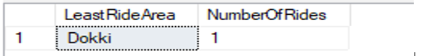

**Query 2:**

SELECT *

FROM (

SELECT d.name as DriverName, COUNT(*) as NumberOfRides

FROM Trip as t

JOIN Vehicle as v

ON t.vehicleId = v.Id

JOIN Driver as d

ON v.driverId = d.Id

GROUP BY d.name

HAVING count(*) = (select max(NumberOfRides) FROM (SELECT d.name as DriverName, COUNT(*) as NumberOfRides FROM Trip as t JOIN Vehicle as v ON t.vehicleId = v.Id JOIN Driver as d ON v.driverId = d.Id GROUP BY d.name) Trip)

) as cmobined



**Query 3:**

SELECT d.id as DriverId,

d.name as DriverName,

d.address as DriverAddress,

d.dob as DriverDateOfBirth,

d.mobile as DriverMobileNumber,

d.license as DriverLicense,

d.joindate as DriverJoinDate,

**count(*) as DriverNumOfRides**

FROM Driver as d

JOIN Vehicle as v

ON d.id = v.driverId

JOIN Trip as t

ON v.Id = t.vehicleId

GROUP BY d.id, d.name, d.address, d.dob, d.mobile, d.license, d.joindate;

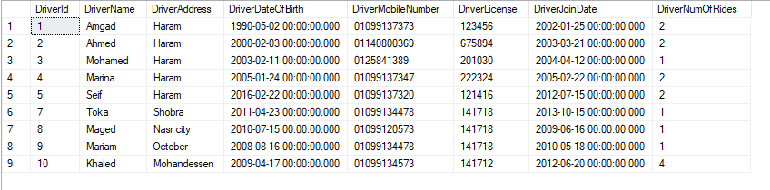

**Query 4:**

SELECT innerq.dname as DriverName

FROM (SELECT d.name as dname, count(*) as nor, SUM(t.rating) as nor1

FROM Driver as d

JOIN Vehicle as v

ON d.id = v.driverId

JOIN Trip as t

ON v.Id = t.vehicleId

GROUP BY d.name

HAVING SUM(t.rating) >= 4.5 * count(*)) as innerq

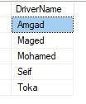

**Query 5:**

SELECT d.Id as DriverId, d.name as DriverName

FROM Driver d

WHERE NOT EXISTS (SELECT t.Id FROM Vehicle as v JOIN Trip as t ON v.Id = t.vehicleId

WHERE v.driverId = d.Id

AND DATEPART(m, t.tripDate) = DATEPART(m, DATEADD(m, -1, getdate()))

AND DATEPART(yyyy, t.tripDate) = DATEPART(yyyy, DATEADD(m, -1, getdate())))

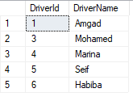

**Query 6:**

SELECT *

FROM (

SELECT vt.name as VehicleType, COUNT(*) as NumberOfRequests

FROM VehicleType as vt

JOIN Vehicle as v

ON vt.Id = v.typeId

JOIN Trip as t

ON v.Id = t.vehicleId

WHERE DATEPART(m, t.tripDate) = DATEPART(m, DATEADD(m, -1, getdate()))

AND DATEPART(yyyy, t.tripDate) = DATEPART(yyyy, DATEADD(m, -1, getdate()))

GROUP BY vt.name

HAVING count(*) = (select max(NumberOfRequests) FROM (SELECT vt.name as VehicleType, COUNT(*) as NumberOfRequests FROM VehicleType as vt JOIN Vehicle as v ON vt.Id = v.typeId JOIN Trip as t ON v.Id = t.vehicleId WHERE DATEPART(m, t.tripDate) = DATEPART(m, DATEADD(m, -1, getdate())) AND DATEPART(yyyy, t.tripDate) = DATEPART(yyyy, DATEADD(m, -1, getdate())) GROUP BY vt.name) Trip)

) as combined



# References

* [https://www.smartdraw.com/entity-relationship-diagram](https://www.smartdraw.com/entity-relationship-diagram/)
* [https://www.lucidchart.com](https://www.lucidchart.com/pages/landing?utm_source=google&utm_medium=cpc&utm_campaign=en_tier3_desktop_branded_x_exact_lucidchart&km_CPC_CampaignId=1484560207&km_CPC_AdGroupID=60168113951&km_CPC_Keyword=lucid%20chart&km_CPC_MatchType=e&km_CPC_ExtensionID=&km_CPC_Network=g&km_CPC_AdPosition=&km_CPC_Creative=354596054341&km_CPC_TargetID=kwd-55720648523&km_CPC_Country=21468&km_CPC_Device=c&km_CPC_placement=&km_CPC_target=&mkwid=sHItfOEwL_pcrid_354596054341_pkw_lucid%20chart_pmt_e_pdv_c_slid__pgrid_60168113951_ptaid_kwd-55720648523_&gclid=CjwKCAjwztL2BRATEiwAvnALcu9M_YU6I4f28eyzjgasEwXJHqHI0PQp8F-mYVRHNTDu4hfSv0CXWBoC1ikQAvD_BwE)
* [https://stackoverflow.com](https://stackoverflow.com/)
* [https://ar.quora.com](https://ar.quora.com/)