**Project Data Analysis with power bi**

* What is the overall churn rate?

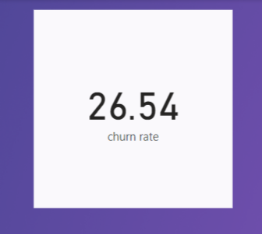

* Which contract type (e.g., month-to-month, one year) has the highest churn rate?

month-to-month

* What is the average tenure of churned customers versus retained customers?

the average tenure of churned customers: 17.98

the average tenure of retained customers: 37.57

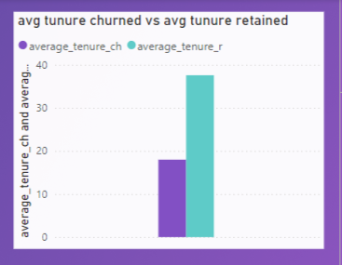

* What is the average of tenure across customers with different contract types?

* Do customers with certain Service types churn more frequently?

No, if you want to know the churn rate of services

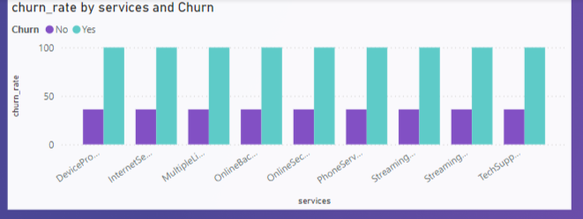

If you want to know the churn rate of only services that he used

* What is the average tenure for customers by gender and status?

* Is there a noticeable difference in churn between customers with dependents versus those without?

Yes, customers with dependents churned more than not

* Are there any trends for Churned and active customers over time?

Yes, more active in 2019 , more churned in Nov

* What are the average MonthlyCharges and TotalCharges for churned vs. retained customers?

* Do certain PaymentMethod types (e.g., Credit Card, Electronic Check) have higher churn rates?

Electronic check

* Do customers with multiple service subscriptions churn less than those with fewer subscriptions? Yes

* What are the key predictors of churn in the dataset?

Included in report

**Customer Churn Analysis Report**

**Overview of Churn Rate**

* The **overall churn rate** is **26.54%**, which means more than a quarter of the customers are leaving the company. This high churn rate is concerning and indicates the need for immediate action to improve customer retention.

**Key Insights and Factors Affecting Churn**

**2.Contract Type:**

* + Customers with a **month-to-month contract** have the highest churn rate. The flexibility of these contracts allows customers to leave easily, suggesting dissatisfaction with service quality or pricing.

1. **Dependents:**
   * Customers **without dependents** show a higher churn rate. These customers may have fewer obligations, making it easier for them to switch to competitors.
2. **Payment Method:**
   * Customers using **Electronic Check** for payments experience a higher churn rate. This may indicate:
     + Potential issues during the payment process.
     + Additional fees or inconvenience associated with this payment method.
3. **Service Subscriptions:**
   * Customers with **multiple services** tend to churn more frequently. This suggests dissatisfaction with bundled offerings or the complexity of managing multiple services.
4. **Online Security and Tech Support:**
   * Customers who subscribe to **Online Security** and **Tech Support** services have the **lowest churn rates**. These services may provide value or security that encourages retention.
5. **Churn Trends Over Time:**
   * Since the **beginning of 2024**, the churn rate has been **steadily increasing**. It's important to analyze what changes occurred at the start of the year to understand this trend.
   * The **lowest churn rate** was recorded in **2018**. Reviewing what services, pricing, or customer support strategies were available in 2018 (and have since changed) could provide insights into improving retention.

**Recommendations**

1. **Focus on Long-Term Contracts:**
   * Encourage customers to switch to **annual or longer-term contracts** by offering discounts or incentives.
2. **Improve Payment Methods:**
   * Investigate and resolve issues related to **Electronic Check** payments to ensure a smoother customer experience.
   * Motivate customers to switch to **Credit Card payments** instead of using **Electronic Check**
3. **Enhance Service Offerings:**
   * Promote **Online Security** and **Tech Support** services as part of customer retention strategies, as they correlate with lower churn rates.
4. **Analyze Changes from 2024:**
   * Identify what policies or service changes occurred in 2024 that may have led to the increasing churn rate.
5. **Learn from 2018:**
   * Study customer satisfaction and service offerings from 2018 to understand what contributed to the lower churn rate during that period.