Student ID: 103340660

Name: Marina Pajvancic

# Setup Screenshot

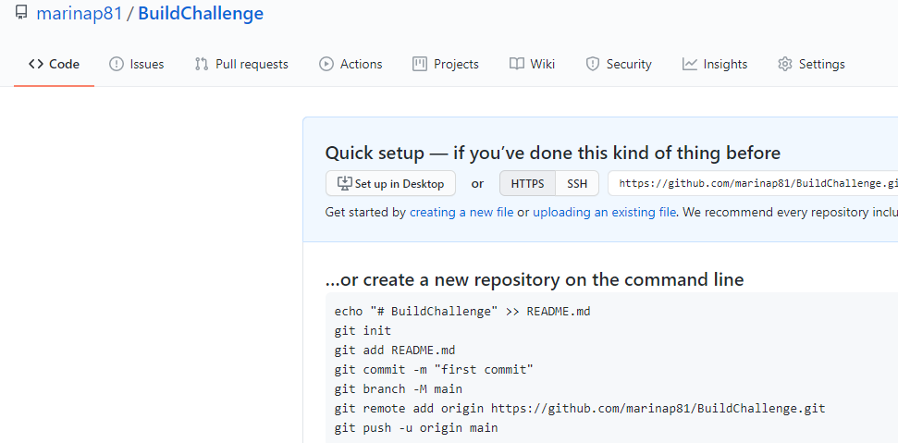

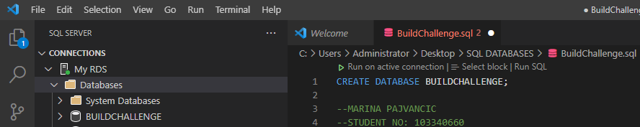

# Task 2 Screenshot

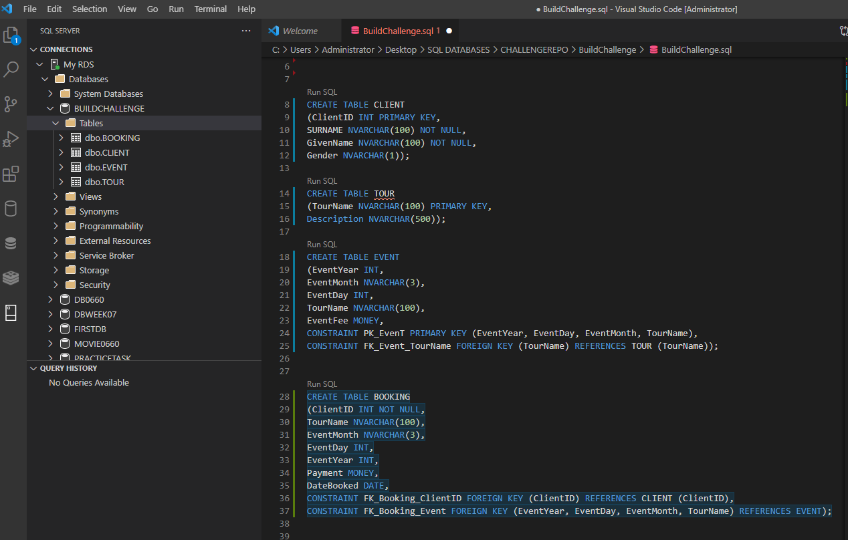

# Task 3 Screenshot

