Marina Perdiguero

IS361

John Ciarrochi

February 21, 2025

**Unit 6: Unit Lab Assignment**

1. **Write a SQL SELECT command to create the Faculty dimension table for the data-mart. You may only use the tables from the original transactional database for the small college.**

CREATE TABLE FACULTY_DIMENSION  
SELECT FacultyID, LastName, FirstName  
FROM FACULTY;

1. **Write a SQL SELECT command to create the Course dimension table for the data-mart. You may only use the tables from the original transactional database for the small college.**

CREATE TABLE COURSE_DIMENSION

SELECT CourseID, Name, CreditHours

FROM COURSE;

1. **Write a SQL SELECT command to create the Fact-Table for the data-mart. You may only use the tables from the original transactional database for the small college and the Time dimension from the data-mart (assume it was already created).**

CREATE TABLE FACT_TABLE

SELECT

TIME_DIMENSION.TimeID,

OFFERINGS.CourseID,

OFFERINGS.FacultyID,

AVG(OFFERINGS.Grade) AS Class_Grade_Average

FROM OFFERINGS

JOIN TIME_DIMENSION ON OFFERINGS.Semester = TIME_DIMENSION.Semester

GROUP BY TIME_DIMENSION.TimeID, OFFERINGS.CourseID, OFFERINGS.FacultyID;

1. **Design and draw a star-schema for a new data-mart that will keep track of the grades made by students in courses, This data-mart will have the same Time and Course Dimensions that the first data-mart shows, but it will also have a new Student dimension with information about a Student instead of the Faculty dimension. This information includes StudentID, names, major, and school. The Fact-Table will also change and it will hold the grade obtained by a student in a course in a semester.**

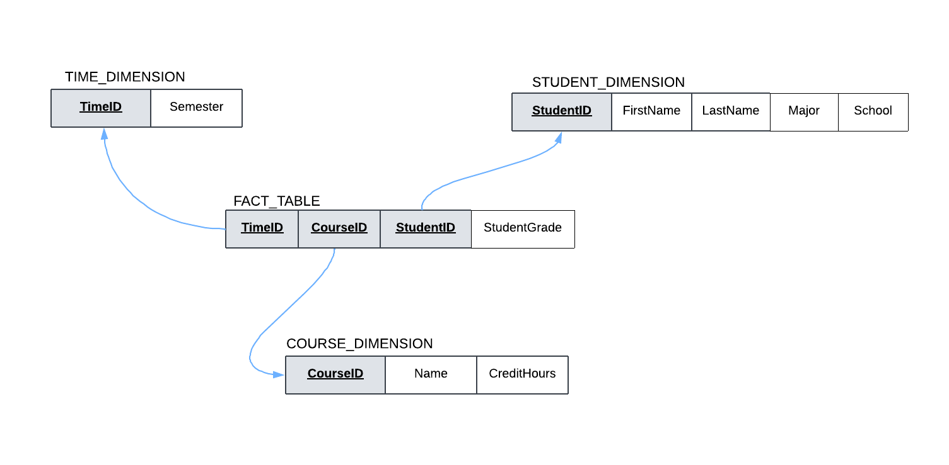

1. **Write a SQL SELECT command to create the Student dimension table for the new data-mart you designed. You may only use the tables from the original transactional database for the small college.**

CREATE TABLE STUDENT_DIMENSION

SELECT StudentID, FirstName, LastName, Major, School

FROM STUDENT;

1. **Write a SQL SELECT command to create the Fact-Table for the new data-mart you designed. You may only use the tables from the original transactional database for the small college and the Time dimension from the data-mart (assume it was already created).**

CREATE TABLE STUDENT_FACT_TABLE

SELECT

TIME_DIMENSION.TimeID,

OFFERINGS.CourseID,

OFFERINGS.StudentID,

OFFERINGS.Grade

FROM OFFERINGS

JOIN TIME_DIMENSION ON OFFERINGS.Semester = TIME_DIMENSION.Semester;