**Yemeni Americans Who Fought Trump’s Muslim Ban, Now Voted For Him**

December 3, 2024

By Marina Samuel and Mrwa Abbas

Yemeni-American bodega owners, once key organizers of a major strike against Trump’s travel ban in New York, have overwhelmingly shifted their support towards him, according to a series of interviews in Mott Haven and Melrose. South Bronx Yemeni community members cited issues like crime, the economy, and the Israel-Gaza war as reasons for their shift.

Despite prior vocal criticism of the Trump administration, most Yemeni Americans interviewed after the 2024 election said they voted for Trump. While no comprehensive polling focused on Yemeni American voters in New York, national exit polls by the Council on American-Islamic Relations (CAIR) showed Jill Stein receiving over 50% of the Muslim vote, with the rest evenly split between Trump and Harris.

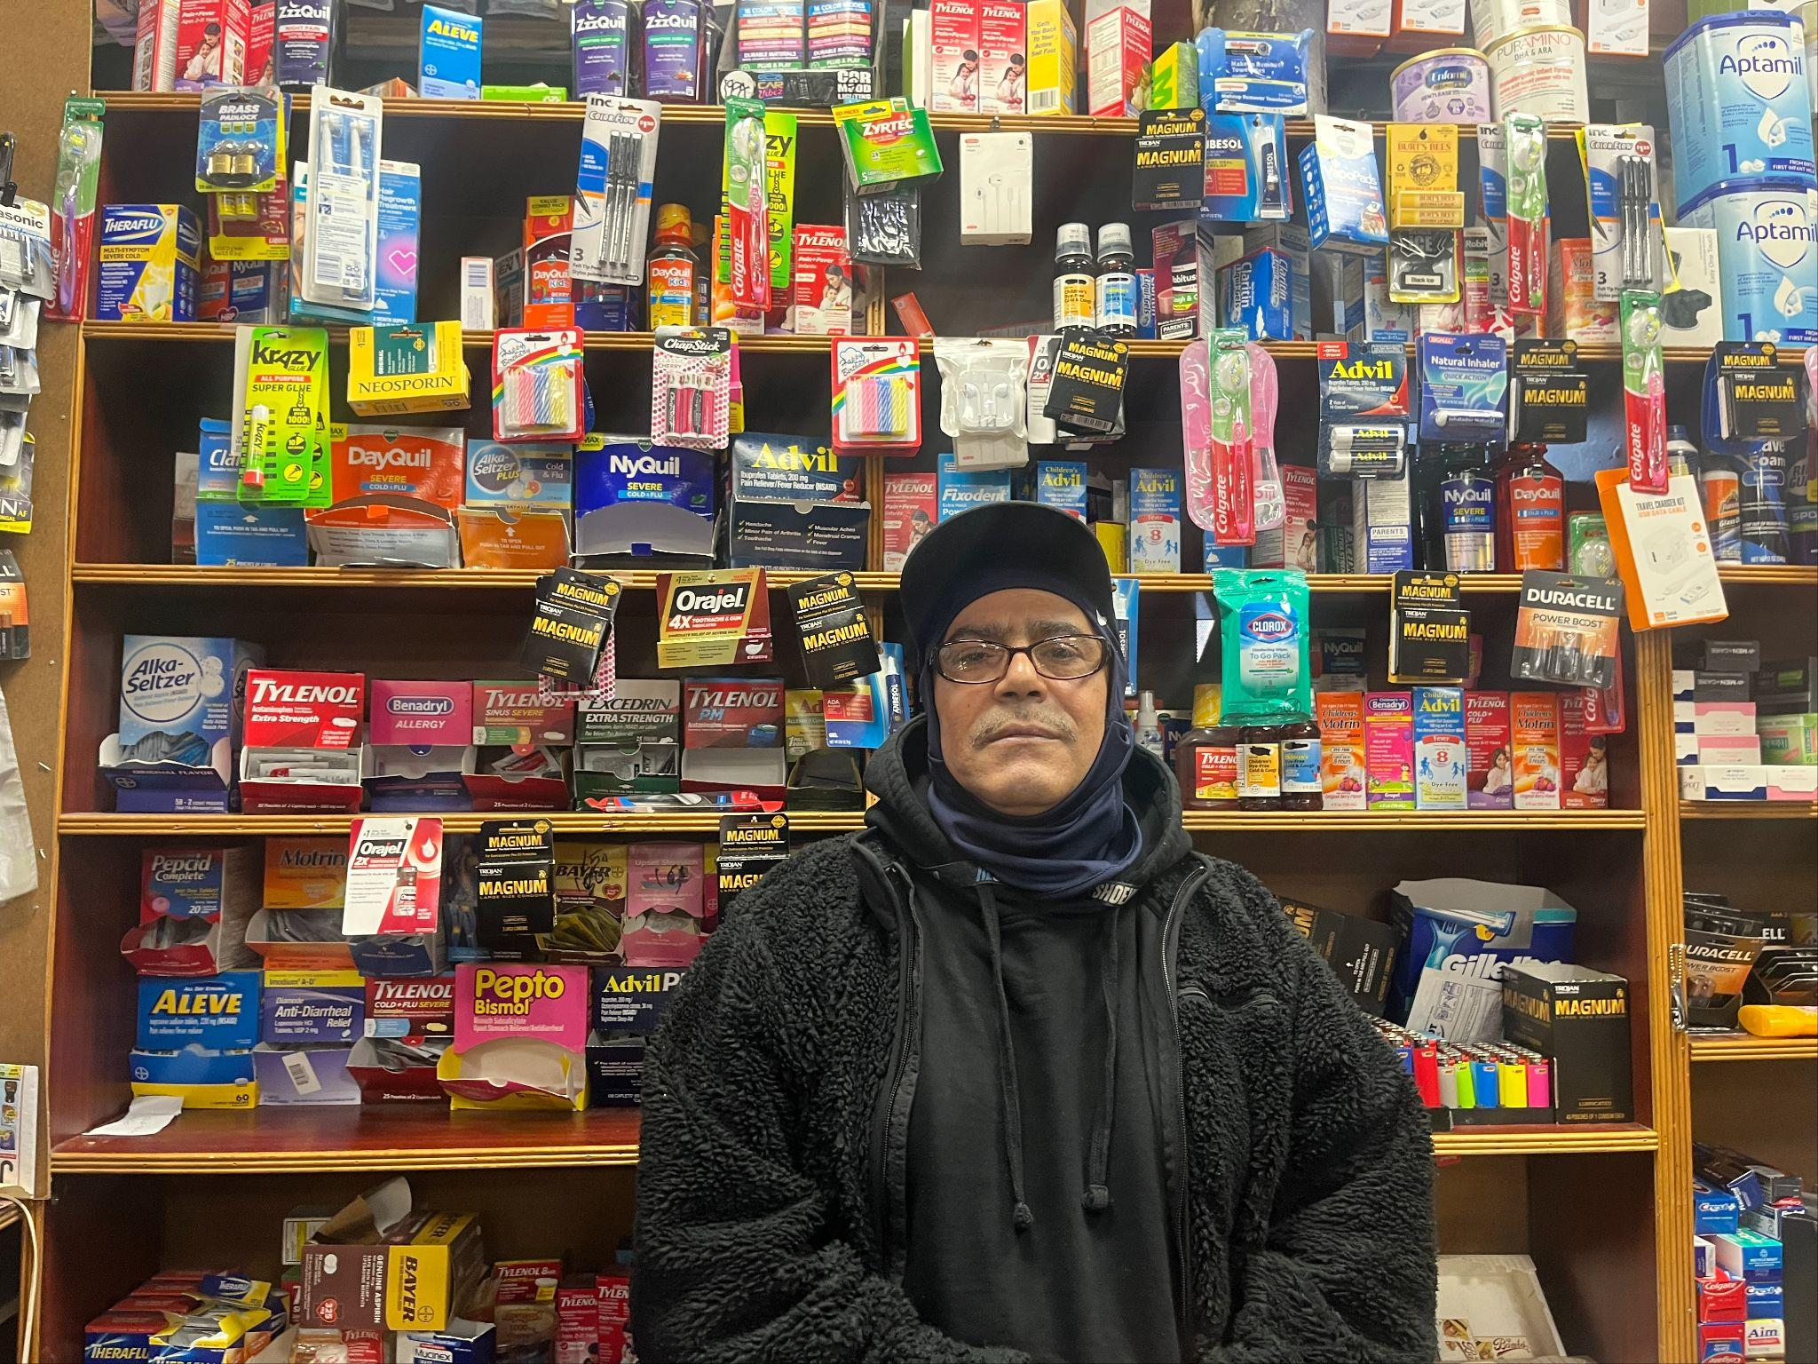

*Sammy Ali, 63, Bodega employee in Mott Haven, Originally from Yemen. Photo by Mrwa Abbas*

"Everything is getting expensive; we can't live. When Trump was president, everything was a little better," said Sammy Ali, an employee at a deli in Mott Haven, who mentioned that he and his family all voted for Trump.

The Yemeni community vehemently opposed one of the signature policies of Trump’s first presidency, [organizing a bodega strike](https://gothamist.com/food/yemeni-american-bodega-owners-will-close-thursday-to-protest-trumps-travel-ban) in 2017 and closing their shops for a day in protest against the “Muslim Ban,” a series of executive orders prohibiting immigration to the United States from seven predominantly Muslim countries, including Yemen.

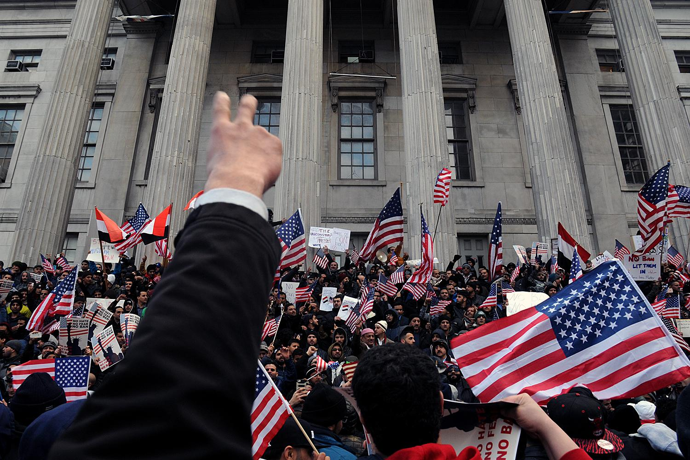

Caption: Yemeni bodega owners organized a rally outside Brooklyn Borough Hall in protest of President Donald Trump’s Muslim travel ban, Feb. 2, 2017. Credit: Ben Fractenberg/DNAinfo

At a [Republican donor event](https://time.com/7022828/trump-travel-ban-refugees-gaza/) in September, Trump claimed that he would reinstate a travel ban against countries he described as “terror infested areas like the Gaza Strip.” Despite these threats, several people who spoke to the Mott Haven Herald and Hunts Point Express did not believe that the travel restrictions would go into effect under his presidency.

“This time around, it seems more geared towards illegal immigration from South America, the Caribbean, and Africa but I don't think it stops at just them. It's a continuation of the same efforts and mindset of the 2016 administration,” said Gabriel Hernandez, community and external affairs manager of Yemeni American Merchants Association (YAMA). Still, he acknowledged that many members nonetheless threw their support to Trump.

“Yemenis are not a small community anymore,” said David Mozalem, owner of 2020 Deli and Convenience in Melrose. “We all shifted [towards Trump].”

YAMA estimates there are approximately 50,000 Yemenis in NYC with approximately 6,000 bodegas owned by Yemeni-Americans, more than half of the city’s total.

Mozalem, who has owned businesses for over 20 years, said he voted for Trump because his store was the target of three crimes in the past year, with one incident involving an assailant attacking his 16-year old son who was working as a cashier. He contacted the police for each incident but did not think their response was appropriate for the severity of the incidents.

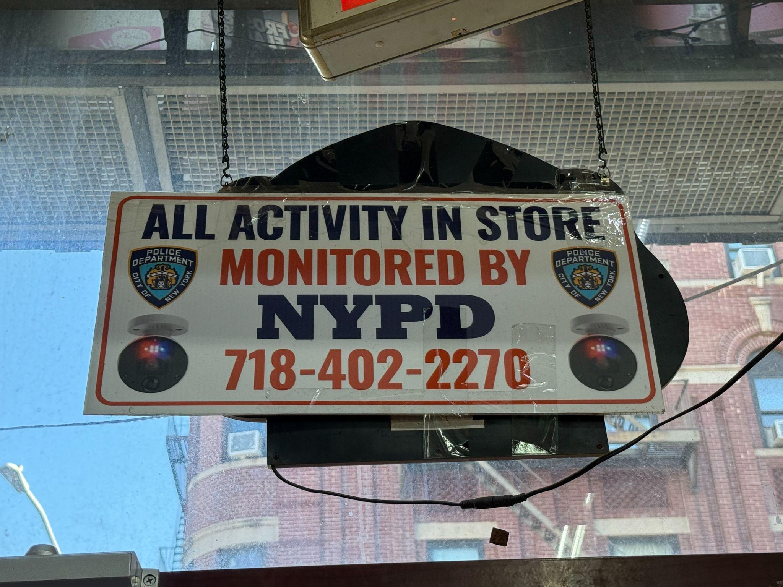

NYPD surveillance sign hanging in Mike’s Family Deli in Melrose. Photo by Marina Samuel

Bodegas are a central feature of any New York City neighborhood, providing groceries, hot food, and many everyday items in one place. Over the last 20 years, a majority of these bodegas have come under ownership of the Yemeni-American community, learning the trade from their Latino neighbors.

“Trump loves business,” said Ali Syed, owner of Brook Ave Convenience. His sales had been down in the last 2 years and attributed it to the poor economy during Biden’s presidency, resulting in him casting his vote for Trump in his first presidential election as a citizen.

His sentiments are shared by many, according to research conducted by the Council on Islamic American Relations. “In an August poll, CAIR found that 29% of Muslim voters identify as fiscally conservative, and another 25% identify as socially conservative,” explained Robert McCaw, director of CAIR’s National Government Affairs Department. The survey, conducted before the election and analyzed by University of West Georgia researchers, included responses from over 2,500 American Muslim voters.[Pew Research Center](https://www.pewresearch.org/religion/2017/07/26/demographic-portrait-of-muslim-americans/) estimates that at least 41% of Muslim Americans identify as white, which includes those who describe their race as Arab, Middle Eastern, or Persian/Iranian.

He further explained, “The number of fiscally conservative Muslim voters has remained relatively consistent over the past decade. However, we’ve observed a slight increase in support for the Republican Party during this time, which we attribute more to Biden and Harris's handling of the election than to a broader endorsement of the party. That said, a consistent 25 to 30% of Muslims have voted for the Republican Party for the past two decades.”

Before 2001, [Republican politicians courted Arab American voters](https://www.politico.com/magazine/story/2016/08/arab-american-muslim-vote-2016-trump-bush-dearborn-detroit-michigan-214134/), whose entrepreneurial and socially conservative values aligned with the party. It was only after 9/11, the U.S. invasion of Iraq and Afghanistan, the targeting of Arab and other Muslim Americans for detention, registration and the widespread government surveillance of Muslim religious institutions launched by President George W. Bush’s War on Terror, that the community’s relationship with the party faltered.

The Israel-Gaza war has been a huge deciding factor for Muslim and Arab voters in this election, with 81% Arab Americans identifying the conflict as a deciding factor in their vote, according to the [Arab American Institute](https://www.aaiusa.org/library/the-arab-american-vote-2024). Meanwhile, the Democratic Party has made conflicting statements of calls for a ceasefire while increasing military aid to the country.

Elzopide, an employee at Life Saver’s Deli in Mott Haven, who asked to only be referred to by his last name, said he voted for the first time along with his family for Trump.

“Trump said he was going to stop the war in Gaza. I don’t think Kamala meant it.”

Despite Trump’s stated support for Israel, many interviewees felt alienated by the Democratic Party’s failure to end the crisis in Gaza.

“I started to hate the Democrats because of Biden,” said Mo Obq, an employee at Good Mood Smoke and Deli, who did not vote.

Hernandez, of the Yemeni American Merchants Association said the turn to Trump was a measure of the community’s desperation. “What are we supposed to do if the one administration that's been here consistently doesn't make any steps forward?”