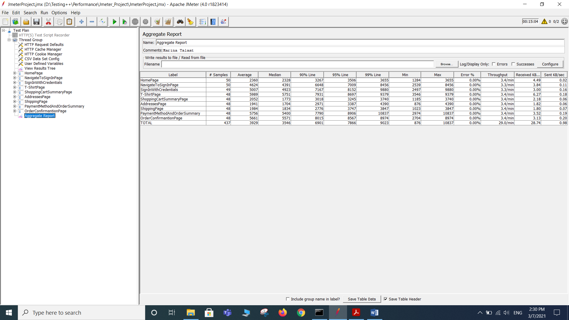

|  |  |
| --- | --- |
| **SLAs** | **Status** |
| 1. **The total error percentage for all samples must not exceed (10 %).** | **PASSED** |
| **2- At least 90% of the total issued requests must not exceed (15 seconds).** | **PASSED** |
| 1. **At least 99% of the “Sign in” requests must not exceed (4 seconds).** | **VIOLETED** |