**CST 2406 – System Analysis and Design Project**

**Marina Zheng**

Company Description--------------------------------------------------------------------------3-4

Scope Definition--------------------------------------------------------------------------------5

Problem Analysis-------------------------------------------------------------------------------6

Requirement Analysis--------------------------------------------------------------------------7-8

Logical Design----------------------------------------------------------------------------------9

Decision Analysis------------------------------------------------------------------------------10

Physical Design and Integration--------------------------------------------------------------11-15

Construction and Testing----------------------------------------------------------------------16-17

Installation and Delivery-----------------------------------------------------------------------18

Company Description

Gong Cha is an international Taiwan-style drink shop franchise. Since being established in 2006, the number of Gong Cha chain stores, in over 10 countries, has gradually increased over 1000 and keeps on blooming. Gong-Cha-USA, are the first Franchisee Company to bring the brand to the west coast of the United States, California. A year later, in 2014, Gong Cha USA Franchisee Company established on the east coast of the United States, New York. Both Gong-Cha-USA and Gong Cha USA is established by different owner, they are a separate Franchisee Company in the United States, of course both companies work with the support from Headquarter back in Taiwan.

Gong Cha USA on the east coast New York, currently, they have 6 stores in the metropolitan area, four in Manhattan, and two in Queens. The stores ranged from standard store to a mall store. Depend on the location, their business traffic varies, few are making high standard sales, and rest low on sales. Bases on the location traffics, number of employees on duty goes from 5-2 person per shifts, with AM and PM shifts each day. The majority of their hired employees is young college students working part-time.

As mentioned, sales vary between locations, some are doing better than others. Sales categorized into cash sales, credit sales, number of product/cups sold, hourly transaction sales. Hourly sales transaction goes from high $400 to low $20. Daily sales goes from high over $3000 to low $500. Annual sales goes from high $800,000 to low $370,000. Few locations are offering online transaction sales. The price of drinks by location also varies, stores located in Queens, and Chinatown is around.25-. 50cents cheaper, and the store tax is included in the menu price. Those other locations in Manhattan are priced menu price before tax.

All ingredients and about all supplies of the store are bought from headquarter back in Taiwan, the owner placed an order to be shipped overseas from Taiwan to United States monthly. Each location store place their inventory order weekly, few smaller and busier stores have to place two orders each week to the warehouse located in New York.

Currently, started this year, they are offering a franchise opportunity to other that wants to open their Gong Cha stores. The territories available for open development are NY, NJ, MA, and TX. I got news that new stores will be open in a few months in Brooklyn, other locations in Queens and Manhattan. It will be 6+n locations in the New York in a few more months, and more locations as stores open up in other states being under Gong Cha USA.

Scope Definition

Gong Cha USA in New York is a new establishment. This franchise expands relatively fast with new stores opening speediness. The company needed to be organized in the inventory control. The new system needed to be able to gather updated sales of each store, from which estimate the weekly delivery control to the individual stores. It should be able to identify the top profiting stores, which business owners can use those locations as model for new expansions. Also, able to calculate the different factors associate with low or under profiting stores.

For the new system to design, implement, and install, the overall process needs all info and pass sales record of all individual stores. The record since the first store opened back in 2014 until now. Having a closer analyze at the seasonal difference, the geographical factors, warehouse management, and new implement throughout the pass years. It will be a time consuming process to analyze, as individuals involved in this new system, will also be spending time at each individual stores analyze daily store operation in person. At least 4-6 person is needed, takes around 4-5 months of the period, and at a total estimate cost of $500,000.

Problem Analysis

1. Sales record is update to the business owner monthly by each store manager. The system improvement objective is the new system able to gather the real-time daily sales.
2. The delivery list is made weekly by each store manager. The system improvement object is the new system able to calculate the sales of each item in the transactions. To report out the top sales ingredients and the delivery list should be created based on the report. This helps in overstocking, understocking, and organization of the limited storage spaces.
3. The current store menu is glossy paper inside LED poster display. Each time when need to update the menu, they need to reorder the store menu sheets for the LED poster display. The system improvement object is the new system will connect with digital menu screen, which makes it easier to update the menu screen at any time.
4. The current employee clock in and clock out method is entering employee pins. The system improvement object is the new system will setup finger print clock in method. This prevents a situation such as clocking in earlier for co-worker that is arriving late.
5. Employees have to memorize SOP (recipes) and keep up with update on the SOP. The system improvement object is the new system able to set up quizzes for individual employees. Employee scores will be saved in the system. This helps to be sure employee knows their SOP.

Requirement Analysis

Clients

1. When clients order either in store or online, the system will be able to provide the clients with status of the order. It will be on the phone app, where client can enter in their order number to look up for the order status.
2. Special reward for royalty clients, when a client buys 9 drinks of any size, the 10th drink will be for free. This is called “Stamp Points”. It will be on the phone app, where client can keep a record for themselves. When the time comes to redeem for the free drink, they can show their phone.

Supplier

1. The new system will be able to keep an update on the store inventory daily. Suppliers will be able to look up the report, and use the data when calculating how much of supplies to manufacture.
2. The new system will be able to produce “order list” for each store. Store managers will double check and open access to the Supplier, where Supplier can gather and deliver the supplies base on the list.

Administer

1. The new system will be able to keep a record of the hourly sales for each day. Administer will use the data to make a weekly schedule base on the hourly sales. This is to be sure, store will have enough employees to work on rush hours, and not over staffing on certain time period. Employees will use finger print time clock.
2. With the new system, administer will be access to add, delete, modify store POS. The store menu is also shown on digital screens for the customers. Administer will also have access to add, delete, edit the menu screen.

Analytics

1. The new system will produce a separate report for each stores. Analytics will be able to view the top selling stores, use the data in those stores as guideline for feature opening stores. They will be able to view the low profiting stores, and make sure to make change for those stores.
2. Analytics will be able to use the system to input in the future promotions for each store.

Logical Design

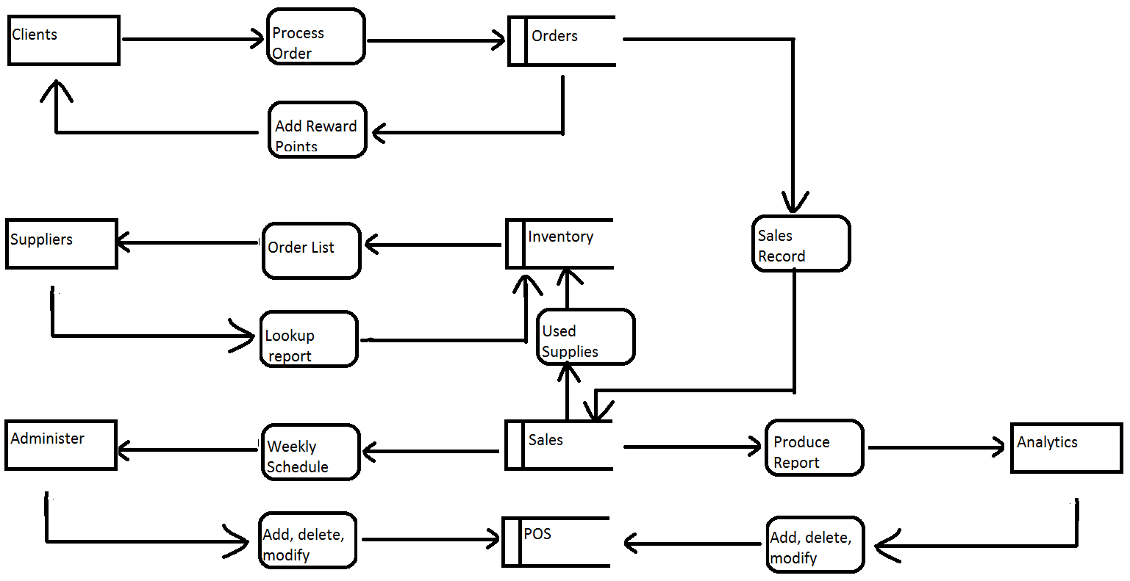

Decision Analysis

Technical Feasibility: The new system setup includes the following: store system, customer phone app, and online site for customers and employees. The amount of technical work is immense. This whole new system will be connected to one server. Every conduct on the system will be recorded.

Operational Feasibility: The team will conduct the project, and each store have to operate with the team. Store employees will work as regularly as the project workers sit in the store to watch and gather record. After the new system is completed, project workers will conduct trainings in using the new system.

Economic Feasibility: The estimated cost is $500,000. The reason to change into a new system that best fits for the brand need is for current and future benefits in client and employee royalty, expanding market's incorrect path, and rise in profit sales. The amount of data to be collected when the new system is set up are point to point structured that the current system are unable to produce.

Schedule Feasibility: The estimated period for the new system to fully develop is 4-5 months. At the beginning workers will be sent to each store to analyze the operation and gather data. The project will stay with the estimated period unless a major change occurs.

Physical Design and Integration

ERD:

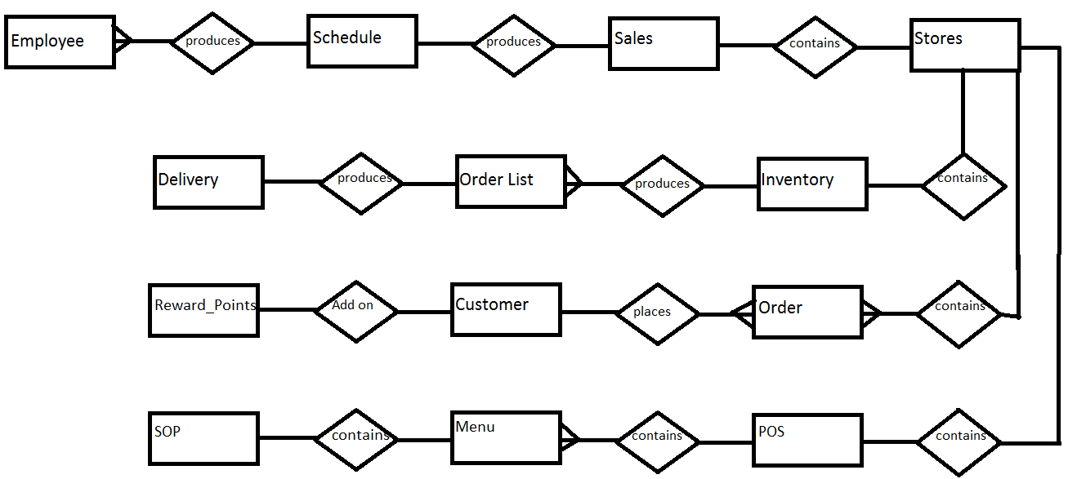

Each **Store** makes **Sales.** There are hourly, daily **Sales** record for each **Store.**

The hourly, daily **Sales** maps out how shift **Schedule** should be.

**Schedule** depend on the available **Employees**. Many **Employees** are put into **Schedule** to work.

Each **Store** has **Inventory** in stock. **Inventory** is needed for **Stores** to operate.

After counting **Inventory** in stock, **Order_List** can be made. **Order_List** are the supplies needed to add into store **Inventory**.

When **OrderList** is sent out to supplier, they will ship out **Delivery**.

Each **Store** contains many **Order.**

Each **Order** have a **Customer** associated with.

The **Customer** has their **Reward_Points** record.

Each **Store** has their **POS** system.

Within **POS**, there are **Menu** items set up.

Each **Menu** item, there is **SOP**(Standard Operating Procedures) in how making each item.

**Stores**

Store_id int primary key

Date Open varchar

Address varchar

**Sales**

Sales_id int primary key

Store_id int foreign key

Date varchar

Time varchar

Hourly_sales varchar

Transcation_num int

**Schedule**

Schedule_id int primary key

Sales_id int foreign key

Date varchar

Shift varchar

**Employee**

Employee_id int primary key

Schedule_id int foreign key

Date_hire varchar

Address varchar

Rate int

Position varchar

**Inventory**

Item_id int primary key

Store_id int foreign key

Name varchar

Description varchar

InStock int

Date_In varchar

Used int

**OrderList**

OrderList_id int primary key

Date varchar

Item_id int foreign key

Amount int

Comment varchar

**Delivery**

Delivery_id int primary key

Date varchar

OrderList_id int foreign key

**Order**

Order_id int primary key

Store_id int foreign key

Drink varchar

Drink_Size varchar

Customer_id int foreign key

Comment varchar

**Customer**

Customer_id int primary key

Order_id int foreign key

Name varchar

Age int

Comment varchar

**Reward_Points**

Reward_id int primary key

Customer_id int foreign key

Current_point int

Used_point int

**POS**

POS_id int primary key

Store_id int foreign key

Model varchar

Date_setup varchar

Last_upgrade varchar

**Menu**

Menu_id int primary key

POS_id int foreign key

Name varchar

Drink_size varchar

Price int

Comment varchar

**SOP**

SOP_id int primary key

Menu_id int foreign key

Name varchar

Procedure varchar

Comment varchar

Construction and Testing

Clients:

1. Place orders from both phone app and website. The stores should receive the order immediately and able to confirm receiving on the order. Clients must be able to verify the confirmation and view status order.
2. Place orders from both phone app and website. After the confirmation from the store, and with pending status (Not in Kitchen), make changes in order, store must be able to verify the change in order.
3. Gather reward points for free drink, save the points for future use. Try to add on more points when there are already enough points to redeem reward.
4. When in the store, use customers phone to scan points into their phone when wifi is off. When wifi goes on, the status of points should be refreshed and updated. Our system should be able to gather this data.

Suppliers:

1. Make immediate changes in the inventory, and supplier should be able to lookup the immediate updates.
2. Using the daily inventory record from the system, and compare the amount in the system with the actual counted amount in the storage. The number should match at all time.
3. The order list produces by the system should be accurate. Hand produce order lists and compare it with the system.
4. Store manager tries to lock the access to open the order list. The supplier should not be able to open the list until reopen by the manager.

Administer:

1. Check with the sales record to make sure canceled and voided orders are taken out of the data and being recorded in a separate file.
2. Store manager hand produces a weekly schedule to fit store need, compare with the schedule system produced, be sure system produce the most usable shift schedule.
3. Add, delete, and modify the menu in the system. The menu screen should display the change when saved.
4. Do regular change in menu item prices, the system should have a record of the past price saved.

Analytics

1. Gather reports of each store, goes to each store, analyze the operation base on the report. The operation and reports should be relatively close.
2. Make change in the reports instore, analytics should be able to print out the record with changes.
3. Add, delete, and modify the input for future promotions. On the start date of the promotion, the system should automatically update for the promotion.
4. The sales during promotion should be saved and record in the database with noted.

Installation and Delivery

The new system is fully developed. The system team developers will conduct training to the owner and store manager. The team and store manager will conduct training to the employees. Customers will be introduced to our new phone app and online site, where they can sign up an account, place orders online, lookup order status, and enjoy the new reward point system.

The owner will meet up with the supplier to introduce the new system. The suppliers will test out the system with the part they have access to. Manager or administer and analytics can now use the system efficiently and easily to report out how well is the store operating.