Board Game without Name

(This is Monopoly based, board game for 2 to 5 players)

# Turn info

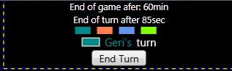

Here you can find:

-the time that left from the game

-the time that left for current player’s turn

-the order of the players

-the current player’s name and color

**Notice**: If the player does not finish his/her turn (confirming it with the “End Turn” button) before time for current turn is finished, he/she will pay a **fine for the slow turn**.

# Dice

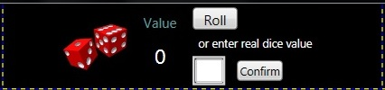

You need to set the value of the dice to be able to move. It can be any integer number in the interval [2-12]. You can do this either by “Roll” button that will set the value automatically or you can use real dices (normally 2 dices with values from 1 to 6). If you use real dices you have to click “Confirm” after you enter your value in the box.

# Players info



Here you can find:

-the name of the player

-the sum of all credit payments that the player have to pay in the future

-the current amount of money

-the health status – The player with 100% or more is healthy. If you notice the C:\Users\Medis\Desktop\HealthInsurance.png sign, next to the health status, it stands to show that the player have a valid health insurance.

# Map fields

## Start

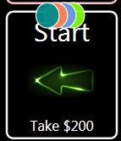 All players begin the game from the “Start” field. Every time the player passes through the “Start”, they:

-take bonus that is mentioned on the field

-pay one payment from every credit they got from the bank

-the validity of all their health and property insurances is reduced by 1

**Notice: If after passing through the “Start”(including paying of credits and getting bonus), the money balance of the player is negative, the player is considered for bankrupt and no longer take part of the game.**

## Street

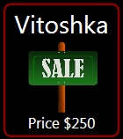

Once you step on a “Street“, that does not have owner, you can buy it if you wish and have enough money. If the street you step on, already has owner you must pay the rent amount to the owner. If you do not have enough money to pay the rent, your money balance will become negative.

You can repair and upgrade you streets every time when it’s your turn.

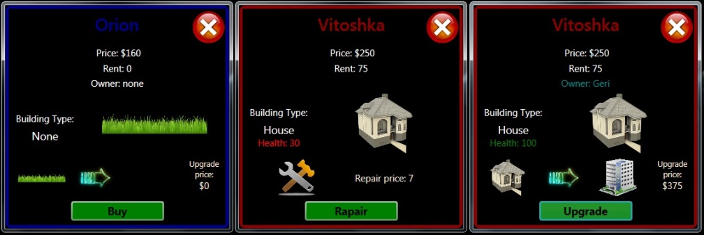 **You can access all streets’ info panel by click on them. You need to use this panel to buy, upgrade or repair the street.**

In the “Street” info panel you can find:

-the rent amount

-building type – The more advanced building you have, the bigger rent you will get.

-building health status – You need the building health status to be 100%, if you like to upgrade the property. If the building health status becomes 0% you will lose your building.

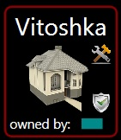You can notice two types of signs on the streets:

-the “repair” sign C:\Users\Medis\Desktop\repair.png shows that the building health status is under 100%

-the “protect” sign C:\Users\Medis\Desktop\Protected3.png shows that the property is protected against earthquake.

## C:\Users\Medis\Desktop\CreditOffer.jpgBank



When you step on “Bank” field you will receive credit offer:

-credit amount – The amount you will receive instantly.

-payment amount – The amount you will when you pass through the “Start” field.

-payment count – The number of payments you have to do before the credit will consider repaid.

## C:\Users\Medis\Desktop\InsuranceOffer.jpgInsurance Agency

## C:\Users\Medis\Desktop\FieldInsurance.jpg

When you step on “Insurance” field you will receive insurance offer:

-insurance price

-insurance validity – The validity is reduced by 1 every time you pass through the “Start” field.

There are two types of insurances. The **property insurance** protects all buildings on the streets you have and you can see the C:\Users\Medis\Desktop\Protected3.png sign on your streets during the period you have valid property insurance. The second type is health insurance that protects your health and you can see theC:\Users\Medis\Desktop\HealthInsurance.pngsign next to your health status during its validity period.

## Lottery

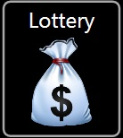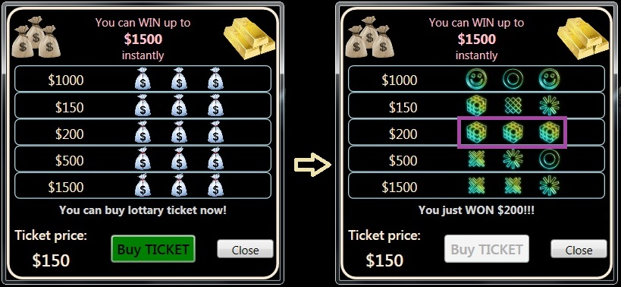

When you step on “Lottery” field you can buy ticket in you wish and if you have enough money. You can see the ticket price and the possible prizes. If you find 3 same symbols on the one row you will win the prize on the row.

## C:\Users\Medis\Desktop\LuckyCard.jpgLucky field

When you step on “Lucky field” you can try your chance by drawing a card. Your luck can be good, but also there are misfortune cards.

## Hospital

When you step on “Hospital” field you will be healed up to 130% health.

## Cross Road

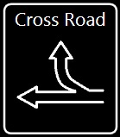The “Cross Road” give you chance to choose the direction you want to continue after it.

# Disasters

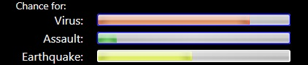Every time the last player end his/her turn, disaster could happen. There are 3 types of disasters and these bars show the possibility to happen any of them after the last player end his/her turn.

Every disaster has:

-location – field where it happens

-type – **earthquake, assault or virus**

-power – More powerful disaster is, more damage it produces.

## C:\Users\Medis\Desktop\DisasterEarthquake.jpgEarthquake

The earthquake damage buildings’ health. It affect the disaster’s location field and nearby fields also.

## Virus and Assault

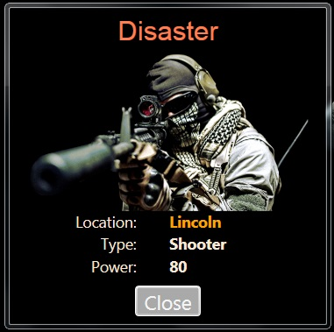 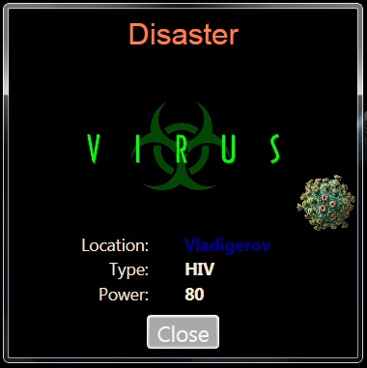

The disasters of type virus or assault damage the players’ health. The assault disasters affect only the disaster’s location field while the virus disasters also affect nearby fields.

**Notice:** When your helth is damaged it reduces your possibility to move. If your health is **X**(less than 100%) the then the length of you move will be: DiceValue – (100 – **X**) / 10, but never less than 1.

For example if the dice value is 9 and your health status is 80%, the length of the move will be:

9 – (100 – 80) / 10 = 7

# Winner



If all players but one bankrupt(with negative money amount), the he/she is the winner. Also if the game time finished the most rich player wins. In this case the most rich player is the one with the bigest money balance.

MoneyBalance = MoneyAmount – Credit

Example:

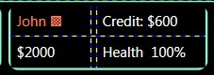 MoneyBalance = 2000 – 600 = $1400