Biodiversity Sampling: Exposed vs Sheltered

Andrew Bickell, Gabrielle Languedoc, Joan Moreaux and Mara Bohm

01/11/2021

## Hypothesis

We hypothesize that there will be greater biodiversity found in the sheltered site because it experiences less hydrodynamic stress.

## Data Collection

We collected data from both wave-sheltered and an wave-exposed sites, at Scott’s Bay, Bamfield. We counted species richness and abundance within ten haphazardly selected 10 cm by 10 cm quadrats along two parallel transect lines per site.

## Analysis

We compared Shannon-Weiner diveristy indexs (H’), species richness and, species evenness between the exposed and sheltered sites. We ran the statistical analysis ANOVA to determine the significance of our results.

## Results and Conclusions

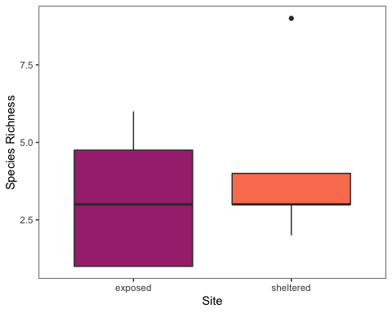

Species richness present at the exposed and sheltered sites at Scott’s Bay, Bamfield, Canada. Determined using 10 quadrats haphazardly sampled along two parallel transect lines per site

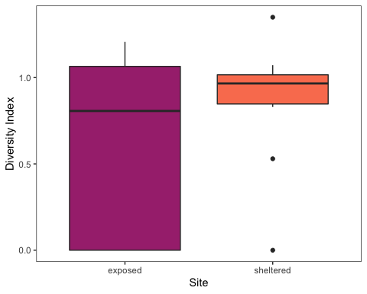

H’ value of Shannon-Wiener Diversity Index present at the exposed and sheltered sites at Scott’s Bay, Bamfield, Canada. Determined using 10 quadrats haphazardly sampled along two parallel transect lines per site.

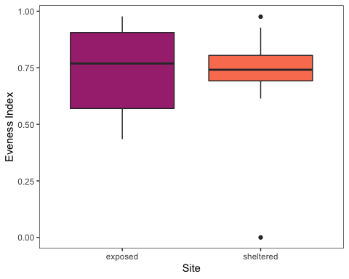

Diversity evenness values of the exposed and sheltered sites at Scott’s Bay, Bamfield, Canada. Determined using 10 quadrats haphazardly sampled along two parallel transect lines per site.

Table 1. | Index | P Value | | ——- | ——— | | Shannon-Weiner Diversity (H’) | 0.218 | | Species Richness | 0.43 | | Species Evenness | 0.78 |