A Minimal Book Example

Yihui Xie

2021-02-07

Table of Contents

# 1 Prerequisites

This is a *sample* book written in **Markdown**. You can use anything that Pandoc’s Markdown supports, e.g., a math equation $a^{2}+b^{2}=c^{2}$.

The **bookdown** package can be installed from CRAN or Github:

Remember each Rmd file contains one and only one chapter, and a chapter is defined by the first-level heading #.

To compile this example to PDF, you need XeLaTeX. You are recommended to install TinyTeX (which includes XeLaTeX): <https://yihui.org/tinytex/>.

# 2 Introduction

You can label chapter and section titles using {#label} after them, e.g., we can reference Chapter 2. If you do not manually label them, there will be automatic labels anyway, e.g., Chapter 4.

Figures and tables with captions will be placed in figure and table environments, respectively.

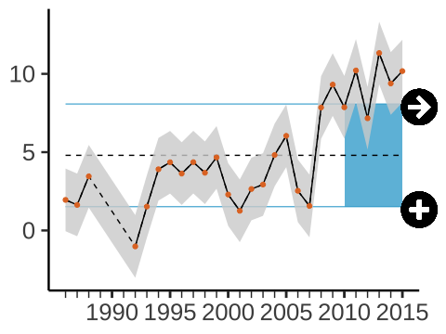

Figure 2.1: The index changed by less than one standard deviation of the full time series over the last 5 years. The mean of the last 5 years was more than one standard deviation below the mean of the full time series.

Reference a figure by its code chunk label with the fig: prefix, e.g., see Figure 2.1. Similarly, you can reference tables generated from knitr::kable(), e.g., see Table 2.1.

Table 2.1: Here is a nice table!

|  |  |  |  |  |
| --- | --- | --- | --- | --- |
| Sepal.Length | Sepal.Width | Petal.Length | Petal.Width | Species |
| 5.1 | 3.5 | 1.4 | 0.2 | setosa |
| 4.9 | 3.0 | 1.4 | 0.2 | setosa |
| 4.7 | 3.2 | 1.3 | 0.2 | setosa |
| 4.6 | 3.1 | 1.5 | 0.2 | setosa |
| 5.0 | 3.6 | 1.4 | 0.2 | setosa |
| 5.4 | 3.9 | 1.7 | 0.4 | setosa |
| 4.6 | 3.4 | 1.4 | 0.3 | setosa |
| 5.0 | 3.4 | 1.5 | 0.2 | setosa |
| 4.4 | 2.9 | 1.4 | 0.2 | setosa |
| 4.9 | 3.1 | 1.5 | 0.1 | setosa |
| 5.4 | 3.7 | 1.5 | 0.2 | setosa |
| 4.8 | 3.4 | 1.6 | 0.2 | setosa |
| 4.8 | 3.0 | 1.4 | 0.1 | setosa |
| 4.3 | 3.0 | 1.1 | 0.1 | setosa |
| 5.8 | 4.0 | 1.2 | 0.2 | setosa |
| 5.7 | 4.4 | 1.5 | 0.4 | setosa |
| 5.4 | 3.9 | 1.3 | 0.4 | setosa |
| 5.1 | 3.5 | 1.4 | 0.3 | setosa |
| 5.7 | 3.8 | 1.7 | 0.3 | setosa |
| 5.1 | 3.8 | 1.5 | 0.3 | setosa |

You can write citations, too. For example, we are using the **bookdown** package (Xie 2020) in this sample book, which was built on top of R Markdown and **knitr** (Xie 2015).

# 3 Literature

Here is a review of existing methods.

# 4 Methods

We describe our methods in this chapter.

# 5 Applications

Some *significant* applications are demonstrated in this chapter.

## 5.1 Example one

## 5.2 Example two

# 6 Final Words

We have finished a nice book.

Xie, Yihui. 2015. *Dynamic Documents with R and Knitr*. 2nd ed. Boca Raton, Florida: Chapman; Hall/CRC. <http://yihui.org/knitr/>.

———. 2020. *Bookdown: Authoring Books and Technical Documents with R Markdown*. <https://github.com/rstudio/bookdown>.