What can we learn from natural and artificial dependency trees
First Author  Affiliation / Address line 1  Affiliation / Address line 2  Affiliation / Address line 3  email@domain | Second Author  Affiliation / Address line 1  Affiliation / Address line 2  Affiliation / Address line 3  email@domain

Abstract
This paper is centered around two main contributions : introducing several procedures for generating random dependency trees with constraints and comparing the properties of these random trees with natural trees (i.e trees extracted from treebanks) and analyzing the relationships between these properties in both cases in order to better understand which relationships are formally constrained and which relationships are linguistically motivated.
We took into consideration five metrics: tree length, height, arity, mean dependency distance and mean flux weight, and also looked into the distribution of configurations for pairs and triples of nodes. This analysis is based on UD treebanks (version 2.3, Nivre et al. 2018) for four languages : English, Japanese, Chinese and French
- Introduction
Our objective is twofold : first we want to see how different properties of syntactic dependency trees correlate, in particular properties that are related to syntactic complexity such as height, mean dependency distance and mean flux weight, then we want to find out if these properties can allow us to distinguish between artificial dependency trees (trees that have been manipulated using random components and constraints), and dependency trees from natural languages.

(marine) paragraph on why we’re doing this, recontextualizing, motivations...

- Looking into the properties of syntactic dependency trees
In this work we use five metrics based on the dependency trees: first the length which is a basic property of the tree, then the height and maximum arity in the tree, the arity is the maximum number of dependents of a node in a dependency tree. The arity value could influence the strategy of linearization of unordered trees in natural languages. Regarding dependencies, the dependency distance (Haitao Liu, 2008) is a linear property indicating the number of words between a dependent and its governor. Recently, there has been many quantitative works ​​( (Futrell, Mahowald, & Gibson, 2015); (Haitao Liu, 2008) that have focussed on dependency length and its minimization across many natural languages. In complement to these linear properties we also use “flux weight”, a metric proposed by (Kahane, Yan, & Botalla, 2017) which captures the level of nestedness of a syntactic construction (the more nested the construction is, the higher its weight in terms of dependency flux), and they have shown that flux weight seems limited to 5 for 70 treebanks in 50 languages.

Feature name | Description
Length | Number of nodes in the tree
Height | Number of edges between the root and its  deepest leaf
Mean Dependency Distance (MDD) | Two nodes in a governor -> dependent relation are at distance one if they are neighbours, distance two if there is a node between them etc. For every tree, we look at the mean of those dependency distances.
Mean flux weight | Mean of the flux weight introduced by Kahane et al. (2017)

Table 1: Tree-based metrics

In addition to these tree-based metrics, we are also interested in studying local configurations using the linearised dependency trees. To look at these configurations, we extract and compare the proportion of all potential configurations of bigrams (two successive nodes) and trigrams (three successive nodes).

For bigrams, we have three possible configurations: a> b which indicates that a and b are linked with a relation on the right, a <b which indicates that a and b are linked with a relation on the left, and a ^ b, which indicates that a and b are not in a governor dependent relation.

For trigram configurations (a, b, c), the possibility is much wider, we have 27 configurations. There are projective configurations like: a> b> c, (a> b) & (a> c), (a> c) and (b <c), but also non-projective cases like: a <c and b> c.

- Hypotheses
Relations between properties :

length : high effect of length on the value of other properties. With more nodes there is a potential for more complex configurations, longer dependencies (which would increase mdd and mean flux weight), higher height, more important arity (it seems less likely to get a node with arity 4 in a very small tree, but in a larger tree it is more likely)…

length/height : formally related

mdd / mfw : as nestedness increases, more descendents will be placed between the governor and its direct dependents which will increase dependency distances, see graph below :

Our hypotheses :
on bigrams : words that are in a governor-dependent relation will tend to be close together. The most frequent dependency distance is 1 and the frequency of dependencies will decrease as the dependency distance increases.

trigram: how they ordered locally, linked == share information, not linked? if two nodes linked with one, if three nodes linked in a chain.
The typological difference in direction, but may be common for the proportion of linked relations in bigram trigram because of “share information” which indicate more economic computational processing of sequence. And the difference could be shown in random treebanks.

Hypothesis from (Temperley, 2008): even languages that are strongly head-initial or head-final will tend to have short dependents on the opposite direction, so as to keep a balance between dependency length minimization and preference for a governor-dependent direction. Experiment : look at the most frequent bigram proportion -> how frequent is the associated trigram ?

Trigrams : Looking in particular at trigrams where all three nodes are linked to one another, we would like to know which of these types of configurations is the most frequent : a subtree with more depth, where all dependents are chained (chain subtree), a subtree with dependents on every side (balanced subtree), or a subtree with several dependents linked to the same governor ? (bouquet subtree). This could indicate that one of these types of configuration is easier to process and more economical.

(graph)

- Random tree generation with constraints
In this section we will look at random dependency tree generation with constraints. We distinguish two different steps in the dependency tree generation process : the generation of the unordered structure, and the generation of the linearisation of the nodes. In order to compare the properties of natural and random trees we used 3 different tree generating algorithm, to which we assign the following names : original_random (1), original_optimal (2) and random_random (3).

1) The first algorithm “original_random” samples an unordered dependency structure from a treebank (i.e the original structure), and generates a random linearisation for it. We imposed a projectivity constraint on this linearisation and proposed the following algorithm to generate it:

____

2) The second algorithm “original_optimal” also sample an unordered dependency structure from a treebank, but instead of generating a simple projective linearisation, we add a second constraint to minimize dependency distances inside the linearised dependency tree. The idea is inspired from (Temperley, 2008) : to minimize dependency distances in a projective setting dependents of a governor should be linearized alternatively on opposing sides of the governor, with the smallest dependent nodes (i.e those that have the smallest number of direct and indirect descendants) linearized first. The algorithm implementing this constraint is explained in the graph below :

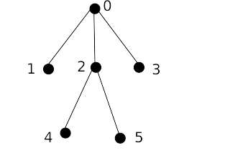

0) We start the linearisation at the root
1) Then, we select its dependent node [1,2,3] and order them in order of their decreasing number of descendant nodes, which gives us [1,3,2].
2) We select a first direction at random, for example “left”, and order these nodes alternating between left and right, which gives us these linearisation steps [0], [10], [103], [2103].
We repeat steps 1 through 2 until every node has been linearized, which gives us for example [425103]

3) The third algorithm “random_random” is the only one to implement two random steps : first generate a completely random structure, then linearize it following the same procedure as in algorithm 1). The unordered structure generation step is described in the graph below :

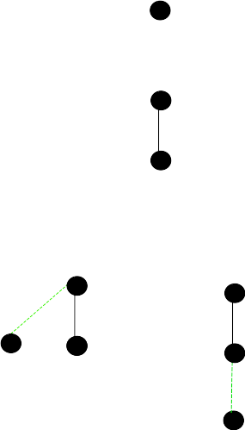

0) We start the generation process with a single node
1) We introduce a new node and randomly draws its governor. For now since there is only one potential governor, the edge has a probability of 1.
2) We introduce a new node and randomly draws its governor. There are two potential governors which gives us a probability 0.5 of drawing the node 0 and the same probability for the node 1. These potential edges are drawn in green on the graph.
3) We repeat this step until all nodes have been drawn and attached to their governor.

These tree generation algorithms give us tools to analyze how different generation strategies will affect the properties of the generated trees as we incorporate more and more constraints into the two generation steps. For example during the linearisation process in 1) we could introduce a probability of creating a head-final edge, to produce trees that resemble more the trees of a head-final language like japanese. For the unordered structure generation, we could introduce a constraint to limit length, arity or height. We need to distinguish constraints that happen during the unordered structure generation step and constraints that have to do with linearisation, like constraints on dependency distances and on flux weight.

One question that still remains concerns the ordering of the two steps : unordered structure generation and linearisation generation. So far we have only implemented the full generation starting with the generation of the unordered structure and then moving on to the linearisation, which is a synthesis approach as described in Meaning-Text-Theory [Mel'čuk 1998], but it would be interesting to go in the analysis direction, where we start with a linearisation, that we then produce a structure for, in order to see if and how it affects the distributions of configurations inside the trees, especially as more constraints are added at different stages. We could then see if one type of random generation (synthesis vs analysis) produces structures that resemble natural dependency structures more.

- Results and discussion
  - A continuum of constraints
When we look at the relationship between properties of the trees we can see how the trees are affected by the generation process. One such example can be found in the graph below :

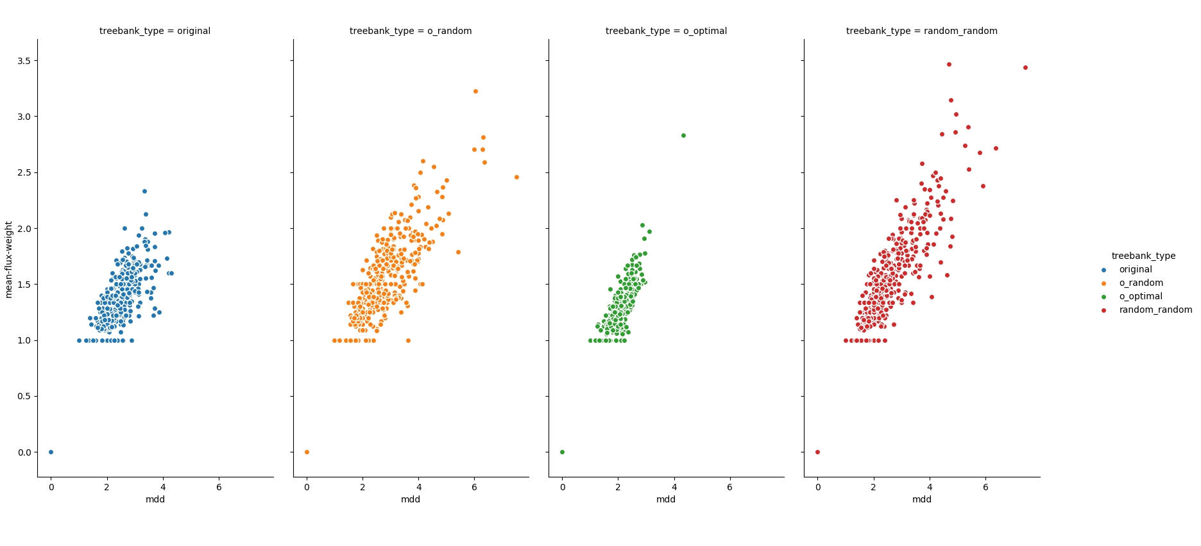
These graphs show the relation between the mean dependency distance and the mean flux weight. From the shape of the plots, we can tell that the o_optimal treebank has been generated with more constraints : it contains less variation in terms of configurations and the relationship between the two properties is more apparent, there is less dispersion on the plot. The next treebank showing the most constraints is the original one, it has lost the “optimality” constraint, but is still more constrained than the two random treebanks as it possesses some linguistic constraints. The two random treebanks show more variation, with the original_random one still showing more constraints than the random_random one, as it still preserves the integrity of the unordered structure (which follows linguistic constraints from natural languages).

  - Correlation between properties
Strongest correlations based on the treebank format :
original : height_length, mdd_arity, mdd_mfw
original_random : mdd_mfw, mdd_length, mfw_height
original_optimal : mdd_mfw, mdd_length, mfw_height
random_random : mdd_mfw, mfw_height, mdd_length

→ point to table in annex

  - Distribution of configurations
barplot vertical showing proportion of balanced/chained/bouquet for each treebank (or for every language if its similar between the treebanks of each language)

- Conclusion
limit : only looked at projective random structures : really strong limitations on the configurations that exists, we don’t see as clearly how this affects the structures produced
we could also look at how the properties and their relationships (correlation) are affected by annotation scheme, in particular contrasting schemas where content words are governors (as is the case in UD) and schemas where function words are governors (for example using the SUD schema proposed by xxx)
we could try to build predictive models to predict tree properties, this would better allow us to understand the relationships between the individual features of trees

References
Futrell, R., Mahowald, K., & Gibson, E. (2015). Large-scale evidence of dependency length minimization in 37 languages. Proceedings of the National Academy of Sciences, 112(33), 10336–10341. https://doi.org/10.1073/pnas.1502134112
Haitao Liu. (2008). Dependency Distance as a Metric of Language Comprehension Difficulty. Journal of Cognitive Science, 9(2), 159–191. https://doi.org/10.17791/jcs.2008.9.2.159
Kahane, S., Yan, C., & Botalla, M.-A. (2017). What are the limitations on the flux of syntactic dependencies? Evidence from UD treebanks. 11.
Mel'cuk, Igor Aleksandrovic (1998). Dependency syntax: theory and practice. SUNY press.
Nivre, Joakim; Abrams, Mitchell; Agić, Željko; et al., 2018, Universal Dependencies 2.3, LINDAT/CLARIN digital library at the Institute of Formal and Applied Linguistics (ÚFAL), Faculty of Mathematics and Physics, Charles University, http://hdl.handle.net/11234/1-2895.
Temperley, D. (2008). Dependency-length minimization in natural and artificial languages∗. Journal of Quantitative Linguistics, 15(3), 256–282. https://doi.org/10.1080/09296170802159512

Note that this algorithm gives us a uniform probability on derivations, but that some derived trees are more probable than others, for example if the length of the tree is 4 we only have 1 derivation to obtain a tree of height 4, and 2 derivations to obtain a tree with 2 dependent on the root and 1 on one of these dependents.

