What can we learn from natural and artificial dependency trees
Chunxiao Yan  Modyco  Université Paris Nanterre  CNRS - France  yanchunxiao@yahoo.fr | Marine Courtin  LPP  Université Paris 3 Sorbonne Nouvelle  CNRS - France  marine.courtin@sorbonne-nouvelle.fr

Abstract
This paper is centered around two main contributions : the first one consists in introducing several procedures for generating random dependency trees with constraints, we later use these artificial treebanks to compare the properties of these random trees with natural trees (i.e trees extracted from treebanks) and analyze the relationships between these properties in both cases in order to better understand which relationships are formally constrained and which relationships are linguistically motivated. We take into consideration five metrics: tree length, height, maximum arity, mean dependency distance and mean flux weight, and also look into the distribution of configurations for pairs and triples of nodes. This analysis is based on UD treebanks (version 2.3, Nivre et al. 2018) for four languages: Chinese, English, French and Japanese.
- Introduction
We are interested in looking at the linguistic constraints on syntactic dependency trees to understand what makes certain structures plausible while others are not so plausible. To effectively do this kind of work, we need to observe natural trees (syntactic trees that are the results of linguistic analysis) to see what this population looks like. Similar work has been done for example by (Jiang and Liu 2015) on the relation between sentence length, dependency distance and dependency direction. But if we only look at natural trees we are limited because we cannot cleanly separate every constraint from the others to see its effect. We only get the structures that are the result of all the constraints and their interactions. On the other hand, if we start from a blank canvas, randomly generated trees, and incrementally add constraints on these trees, we might closer and closer to natural trees, and we can use those trees to determine which constraints are formally motivated (they are a result of the mathematical structure of the tree) and which constraints are linguistically and cognitively motivated. Research in the line of (Gildea and Temperley, 2009) who have used random and optimal linearisations to study dependency length and its varying degrees of minimization can help us to discover constraints that would be helpful to explain why we only find a small subset of all potential trees in syntactic analyses on real data.

Our objective is therefore twofold: first we want to see how different properties of syntactic dependency trees correlate, in particular properties that are related to syntactic complexity such as height, mean dependency distance and mean flux weight, then we want to find out if these properties can allow us to distinguish between artificial dependency trees (trees that have been manipulated using random components and constraints), and dependency trees from real data.

- Looking into the properties of syntactic dependency trees
  - Features
In this work we use the five following metrics to analyze the properties of dependency trees:

Feature name | Description
Length | Number of nodes in the tree
Height | Number of edges between the root and its  deepest leaf
Maximum arity | Maximum number of dependents of a node
Mean Dependency Distance (MDD) | Two nodes in a dependency relation are at distance 1 if they are neighbours, distance 2 if there is a node between them etc. For every tree, we look at the mean of those dependency distances. See (Liu 2008) for more information about this property.
Mean flux weight | Mean of the number of concomitant disjoint dependencies (Kahane et al. 2017; see comments below)

Table 1: Tree-based metrics

We chose these properties because we believe that they all interfere in linearization strategies, that is how words are ordered in sentences, and the effects of those linearisation strategies. Recently, there have been many quantitative works ​​(Futrell et al., 2015; Liu 2008) that have focussed on dependency length and its minimization across many natural languages. In complement to these linear properties we also use “flux weight”, a metrics proposed by Kahane et al. (2017) which captures the level of nestedness of a syntactic construction (the more nested the construction is, the higher its weight in terms of dependency flux). In their paper, they claim the existence of a universal upper bound for flux weight, as they have found it to be to 5 for 70 treebanks in 50 languages.

In addition to these tree-based metrics, we are also interested in studying local configurations using the linearised dependency trees. To look at these configurations, we extract and compare the proportion of all potential configurations of bigrams (two successive nodes) and trigrams (three successive nodes). For bigrams, we have three possible configurations: a -> b which indicates that a and b are linked with a relation on the right, a <- b which indicates that a and b are linked with a relation on the left, and a ♢ b, which indicates that a and b are not linked by a dependency. For trigram configurations (a, b, c), the possibility is much wider, we have 25 possible configurations. There are projective configurations like: a -> b -> c, (a -> b) & (a -> c), (a -> c) and (b <- c), but also non-projective cases like: a <- c and b -> c.

  - Hypotheses
In this section, we describe some of our hypotheses concerning the relationship between our selected properties. First, we expect to find that tree length is positively correlated with other properties. As the number of nodes increases, the number of possible trees increases including more complex trees with longer dependencies (which would increase MDD) and more nestedness (which would result in a higher mean flux weight). The relationship with maximum arity is less clear, as there could be an upper limit, which would make the relation between both of these properties non-linear. We’re also particularly interested in the relationship between mean dependency distance and mean flux weight. An increase in nestedness is likely to result in more descendents being placed between a governor and its direct dependents, which would mean an overall increase in mean dependency distance.
For local configurations, we know that in natural trees, most of the dependencies occur between neighbours, see for example (Liu, 2008), the proportion varying depending on the language. It will be interesting to see how much that is still the case in the different random treebanks, depending on the added constraints.

For trigrams of nodes we are interested in particular in the distribution of four groups of configurations that represent four different strategies of linearization : “chained” subtrees that introduce more depth in the dependency tree in one direction, “balanced” subtrees that alternate dependents on both sides of the governor, “zigzag” subtrees which are similar to chains but with the second dependent going in the opposite direction as the first one, and “bouquet” subtrees where the two dependents are linked to the same governor (see example in Figure A1 in the Annex). If one group of configurations is preferred, it could indicate that this linearisation strategy follows the principle of least effort and is more economical. We’re also interested in the hypothesis advanced by (Temperley, 2008) who proposes that languages that strongly favor head-initial or head-final dependencies will still tend to have some short phrases depending on the opposite direction, which could constitute a way of limiting dependency distances.
- Random tree generation with constraints
In this section we will look at random dependency tree generation with constraints. We distinguish two different steps in the dependency tree generation process : the generation of the unordered structure, and the generation of the linearisation of the nodes. Throughout this generation process, we limited ourselves to projective trees. In order to compare the properties of natural and random trees we used 3 different tree generating algorithm, to which we assign the following names : original random (1), original optimal (2) and random random (3).

The first algorithm “original random” samples an unordered dependency structure from a treebank (i.e the original structure), and generates a random projective linearisation for it:
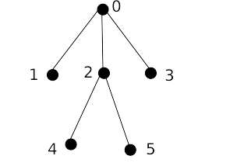Figure 1: unordered tree
- We start the linearisation at the root.
- Then, we select its dependent nodes [1,2,3] and randomly order them, which gives us [2,1,3].
- We select their direction at random, which gives us [“left”, “left”, “right”], and the linearisation steps [0], [20], [120], [1203].
- We repeat steps 1 through 2 until every node has been linearized, which gives us for example [124503].

The second algorithm “original optimal” also sample an unordered dependency structure from a treebank, but instead of generating a simple projective linearisation, we add a second constraint to minimize dependency distances inside the linearised dependency tree. The idea is inspired from [Temperley 2008]: to minimize dependency distances in a projective setting dependents of a governor should be linearized alternatively on opposing sides of the governor, with the smallest dependent nodes (i.e those that have the smallest number of direct and indirect descendants) linearized first. Using the same structure unordered tree as in fig. 1 we described the procedure below:
- We start the linearisation at the root.
- Then, we select its dependent node [1,2,3] and order them in order of their decreasing number of descendant nodes, which gives us [1,3,2].
- We select a first direction at random, for example “left”, and order these nodes alternating between left and right, which gives us these linearisation steps [0], [10], [103], [2103].
- We repeat steps 1 through 2 until every node has been linearized, which gives us for example [425103].

The third algorithm “random random” is the only one to implement two random steps : first generate a completely random structure, then linearize it following the same procedure as in algorithm 1). The unordered structure generation step is described in fig 2.
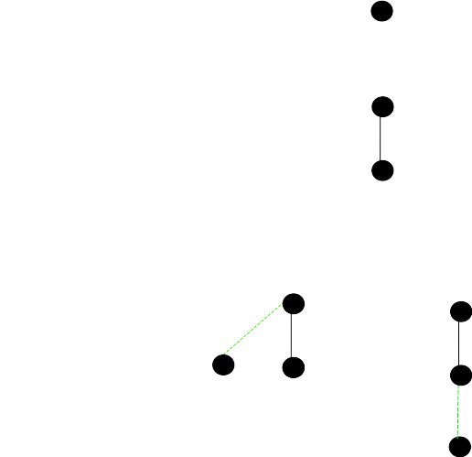Figure 2: Random tree generation
step 1.

step 2.

step 3.

- We start the generation process with a single node
- We introduce a new node and randomly draws its governor. For now since there is only one potential governor, the edge has a probability of 1.
- We introduce a new node and randomly draws its governor. There are two potential governors which gives us a probability 0.5 of drawing the node 0 and the same probability for the node 1. These potential edges are drawn in green on the graph.
- We repeat this last step until all nodes have been drawn and attached to their governor..

These tree generation algorithms are only some of the many possible algorithms that could be implemented, but they us give us tools to analyze how different generation strategies will affect the properties of the generated trees as we incorporate more and more constraints into the two generation steps. They are also easily extensible, for example during the linearisation process we could introduce a probability of creating a head-final edge, to produce trees that resemble more the trees of a head-final language like Japanese. For the unordered structure generation, we could introduce a constraint to limit length, arity or height. We need to distinguish constraints that happen during the unordered structure generation step and constraints that have to do with linearisation, like constraints on dependency distances and on flux weights.

One question that still remains concerns the ordering of the two steps : unordered structure generation and linearisation generation. So far we have only implemented the full generation starting with the generation of the unordered structure and then moving on to the linearisation, which is a synthesis approach as described in Meaning-Text-Theory [Mel'čuk 1998], but it would be interesting to go in the analysis direction, starting with a sequence of nodes, and then randomly producing a structure for it. This could allow us to see how the distribution of trees is impacted, especially as more constraints are added on the generation. We could then see if one type of random generation (synthesis vs analysis) produces structures that resemble natural dependency structures more.
- Results and discussion
  - Correlation between properties
For each pair of properties, we measured the pearson correlation coefficient to find out the extent to which thes relationship between these variables can be linearly captured. We looked into these results for the different natural treebanks and the artificial ones (“original random”, “random random” and “original optimal”). Tables presenting the full results are showcased in tables 1-4 in annex, with rankings for the correlation between parentheses.

Based on these results, we notice that mean dependency distance and mean flux weight are overall the most correlated properties with values ranging from 0.70 (jp_pud, “original”) to 0.95 (fr_partut, “original optimal”). This can be explained by the fact that mean flux weight increases as the number of disjoint flux increases, which in turn tends to create longer dependencies than structure with few disjoint flux as shown in the graph below :
[graph of disjoint flux]
An interesting observation about this correlation is that it is intensified in the various artificial treebanks, and is the strongest in the “original optimal” version. Introducing a dependency distance minimization constraint will favour shorter dependencies, which provides less opportunities for configurations that introduce disjoint flux. Therefore the mean flux weight will also decrease.

If we look at the the correlation between length and height, we find that it is strong in original structures (0.78 correlation) as well as in the random ones (0.71 correlation in “random random”, which is the only format in which the height is affected by the manipulation). This means that the relationship between these two properties is not motivated by linguistic factors only. From a mathematical point of view, longer sentences have the potential to introduce more hierarchy which increases the height. Thus, there is a correlation between these two properties regardless of a natural structure or a random structure. Zhang and Liu (2018) have proposed that the relationship between these two properties in natural treebanks of English and Chinese can be described by a power law. Further examination could tell us if it is also the case for randomly generated trees.
We also find quite strong correlations between mean dependency distance and height in the artificial treebanks (0.76, 0.79, 0.72 respectively for “original random”, “original optima” and “random random”) while this correlation is less important for the natural treebanks (0.46). It is quite interesting that the correlation decreases in the original trees. Our interpretation is that perhaps there is a more complex relationship at play between height and mean dependency distance in real data that cannot be linearly captured, and this complex relationship would be altered by the random components when generating the various artificial trees, especially as we relinearize the nodes.
  - Distribution of configurations
For configurations, we are mainly interested in the distribution of the four different groups presented in section 2.2, and how they are impacted by language and the type of treebank (natural and artificial). We will discuss here a few pointsand present the full results in annex. In fig 4, we can see the distribution of these groups (in terms of percentage of all possible configurations, some of which are not in these four main groups) for French, depending on the type of treebank considered. In the original treebanks of French, the two main types of configurations are chains and “zigzag” with 34% and 33% of all trigram configurations. The balanced strategy is far less used, as it represents only 7% of all occurences, which is interesting as this strategy is more frequent in the artificial treebanks, especially in those that optimize for dependency distances, where they reach 18%. The proportion of “bouquet” configuration is stable across the treebanks, with the exception of the completely random ones that use this strategy less. The two types of treebanks that include random components seem to favour chain and zigzag configurations.
Across the four languages, the zigzag configurations seem to take the lead, especially in Japanese where they are far more frequent than in the artificial treebanks. This type of configuration is used in the Japanese treebanks to annotate various types of particles which are very frequent, such as the case markers に, が, の or the topic marker は, which explains why these configurations are much more frequent than in the artificial ones.
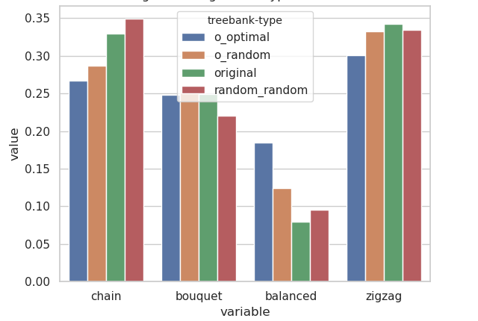Figure 3: Trigram configuration types in French

There is also a second type of configuration grouping that is interesting to look at, especially zs we want to understand the differences in distribution between original and random_random trees. The configurations discussed previously are linearized, but there could already be differences in configuration distribution at the purely structural level. If we only look at structures, there are two possible derived trees : a→b→c (height 3) and b<-a→c (height 2). The configuration a→b→c leads to “chain” and “zigzag” linearized configurations and b<-a→c to “balanced” and “bouquet” configurations. In Fig 5. we show the distribution of these non-linearized configurations for French :

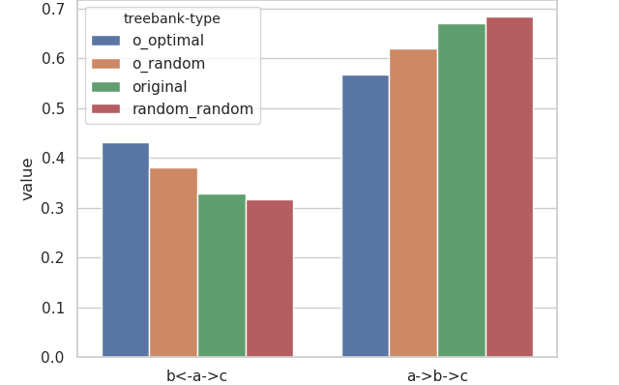Figure 4: Distribution of non-linearized configurations in French
First is should be noted that there are similarities in this distribution for all 4 languages : a→-b→ is always the most frequent configuration, in natural and artificial trees. Since this is applicable for randomly generated trees as well as original ones, we propose that this is not due to linguistic constraints but to formal ones, i.e that there is a higher probability to generate the deeper configurations. For Chinese, English and French there is a common trend where random and original trees have the most of this configuration, followed by original_random trees and finally original_optimal trees. In Japanese, the difference between the two groups is not as pronounced and the distribution for original trees resembles more that of optimal trees. These observations provide some insight for the discussion on linearized configurations :
- Conclusion
In this paper we introduced several ways to generate artificial syntactic dependency trees and proposed to use those trees as a way of looking into the structural and linguistic constraints on syntactic structures for 4 different languages. We propose to incrementally add constraints on these artificial trees to observe the effects these constraints produce and how they interact with each other. We limited ourselves to generating projective trees, which we now realize was a very strong constraint that strongly restricts the types of structures available, and therefore the variations of the different observed properties, and it would be interesting to also look at the result if we allow for non-projective edges.
To expand on this work we would also like to see how the observed properties and the relations between them are affected by the annotation scheme, in particular contrasting schemas where content words are governors (as is the case in UD) and schemas where function words are governors (for example using the SUD schema proposed by [Gerdes et al. 2018]), as it will have an impact on height, dependency distances, and the types of configurations that can be extracted from the treebanks. In the present paper, we have looked at local syntactic configurations through the extraction of sequences of nodes (pairs and triplets). However these configurations are not representative of all configurations inside the trees, as some syntactic relations are more likely to appear in more global configurations. In the future we also plan on looking at these larger configurations by extracting subtrees and analyzing their distribution. We also plan on digging deeper into the analysis of the present data, through the use of predicting models, that could help us clarify the relationship (whether they be linear or not) between the different features and to build a more solid basis to verify our hypotheses.

References
Richard Futrell, Kyle Mahowald and Edward Gibson. 2015. Large-scale evidence of dependency length minimization in 37 languages. Proceedings of the National Academy of Sciences, 112(33), 10336–10341. https://doi.org/10.1073/pnas.1502134112
Daniel Gildea and David Temperley. 2010. Do Grammars Minimize Dependency Length? Cognitive Science, 34(2), 286–310. https://doi.org/10.1111/j.1551-6709.2009.01073.x
Haitao Liu. 2008. Dependency Distance as a Metric of Language Comprehension Difficulty. Journal of Cognitive Science, 9(2), 159–191. https://doi.org/10.17791/jcs.2008.9.2.159
Jingyang Jiang and Haitao Liu. 2015. The effects of sentence length on dependency distance, dependency direction and the implications–based on a parallel English–Chinese dependency treebank. Language Sciences 50 (2015: 93-104).
Sylvain Kahane, Chunxiao Yan and Marie-Amélie Botalla. 2017. What are the limitations on the flux of syntactic dependencies? Evidence from UD treebanks. In Proceedings of the Fourth International Conference on Dependency Linguistics (Depling2017) (pp.73-82).
Igor Mel'čuk. 1998. Dependency syntax: Theory and Practice. SUNY press.
Joakim Nivre, Mitchell Abrams, Željko Agić et al. 2018. Universal Dependencies 2.3, LINDAT/CLARIN digital library at the Institute of Formal and Applied Linguistics (ÚFAL), Faculty of Mathematics and Physics, Charles University, http://hdl.handle.net/11234/1-2895.
David Temperley. 2008. Dependency-length minimization in natural and artificial languages∗. Journal of Quantitative Linguistics, 15(3), 256–282. https://doi.org/10.1080/09296170802159512
Hongxin Zhang and Haitao Liu. 2018. Interrelations among Dependency Tree Widths, Heights and Sentence Lengths. In: Jingyang Jiang & Haitao Liu (eds.). Quantitative Analysis of Dependency Structures, Berlin/Boston: DE GRUYTER MOUTON. pp. 31-52.

Annex

original treebanks

 | height_length | arity_length | arity_height | mdd_length | mdd_height | mdd_arity | mfw_length | mfw_height | mfw_arity | mfw_mdd
en_lines | 0.77 (1) | 0.62 (6) | 0.37 (10) | 0.68 (4) | 0.44 (8) | 0.72 (3) | 0.65 (5) | 0.49 (7) | 0.42 (9) | 0.77 (2)
en_gum | 0.8 (2) | 0.68 (4) | 0.5 (10) | 0.68 (5) | 0.53 (9) | 0.79 (3) | 0.64 (6) | 0.57 (7) | 0.56 (8) | 0.83 (1)
en_esl | 0.71 (2) | 0.57 (6) | 0.2 (10) | 0.62 (5) | 0.23 (9) | 0.65 (3) | 0.62 (4) | 0.33 (7) | 0.32 (8) | 0.72 (1)
en_partut | 0.76 (2) | 0.55 (6) | 0.3 (10) | 0.57 (5) | 0.31 (9) | 0.6 (3) | 0.58 (4) | 0.37 (7) | 0.33 (8) | 0.78 (1)
en_ewt | 0.82 (3) | 0.72 (4) | 0.61 (10) | 0.7 (5) | 0.64 (9) | 0.85 (2) | 0.65 (8) | 0.66 (7) | 0.68 (6) | 0.87 (1)
en_pud | 0.65 (2) | 0.44 (6) | 0.09 (9) | 0.49 (3) | 0.08 (10) | 0.48 (5) | 0.48 (4) | 0.19 (7) | 0.13 (8) | 0.72 (1)
fr_gsd | 0.73 (2) | 0.52 (6) | 0.22 (10) | 0.61 (5) | 0.28 (9) | 0.65 (3) | 0.63 (4) | 0.37 (7) | 0.32 (8) | 0.74 (1)
fr_sequoia | 0.81 (3) | 0.69 (4) | 0.56 (9) | 0.68 (5) | 0.54 (10) | 0.82 (2) | 0.67 (6) | 0.59 (8) | 0.63 (7) | 0.83 (1)
fr_spoken | 0.84 (1) | 0.59 (6) | 0.42 (10) | 0.61 (5) | 0.44 (9) | 0.78 (2) | 0.67 (4) | 0.56 (7) | 0.46 (8) | 0.71 (3)
fr_partut | 0.79 (1) | 0.54 (6) | 0.35 (10) | 0.61 (5) | 0.37 (8) | 0.67 (3) | 0.65 (4) | 0.47 (7) | 0.37 (9) | 0.77 (2)
fr_pud | 0.64 (2) | 0.47 (6) | 0.1 (10) | 0.58 (3) | 0.17 (9) | 0.54 (5) | 0.56 (4) | 0.29 (7) | 0.21 (8) | 0.77 (1)
zh_cfl | 0.76 (2) | 0.61 (5) | 0.37 (10) | 0.58 (7) | 0.52 (8) | 0.63 (4) | 0.6 (6) | 0.66 (3) | 0.42 (9) | 0.78 (1)
zh_gsd | 0.58 (6) | 0.56 (7) | 0.14 (10) | 0.61 (4) | 0.39 (8) | 0.65 (2) | 0.63 (3) | 0.6 (5) | 0.27 (9) | 0.74 (1)
zh_pud | 0.57 (3) | 0.53 (6) | 0.07 (10) | 0.56 (5) | 0.41 (8) | 0.52 (7) | 0.56 (4) | 0.59 (2) | 0.19 (9) | 0.77 (1)
zh_hk | 0.83 (2) | 0.73 (6) | 0.56 (10) | 0.79 (4) | 0.72 (7) | 0.79 (3) | 0.69 (8) | 0.74 (5) | 0.61 (9) | 0.86 (1)
jp_pud | 0.58 (4) | 0.47 (6) | 0.0 (10) | 0.59 (3) | 0.13 (9) | 0.59 (2) | 0.54 (5) | 0.36 (7) | 0.17 (8) | 0.7 (1)
jp_gsd | 0.74 (2) | 0.61 (6) | 0.31 (10) | 0.69 (4) | 0.37 (9) | 0.7 (3) | 0.66 (5) | 0.48 (7) | 0.4 (8) | 0.8 (1)
jp_modern | 0.85 (1) | 0.62 (4) | 0.46 (9) | 0.58 (6) | 0.44 (10) | 0.72 (3) | 0.61 (5) | 0.58 (7) | 0.5 (8) | 0.81 (2)

original_optimal

 | height_length | arity_length | arity_height | mdd_length | mdd_height | mdd_arity | mfw_length | mfw_height | mfw_arity | mfw_mdd
jp_gsd | 0.74 (4) | 0.61 (7) | 0.31 (9) | 0.76 (3) | 0.74 (5) | 0.57 (8) | 0.68 (6) | 0.79 (2) | 0.26 (10) | 0.89 (1)
jp_pud | 0.58 (5) | 0.47 (7) | 0.01 (10) | 0.64 (3) | 0.59 (4) | 0.36 (8) | 0.57 (6) | 0.71 (2) | 0.05 (9) | 0.88 (1)
jp_modern | 0.85 (4) | 0.62 (7) | 0.46 (9) | 0.81 (5) | 0.86 (3) | 0.6 (8) | 0.79 (6) | 0.88 (2) | 0.41 (10) | 0.94 (1)
en_esl | 0.71 (4) | 0.57 (7) | 0.2 (9) | 0.73 (3) | 0.7 (5) | 0.48 (8) | 0.63 (6) | 0.75 (2) | 0.16 (10) | 0.89 (1)
en_ewt | 0.82 (4) | 0.72 (7) | 0.61 (10) | 0.8 (6) | 0.84 (2) | 0.8 (5) | 0.69 (8) | 0.82 (3) | 0.63 (9) | 0.93 (1)
en_partut | 0.76 (4) | 0.55 (7) | 0.3 (9) | 0.76 (5) | 0.77 (3) | 0.47 (8) | 0.71 (6) | 0.8 (2) | 0.27 (10) | 0.94 (1)
en_lines | 0.77 (4) | 0.62 (8) | 0.37 (9) | 0.79 (3) | 0.77 (5) | 0.63 (7) | 0.72 (6) | 0.8 (2) | 0.35 (10) | 0.9 (1)
en_gum | 0.8 (4) | 0.68 (8) | 0.5 (9) | 0.79 (5) | 0.81 (3) | 0.7 (7) | 0.7 (6) | 0.81 (2) | 0.49 (10) | 0.92 (1)
en_pud | 0.65 (4) | 0.44 (7) | 0.08 (9) | 0.68 (3) | 0.62 (5) | 0.35 (8) | 0.61 (6) | 0.69 (2) | 0.07 (10) | 0.89 (1)
zh_gsd | 0.58 (5) | 0.56 (6) | 0.13 (10) | 0.72 (2) | 0.55 (7) | 0.53 (8) | 0.65 (4) | 0.65 (3) | 0.21 (9) | 0.86 (1)
zh_cfl | 0.76 (2) | 0.61 (8) | 0.38 (10) | 0.75 (4) | 0.69 (6) | 0.68 (7) | 0.7 (5) | 0.75 (3) | 0.39 (9) | 0.87 (1)
zh_hk | 0.83 (2) | 0.73 (6) | 0.57 (9) | 0.81 (4) | 0.79 (5) | 0.81 (3) | 0.62 (8) | 0.73 (7) | 0.55 (10) | 0.87 (1)
zh_pud | 0.58 (5) | 0.53 (7) | 0.08 (9) | 0.65 (3) | 0.6 (4) | 0.39 (8) | 0.54 (6) | 0.68 (2) | 0.07 (10) | 0.86 (1)
fr_sequoia | 0.81 (4) | 0.69 (8) | 0.56 (10) | 0.8 (5) | 0.83 (2) | 0.72 (7) | 0.73 (6) | 0.83 (3) | 0.56 (9) | 0.94 (1)
fr_gsd | 0.73 (4) | 0.52 (7) | 0.22 (10) | 0.74 (3) | 0.73 (5) | 0.44 (8) | 0.69 (6) | 0.78 (2) | 0.22 (9) | 0.92 (1)
fr_partut | 0.78 (4) | 0.54 (7) | 0.35 (9) | 0.75 (5) | 0.81 (3) | 0.47 (8) | 0.71 (6) | 0.82 (2) | 0.31 (10) | 0.95 (1)
fr_spoken | 0.84 (3) | 0.59 (8) | 0.42 (9) | 0.82 (4) | 0.81 (5) | 0.67 (7) | 0.77 (6) | 0.84 (2) | 0.32 (10) | 0.88 (1)
fr_pud | 0.64 (5) | 0.47 (7) | 0.1 (10) | 0.68 (3) | 0.65 (4) | 0.36 (8) | 0.63 (6) | 0.72 (2) | 0.14 (9) | 0.92 (1)

original_random

 | height_length | arity_length | arity_height | mdd_length | mdd_height | mdd_arity | mfw_length | mfw_height | mfw_arity | mfw_mdd
fr_pud | 0.64 (3) | 0.47 (7) | 0.1 (10) | 0.63 (4) | 0.62 (5) | 0.37 (8) | 0.61 (6) | 0.71 (2) | 0.2 (9) | 0.85 (1)
fr_spoken | 0.84 (3) | 0.59 (8) | 0.42 (9) | 0.82 (4) | 0.8 (6) | 0.6 (7) | 0.81 (5) | 0.86 (2) | 0.4 (10) | 0.9 (1)
fr_partut | 0.79 (4) | 0.54 (8) | 0.36 (10) | 0.78 (5) | 0.79 (3) | 0.55 (7) | 0.76 (6) | 0.85 (2) | 0.41 (9) | 0.92 (1)
fr_gsd | 0.73 (3) | 0.52 (7) | 0.22 (10) | 0.71 (4) | 0.69 (6) | 0.45 (8) | 0.7 (5) | 0.78 (2) | 0.26 (9) | 0.88 (1)
fr_sequoia | 0.81 (4) | 0.69 (8) | 0.56 (10) | 0.81 (5) | 0.82 (3) | 0.69 (7) | 0.78 (6) | 0.86 (2) | 0.59 (9) | 0.93 (1)
jp_gsd | 0.74 (4) | 0.61 (7) | 0.31 (10) | 0.75 (3) | 0.71 (6) | 0.57 (8) | 0.73 (5) | 0.8 (2) | 0.37 (9) | 0.87 (1)
jp_modern | 0.85 (4) | 0.62 (7) | 0.46 (10) | 0.85 (3) | 0.83 (6) | 0.6 (8) | 0.84 (5) | 0.87 (2) | 0.47 (9) | 0.93 (1)
jp_pud | 0.58 (4) | 0.47 (7) | 0.0 (10) | 0.6 (3) | 0.54 (6) | 0.39 (8) | 0.57 (5) | 0.71 (2) | 0.07 (9) | 0.78 (1)
en_esl | 0.71 (3) | 0.57 (7) | 0.2 (10) | 0.69 (4) | 0.64 (6) | 0.44 (8) | 0.65 (5) | 0.74 (2) | 0.23 (9) | 0.85 (1)
en_pud | 0.65 (3) | 0.44 (7) | 0.08 (10) | 0.6 (5) | 0.62 (4) | 0.33 (8) | 0.6 (6) | 0.71 (2) | 0.13 (9) | 0.85 (1)
en_partut | 0.76 (3) | 0.55 (7) | 0.3 (10) | 0.73 (6) | 0.74 (4) | 0.48 (8) | 0.73 (5) | 0.81 (2) | 0.33 (9) | 0.9 (1)
en_gum | 0.8 (3) | 0.68 (7) | 0.5 (10) | 0.79 (4) | 0.77 (5) | 0.67 (8) | 0.76 (6) | 0.82 (2) | 0.55 (9) | 0.9 (1)
en_ewt | 0.82 (4) | 0.72 (8) | 0.61 (10) | 0.81 (5) | 0.82 (3) | 0.76 (7) | 0.77 (6) | 0.86 (2) | 0.67 (9) | 0.92 (1)
en_lines | 0.77 (4) | 0.62 (7) | 0.37 (10) | 0.77 (3) | 0.74 (6) | 0.58 (8) | 0.75 (5) | 0.8 (2) | 0.42 (9) | 0.9 (1)
zh_gsd | 0.58 (5) | 0.56 (6) | 0.13 (10) | 0.66 (2) | 0.48 (8) | 0.52 (7) | 0.64 (3) | 0.63 (4) | 0.23 (9) | 0.8 (1)
zh_hk | 0.83 (2) | 0.73 (8) | 0.56 (10) | 0.82 (3) | 0.79 (5) | 0.75 (6) | 0.74 (7) | 0.8 (4) | 0.6 (9) | 0.89 (1)
zh_cfl | 0.76 (3) | 0.61 (8) | 0.37 (10) | 0.75 (4) | 0.67 (6) | 0.63 (7) | 0.71 (5) | 0.76 (2) | 0.42 (9) | 0.85 (1)
zh_pud | 0.57 (5) | 0.53 (6) | 0.07 (10) | 0.63 (2) | 0.47 (7) | 0.45 (8) | 0.59 (4) | 0.62 (3) | 0.18 (9) | 0.81 (1)

random_random

 | height_length | arity_length | arity_height | mdd_length | mdd_height | mdd_arity | mfw_length | mfw_height | mfw_arity | mfw_mdd
zh_gsd | 0.61 (5) | 0.53 (7) | 0.14 (10) | 0.65 (3) | 0.55 (6) | 0.42 (8) | 0.64 (4) | 0.65 (2) | 0.23 (9) | 0.85 (1)
zh_hk | 0.8 (3) | 0.75 (7) | 0.58 (10) | 0.8 (4) | 0.79 (5) | 0.73 (8) | 0.75 (6) | 0.81 (2) | 0.63 (9) | 0.91 (1)
zh_pud | 0.57 (5) | 0.54 (6) | 0.14 (10) | 0.62 (3) | 0.54 (7) | 0.44 (8) | 0.61 (4) | 0.62 (2) | 0.25 (9) | 0.85 (1)
zh_cfl | 0.72 (5) | 0.6 (8) | 0.37 (10) | 0.77 (2) | 0.68 (6) | 0.64 (7) | 0.75 (4) | 0.76 (3) | 0.47 (9) | 0.88 (1)
fr_pud | 0.57 (4) | 0.51 (7) | 0.11 (10) | 0.59 (3) | 0.52 (6) | 0.41 (8) | 0.57 (5) | 0.61 (2) | 0.19 (9) | 0.83 (1)
fr_partut | 0.68 (6) | 0.65 (7) | 0.42 (10) | 0.72 (3) | 0.68 (5) | 0.61 (8) | 0.7 (4) | 0.75 (2) | 0.48 (9) | 0.89 (1)
fr_spoken | 0.75 (5) | 0.68 (7) | 0.49 (10) | 0.76 (3) | 0.74 (6) | 0.66 (8) | 0.76 (4) | 0.79 (2) | 0.52 (9) | 0.9 (1)
fr_sequoia | 0.75 (5) | 0.71 (8) | 0.6 (10) | 0.77 (4) | 0.79 (3) | 0.73 (7) | 0.75 (6) | 0.83 (2) | 0.63 (9) | 0.92 (1)
fr_gsd | 0.63 (5) | 0.58 (7) | 0.23 (10) | 0.68 (3) | 0.59 (6) | 0.5 (8) | 0.66 (4) | 0.68 (2) | 0.31 (9) | 0.86 (1)
en_lines | 0.71 (5) | 0.65 (7) | 0.4 (10) | 0.74 (3) | 0.68 (6) | 0.6 (8) | 0.72 (4) | 0.75 (2) | 0.45 (9) | 0.89 (1)
en_pud | 0.58 (5) | 0.52 (6) | 0.08 (10) | 0.61 (3) | 0.51 (7) | 0.4 (8) | 0.6 (4) | 0.64 (2) | 0.18 (9) | 0.82 (1)
en_partut | 0.65 (5) | 0.59 (7) | 0.28 (10) | 0.66 (3) | 0.61 (6) | 0.52 (8) | 0.66 (4) | 0.72 (2) | 0.36 (9) | 0.86 (1)
en_ewt | 0.77 (6) | 0.75 (7) | 0.66 (10) | 0.79 (4) | 0.82 (3) | 0.77 (5) | 0.74 (8) | 0.85 (2) | 0.7 (9) | 0.93 (1)
en_esl | 0.63 (5) | 0.57 (6) | 0.17 (10) | 0.67 (2) | 0.57 (7) | 0.47 (8) | 0.65 (4) | 0.66 (3) | 0.27 (9) | 0.85 (1)
en_gum | 0.73 (6) | 0.71 (7) | 0.53 (10) | 0.77 (3) | 0.75 (4) | 0.69 (8) | 0.74 (5) | 0.8 (2) | 0.59 (9) | 0.91 (1)
jp_gsd | 0.69 (5) | 0.64 (7) | 0.37 (10) | 0.73 (3) | 0.66 (6) | 0.59 (8) | 0.72 (4) | 0.74 (2) | 0.44 (9) | 0.89 (1)
jp_pud | 0.52 (5) | 0.5 (6) | 0.06 (10) | 0.56 (3) | 0.48 (7) | 0.36 (8) | 0.53 (4) | 0.6 (2) | 0.13 (9) | 0.82 (1)
jp_modern | 0.7 (5) | 0.69 (7) | 0.46 (10) | 0.72 (3) | 0.69 (6) | 0.67 (8) | 0.7 (4) | 0.78 (2) | 0.54 (9) | 0.9 (1)

Examples of 4 types of trigram configurations

- Balanced
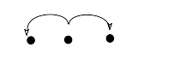
- Chain
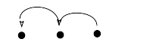
- Zigzag
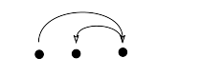

- Bouquet
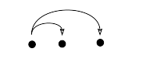
Trigrams configurations by type

Chinese

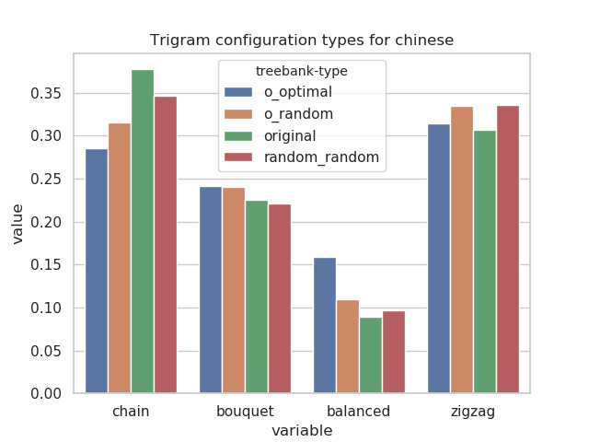

English

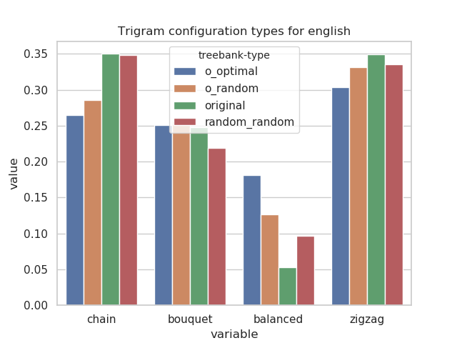

Japanese

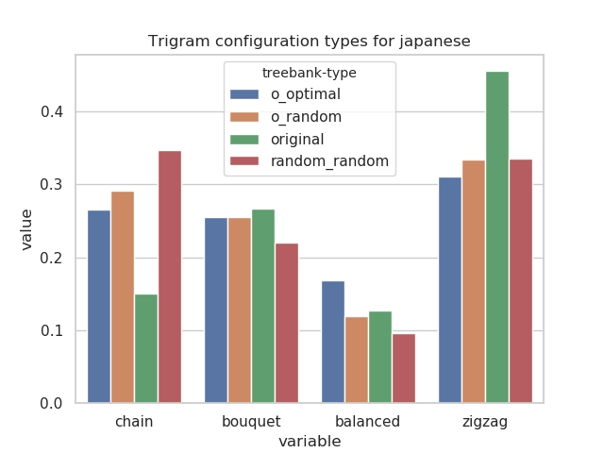

Note that this algorithm gives us a uniform probability on derivations, but that some derived trees are more probable than others, for example if the length of the tree is 4 we only have 1 derivation to obtain a tree of height 4, and 2 derivations to obtain a tree with 2 dependent on the root and 1 on one of these dependents.
Note that this does not mean that original trees have on average a higher height than original_random and original_optimal, but only that for local configurations of triplets of nodes, there is more configurations with the higher height. The mean height is always the same between original, original_random and original_optimal as the global structure is not altered. It’s also interesting to see that on average our randomly generated trees had a higher height than the original ones, which could mean that some linguistic constraints would limit the height either directly or indirectly.

