**Discovery 2021 Plan**

**eDNA Summary:** There are 137 scheduled CTD stations, and 74 samples sites were selected for eDNA sampling (see proposed sites spreadsheet). Sampling sites were selected based on 2020 sampling efforts and on an every-other basis to ensure sufficient sampling along the cruise’s track. Three niskins will be taken at each proposed sample site: bottom, midwater, and surface samples. Based on this plan, there will be 222 samples for filtered eDNA.

* Sample Numbers: E1053 to E1274

**eDNA Protocol:**

*Preparing the lab space*

1. Follow the general schematic for set-up below.
2. Anchor the peristaltic pump to ship bench using screws/eye bolts or bungee cords

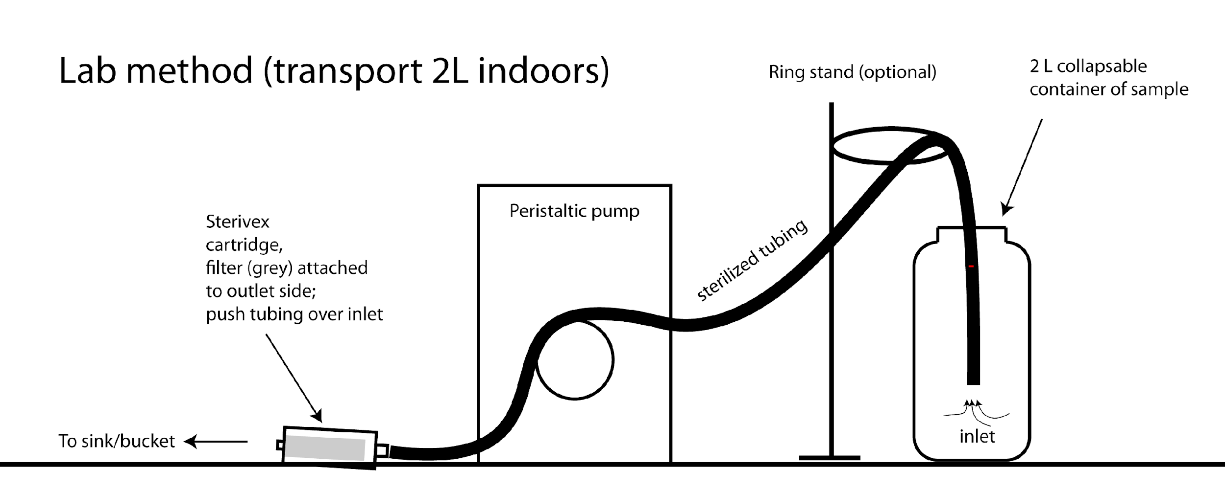

*Preparing to filter*

**Workspace -** Sterilize the workstation by wiping surfaces with a 10% bleach solution before every sampling event. If the workspace surface is wood, use the tabletop covering provided.

1. Nalgene bottle preparation
   1. Sterilized 1 L Nalgene bottles are required for every sample. Label bottle with labeling tape before collecting water sample (e.g., Niskin #, Sample #).
   2. Sterilization Method (RO Available):
      1. Soak bottles in a bucket with 10% bleach for 15 min.
      2. Dump bleach, fill with RO (10-25% full), and shake for 20-30 seconds. Repeat process 2x (= three rinses in total).
      3. Allow the bottles to air dry. Bleach a bucket and lid; set cleaned bottles facing down inside the bucket and close lid while they dry.
      4. Cap and tighten bottles to seal and maintain sterility; wrap in parafilm to keep track of which Nalgenes are sterilized.
   3. Sterilization Method with (RO Not Available):
      1. Soak bottles in a bucket with 10% bleach for 15 min.
      2. Once the CTD is on deck, take bleached Nalgenes and dispense ~250 mL of sample water from the Niskin into the bottle; close the lid and shake vigorously. Dump. This will rid the container of residual bleach. Repeat process 2x (= three rinses in total). Water must come from the same Niskin that will be the source of the actual sample; otherwise, there will be cross-contamination.
2. Tubing
   1. Prepare by soaking the tubing in a bucket with a 10% bleach solution for 15 minutes; make sure the bleach makes it into the inside of the tube.
   2. Sterilization Method (RO Available):
      1. Use an RO squirt bottle to rinse the inside of the tubing.
      2. Clean the outside of the tubing with an ethanol-soaked kimwipe.
      3. Sterile tubing can be stored with sterilized Nalgenes in a sterile bucket.
   3. Sterilization Method (RO Not Available):
      1. With a sterilized Nalgene, collect ~250 mL of Niskin sample in addition to the 1 L Nalgene sample. Before filtering through the sterivex, run the 250 mL of sample water through the tubing to clean off residual bleach.
      2. Before putting one end of the tubing into the clean sample, wipe down with an ethanol-soaked kimwipe to remove any residual bleach.
3. Hands
   1. Squirt 10% bleach solution from a squirt bottle onto new pair of gloves and rub hands together, then squirt with EtOH to get rid of the bleach residue. **Use sterilized gloves at all times.** Gloves from the box are not sterile!
4. Preparing the Bench
   1. All sterile fittings should be left in the packaging until ready to use. Organize your tubing, water catchment container, and sterivex filters for all samples at a station prior to collection. Also, pre-label whirlpaks with sampling number and pre-label the ziplocks with the cast number, location, date, etc.

*Filtering*

1. Fill Nalgene with 1 L of seawater. It is important to do this before the sample has sat on the deck in the sun. After collecting, if you don’t have time to filter, label, and store bottles in the fridge (4˚C) for up to 12 hours or overnight (not ideal).
2. Label outside of sterivex tube with eDNA sample number. Easier to do this beforehand.
3. When filtering: Attach sterile tubing to sterivex.

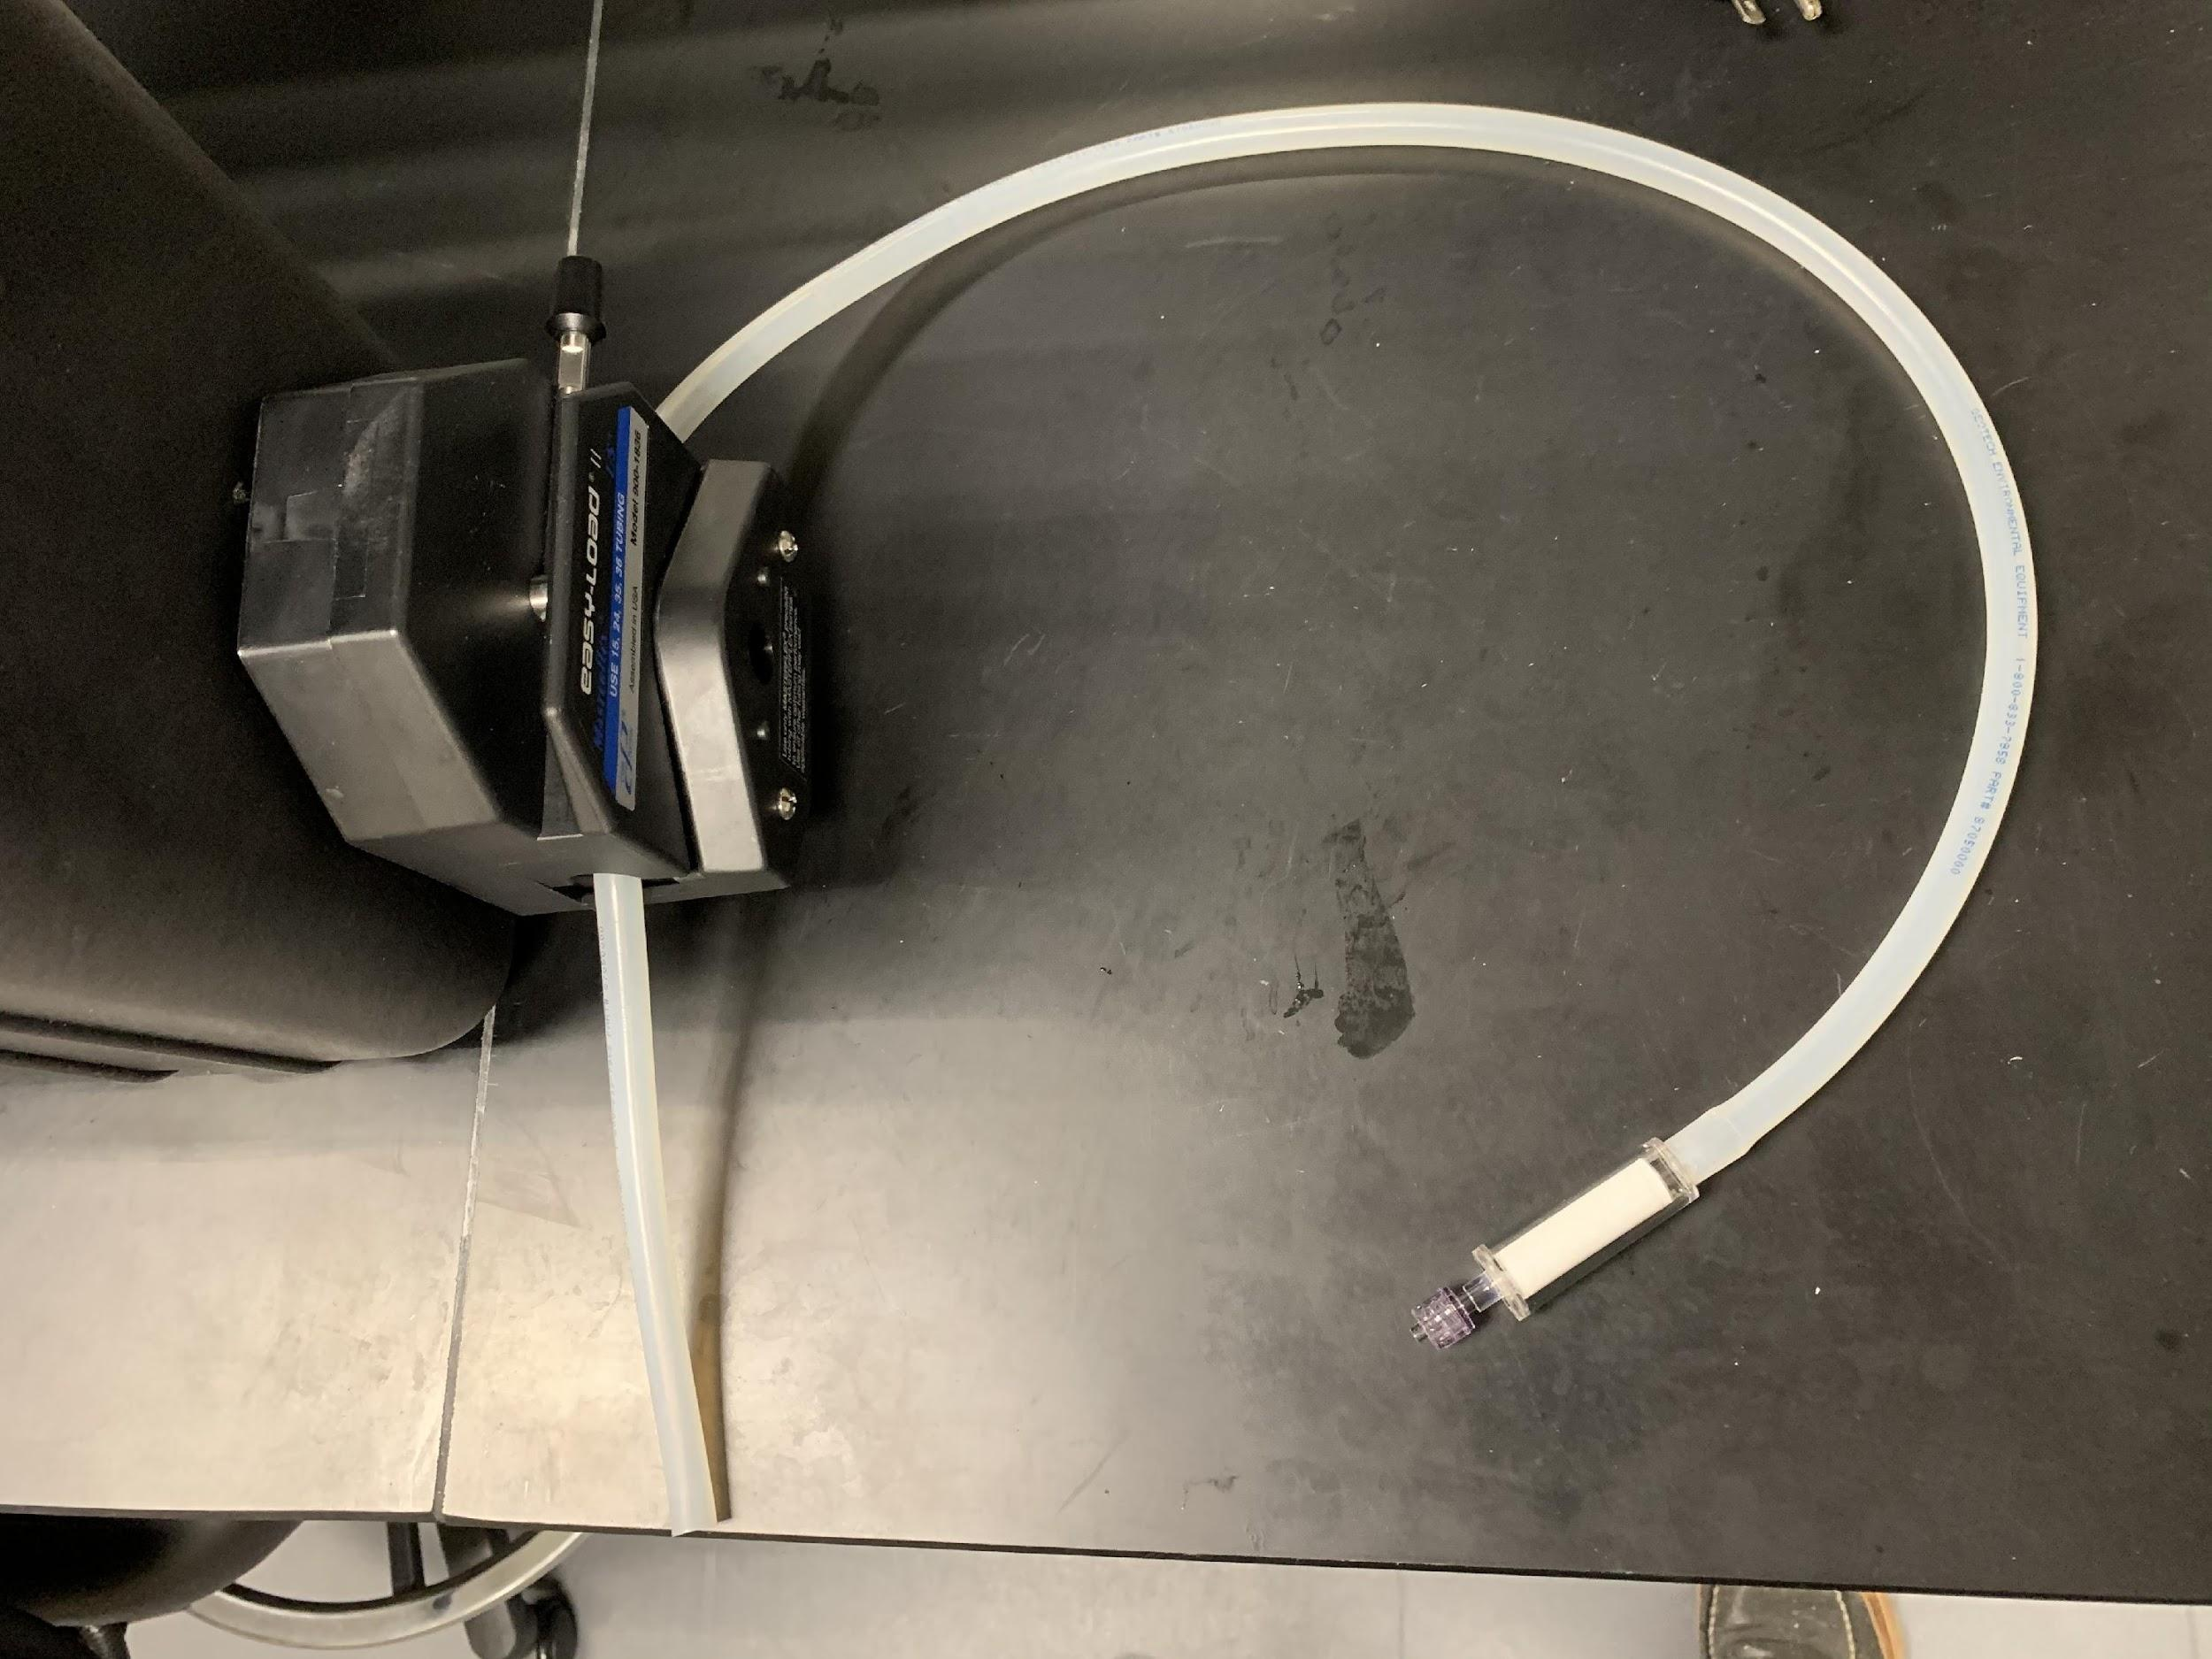

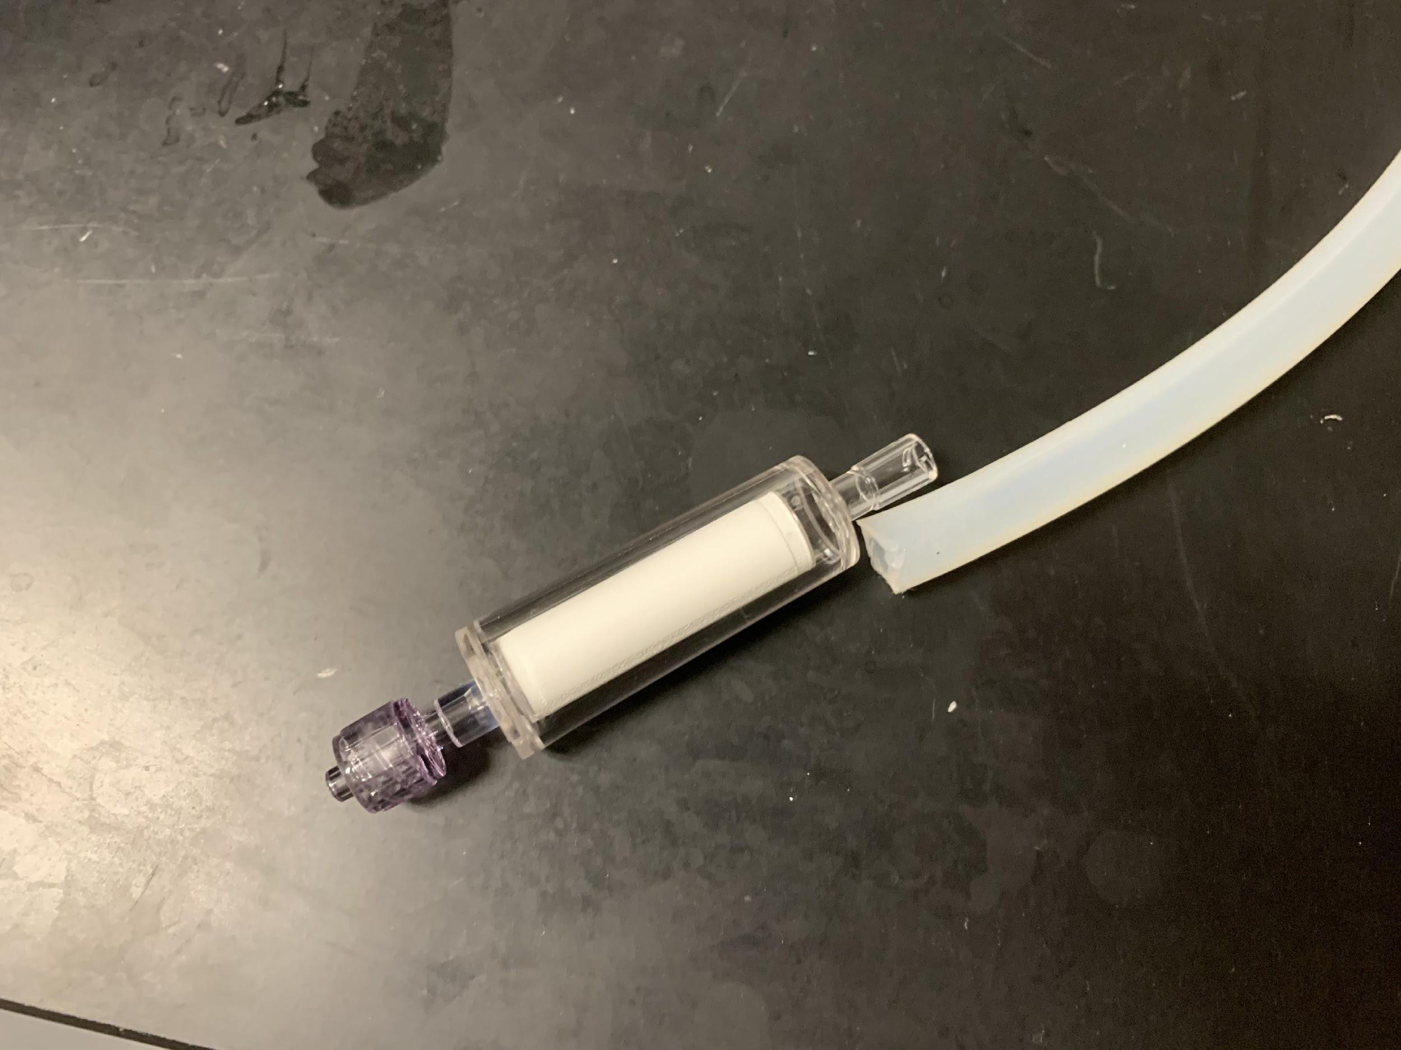

1. Outflow can be directed to the sink. Start the pump at 35-40 and adjust accordingly so that a 1 L sample takes approximately 2-4 minutes for a sample with low turbidity.
2. Once all 1 L of water is filtered, allow the water to be pumped entirely from the sterivex. Remove the sterivex from the tubing and immediately cap the female luer (outflow) end with a sterile cap. Capping the outflow prevents EtOH from leaking out in the next step.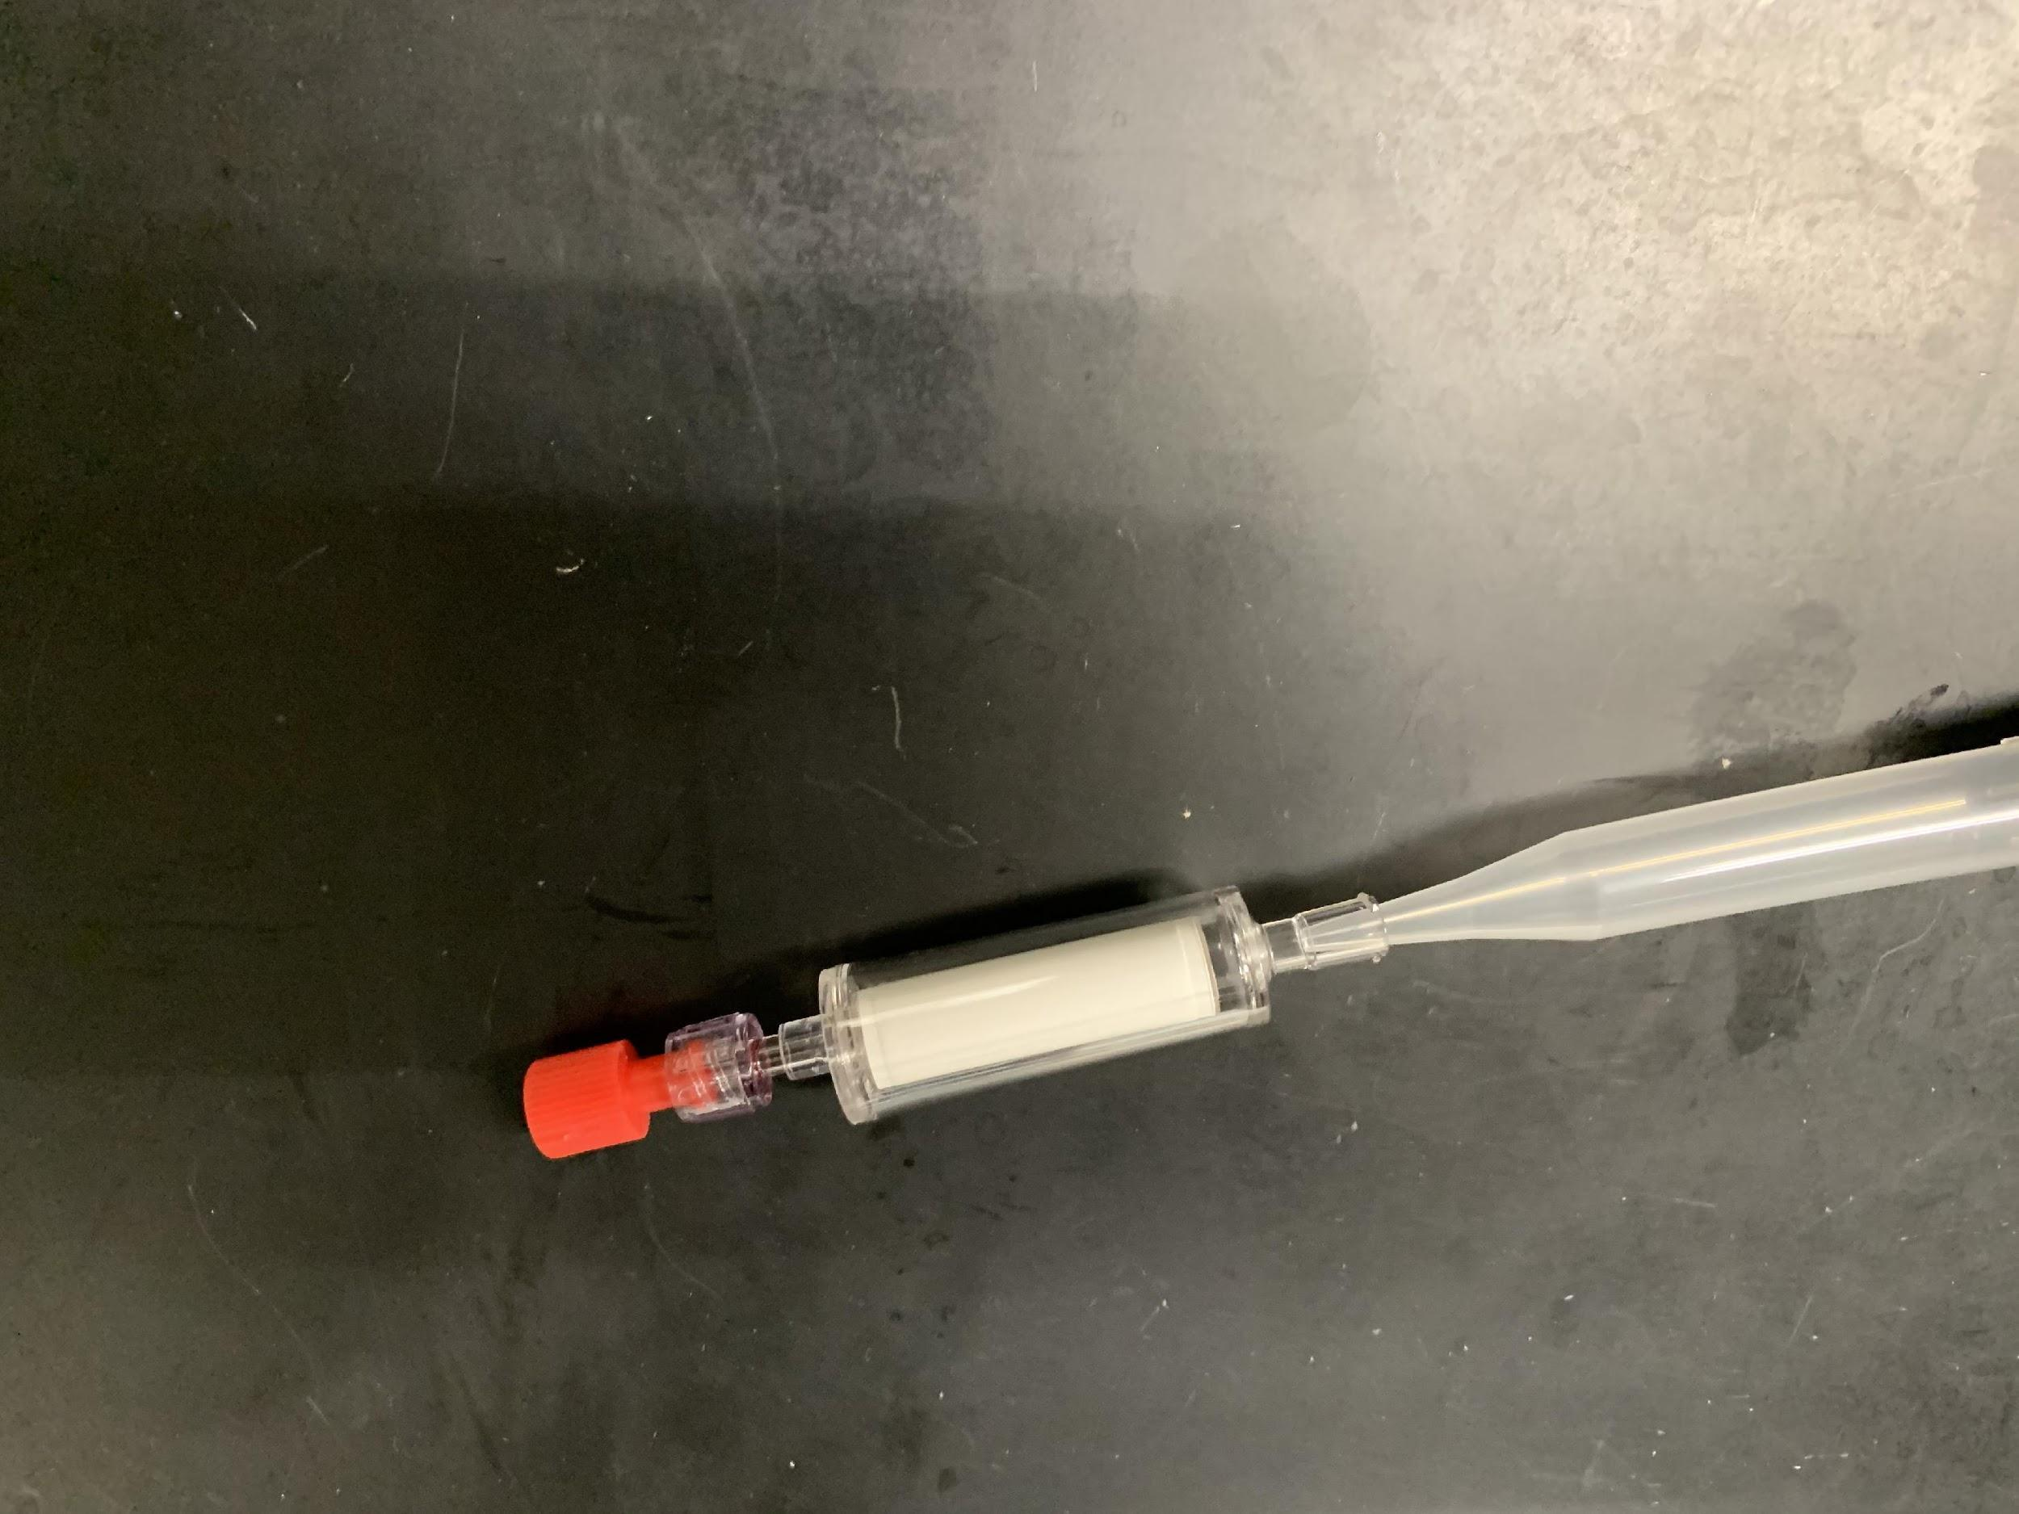
3. Using a 1 mL pipette, push the tip into the sterivex inlet to make a seal (important!) and slowly push 1 mL of 95% ethanol into the sterivex filter to fill. Repeat with a new tip, so the total volume is 2 mL.
4. Cap the remaining male luer inlet with a provided sterile cap. Turn the filter on its side and gently spin to ensure all sides of the filter paper have been saturated with EtOH.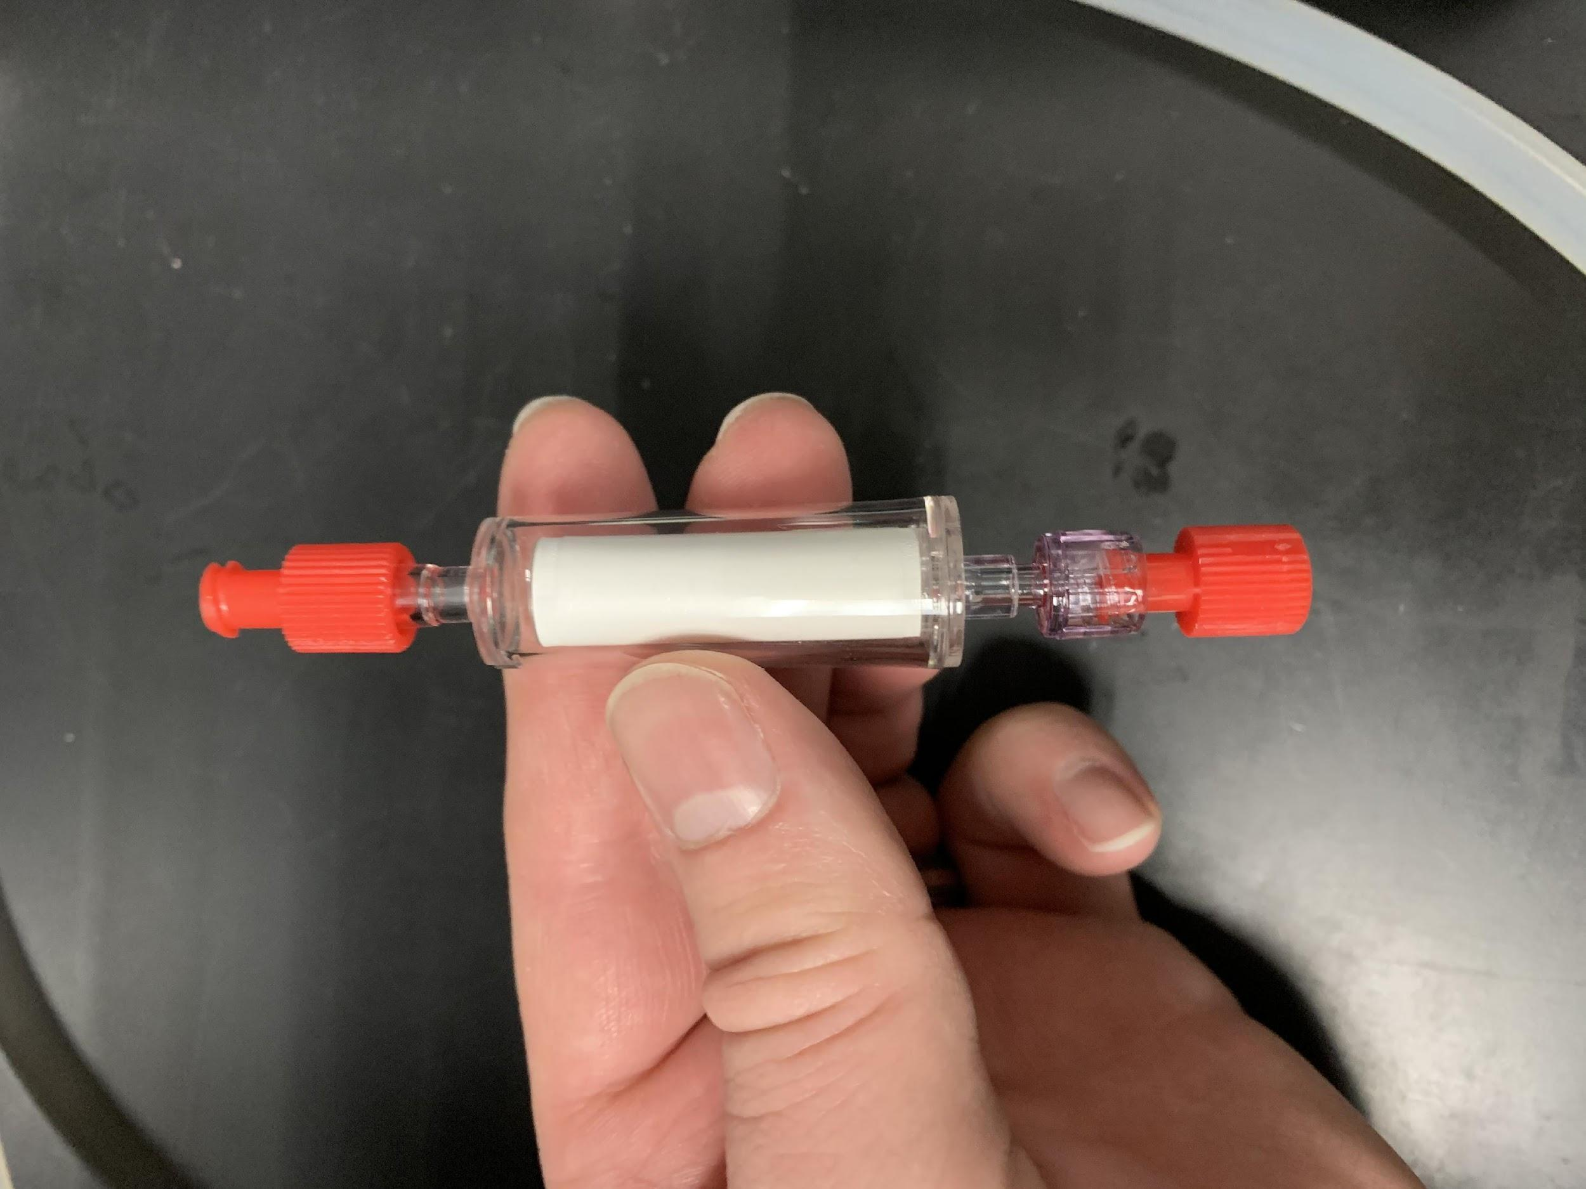
5. Put the entire sealed cartridge into a small labeled whirlpak. Place all sterivex into a single gallon ziplock bag for each cast.
6. Continue until finished! Store samples in the -20˚C freezer for the duration of the cruise.

*Negative controls*

1. At the START, 50, 100, 150, 200, and the END, pump 1 L of RO across a sterivex. Use the 1 L Nalgenes labeled as NC and filled with RO. Preserve and store this sample the same way as other samples, and it will act as a negative control.