**EcoFoci Spring Mooring Cruise 2022 Plan**

We have provided eDNA samples supplies for 57 eDNA samples and two negative controls. Site selection will be based on crew availability and previous sampling efforts. Three niskins will be taken at each proposed sample site: bottom, midwater, and surface (0 m).

**Sample #s: E1147** to **E1206**

**eDNA Protocol:**

*Preparing the lab space*

1. Follow the general schematic for set-up below.
2. Anchor the peristaltic pump to the ship bench using bungee cords or rope.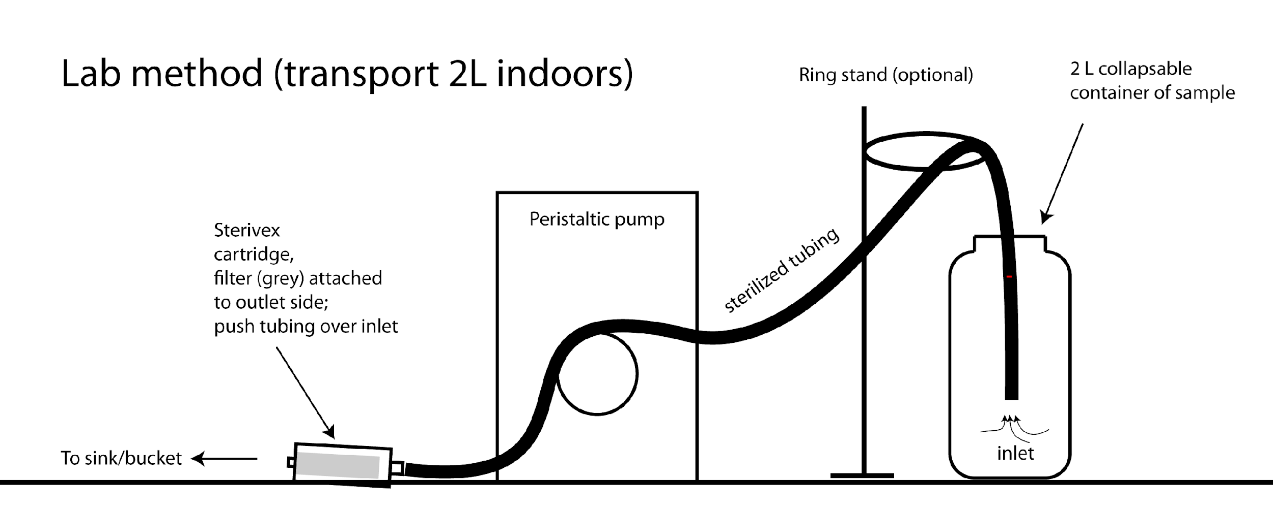



*Preparing to filter*

**Workspace -** Sterilize the workstation by wiping surfaces with a 10% bleach solution before every sampling event. If the workspace surface is wood, use the tabletop covering provided.

1. All Nalgene bottles sealed with parafilm have been sterilized and are ready for use. A sterile bottle is required for each sample. Before use, label bottle with labeling tape before collecting the water sample (e.g., Niskin #, Sample #, Surface/Mid/Bottom)
   1. Bottles containing RO (i.e., negative control) can be sealed after use and considered sterile for one future sampling event.
2. Thirty samples’ worth of tubing has been pre-sterilized, stored in a sterile bucket, and is ready for use. After being used, the tubing needs to be sterilized again (see Step 5).
3. Before each sample, squirt 10% bleach solution from a squirt bottle onto a new pair of gloves and rub hands together, then squirt with EtOH to remove the bleach residue. **Use sterilized gloves when processing samples.** Gloves from the box are not sterile!
4. Preparing the Bench - all sterile fittings should be left in the packaging until ready to use. Organize your tubing, water catchment container, and sterivex filters for all samples n bat a station prior to collection. Also, pre-label whirlpaks with sampling number and pre-label the ziplocks with the cast number, location, date, etc.
5. Sterilization Methods (only required if sterilized tubing or bottles are contaminated)
   1. Nalgene Bottles
      1. Soak bottles in a bucket with 10% bleach for 15 min.
      2. Dump bleach, fill with RO (10-25% full), and shake for 20-30 seconds. Repeat process 2x (= three rinses in total).
      3. Allow the bottles to air dry. Bleach a bucket and lid; set cleaned bottles facing down inside the bucket and close the lid while they dry.
      4. Cap and tighten bottles to seal and maintain sterility; wrap in parafilm to keep track of which Nalgenes are sterilized.
   2. Tubing
      1. Prepare by soaking the tubing in a bucket with a 10% bleach solution for 15 minutes; make sure the bleach makes it into the inside of the tube.
      2. Use an RO squirt bottle to rinse the inside of the tubing.
      3. Clean the outside of the tubing with an ethanol-soaked kimwipe.
      4. Sterile tubing can be stored with sterilized Nalgenes in a sterile bucket.

*Filtering*

1. Take a sterilized Nalgene bottle and fill with 1 L of seawater from Niskin. No tubing or specialized equipment is required for this step—label bottles to distinguish samples.
   1. It is important to do this before the sample has sat on the deck in the sun for multiple hours. After collecting, if you don’t have time to filter, label, and store bottles in the fridge (4°C) for up to 12 hours or overnight (not ideal).
2. Label sterivex tube and whirlpak with eDNA sample number. Easier to do beforehand.
   1. EcoFoci Spring Cruise: **E1147** to **E1208**
   2. Add .NC to the negative control samples

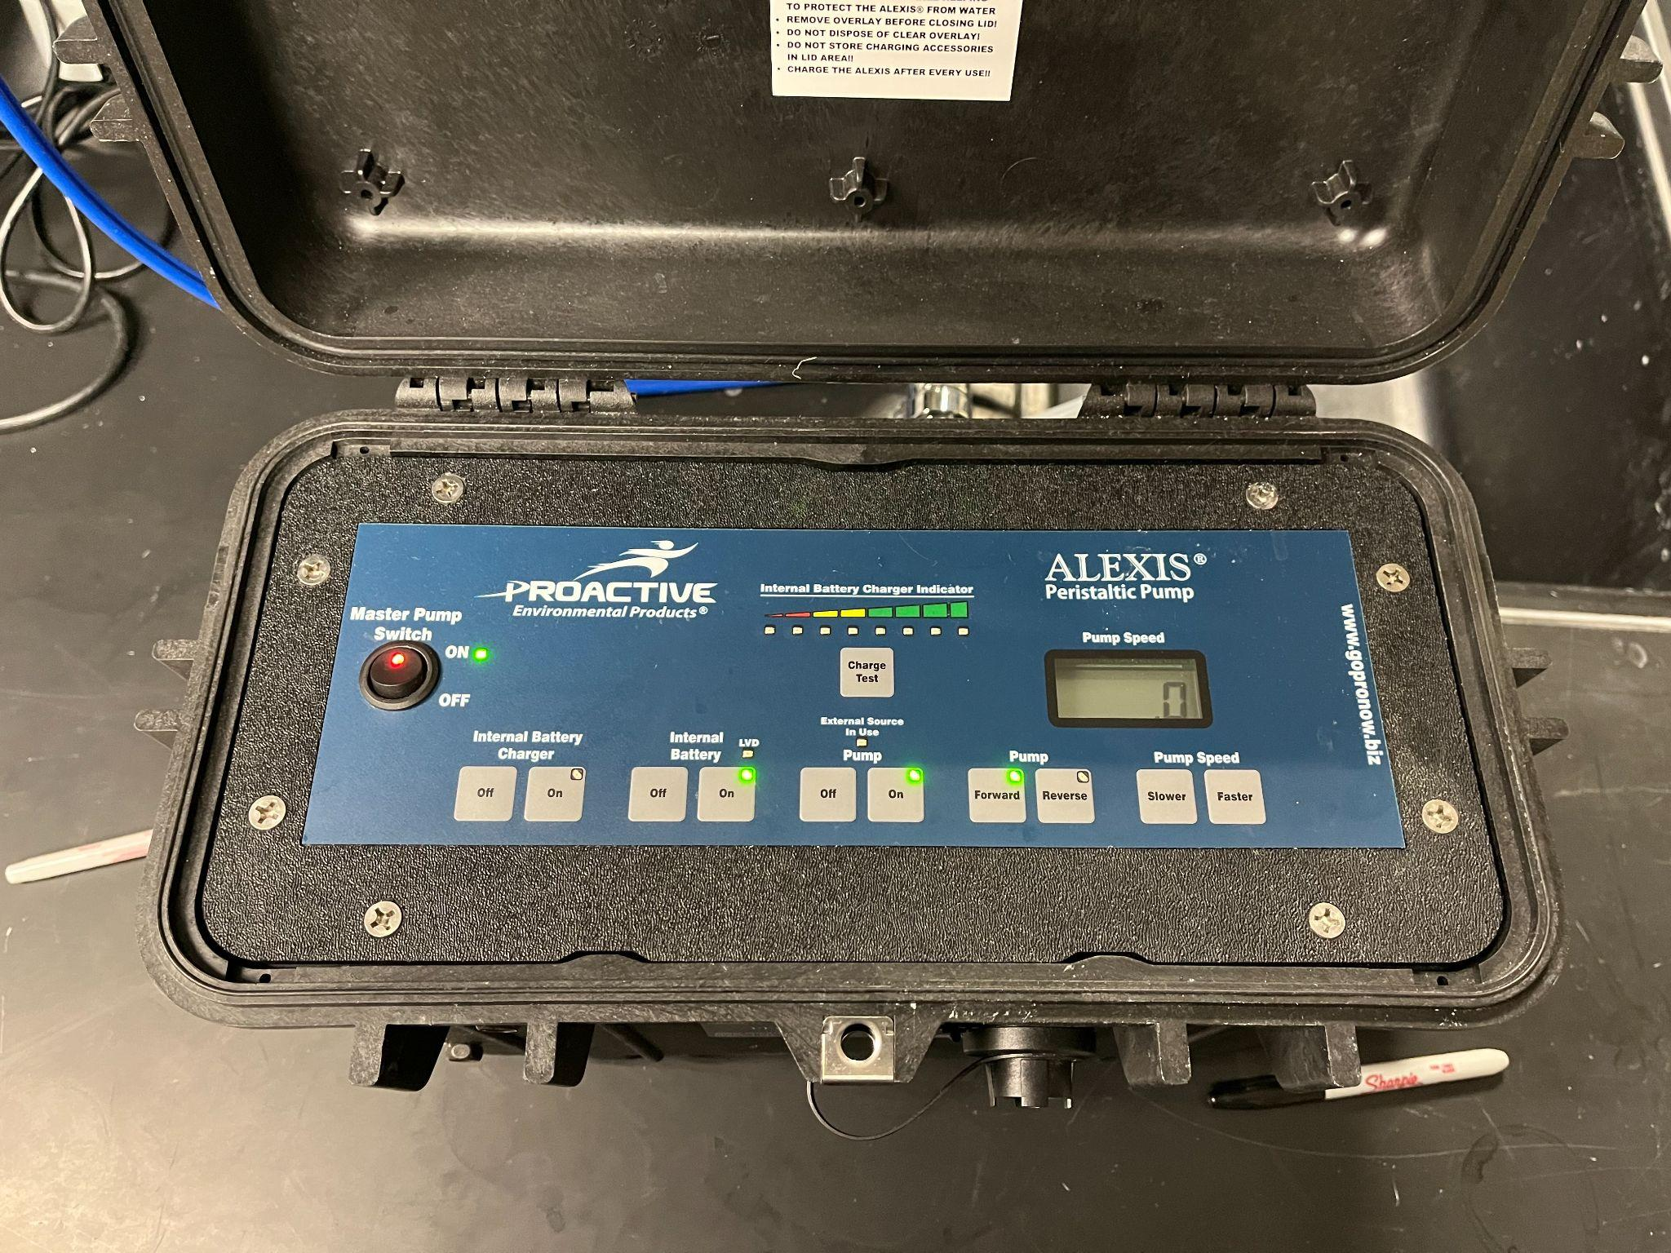

1. Start Peristaltic Pump: MasterPump Switch [On], Internal Battery [On], and Pump [On]
   1. Maximum Pump Speed: 60
   2. Pump Speed Required to Start: ~40
   3. Depending on the which side of the sink you are set up on, you may need to change the pump direction (left-side of sink → forward; right-side of sink → reverse)
2. Carefully remove sterile tubing from the bucket without touching either end. Then attach sterile tubing to sterivex. To prevent contamination, open the sterivex packaging at one end and attach the tubing. 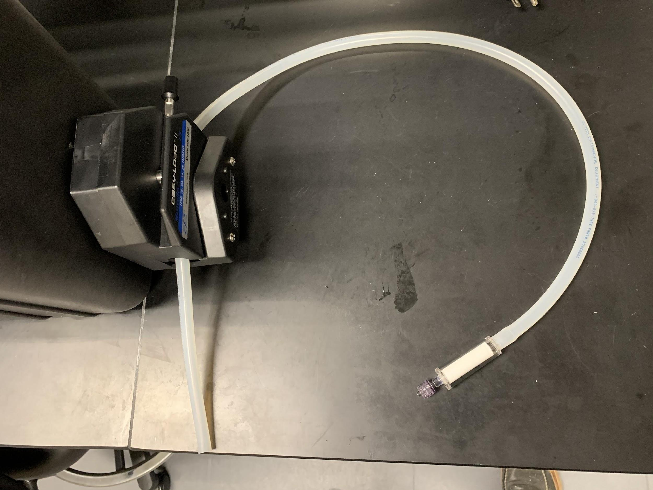

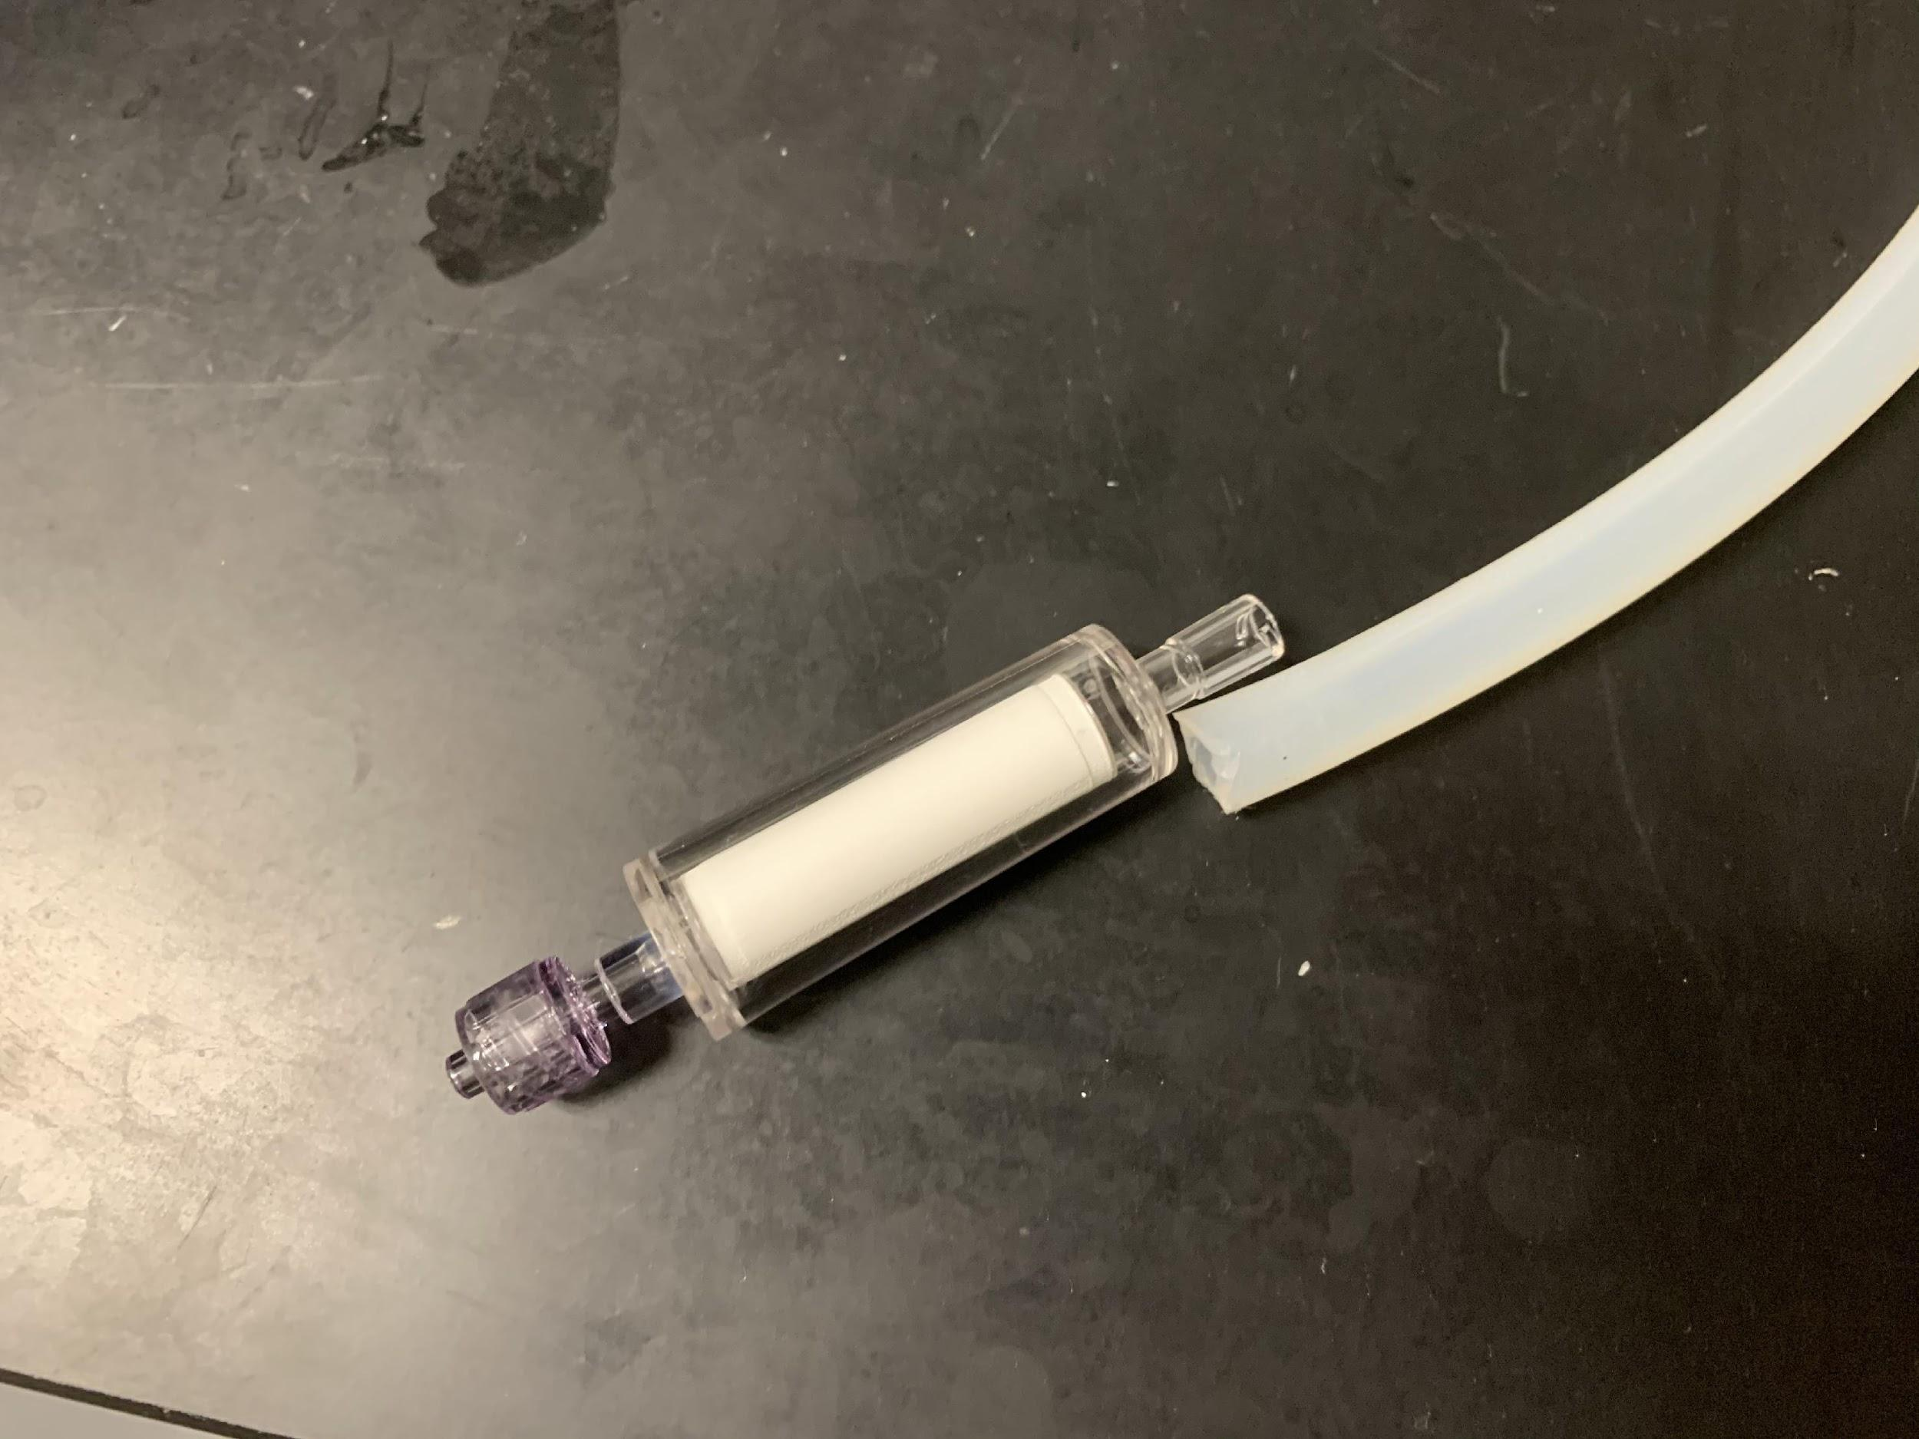

1. Outflow with sterivex can be directed to the sink. Place the other end of the sterile tubing into the 1 L Nalgene, start the pump at 35-40, and adjust accordingly so that a 1 L sample takes approximately 3-4 minutes for a sample with low turbidity.
   1. May need to tip the bottle to get all the water from the bottle.
2. Once all 1 L of water is filtered, allow the water to be pumped entirely from the sterivex (i.e., allow the pump to push air through). Remove the sterivex from the tubing and immediately cap the female luer (outflow) end with a sterile cap. Capping the outflow prevents EtOH from leaking out in the next step.
   1. When capping, avoid touching the side that will be used to seal the sterivex.
3. Using a 1 mL pipette, push the tip into the sterivex inlet to make a seal (important!) and slowly push 1 mL of 95% ethanol into the sterivex filter to fill. Repeat with a new tip, so the total volume is 2 mL.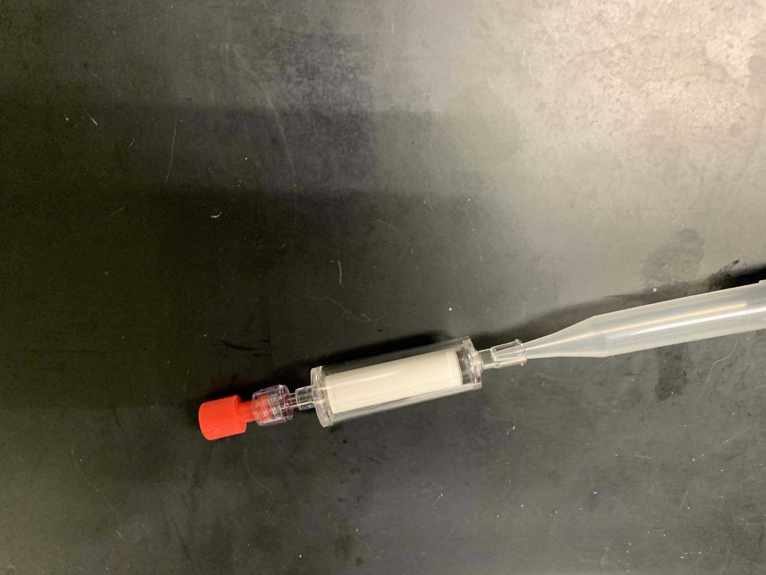
4. Cap the remaining male luer inlet with a provided sterile cap. Turn the filter on its side and gently spin to ensure all sides of the filter paper have been saturated with EtOH.

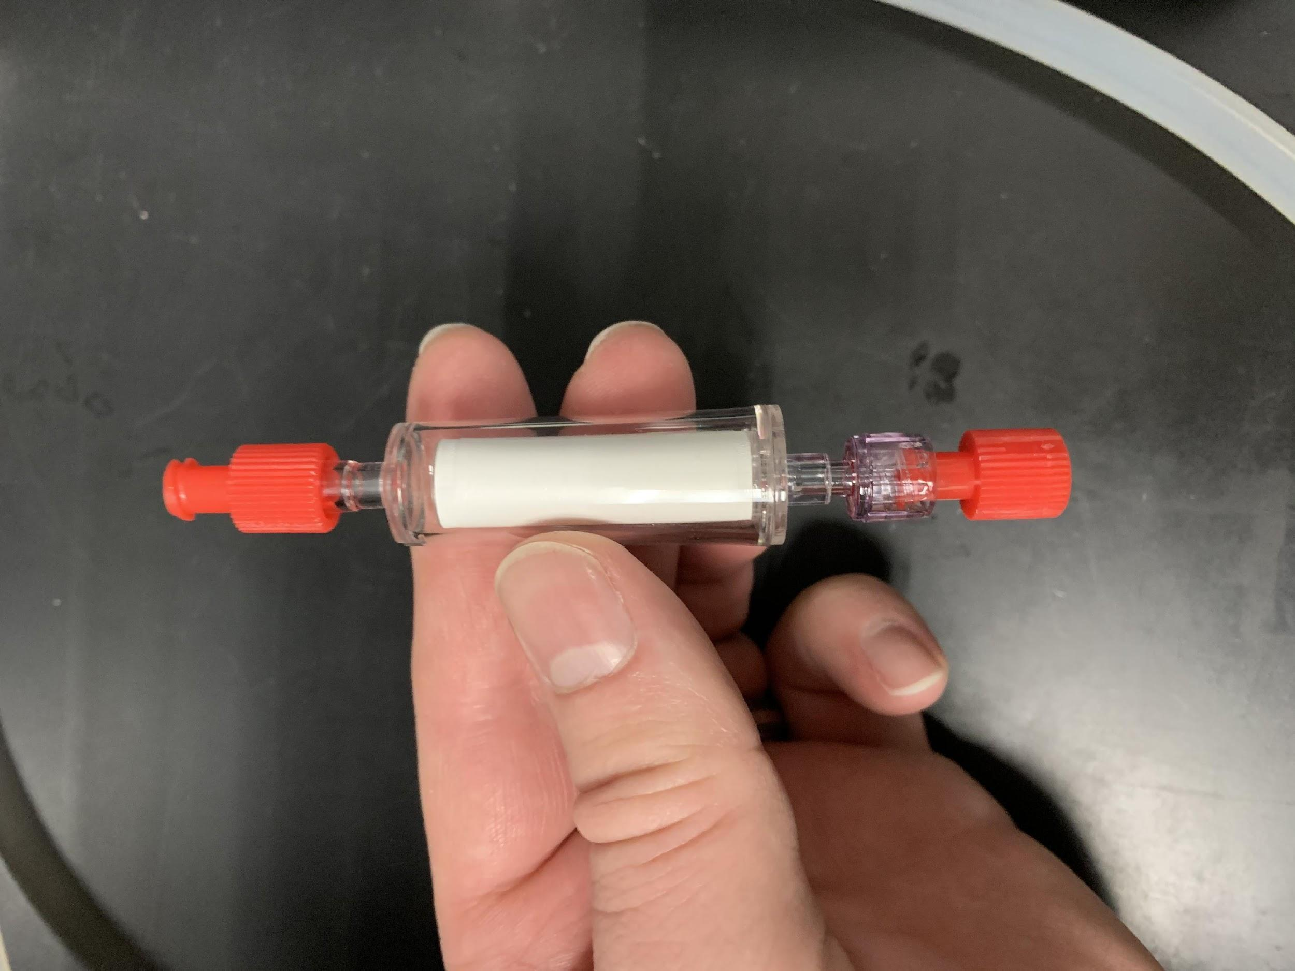

1. Put the entire sealed cartridge into a small labeled whirlpak. Place all sterivex into a single gallon ziplock bag for each cast.
2. Continue until finished! Store samples in the -20°C freezer for the duration of the cruise.

*Negative controls*

1. Before starting the sampling process and at the end of the cruise, pump 1 L of RO across a sterivex. Use the 1 L Nalgenes labeled as NC and filled with RO. Preserve and store this sample the same way as other samples, and it will act as a negative control.