**RC Alaska OA Cruise 2022**

We have provided eDNA samples supplies for 180 eDNA samples and five negative controls. Site selection aims to provide good spatial distribution but will be based on crew availability. Three niskins will be taken at each proposed sample site: bottom, midwater, and surface (0 m).

Side Note: prioritize targeting pycnocline not water masses.

**Sample #s: E1451** to **E1635**

* Negative Controls (e.g, E1451.NC); all other samples are just the # (e.g., E1452)

**eDNA Protocol:**

*Preparing the lab space*

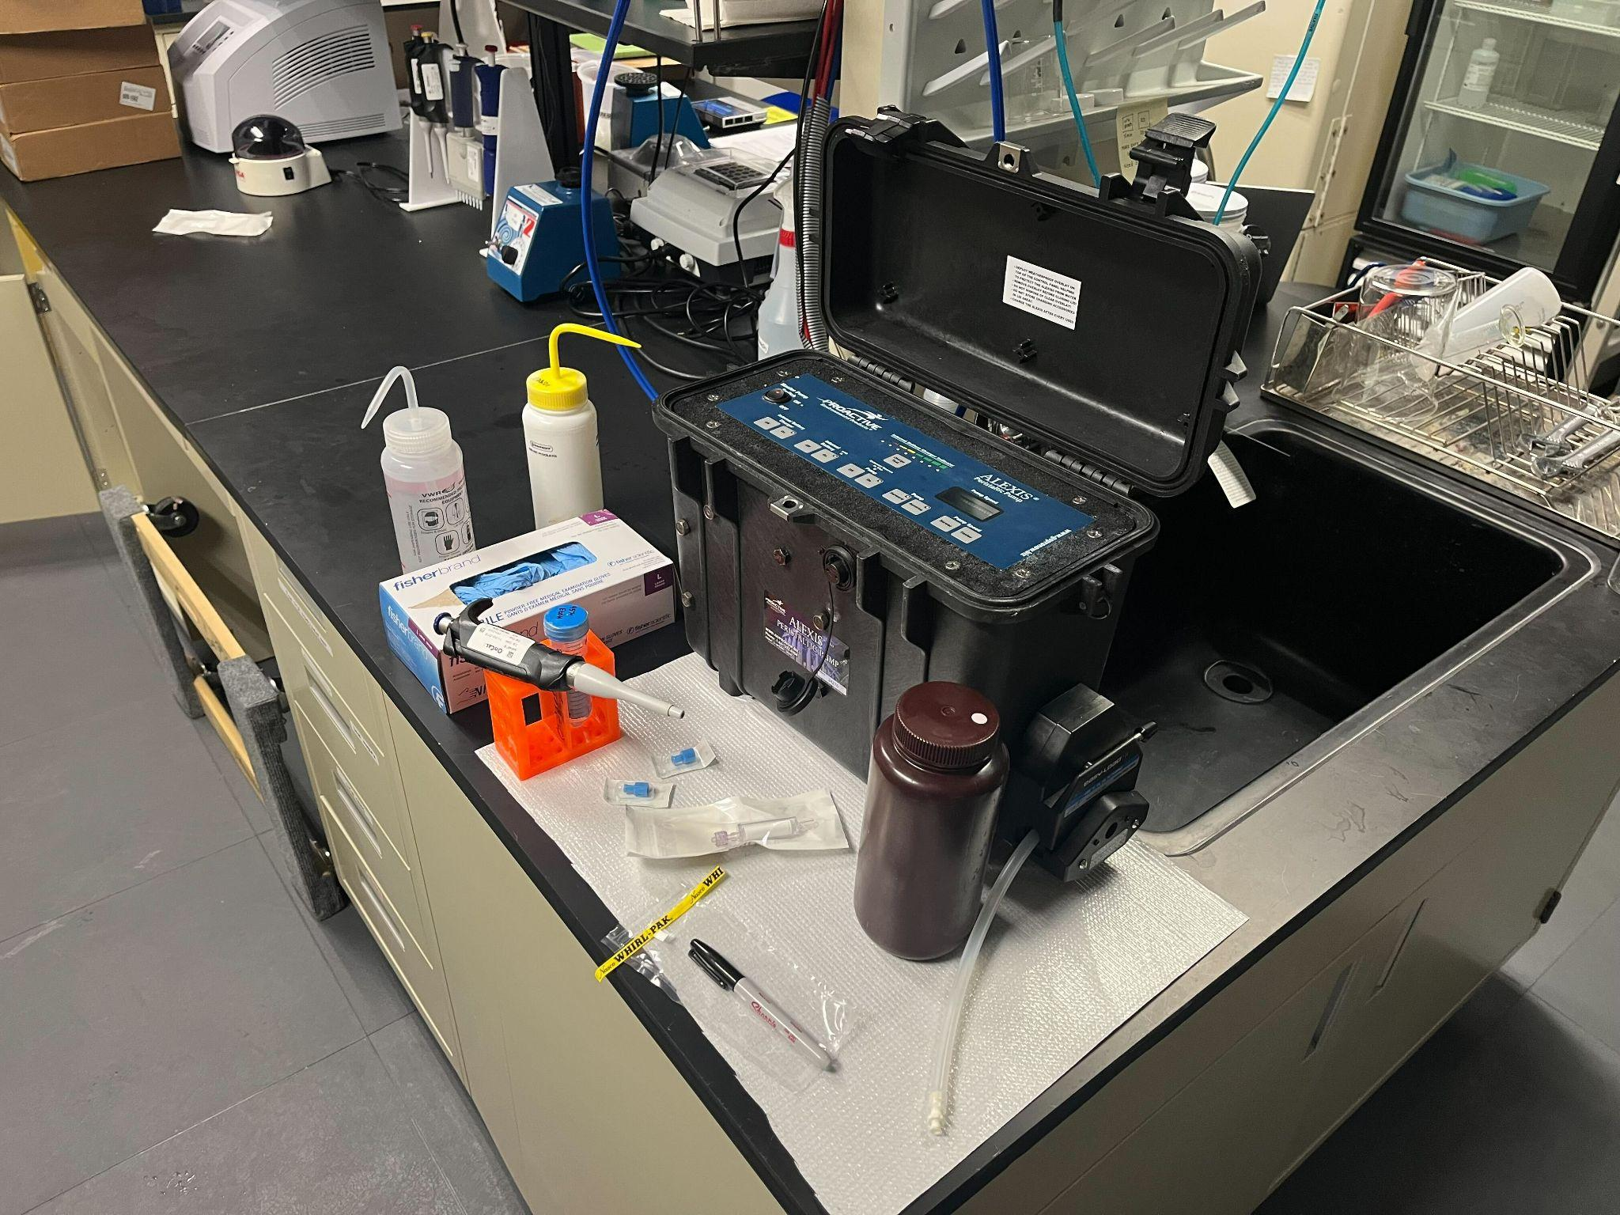

*Preparing to filter*

**Workspace -** Sterilize the workstation by wiping surfaces with a 10% bleach solution before every sampling event. If the workspace surface is wood, use the tabletop covering provided. Tabletop covering needs to be changed between each sampling station, or if spill occurs.

1. All Nalgene bottles sealed with parafilm have been sterilized and are ready for use. A sterile bottle is required for each sample. Before use, label bottle with labeling tape before collecting the water sample (e.g., Niskin #, Sample #, Surface/Mid/Bottom)
   1. Bottles containing RO (i.e., negative control) can be sealed after use and considered sterile for one future sampling event.
2. Thirty-five stations worth of tubing have been pre-sterilized, stored in a sterile bucket, and are ready for use. After being used, the tubing needs to be sterilized again (see Sterilization).
3. Before each sample, squirt 10% bleach solution from a squirt bottle onto a new pair of gloves and rub hands together, then squirt with EtOH to remove the bleach residue. **Use sterilized gloves when processing each sample.** Gloves from the box are not sterile!
4. Preparing the Bench - all sterile fittings should be left in the packaging until ready to use. Organize your tubing, water catchment container, and sterivex filters for all sample. Also, pre-label whirlpaks with sampling number and pre-label the ziplocks with the cast number, location, date, etc.

*Filtering*

1. Take a sterilized Nalgene bottle and fill with 1 L of seawater from Niskin (i.e., up until the bottom of the bottle’s neck). No tubing or specialized equipment is required for this step—label bottles to distinguish samples.
   1. It is important to do this before the sample has sat on the deck in the sun for multiple hours. After collecting, if you don’t have time to filter, label, and store bottles in the fridge (4°C) for up to 12 hours or overnight (not ideal).
2. Label whirlpak with eDNA sample number. Easier to do beforehand.
   1. RC Alaska OA Cruise: **E1451** to **E1635**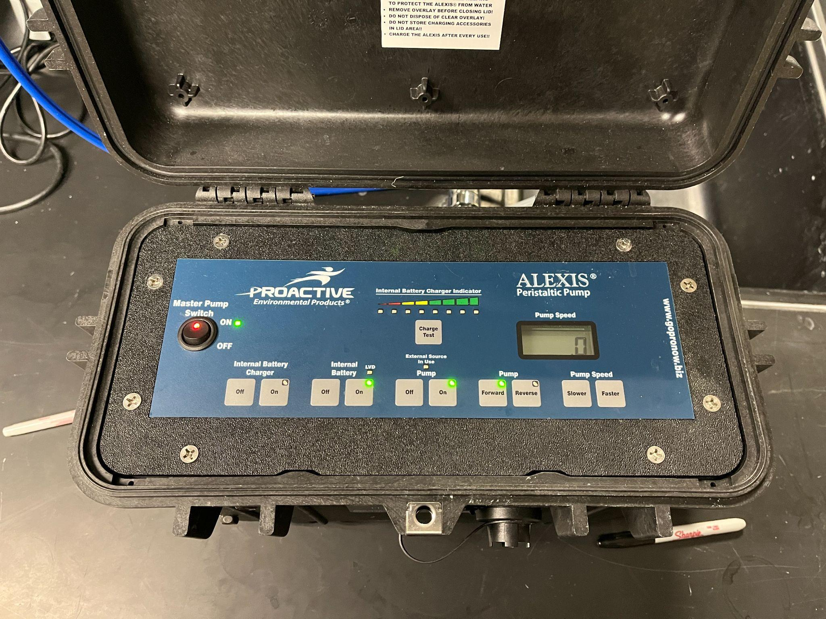
   2. Add .NC to the negative control samples
3. Start Peristaltic Pump: MasterPump Switch [On], Internal Battery [On], and Pump [On]
   1. Maximum Pump Speed: 60
   2. Pump Speed Required to Start: ~30
   3. Pump Direction: Forward
4. For the first sample of each station, remove sterile tubing from the bucket without touching either end. Attach a white female luer barb to the tubing, then attach the male end of the sterile sterivex.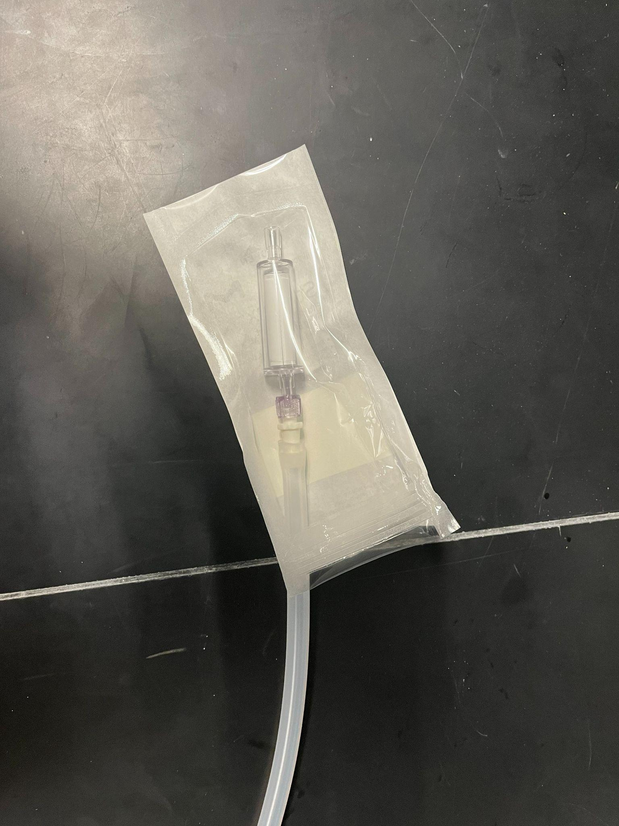
   1. Open the sterivex packaging at one end and attach the tubing to maintain sterility.
5. Tubing outflow can be directed to the sink. Place the end with sterivex into the 1 L Nalgene, make sure the sterivex opening is submerged, start the pump at 35-40, and adjust accordingly so that a 1 L sample takes 3-4 minutes for a sample with low turbidity.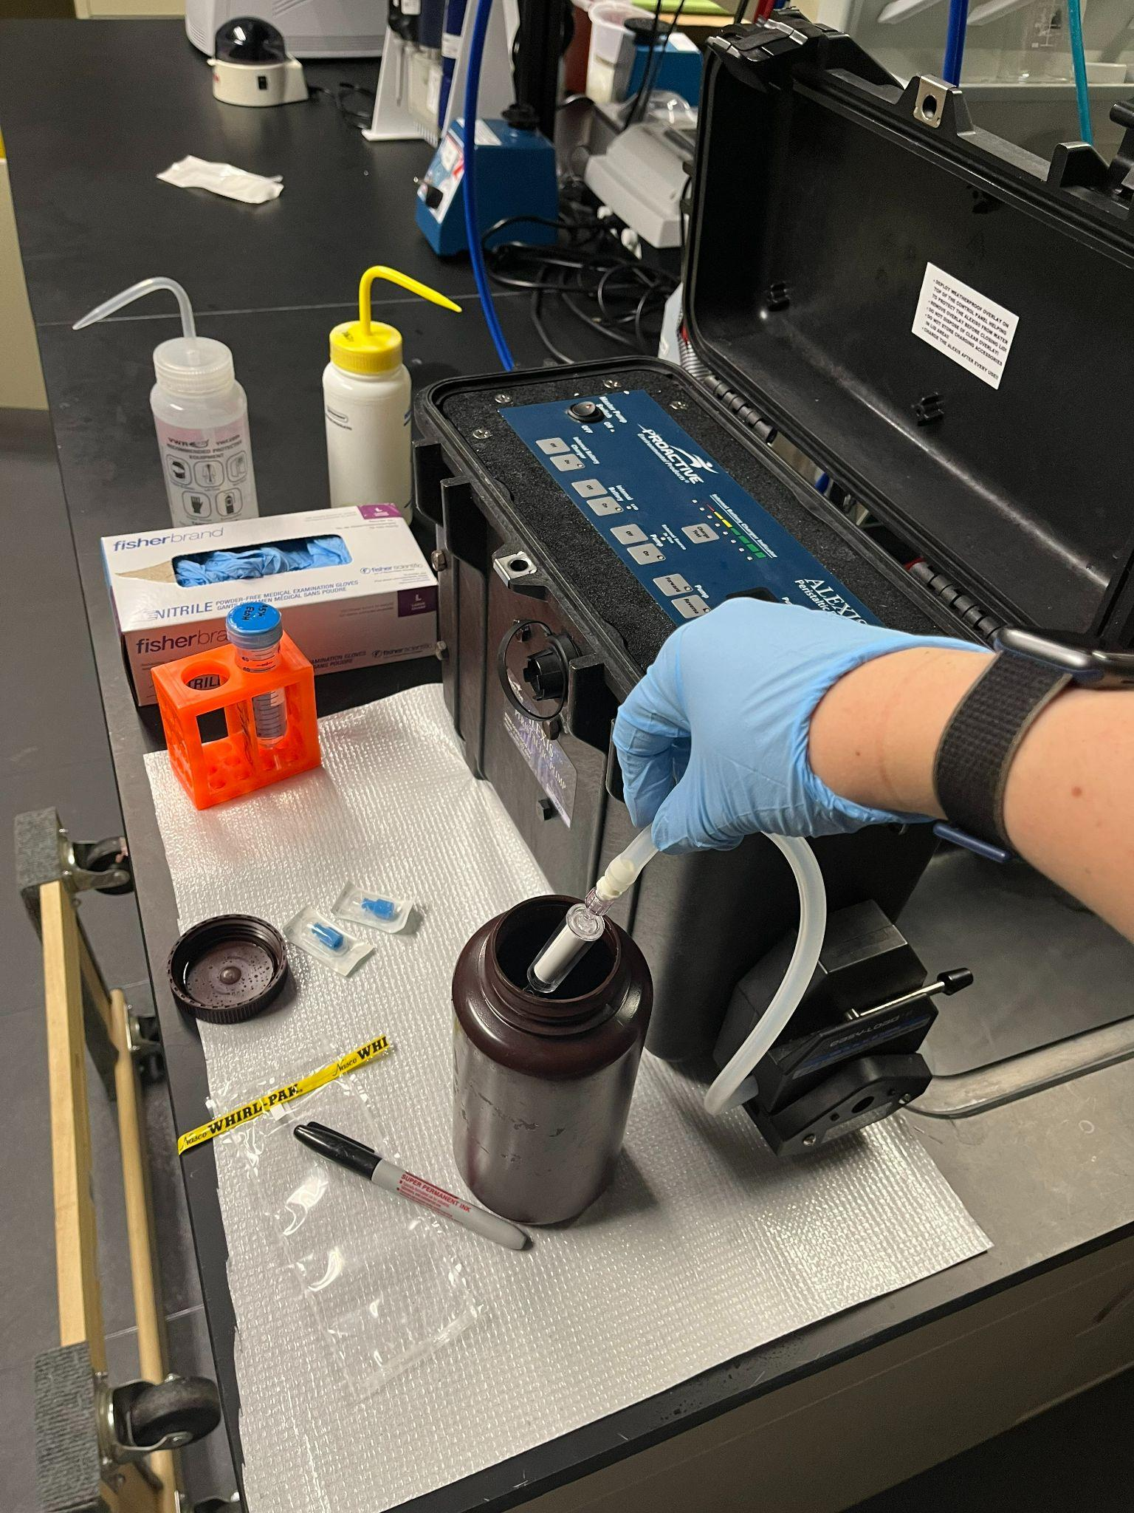
   1. Do not submerge the entire sterivex (i.e., the non-sterile female luer barb)
   2. Tip the bottle to get all the water.
6. Once all 1 L of water is filtered, allow the water to be pumped entirely from the sterivex (i.e., allow the pump to push air through). Remove the sterivex from the tubing and immediately cap the female luer end (i.e., end previous attached to white barb/tube) with a sterile cap. Capping the outflow prevents EtOH from leaking out in the next step.
   1. When capping, avoid touching the side that will be used to seal the sterivex. Strategically open the sterile package in which the cap is contained.

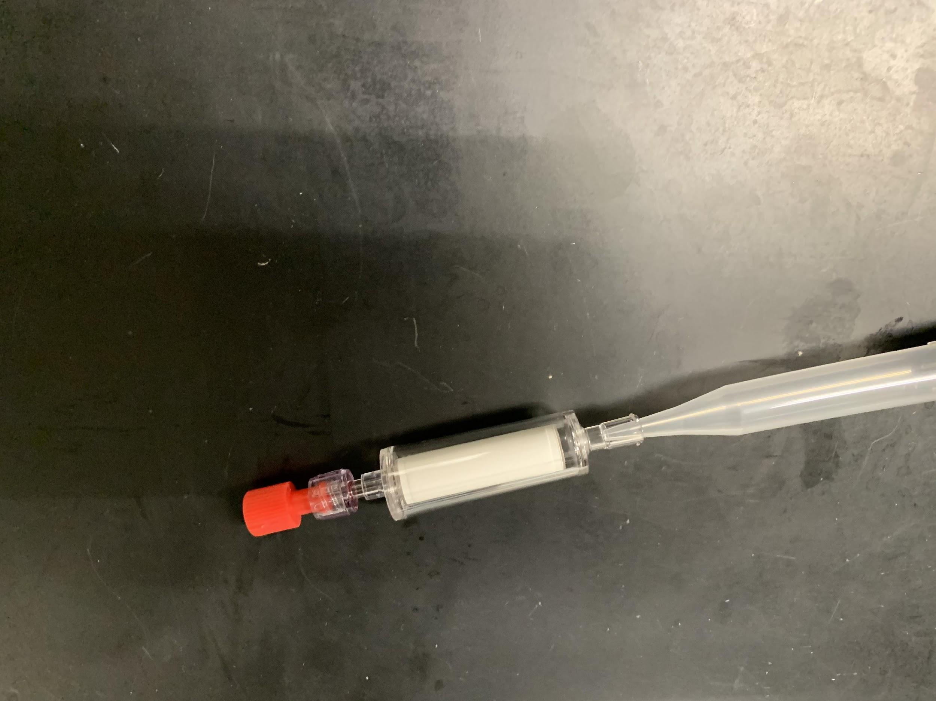

1. Using a 1 mL pipette, push the tip into the sterivex inlet to make a gentle seal and slowly push 1 mL of 95% ethanol into the sterivex filter to fill. Repeat with a new tip, so the total volume is 2 mL.
2. Cap the remaining male luer inlet with a provided sterile cap. Turn the filter on its side and gently spin to ensure all sides of the filter paper have been saturated with EtOH.

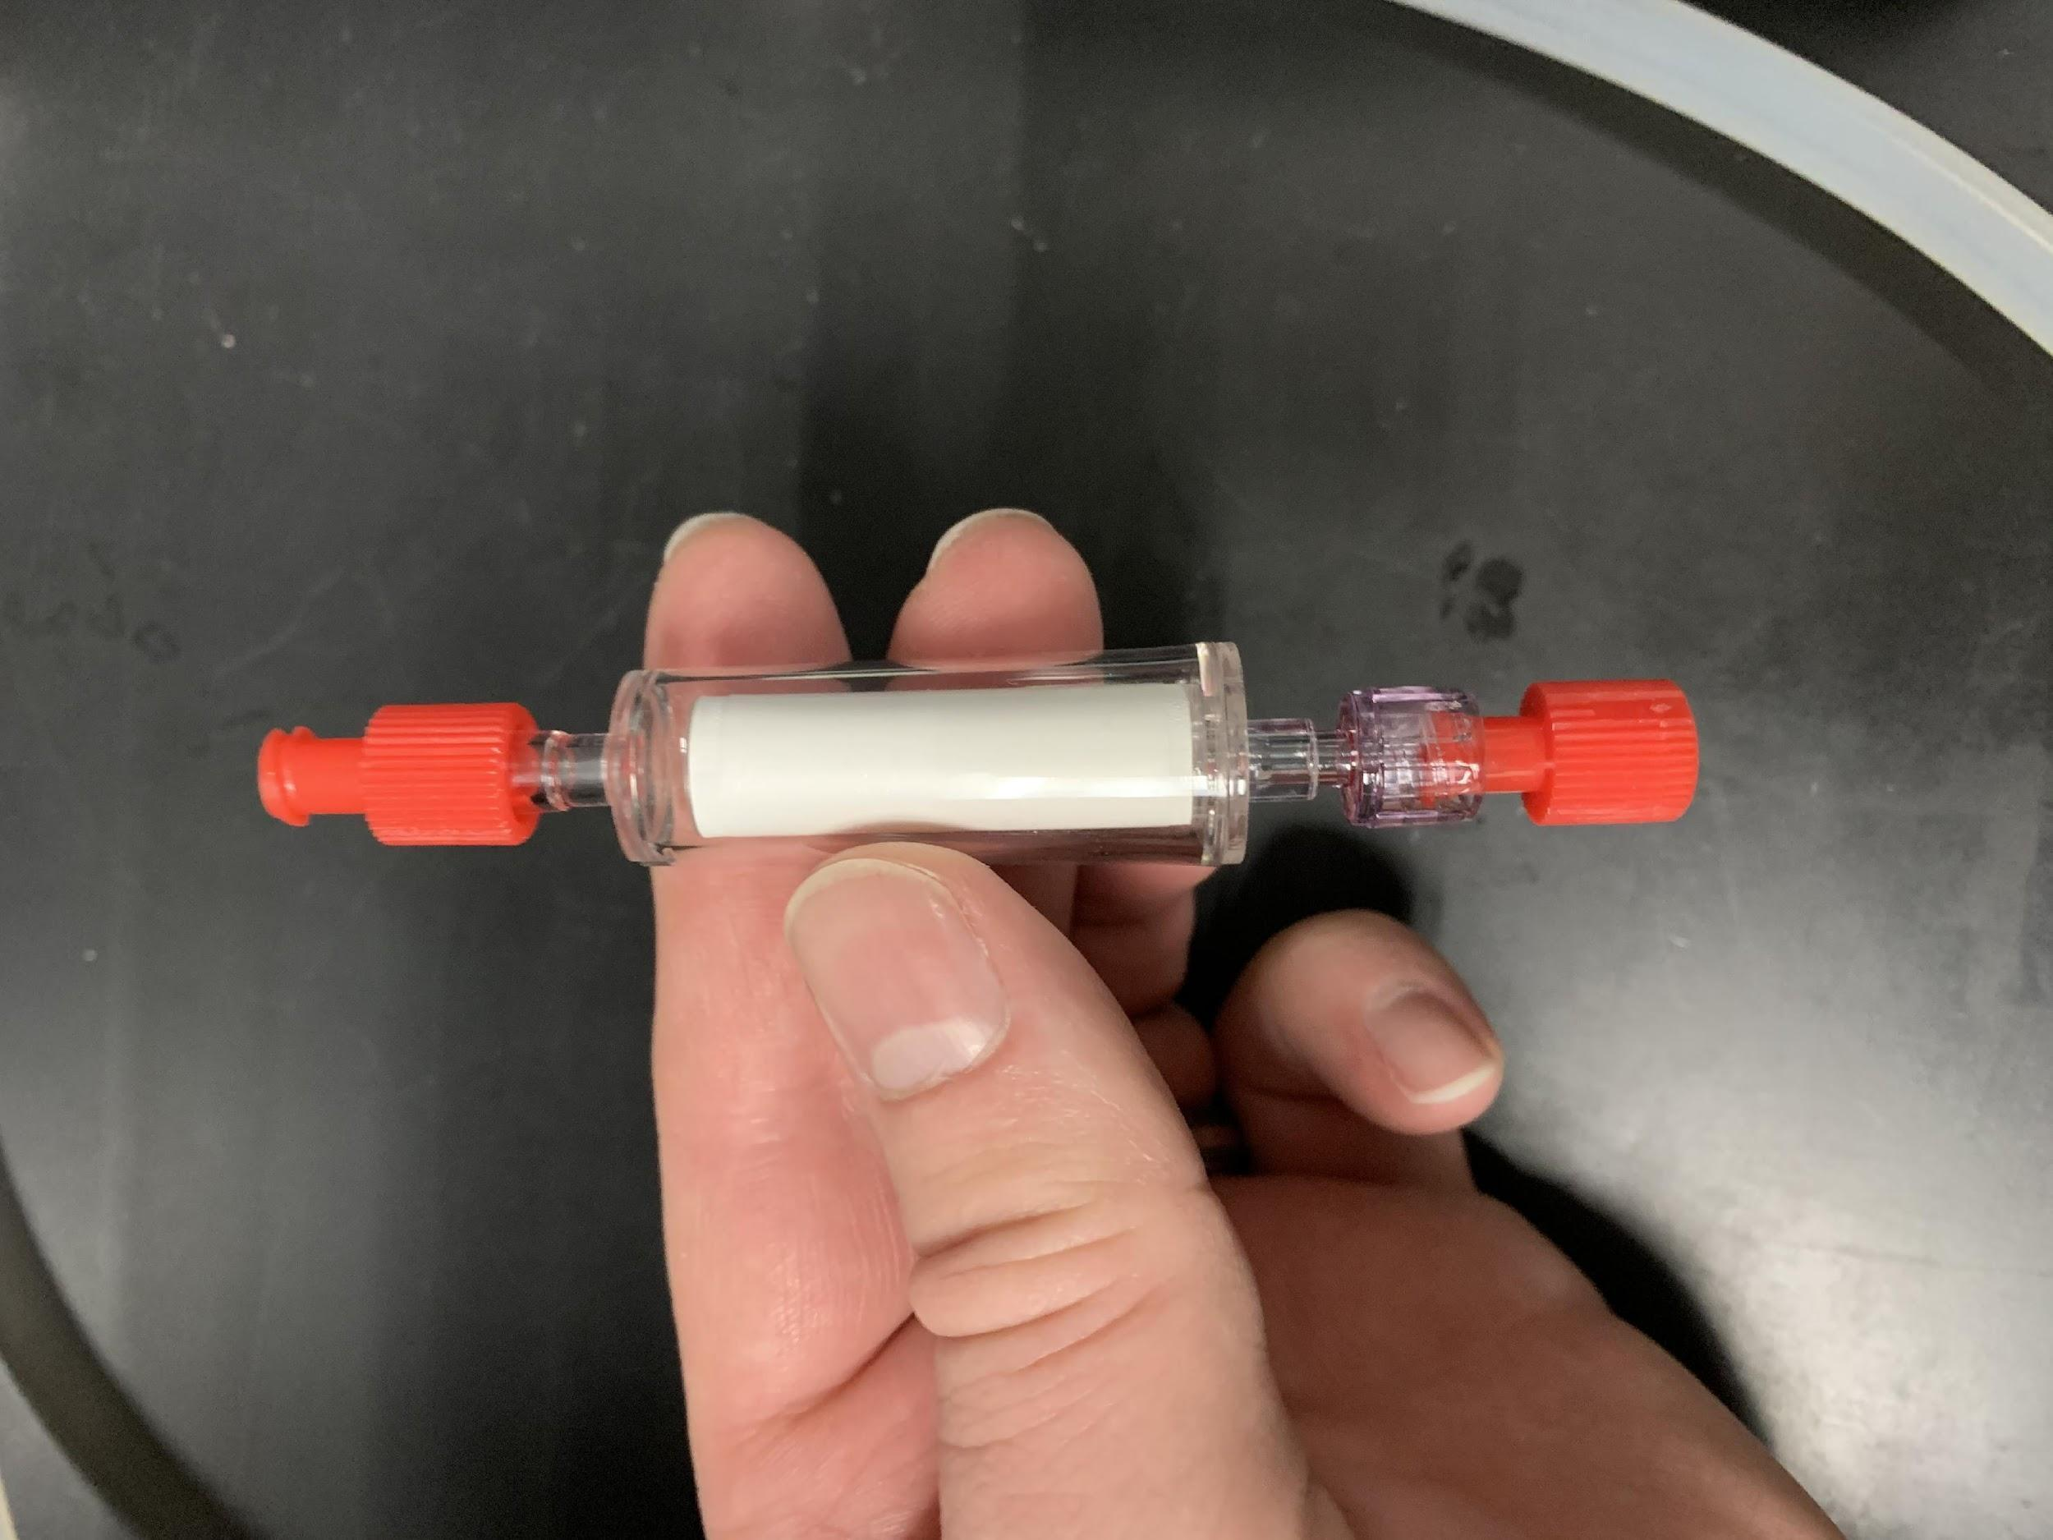

1. Label sterivex with sampling number. Put the entire sealed cartridge into a small labeled whirlpak. Place all sterivex into a single gallon ziplock bag for each cast.
2. Continue until finished! Store samples in the -20°C freezer for the duration of the cruise.

*Negative controls*

1. Before starting the sampling process, intermittently throughout the cruise (i.e., every 30-50 samples), and at the end of the cruise, pump 1 L of RO across a sterivex. Use the 1 L Nalgenes labeled as NC and filled with RO. Preserve and store this sample the same way as other samples, and it will act as a negative control.

*Sterilization*

Nalgene Bottles

1. Sterilization Method (RO Available):
   1. Fill bottles entirely with 10% bleach, cap them, and allow to sit in a bucket for 15 min (Option 1), or fill bottles with 200-300 mL of 10% bleach, cap them, and shake for 30-45 seconds (Option 2).
      1. Both options are good; please select the most appropriate for your team.
   2. Dump bleach, fill with RO (10-25% full), and shake for 20-30 seconds. Repeat process 2x (= three rinses in total). Bleach can be reused on numerous bottles.
   3. Cap and tighten bottles to seal and maintain sterility; wrap in parafilm to keep track of which Nalgenes are sterilized. No air drying required.
2. Sterilization Method with (RO Not Available):
   1. Use either Option 1 or 2 listed above in 1a.
   2. No RO rinse is required. Unless you plan to immediately use the bleached bottles, place them while open with their cap into a sterile bucket to air dry.
   3. Once the CTD is on deck, take bleached Nalgenes and dispense ~250 mL of sample water from the Niskin into the bottle; close the lid and shake vigorously. Dump. This will rid the container of residual bleach. Repeat process 2x (= three rinses in total). Water must come from the same Niskin that will be the source of the actual sample; otherwise, there will be cross-contamination.

*If using the RO available method, bottles can be sterilized days in advance. However, if using the bleaching method, please only prepare bottles ~1 day in advance to avoid bleach damage.

Tubing

1. Prepare by soaking the tubing in a bucket with a 10% bleach solution for 15 minutes; make sure the bleach makes it into the inside of the tube.
2. If you plan to use the tubing in the next 1-2 days, no RO rinse is required. Instead, tubes can be returned to a sterilized bucket to air dry and are ready to use. If not, use the RO squirt bottle provided to rinse the inside of the tubing and wipe down the outside of the tubing with EtOH then return to the sterilized bucket.
3. At the end of the cruise, to avoid bleach damage, please give all tubes a quick rinse in tap water to ensure there is no residual bleach left on the tubing. Don’t use tubes rinse in tap water for any subsequent sampling.

Buckets

1. For a bucket to be sterile, it needs to be rinsed in a 10% bleach solution followed by 3x RO rinses. Do not fill the entire bucket for this process; instead simply fill the bucket with ~1 L and shake. A bucket can be sterilized and then used multiple times, as long as it’s only used to hold sterile tubing or sterile bottles.

*Charging the Peristaltic Pump*

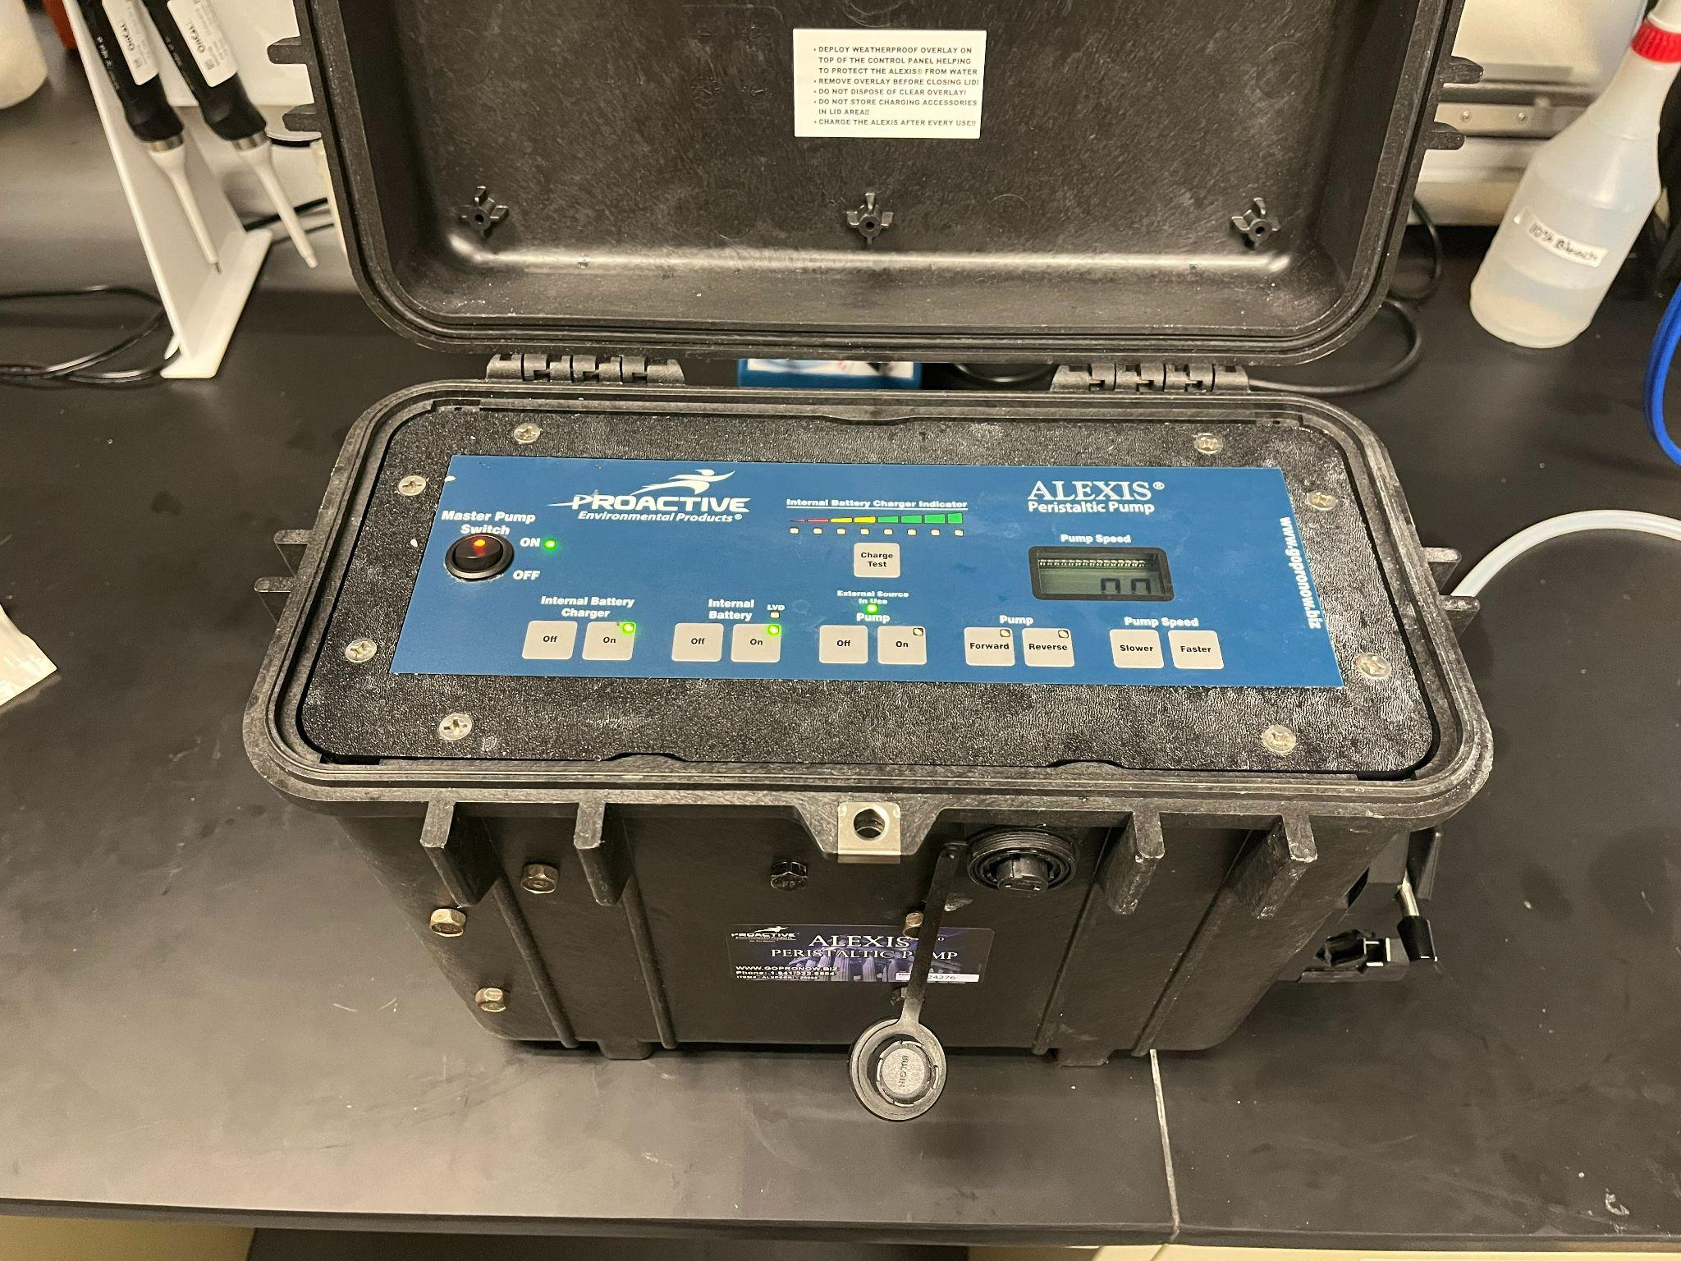

1. If the pump appears to be operating at a slower pace (i.e., low on battery), use the cable provided to charge the peristaltic pump. Connect the cable to the port on the front-side.
   1. The Charge Test on the pump is inaccurate. If you need to determine the pump’s charge, plug in the cable and a percentage (e.g., 25%, 100%) will be shown on the cable’s transformer.
2. Charge Peristaltic Pump: MasterPump Switch [On], Internal Battery Charge [On], and Internal Battery [On]