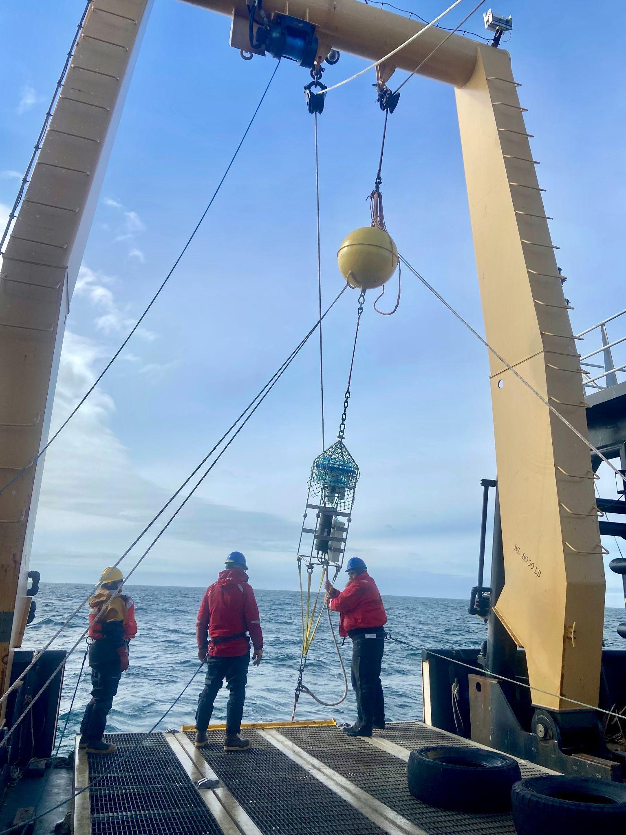**Ocean Molecular Ecology: Automated Sampler Recovery**

Written by: Shannon Brown (Cell: 847-445-2292)

**Automated Sampler Recovery**

* Recovery is usually 2-picks unless craned from the side. Direction of the sampler for recovery doesn’t matter.
* For easier storage in a wooden crate, remove shackles from top of sampler and the bridle from the bottom.
* Sampler can be stored vertically or horizontally. After samples are removed, the preference is to move the sampler to its wooden crate within 1-2 days.
  + The wooden crate can be stored indoors or in a relatively dry area outdoors.

**Removing Samples**

* Remove deer fencing attached with zip ties. If mangled, toss. If not, throw it in the crate.
  + If any filter holders have been dislodged or become unattached, determine their number by the label on their tubing or by process of elimination (i.e., what port is empty). Then complete sample storage instructions as noted below.
    - Rarely happens; the reason behind the deer fencing in the first place.
    - Port 24 is already missing a holder since it was broken on deployment
* Quickly upon recovery wash the unit with a fresh water hose to remove any building up
  + Stand 2-3 ft away to avoid dislodging any tubing; no power-washing
* Within 2-3 hours, write the filter holder number on the blue filter holder with a sharpie.
  + Sample numbers can be found on the valve (yellow) or the manifold (green). Technically, the tubing should also have a number tag, but some have fallen off.

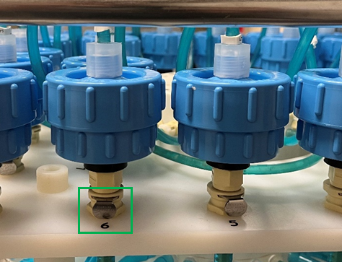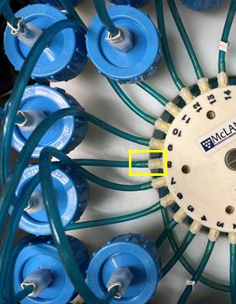

* One by one, disconnect each filter holder from the manifold by clicking the silver button (green) and gently pull the filter holder upward. Then disconnect the small tubing from the valve (yellow) by twisting counterclockwise to unlock.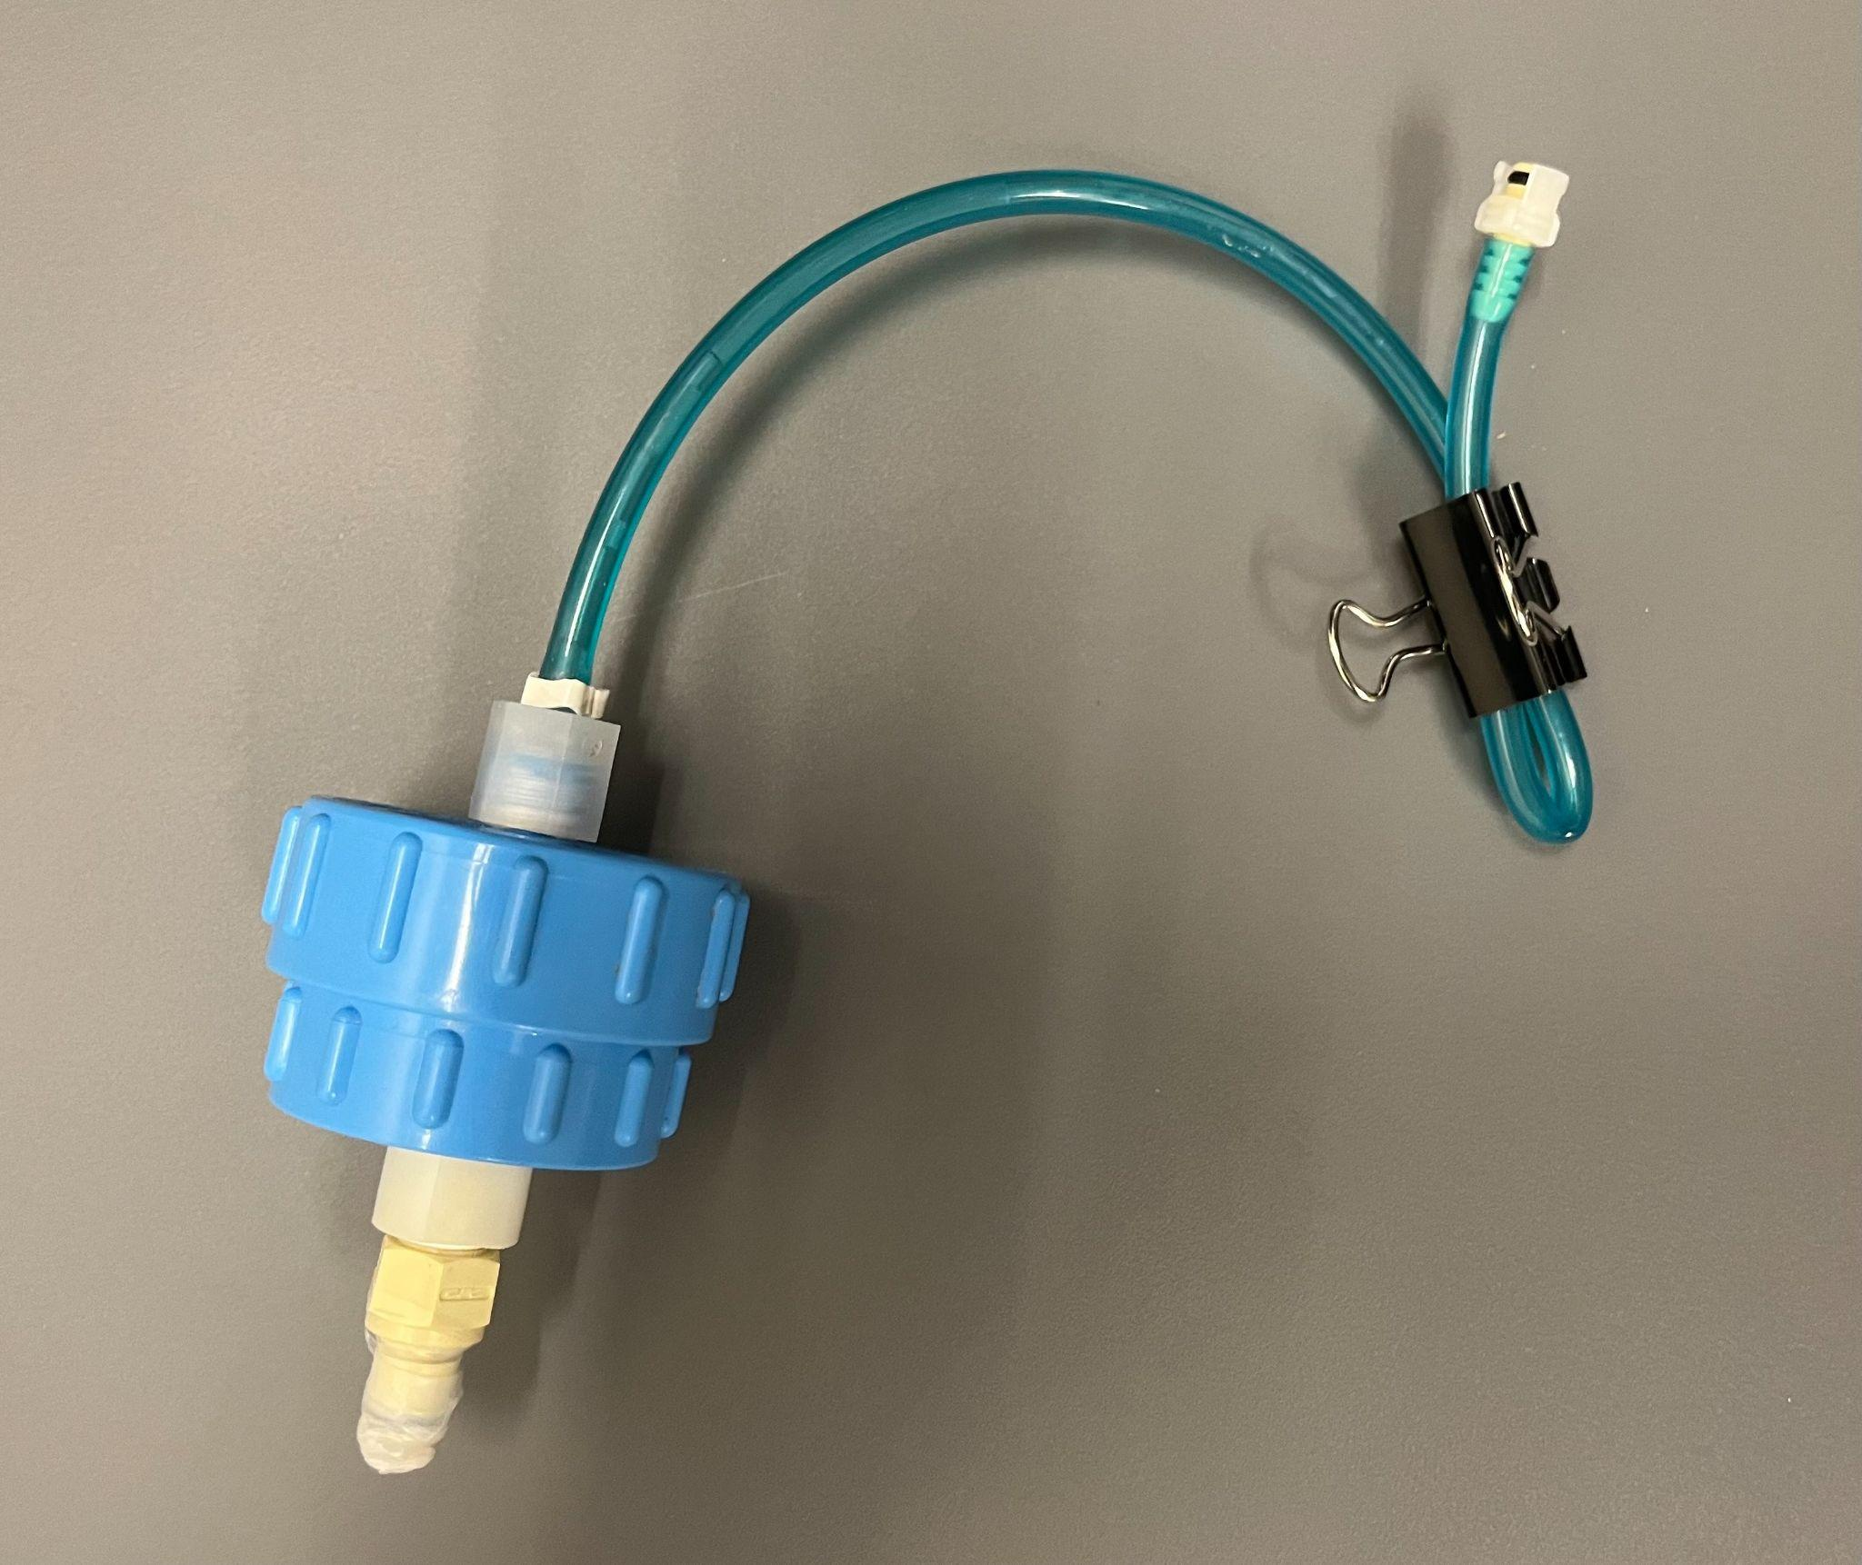
* For all 23 samples, you’ll parafilm the bottom of the filter holder and binder clip the upper tubing to prevent evaporation.
  + Pre-labeled, double plastic bags have been provided. Each filter holder corresponds to a bag (Port 1, etc.).
* Remove extra air from bag and store in -20 or -40 C Freezer

**Shipping**

*eDNA Samples*

* Remove samples from the freezer and place in the blue RTIC cooler with provided techni ice. Techni ice needs to be placed in the freezer in advance to freeze before transfer.
* Hand-off to Matt on the Sikuliaq, or worst-case, fly home with the cooler as a checked bag. The water samples within each filter holder have an extremely low volume of ethanol still on the filter, so they don’t need to be claimed as hazmat.

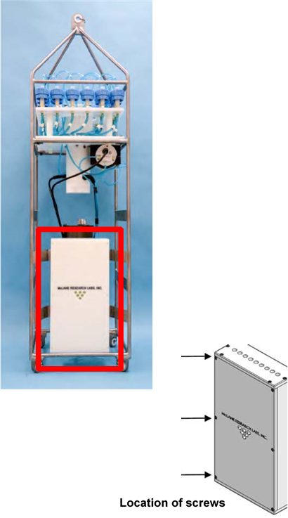

*Automated Sampler*

* Open the white fixation box (red), unscrew the six nylon screws with the provided ball driver, and add the gray, absorbent non-flammable packing material provided. Then reattach the lid and screw in place.
  + Packing materials make this unit eligible for hazmat shipment as there is an estimated ~600 mL of 95% ethanol in the fixative box.
* Store the unit in the crate provided. Can store vertically or horizontally, but make sure if stored vertically, to store with the top up (i.e., the pyramid).
  + Reattach the lid before shipment (blue - screw location; same on other side). Not all spots have a screw, and just use 4-6 until the lid is secure.

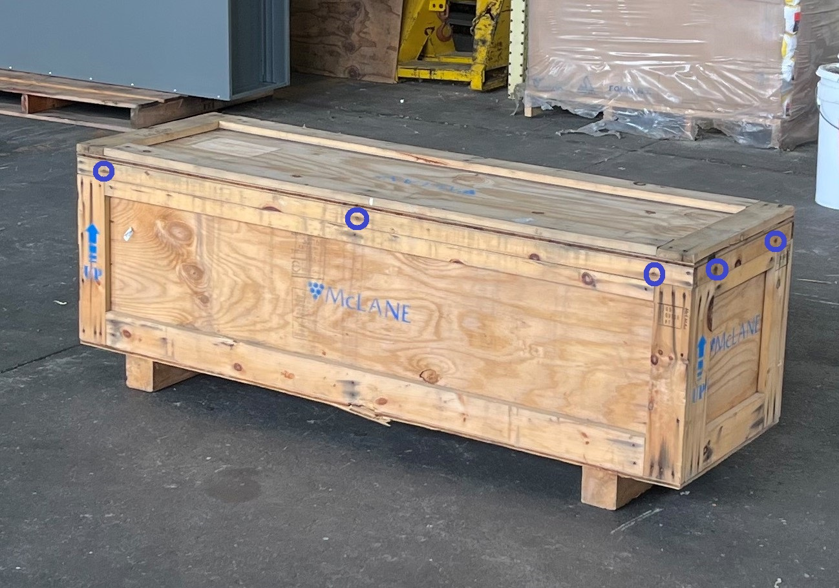

**Ocean Molecular Ecology: R/V Aquila Packing List**

Wooden Crate for Automated Sampler

RTIC Cooler

* Scissors, labeling materials, and tape
* Absorbent, non-flammable material
* Techni ice
* Ball driver to remove nylon screws
* Binder clips
* Parafilm

Plastic bin

* Pre-labeled plastic bags for sample recovery