PERSONAL DETAILS |  | 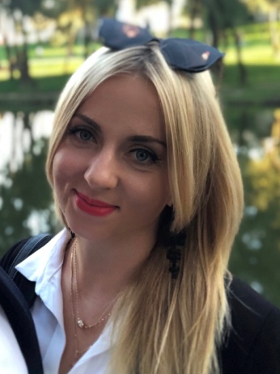
Name | Pastukh Maryna
Date of Birth | 8th August 1992
Age | 29 years
Address | Kyiv, Ukraine
Tel. | +380673143969
E-mail | rogozamar@gmail.com
Marital Status | Married
EDUCATION
2009-2015 | Taras Shevchenko National University of Kyiv  Field of study: Chemistry  Speciality: Chemical analysis and management of analytical laboratory  Qualification: Chemist. Researcher in Chemistry. Lecturer.
WORK EXPERIENCE
2019- present  2015 – 2019 | Expert of Expertise department PJSC SIC “Borshchahivskiy CPP”, Kyiv, Ukraine  Chemist of Research and Development Laboratory, PJSC SIC “Borshchahivskiy CPP”, Kyiv, Ukraine  My responsibilities include:  - development and implementation to the production of new medicinal products;  - preparation of documents for registration of medicinal products;  - development of specifications and control procedures, validation analytical procedures;  - quality control of raw materials, auxiliary substances, and finished products to meet the requirements of regulatory documents by physico-chemical methods.  - work with pharmacopoeias (EP, USP, DFU) and regulatory documents (EMA/ICH, FDA, WHO).
ADDITIONAL SKILLS
Languages | Ukrainian, Russian - mother tongue  English – Intermediate Level
Computer | confident in Microsoft Office packages.
Qualified and highly-professional; highly-motivated; enthusiastic; good communication skills; eager to experience and learn new skills.

