Chesapeake Biological Laboratory’s Report of Monthly Cove Point Marsh Restoration Monitoring

Erin Reilly

May 1, 2019

## Activity Summary

#### April

* Salinity Surveys
* Maintain Hobo sensors and download Hobo data
* Work on annual report
* Present results of monitoring at Atlantic Estuarine Research Society meeting
* rSET and Marker Horizon Readings
* Demonstrations of Marsh Monitoring Techniques

#### May (expected)

* Salinity Surveys
* Maintain Hobo sensors and download Hobo data
* Spring Percent Cover Surveys
* High School Planting event
* Submit annual report draft for comment

## Items of Note/Concern:

* Hobos at the North, South and Mid Station were pulled April 16th after YSI had redeployed the Sondes.

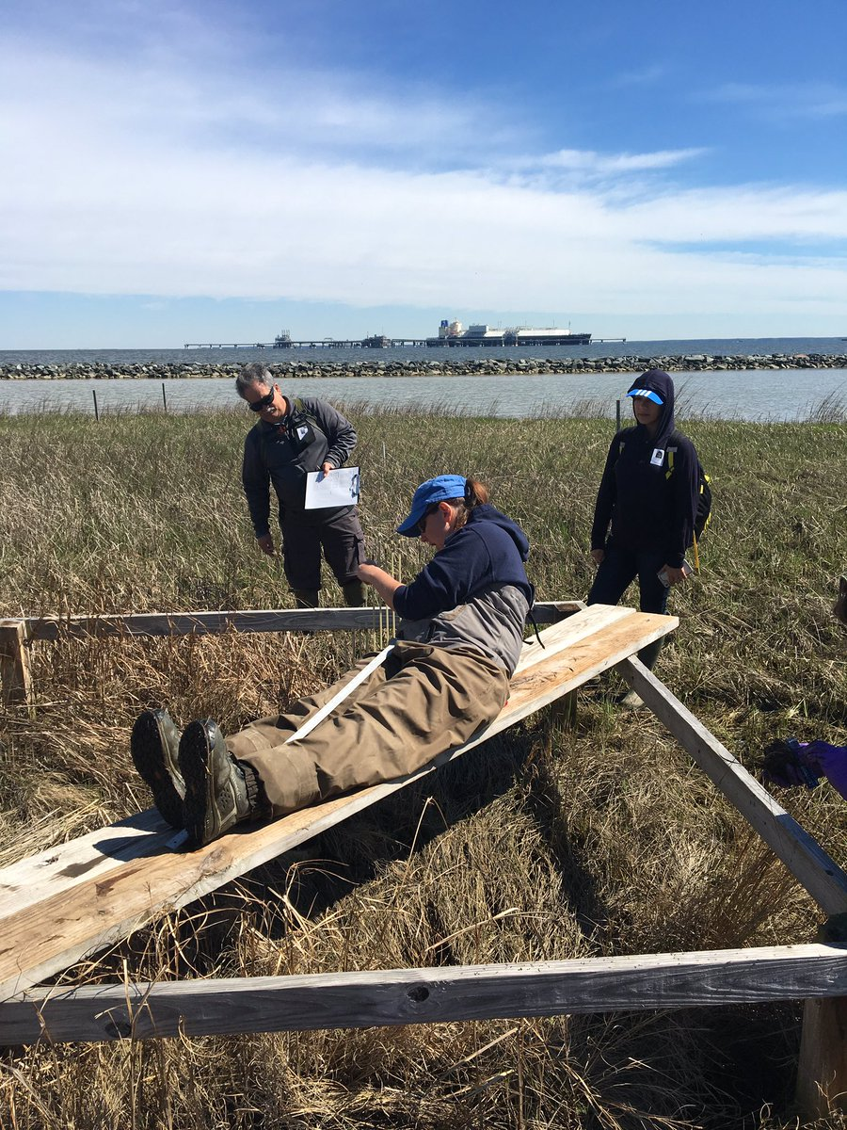

Erin Reilly demonstrating how the Surface Elevation Tables work to visiting researchers

## Plots

Below are the plots for the Hobos for the month of April.

### Water Level

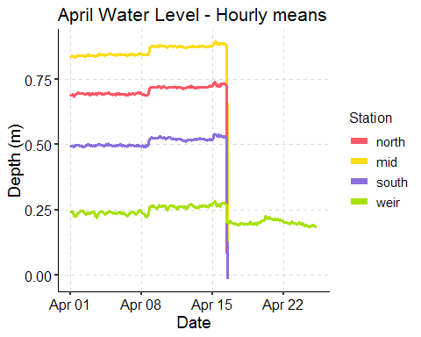

### Salinity

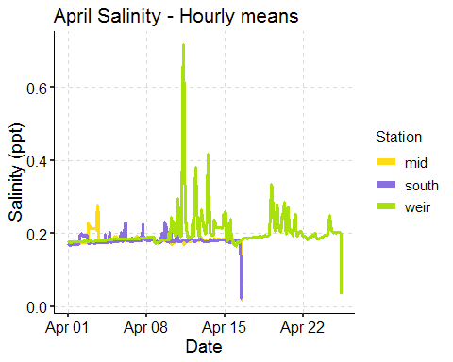

[Note that there is no South Station because of the lost Hobo.]

### Dominion Distribution List

1. Paul Dickson, Dominion ([paul.e.dickson@dom.com](mailto:paul.e.dickson@dom.com))
2. Mike Gardner, Dominion ([Michael.e.gardner@dom.com](mailto:Michael.e.gardner@dom.com))
3. Jasmine L Morris ([Jasmine.L.Morris@dom.com](mailto:Jasmine.L.Morris@dom.com))
4. Dominion Biology Group Contact, Matt Overton ([matt.overton@dom.com](mailto:matt.overton@dom.com))