Chesapeake Biological Laboratory’s Report of Monthly Cove Point Marsh Restoration Monitoring

Erin Reilly

May 1, 2019

## Activity Summary

#### April

* Salinity Surveys
* Maintain Hobo sensors and download Hobo data
* Work on annual report
* Present results of monitoring at Atlantic Estuarine Research Society meeting
* rSET and Marker Horizon Readings
* Demonstrations of Marsh Monitoring Techniques

#### May (expected)

* Salinity Surveys
* Maintain Hobo sensors and download Hobo data
* Spring Percent Cover Surveys
* High School Planting event
* Submit annual report draft for comment

## Items of Note/Concern:

* Hobos at the North, South and Mid Station were pulled April 16th after YSI had redeployed the Sondes.

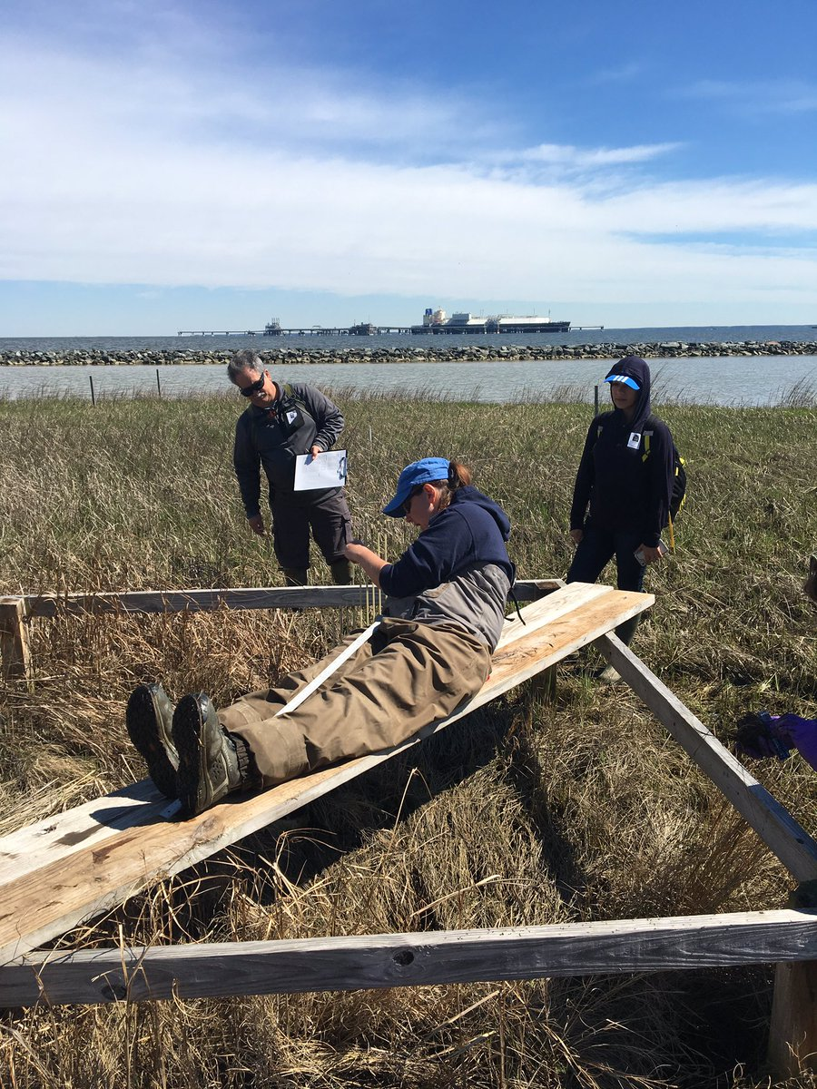

Erin Reilly demonstrating how the Surface Elevation Tables work to visiting researchers

## Plots

Below are the plots for the Hobos for the month of April.

### Water Level

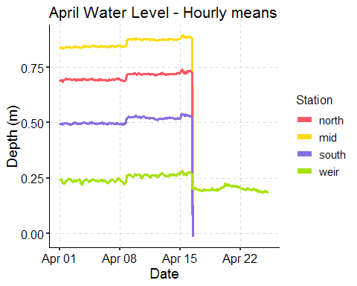

### Salinity

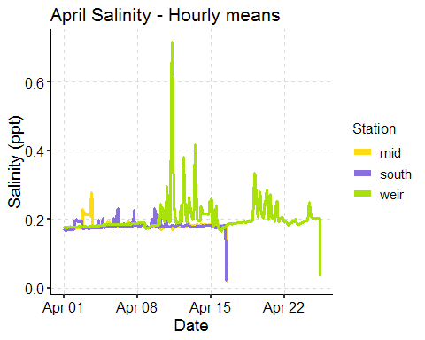

We didn’t note any elevated salinities during our sampling April 16th or 25th however the salinity probe was noticeably fouled on the 16th and this may have contributed to the higher salinity readings. We will continue to monitor and keep everyone informed if anything changes.

### Dominion Distribution List

1. Paul Dickson, Dominion ([paul.e.dickson@dom.com](mailto:paul.e.dickson@dom.com))
2. Mike Gardner, Dominion ([Michael.e.gardner@dom.com](mailto:Michael.e.gardner@dom.com))
3. Jasmine L Morris ([Jasmine.L.Morris@dom.com](mailto:Jasmine.L.Morris@dom.com))
4. Dominion Biology Group Contact, Matt Overton ([matt.overton@dom.com](mailto:matt.overton@dom.com))