Chesapeake Biological Laboratory’s Report of Monthly Cove Point Marsh Restoration Monitoring

Erin Reilly

June 26, 2019

## Activity Summary

#### June

* Salinity Surveys
* Download Weir Hobo Data
* Rare Threatened and Endangered Species Survey with Brent Steury

#### July (expected)

* Salinity Surveys
* Maintain Hobo sensors and download Hobo data

## Items of Note/Concern:

* While we were out June 20th, the Salinity in the bottom of the weir boxes that were not flowing rapidly into the revetment was approximately 5-7 ppt. Water level from the Bay was high at the time, and we did not see elevated Salinities at the surface or further from the boxes.
* The HOBO measurements do show some sustained increases near the weir boxes. When compared to the YSI sonde readings, at least one of the periods matches up with high rainfall and a corresponding increase in the depth of the pond. These other periods also correspond with higher than normal water levels reported at the Solomons Island tide gauge. Given the permeability of sand dunes, I think it likely that we will continue to see occasional temporary increases in salinity close to the barrier when we have higher than normal tides.

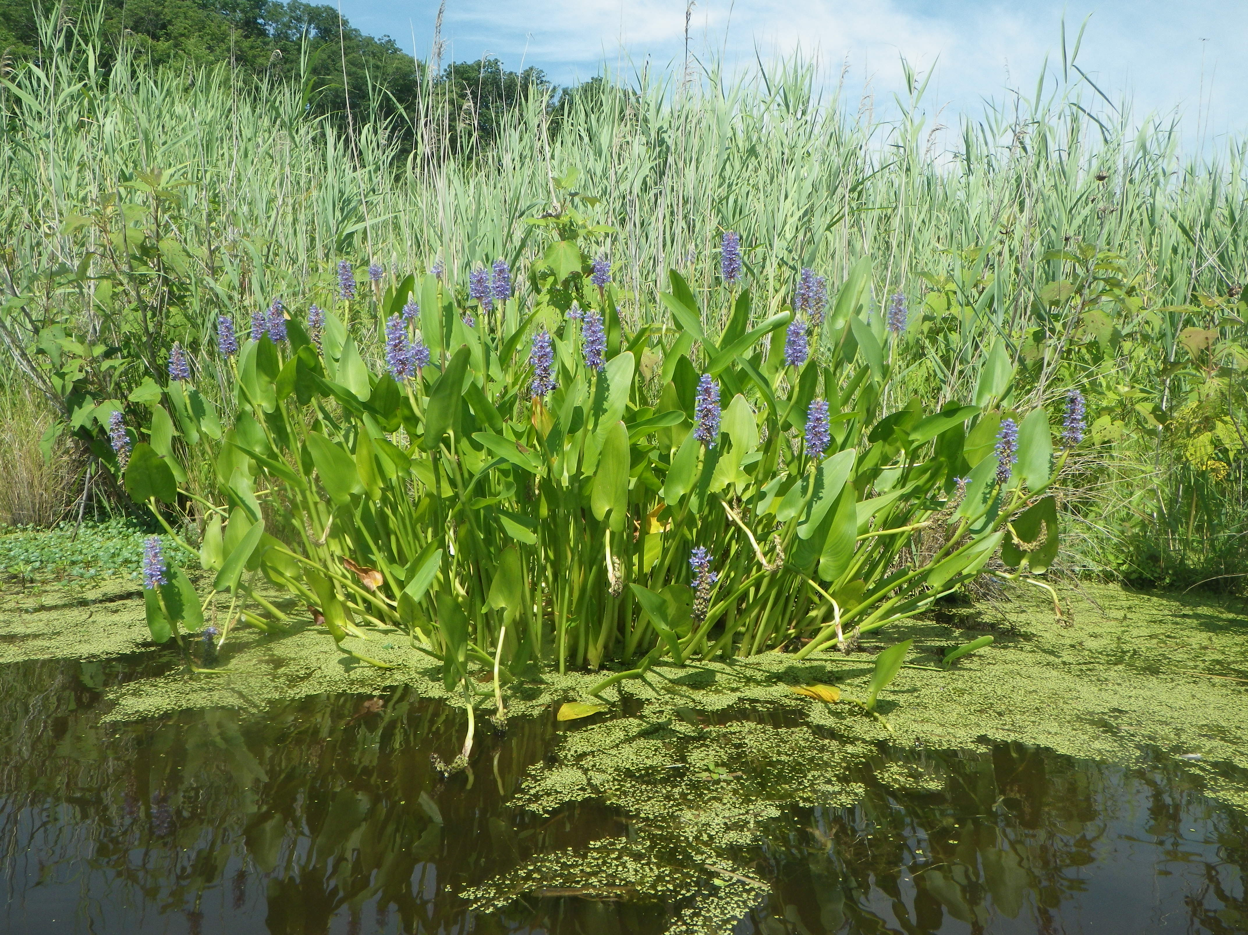

Spring flowers have started to bloom at the marsh

## Plots

Below are the plots for the Hobos for the month of June.

### Water Level

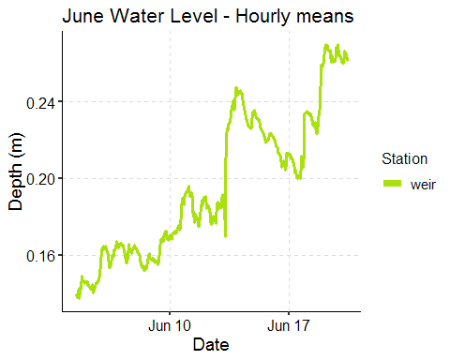

### Salinity

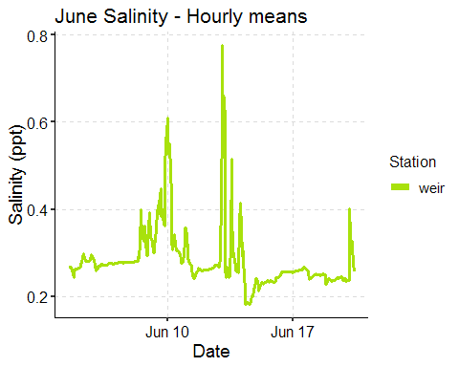

### 

### Dominion Distribution List

1. Paul Dickson, Dominion ([paul.e.dickson@dom.com](mailto:paul.e.dickson@dom.com))
2. Mike Gardner, Dominion ([Michael.e.gardner@dom.com](mailto:Michael.e.gardner@dom.com))
3. Jasmine L Morris ([Jasmine.L.Morris@dom.com](mailto:Jasmine.L.Morris@dom.com))
4. Dominion Biology Group Contact, Matt Overton ([matt.overton@dom.com](mailto:matt.overton@dom.com))