Chesapeake Biological Laboratory’s Report of Monthly Cove Point Marsh Restoration Monitoring

Erin Reilly

September 16, 2019

## Measuring plant biomass during the vegetation surveysActivity Summary

#### August

* Salinity Surveys
* Download Weir Hobo Data
* Percent Cover Surveys
* PEET Plot Surveys
* Phragmites Biomass Collection
* Invasive Species Surveys
* HOBO recovery

#### September (expected)

* Salinity Surveys
* RTE Survey with Brent Steury

## Items of Note/Concern:

* We recovered 5 of the Sensors that were lost this winter and were able to also retrieve data off of them. We are still evaluating the data to see if we think it is good enough to use.
* During the Vegetation Surveys we noticed a large patch of Lespedeza by Transect 3

Measuring plant biomass during the vegetation surveys

## Plots

Below are the plots for the Hobos for the month of August.

### Water Level

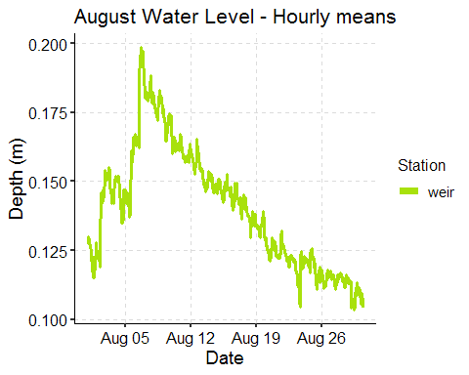

### Salinity

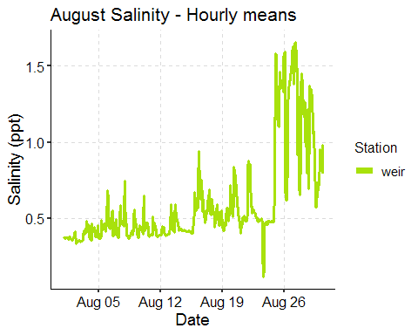

*Note that the sensor was found out of the water when observed August 30 because of the low water levels. The salinity values towards the end of the month are likely suspect as a result and the sonde data does not show any large anomalies.*

### 

### Dominion Distribution List

1. Paul Dickson, Dominion ([paul.e.dickson@dom.com](mailto:paul.e.dickson@dom.com))
2. Mike Gardner, Dominion ([Michael.e.gardner@dom.com](mailto:Michael.e.gardner@dom.com))
3. Jasmine L Morris ([Jasmine.L.Morris@dom.com](mailto:Jasmine.L.Morris@dom.com))
4. Dominion Biology Group Contact, Matt Overton ([matt.overton@dom.com](mailto:matt.overton@dom.com))