## *Higher Diploma in Business Systems Analysis*

HCI & Web Design

## Assignment Two

Mariner Jackson

ID. 20072739

Contents

Website Description: 3

Website Design: 4

Wireframes 4

Good design principles 6

Website testing/implementation issues 8

HTML Validation 8

CSS Validation 8

Accessibility Checking 9

Cross Platform testing 9

# Website Description:

I have designed a fictional website called Upsidedown Wine. My website is an online sales company that specialises in the sales of New Zealand and Australian wines. The purpose of the site is to sell both New Zealand and Australian sourced wine imported directly from wineries. It appeals to wine buffs and restaurant owners who are looking for niche labels and the site promises varieties that are not currently available in Irish supermarkets.

The company operates out of a warehouse in Waterford and all sales are generated via the website.

The company claims to be passionate about southern hemisphere wines and offers links to websites of wineries, wine reviews and provides regional information regarding wine varieties.

The company offers free shipping in Ireland for orders of 6 bottles or more. All wines come with a guarantee of a refund or replacement if the customer is not happy.

The site also offers browsers the ability to communicate with the seller via email regarding any queries.

# Website Design:

## Wireframes

Home page:

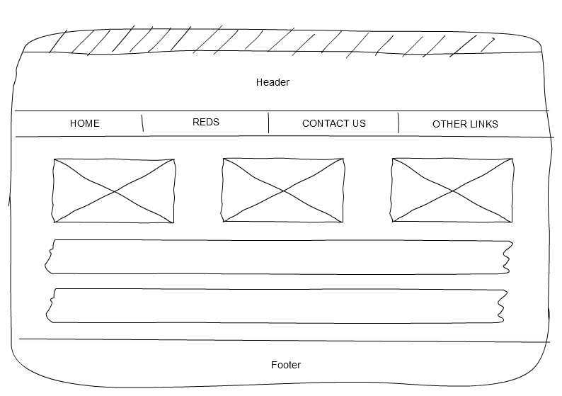

Sales (Reds and Whites) pages:

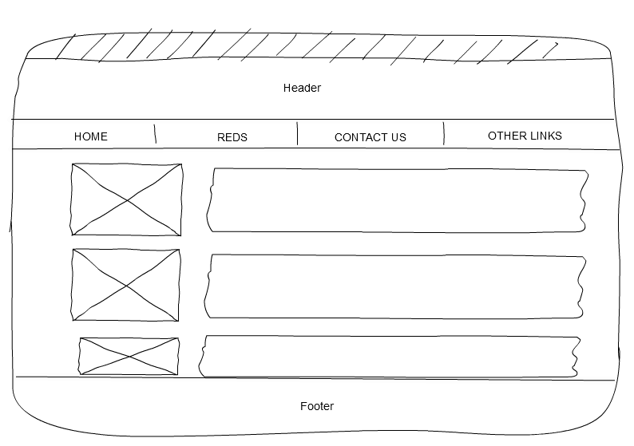

Contact Us page:

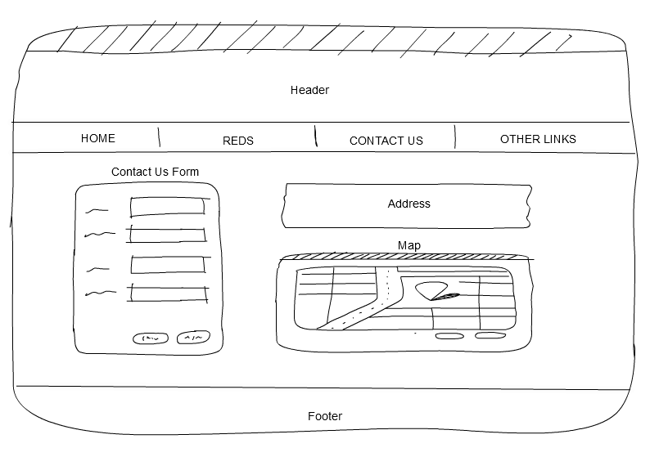

Other Links page:

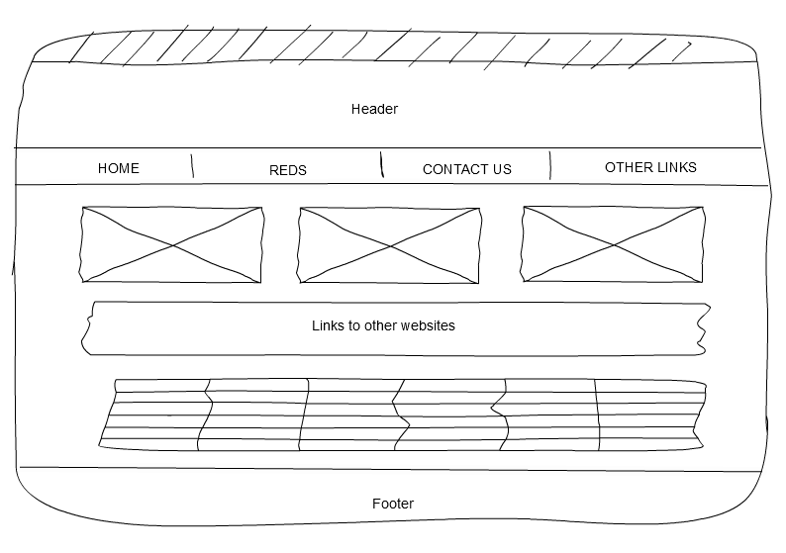

## Good design principles

**Consistency:**

My first key goal was consistency across the site in terms of design, colours used and layout. I think this was achieved through the use of the clear menu bar with the headers and footers on every page and also consistency in the layout of the ‘Reds’ and ‘Whites’ pages. I believe keeping these pages consistent with the image sizing and layout aids the users.

**Know my users:**

Keeping the site relatively simple and easy to use was another important goal during the design phase. As a broad range of users could potentially browse the site I needed to keep it simple for novice users. There potentially could be a lot of images on the site which could mean it may be slow to load without access to broadband. I believed most people would probably be browsing at home on a tablet or laptop thus using broadband.

**Visual attention:**

My aim was to make maximum use of whitespace with minimal clutter. This is demonstrated on the `Reds and White’ pages where each wine has plenty of white spacing between each item. This enables them to be clearly distinguished and users can easily read the results.

**Content:**

I tried to make use of the F pattern where users don’t read they scan. I placed the images of the wine on the right hand side with the text on the left. Most uses will look at the image first then scan the title and then scan down to the price (in red) before coming back to read the wine details (see the last screen shot below).

**Colour:**

My use of colour was subtle and was mainly used to contrast between text- see below index page – background colour used between “Our Story” and the information below regarding Guarantee and shipping.

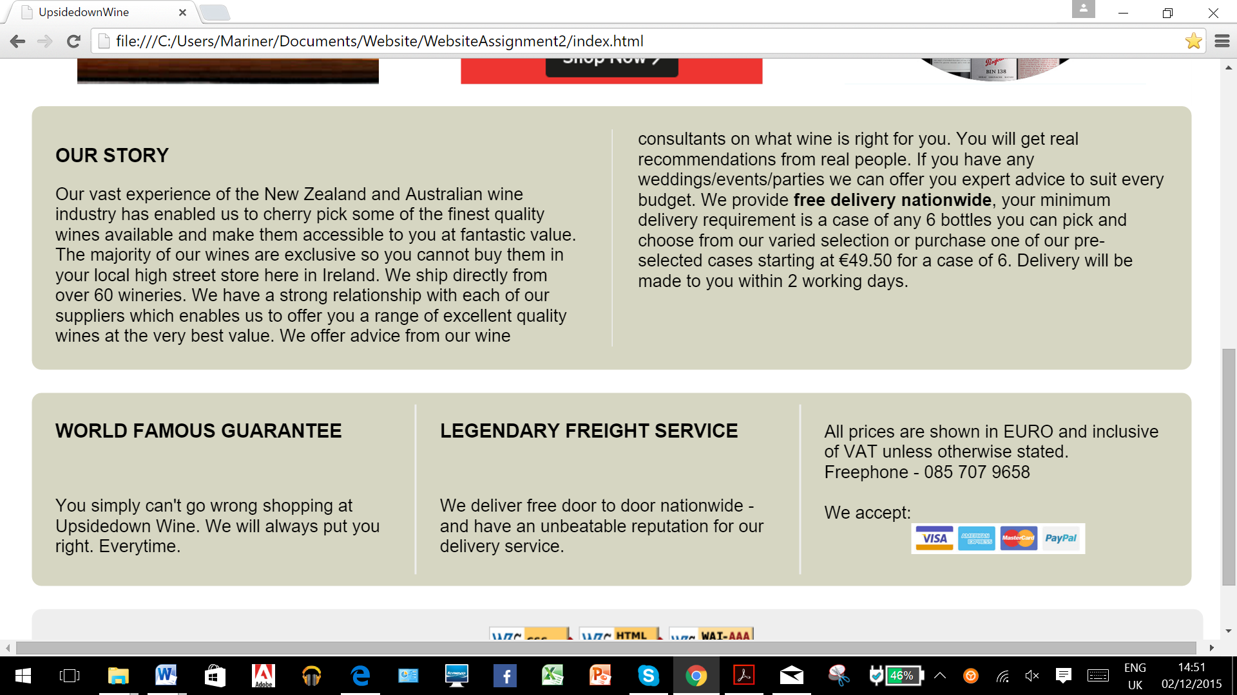

**Navigability:**

Colour is also used for navigability in the menu bar. The menu option changes to white when hovered over and then changes to grey when selected. This helps the user to remember which page they are viewing.

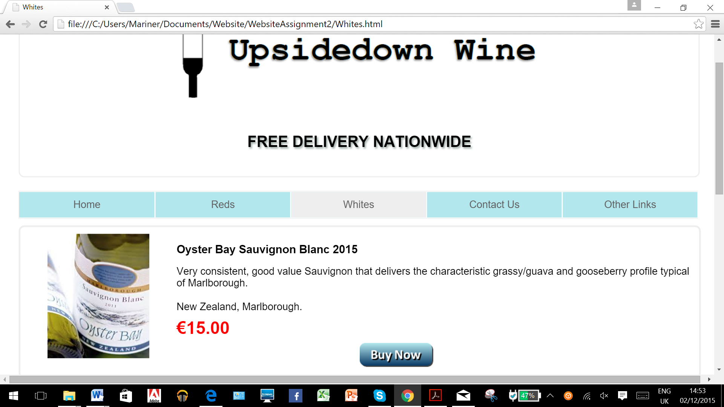

# Website testing/implementation issues

## HTML Validation

All issues were resolved.

I added the html icons into the footer of each page.

## CSS Validation

All issues were resolved.

I added the CSS icons into the footer of each page.

## Accessibility Checking

All issues were resolved.

I have added the WCAG2.0 AAA icon into the footer of each page.

## 

## Cross Platform testing

I tested the site on three browsers:

* Firefox
* Microsoft Edge
* Chrome

No major issues were identified in any of the browsers. However I did identify two minor variations:

**Variance 1- Microsoft Edge**

All phone numbers using Microsoft Edge are underlined.

**Variance 2- Firefox, Microsoft Edge**

The legend on my form on the contact us page using Chrome has text-align: center (which is my code) but using Firefox and Microsoft Edge this aligns to the left.

Chrome:

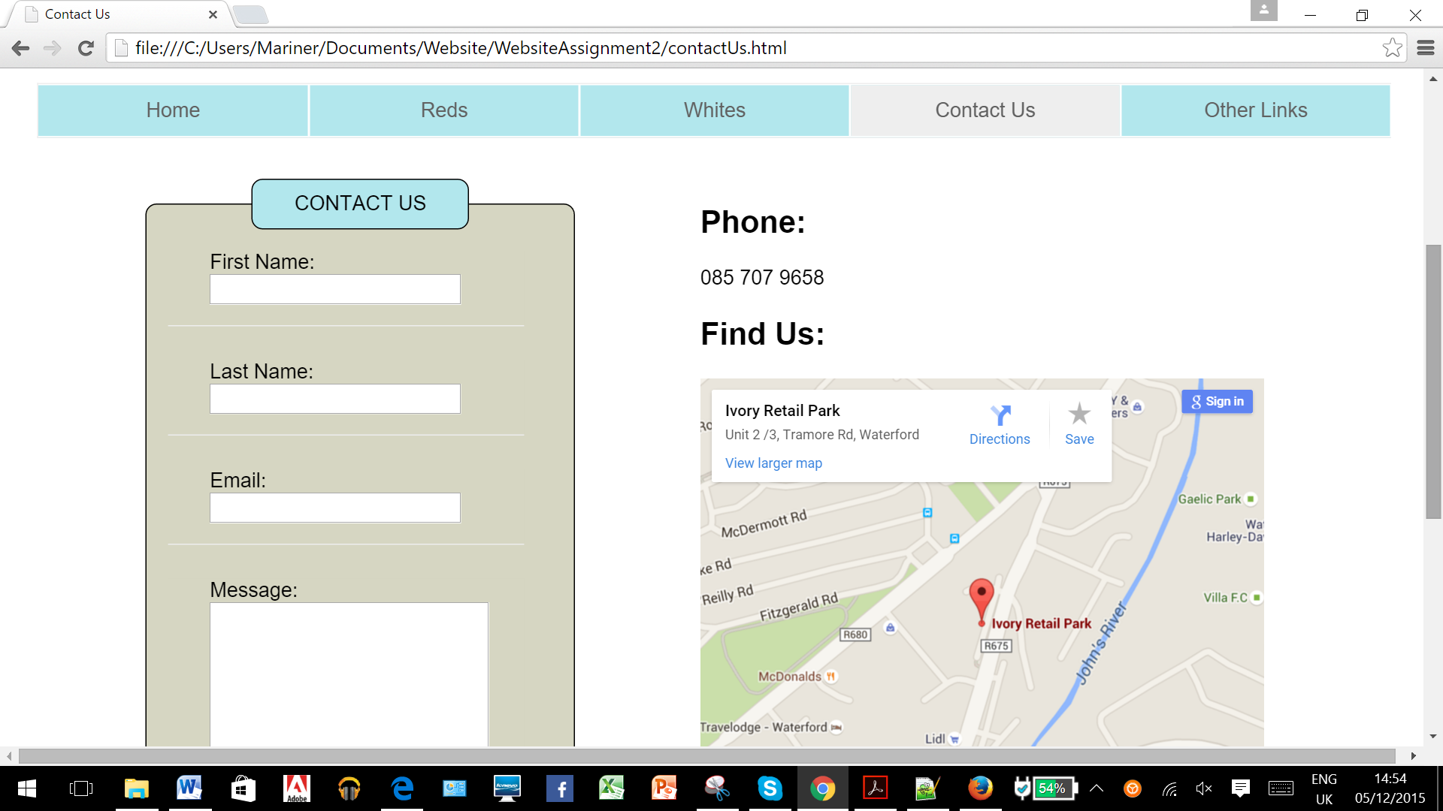

Microsoft Edge (also see phone number underlined):

