**HOMEROOM**

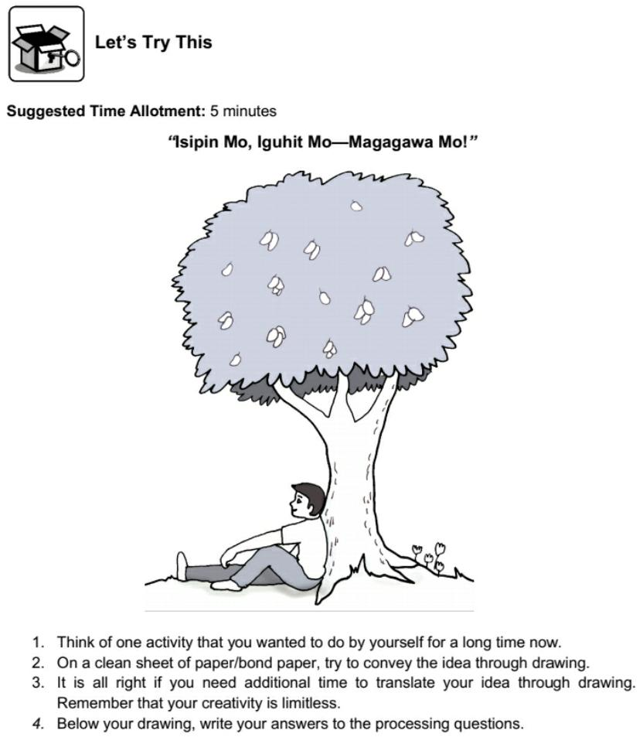

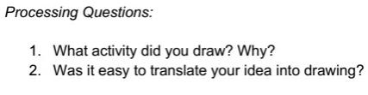

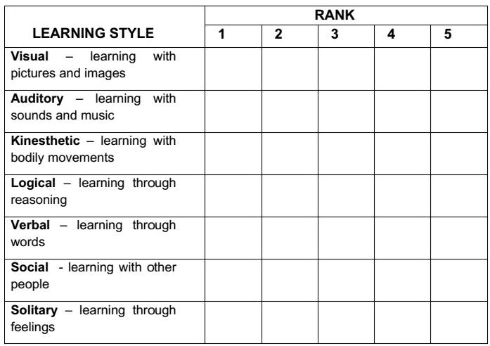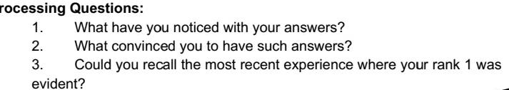

Czer#6635

Czer#6635

Czer#6635

Czer#6635

Czer#6635

Czer#6635

my experiences during the last 8 years of my studies

Answer:

1. My social and kinesthetic learning is superior to all.
2. My experiences during the last 8 years at school.
3. Now in online class, because when sir teaches his lesson the other lesson he teaches us I do not understand so I just ask my classmates how it was done.

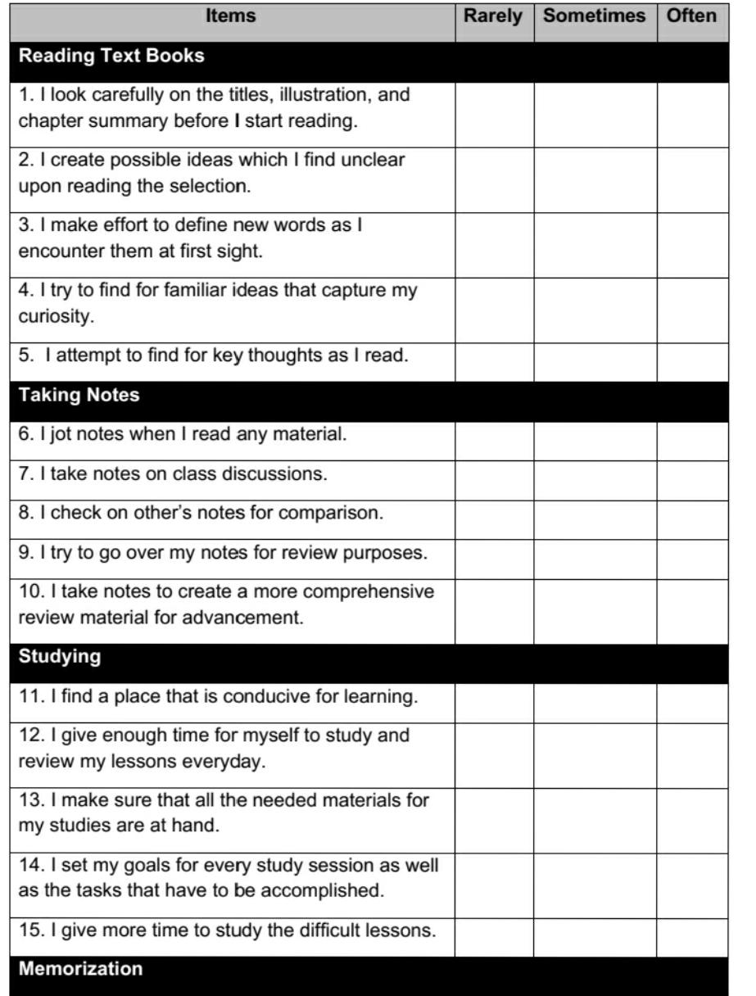

my experiences during the last 8 years of my studies

my experiences during the last 8 years of my studies

my experiences during the last 8 years of my studies

my experiences during the last 8 years of my studies

my experiences during the last 8 years of my studies

my experiences during the last 8 years of my studies

my experiences during the last 8 years of my studies

my experiences during the last 8 years of my studies

my experiences during the last 8 years of my studies

my experiences during the last 8 years of my studies

my experiences during the last 8 years of my studies

my experiences during the last 8 years of my studies

my experiences during the last 8 years of my studies

my experiences during the last 8 years of my studies

my experiences during the last 8 years of my studies

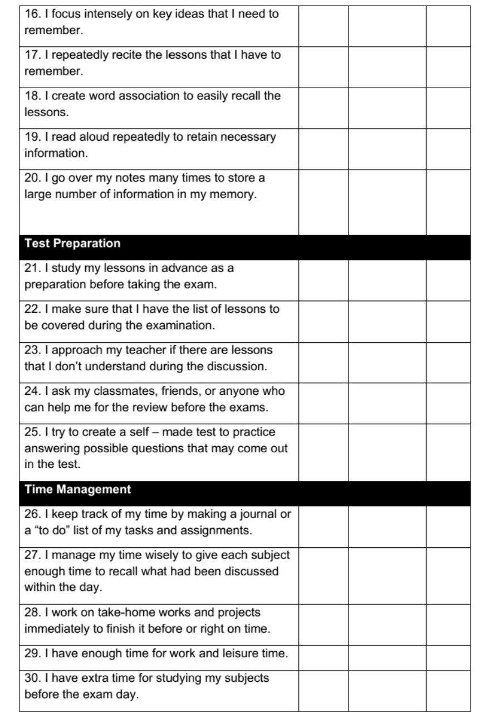

my experiences during the last 8 years of my studies

my experiences during the last 8 years of my studies

my experiences during the last 8 years of my studies

my experiences during the last 8 years of my studies

my experiences during the last 8 years of my studies

my experiences during the last 8 years of my studies

my experiences during the last 8 years of my studies

my experiences during the last 8 years of my studies

my experiences during the last 8 years of my studies

my experiences during the last 8 years of my studies

my experiences during the last 8 years of my studies

my experiences during the last 8 years of my studies

my experiences during the last 8 years of my studies

my experiences during the last 8 years of my studies

my experiences during the last 8 years of my studies

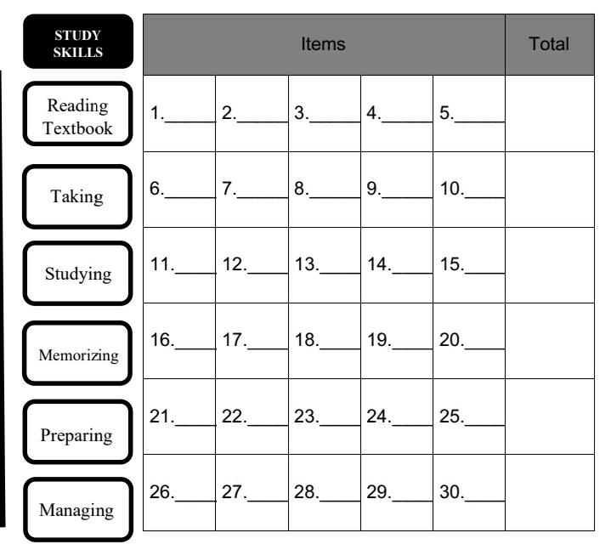

10

5

10

10

5

5

5

0

5

5

5

5

0

5

10

10

5

5

5

0

5

5

0

5

10

10

5

10

5

5

15

25

35

35

40

20

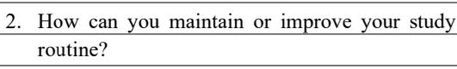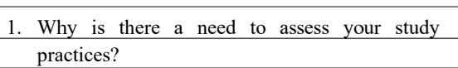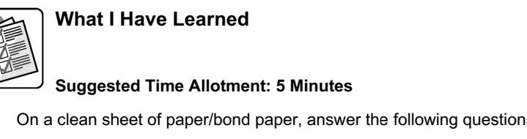Answer:

1. To find out where I am having difficulty in my study practices
2. By motivating myself to do them all.

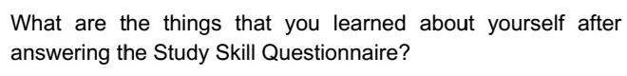

Answer:

1. 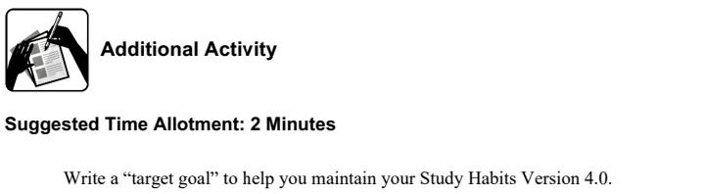I learned from myself that I need to improve and maintain my study routine.

Answer:

My goal so that I can maintain my study habits is to be positive at all times and set in my mind that I must finish what needs to be done.