Data Structure and Algorithm

Laboratory Activity No. 3

Translating Algorithm to Program

|  |  |
| --- | --- |
| *Submitted by:* | *Instructor:* |
| Maringal, Czer Justine D. | Engr. Maria Rizette H. Sayo |

August 02, 2025

# Objectives

Introduction

Data structure is a systematic way of organizing and accessing data, and an algorithm is a step-by-step procedure for performing some tasks in a finite amount of time. These concepts are central to computing, but to be able to classify some data structures and algorithms as “good,” we must have precise ways of analyzing them.

This laboratory activity aims to implement the principles and techniques in:

* Writing a well-structured procedure in programming
* Writing algorithm that best suits to solve computing problems
* Writing an efficient Python program from translated algorithms

# Methods

• Design an algorithm and the corresponding flowchart (Note: You may use LucidChart or any application) for adding the test scores as given below if the number is even: 26,49,98,87,62,75

• Translate the algorithm to a Python program (using Google Colab)

• Save your source codes to GitHub

# Results

Algorithm:

• **Start**: Begin the process.

• **Set** scores to **26, 49, 98, 87, 62, 75**.

• **Set sum_even_scores to 0**.

• **Use the list of scores**.

• **Loop through each score**:

* **Decision**: Is the score even (score % 2 == 0)?
  + **Yes**: Add score to sum.
  + **No**: Skip the score.

• After the loop, **output the sum**.

• **End**: Process is complete.

FLOW CHART  
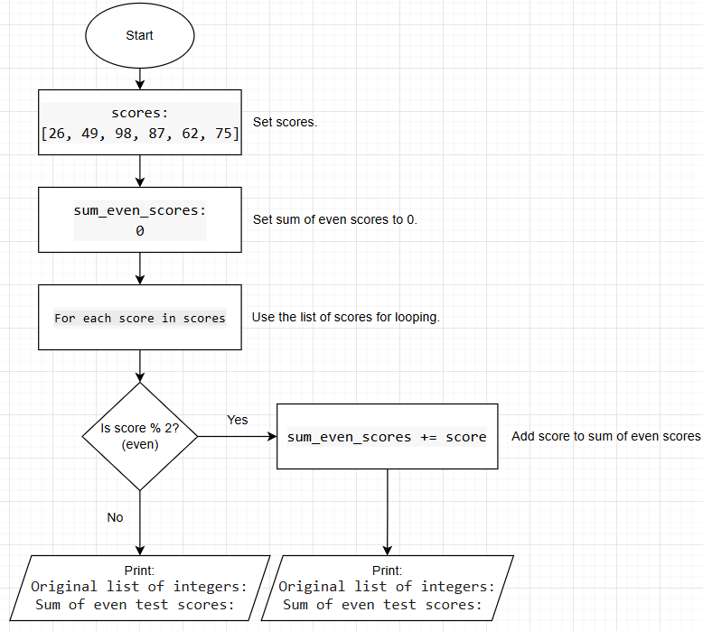

# Conclusion

Through this laboratory activity, I was able to apply my understanding of data structures and algorithms by designing, analyzing, and implementing a solution to this problem. I created an algorithm and flowchart that adds only the even numbers from a set of test scores, which helped me practice writing clear and good structured procedures. Translating the algorithm into a Python program allowed me to see how theoretical logic can be turned into working code. Overall, this activity helped me strengthen my programming skills and deepen my appreciation for writing efficient and organized code to solve problems effectively.

**References**

[1] [Untitled Diagram.drawio - draw.io](https://app.diagrams.net/#G1nZm6_m-X5ydcjd_zo5dBRnHBe2kd2ZSd#%7B%22pageId%22%3A%22K0t6nW25_rmQPbanU8N7%22%7D)