Data Structure and Algorithm

Laboratory Activity No. 5

Implementation of Arrays

|  |  |
| --- | --- |
| *Submitted by:* | *Instructor:* |
| Maringal, Czer Justine D. | Engr. Maria Rizette H. Sayo |

August 16, 2025

# Objectives

Introduction

Array, in general, refers to an orderly arrangement of data elements. Array is a type of data structure that stores data elements in adjacent locations. Array is considered as linear data structure that stores elements of same data types. Hence, it is also called as a linear homogenous data structure.

This laboratory activity aims to implement the principles and techniques in:

* Writing algorithms using Array data structure
* Writing a python program that can implement Array data structure

# Methods

* Write a Python program to create an array of 10 integers and display the array items. Access individual elements through indexes and compute for the sum.
* Write a Python program to append a new item to the end of the array. Original array: numbers = [1, 2, 3, 4, 5, 6, 7, 8, 9, 10]
* Write a Python program to insert a new item before the second element in an existing array. Original array: numbers = [1, 2, 3, 4, 5, 6, 7, 8, 9, 10]
* Write a Python program to reverse the order of the items in the array. Original array: numbers = [5, 4, 3, 2, 1]

Write a Python program to get the length of the array. Original array: numbers = [5, 4, 3, 2, 1]

# Results

In this program, I used the array module and specify ‘i’ for integer type.

Set the value of variable (numbers) to (1,2,3,4,5,6,7,8,9,10) and access it individually using for loop by its index (number[i]). Then, calculate the sum using a Python built in function sum()

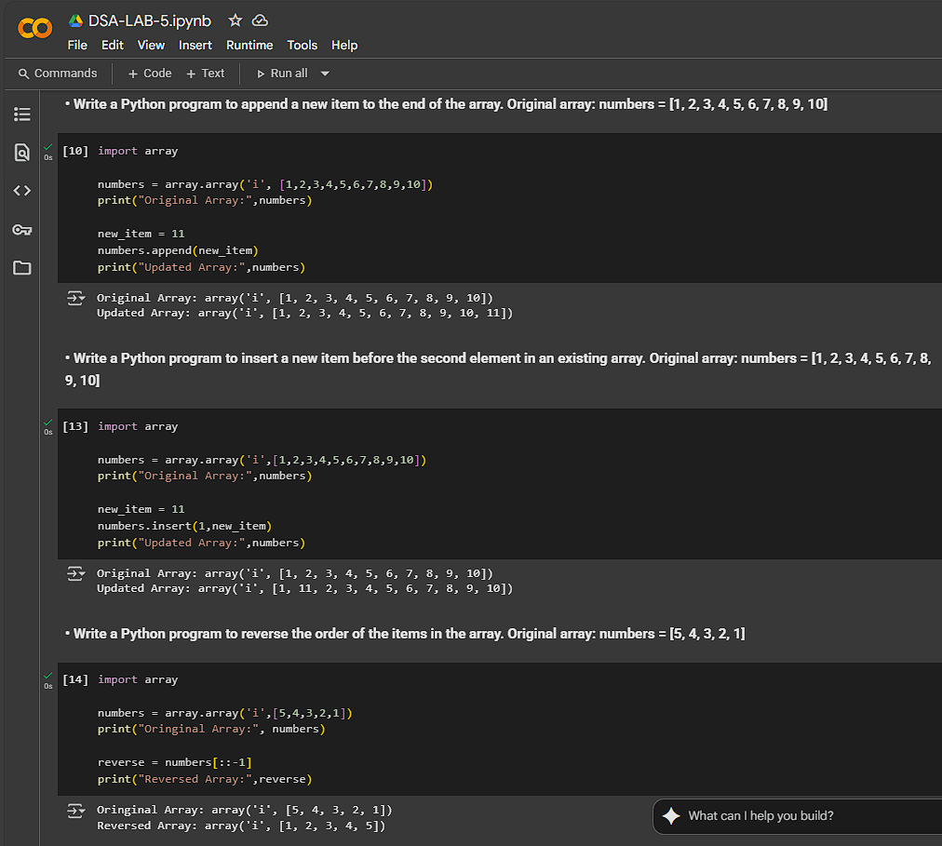

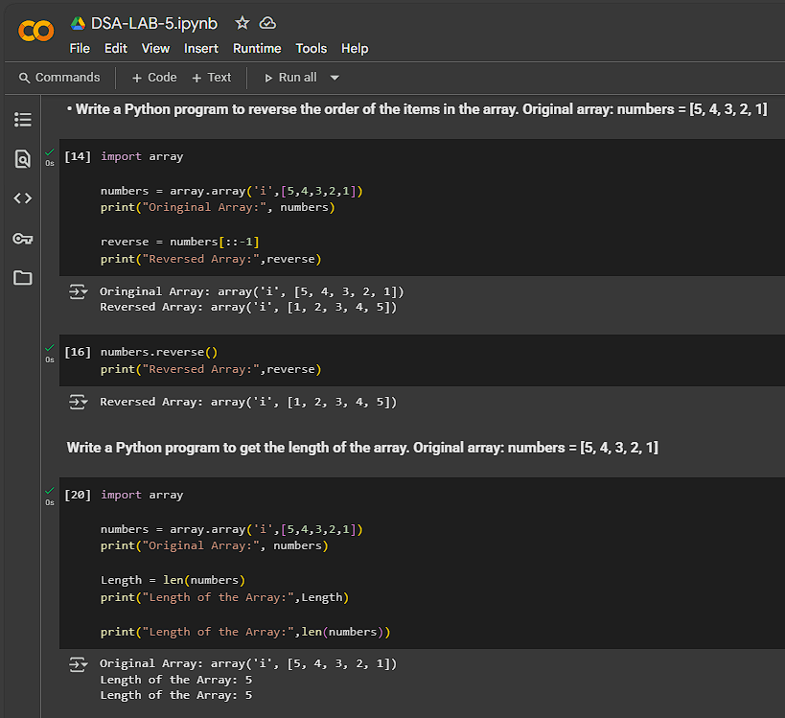

On this part, I made this program with the knowledge I’ve learned in previous lesson and topic. Specially the array part and some function of it.

# Conclusion

I understand how to create arrays, retrieve elements using indexes, and apply built-in methods such as append(), insert(), reverse(), and len() for array manipulation and analysis. Additionally, I develop logical thinking in applying loops for element access and computations, which are foundational skills for data handling and algorithm design in Python programming.

**References**

[1] GeeksforGeeks. (2025, July 23). *Python Array Indexing*. GeeksforGeeks. <https://www.geeksforgeeks.org/python/python-array-indexing/>