FUNCTIONAL REINTEGRATION OF BROWNFIELD LANDS AT REGIONAL AND LOCAL LEVEL.
CASE STUDY: MARAMUREŞ – CHIOAR REGION

Sorin Filip

ABSTRACT – The efficient territorial management represents a necessity of topical interest, both at regional and at local level. In the conditions of an increasing pressure upon the localities’ built-up areas, unsustainable forms of their extension are frequently adopted to the prejudice of the land outside the built-up areas. The physical-geographical characteristics and the economic peculiarities of the Maramureş –Chioar region have generated the existence of some land categories that can represent an outlet in rapport with the space crisis. It refers to the brownfield lands, whose functional reintegration within the territory must represent a constant preoccupation for the local and regional authorities. The possible alternatives for reintegration have in view the re-valorization of the respective lands, both through their ecologization and through associating some necessary and desirable territorial functions. At local level, the adoption of a development direction based on compact spatial patterns and on the preferable and priority use of brownfield lands is necessary.

Keywords: brownfield, regional development, urban planning, environmental rehabilitation, infill development, compact pattern

Introduction
One of the problems territorial development faces more and more frequently is the one related to the ever more obvious crisis related to the areas available for implementing different territorial projects. This is felt both in the case of extended territorial ensembles, such as regions, and at the level of urban and rural localities. If, in the case of regions, the space crisis can be easier “avoided”, in the context of a greater number of alternatives found at the decisional factors’ disposal, in the case of local-level territorial management, the issue presents extremely pressing aspects, with an intensity in direct proportion to the dynamics of the respective localities and to their degree of attractiveness in rapport with the neighbouring territorial systems. In this context, the identification of available areas represents a constant preoccupation within the activities of spatial planning, and one of the solutions that must be taken into consideration is represented by the so-called brownfield lands. Once identified, such lands can be reintegrated into the territory through associating some necessary or desirable functions (e.g. agricultural lands, forestry lands, residential areas, etc.).

TERRITORIAL CONTEXT FOR THE EXISTENCE OF BROWNFIELD LANDS IN THE maramureş – chioar REGION
One of the peculiarities of the Maramureş – Chioar region consists in the diversity of the physical-geographical conditions and, especially, in the morphogenetic diversity of the relief units. From the territorial development viewpoint, this materializes into the manifestation of some restrictions in rapport with the dwelling conditions and the human habitat structures, so that a great part of the region does not offer favourable dwelling conditions (geomorphologic restrictiveness), on the one hand, and into the presence of some underground resources whose economic value has generated intense exploitation and processing activities, on the other hand. It is mainly about the non-ferrous ore resources and about the building materials exploited in numerous locations in the Oaş Mountains, the Gutâi Mountains, the Ţibleş Mountains, and the Maramureş Mountains. The mining activities, initiated since the Dacian period, reached their climax in the second half of the 20th century, when important financial and human resources were allocated to maximize the complex ore (Pb, Cu, Zn, Au, Ag) and ferromanganese ore production. The result materialized under the form of surface and underground mining exploitations (e.g. Baia Mare, Şuior, Baia Sprie, Baia Borşa, Băiuţ, Răzoare, etc.). From the multitude of effects that such a concentration of mining activities had upon territorial systems, we mention land degradation (mine galleries, open pit mines, mine waste dumps), but also the intense development of some activities related to the processing of the exploited ores, which also led to the emergence of some space-consuming industrial structures and of numerous tailings ponds, associated with the technological process for processing the exploited ores. No less significant is the evolution of an urban centre whose economic and spatial development has been supported by mining and its connected activities. It refers to the Municipality of Baia Mare, a second-rank city in the national urban hierarchy, which has managed to impose itself in the territory, gradually taking over the role of the polarizing centre of a functional region, namely the Maramureş – Chioar region (Cocean P., Filip S., 2008). After 1990, in the context of a general national industrial decline and especially of the extractive industry, numerous ore-exploiting units have been closed. The lack of some coherent programmes for the environmental management of the decommissioned mining sites have led to the appearance of abandoned mining areas, as spaces of variable extension characterized by the general degradation of the environmental conditions and by the landscape degradation of the territorial ensembles in which they are placed. A similar phenomenon has been associated also with the non-ferrous ore primary processing units, affected by the economic decline, so that extended areas of the former ore-processing plants have undergone an advanced state of physical degradation, being abandoned in their turn. The differentiated dynamics in closing the mining exploitations and the industrial units of profile has generated the successive emergence of such abandoned lands, so that, nowadays, they are found in different stages of evolution, mentioning that, once abandoned, such areas re-enter a process of re-adaptation to natural conditions, a re-adaptation in stages, from an initial stage of exacerbation of erosional phenomena, to a final stage of revegetation with spontaneous herbal, arbustive and arboreal species. Despite the great extension of this type of lands at regional level, the activities of environmental rehabilitation have had an isolated and sporadic character.
The practice of territorial management and planning appeals more frequently to such lands, called brownfield, defined as those areas previously used for different activities (excepting the agricultural and forestry activities), whose initial spatial functionality is not supported anymore by the activities which generated them. The specialty literature includes in the above-mentioned category the abandoned and degraded lands afferent to industrial activities and sites, lands previously dedicated to military functions, and areas with removed civil or industrial constructions, even if they were previously covered by spontaneous vegetation. Ecologists consider the situation of spontaneous revegetation on such areas as generator of “ecological oases”, especially in the case of the ones situated within or in the proximity of cities, due to a high diversity of species that populate these new biotopes.

POSSIBILIITIES FOR THE REHABILITATION OF BROWNFIELD LANDS IN THE MARAMUREŞ – CHIOAR REGION
The study aims at identifying the possibilities for the re-use of these lands, both from the regional and the local approach viewpoint. The work methodology had in view the identification, the classification, and the typologization of these sites.
Thus, in the first phase, the geographical analysis of the studied territory was made, with a special view on land use. In this respect, the Corine Land Cover database was used (2000 and 2007) in order to identify the areas that meet the conditions for defining brownfields. Additionally, the set of aerial photogrammes (2004 used as reference point) for the territories delineated based on the above-mentioned analysis was also used, which allowed a clear delineation of the respective sites.

Identification in the field represented the second work phase, which allowed the achievement of some territorial correlations. Thus, the positioning peculiarities of the respective lands in rapport with the localities’ built-up area/ the land outside the built-up area, in rapport with the use of the adjoining lands, and in rapport with the functional areas of the localities whose territory they are placed in.
In the third work phase, the mapping, the typologization of the respective lands and the correlation with the urban documents afferent to the involved localities were accomplished. The synthesis of the peculiarities of the analyzed areas and the use of some typologization criteria allowed the identification of several categories (Table 1).
As it was previously mentioned, most brownfields in the Maramureş – Chioar Region are “legacy” of some previous stages of evolution and of a particular land use. For a great part of these lands, a major problem related to their re-use derives from the existence of some polluting substances with potentially noxious effect upon human health (Damian Floarea et al., 2008) and to the manifestation of some risks upon public health, which urgently imposes the need to conduct specialty studies to indicate the contamination degree and the possible decontamination measures. The areas in the proximity of the former ore processing plants in Baia Mare (Cuprom, Romplumb) are the most affected, so that actions of this type are necessary especially on the lands in the eastern, south-eastern and north-eastern parts of the city. Therefore, any initiative of functional reintegration of these lands is required to be made after the approval of the Environmental Protection Agency of the counties they are placed in. Despite such impediments, it is necessary for the development policies to promote the preferable use of brownfield lands, by respecting the quality standards of the environment factors.
At regional level, it can be remarked that brownfields are present under the form of some areas that associate multiple surfaces, genetically alike (e.g. the ones situated in mining zones), either isolated, or under the form of some small-sized areas (under 500 m²), multiple or not, within localities.

Table 1. Categories of brownfield lands in the Maramureş – Chioar Region

Criterion | Brownfield land category | Share in the total brownfield land at regional level  (%)
Administrative | Outside the built-up area | 73
Administrative | Within the built-up area | 27
Genetic | Mine waste dumps afferent to mining exploitations | 30.8
Genetic | Mine waste dumps resulted from the ore processing activities (including ponds with ceased tailings deposition) | 42.5
Genetic | Degraded urban areas (including decommissioned technogene areas) | 26.7
Revegetation state | In incipient stage of revegetation | 46
Revegetation state | With significant revegetation (>50% of the area) | 54
Property regime | In national companies’ property | 80
Property regime | In local councils’ property | 4
Property regime | Uncertain regime | 16

The most significant concentration of brownfield lands within the region is the one situated in the urban and peri-urban area of the Municipality of Baia Mare. This is due to multiple factors such as: the existence of numerous abandoned mining exploitations, the decline of industrial platforms and the degradation of technogenous areas, the inappropriate management of the settling ponds afferent to non-ferrous ore processing industry, the decline and the degradation of some residential areas based on the prolonged economic restructuring. The importance of these lands derives both from their area (4,701,712 m²), with sizes ranging between 1,681,302 m² şi 915 m², and from their position, mainly on topographic surfaces, favourable to the development of anthropic activities, either economic or residential.
The analysis of the peculiarities of brownfields within the Maramureş – Chioar Region indicates two main directions for their possible use. Thus, depending on their position and dimensions, their use can be orientated either towards their reintegration into natural circuits, or towards the necessities of the localities’ urban development.

Reintegration of brownfields within the land outside the built-up areas
A great part of the identified brownfield lands are situated within the land outside the built-up areas, so that the alternatives for their reutilization must take into consideration the function of the adjoining lands, and, on the other hand, the limits imposed by the stipulations afferent to the local urban regulations. In these conditions, the most indicated form of reintegration is the systematic revegetation and the integration of the respective areas in the category of natural lands. A particular situation is represented by the lands that, due to their configuration and dimensions, are suitable for being arranged as spaces with recreational function. This opportunity is supported also by the proximity of some areas with high tourist attractiveness and specific services. In this respect, the arrangement of sport fields within some leisure complexes leads to a higher valorization of the respective areas, integrating them into the local and regional economic chain. Thus, the arrangement of golf courses, lawn tennis grounds or arrangements for mountaineering competitions are some forms of arrangements that assure the observance of local urban stipulations (e.g. Borşa, Baia Mare, Baia Sprie).
Reintegration of brownfields within the built-up areas
The importance of brownfields acquires new meanings when they are situated within the built-up areas. A first aspect is related to the fact that such lands situated within the built-up areas represent weak points for the respective localities, both quantitatively (representing unused lands) and qualitatively (modifying the territorial balance, generating a special perception upon the respective areas and reducing, due to the unaesthetic character, the value of the real estates situated in the neighbouring areas). The second aspect is represented by the fact that once identified and assumed as such by the local authorities, brownfields represent a valuable resource, capable of offering solutions for attenuating/solving space crisis.
The appropriate management of these lands implies a series of actions in which the participation of local authorities is essential. We mention as evidence of such an involvement the necessity of clarifying the juridical regime of the respective areas (a), the promotion of some forms of public-private partnership for developing infrastructure projects (b), the promotion of an urban development policy in which compact spatial patterns should be adopted (c) and, last but not least, the adoption of a development strategy to stimulate local development through the preferable and priority use of brownfield lands (d). In case of a and b, actions are more of administrative nature so that we will not refer to them. The other two reference points require a few explanations.
As regards the adoption of a development direction based on compact spatial patterns, it must be mentioned that despite the existence of such lands within the built-up area of many localities (e.g. Baia Mare, Tăuţii de Sus, Borşa, etc.) and the increasing pressure on the built-up area, generated by the enhanced needs for residential areas or for other purposes, the recent spatial development was done
by using the “greenfield” lands, and worse, by adopting some spatial patterns in which the low density and the dispersed distribution of the new buildings is an ever more present characteristic, both in Baia Mare and in other localities (e.g. Borşa, Vişeu de Sus, Negreşti Oaş). The negative effects of this development pattern have repercussions both on the inhabitants, who mostly lack the possibility of connecting to the infrastructure networks, and on the local authorities, found in the situation of attracting ever more consistent funds, necessary for (unsustainable) extending of infrastructure networks and of other urban utilities (e.g. public transport, educational services, healthcare services, etc.). In the case of rural localities, the main challenge derives from the necessity of reintegrating these lands into the functional balance of the built-up area, so that the situations of their extending in the detriment of the land outside the built-up area should be avoided, as a first-rank resource from the mainly agricultural and forestry destination viewpoint.
As regards the preferable and priority use of brownfield lands in the spatial development of localities, it can be remarked that the lack of such objectives within the local and regional strategies leads, on the one hand, to the neglect of a spatial resource, and, on the other hand, to the aggravation of the territorial problems, with undesirable functional repercussions (depreciation of the adjoining areas, increase in repulsiveness, etc.). A good news is that in some localities, authorities begin to make such approaches a priority, so that once introduced into local development strategies and policies, the actions and the measures taken in this respect should yield good results in the following period (e.g. the case of the Municipality of Baia Mare, which has joined the LUMASEC project – Land Use Management for Sustainable European Cities within the URBACT II programme). The opportunity of activating such initiatives must be fructified also at the level of the other urban centres in the region, in which the efficient management of these lands can contribute to the enhancement of the general urban state (Sighetu Marmaţiei, Negreşti Oaş, Târgu Lăpuş).
Taking into consideration the peculiarities of the brownfields and the necessities of the localities within the analyzed area, a series of alternatives for the functional reintegration of brownfields have been identified:
- the development of some real estate projects within compact spatial patterns, with the generation of some residential areas with both individual and collective dwellings, as premise for the integration of different social categories (e.g. south and south-east of Baia Mare, Borşa, Baia Sprie);
- the promotion of some projects for the arrangement of public spaces with ecological and recreational function (public parks, sports parks, green belts, etc.);
- the promotion of some projects for technological parks and for non-polluting economic activities (e.g. park-office);
- the arrangement of parking spaces (e.g. in the residential areas of Baia Mare);
- the acquisition of the respective lands by the local municipalities, their ecological rehabilitation and their transformation into strategic land reserve (likely to be used for the initiation of urgent projects in subsequent stages of urban development).

In the case of small-sized towns, whose inclusion into urban category was made without a real basis for the manifestation of urban condition (Dragomireşti, Săliştea de Sus, Tăuţii Măgherăuş, Seini, Ulmeni, Şomcuta Mare), the management of brownfields receives particular aspects. This derives from the fact that such areas are small, dispersed, and usually associated with the degradation/abandonment of interstitial urban spaces. Their rehabilitation and the association of urban functions to contribute to the augmentation of the urban state, represent an urgent necessity for the local territorial planning. For the respective localities, a series of alternatives for the functional reintegration have been identified, out of which, the following has a significant positive impact: their (re)-arrangement as public spaces, which, through the adopted elements of urban design, can emphasize the local peculiarities and can contribute to the enhancement of cohesion within community. No matter of the adopted solutions, the respective areas must integrate into the adjoining urban ensemble, either by associating an identical function or a complementary one.
The brownfield lands situated within the built-up area, to whom temporary functions can be assigned, have a special feature in the series of alternatives for functional reintegration. For example, recreational functions with seasonal peculiarity (e.g. skating rink/ kart racing tracks) or temporary commercial functions (e.g. specialized fairs) can be associated. The advantage of such forms of reintegration is related to the minimum investments necessary for the endowment of the respective lands, and, on the other hand, to the reintegration into the urban circuit of the locality and to the change of the inhabitants’ perception on them. The increased adaptability of the temporary urban functions recommends them as rapid and efficient solutions, possible to be applied at the level of all the urban localities in the region.
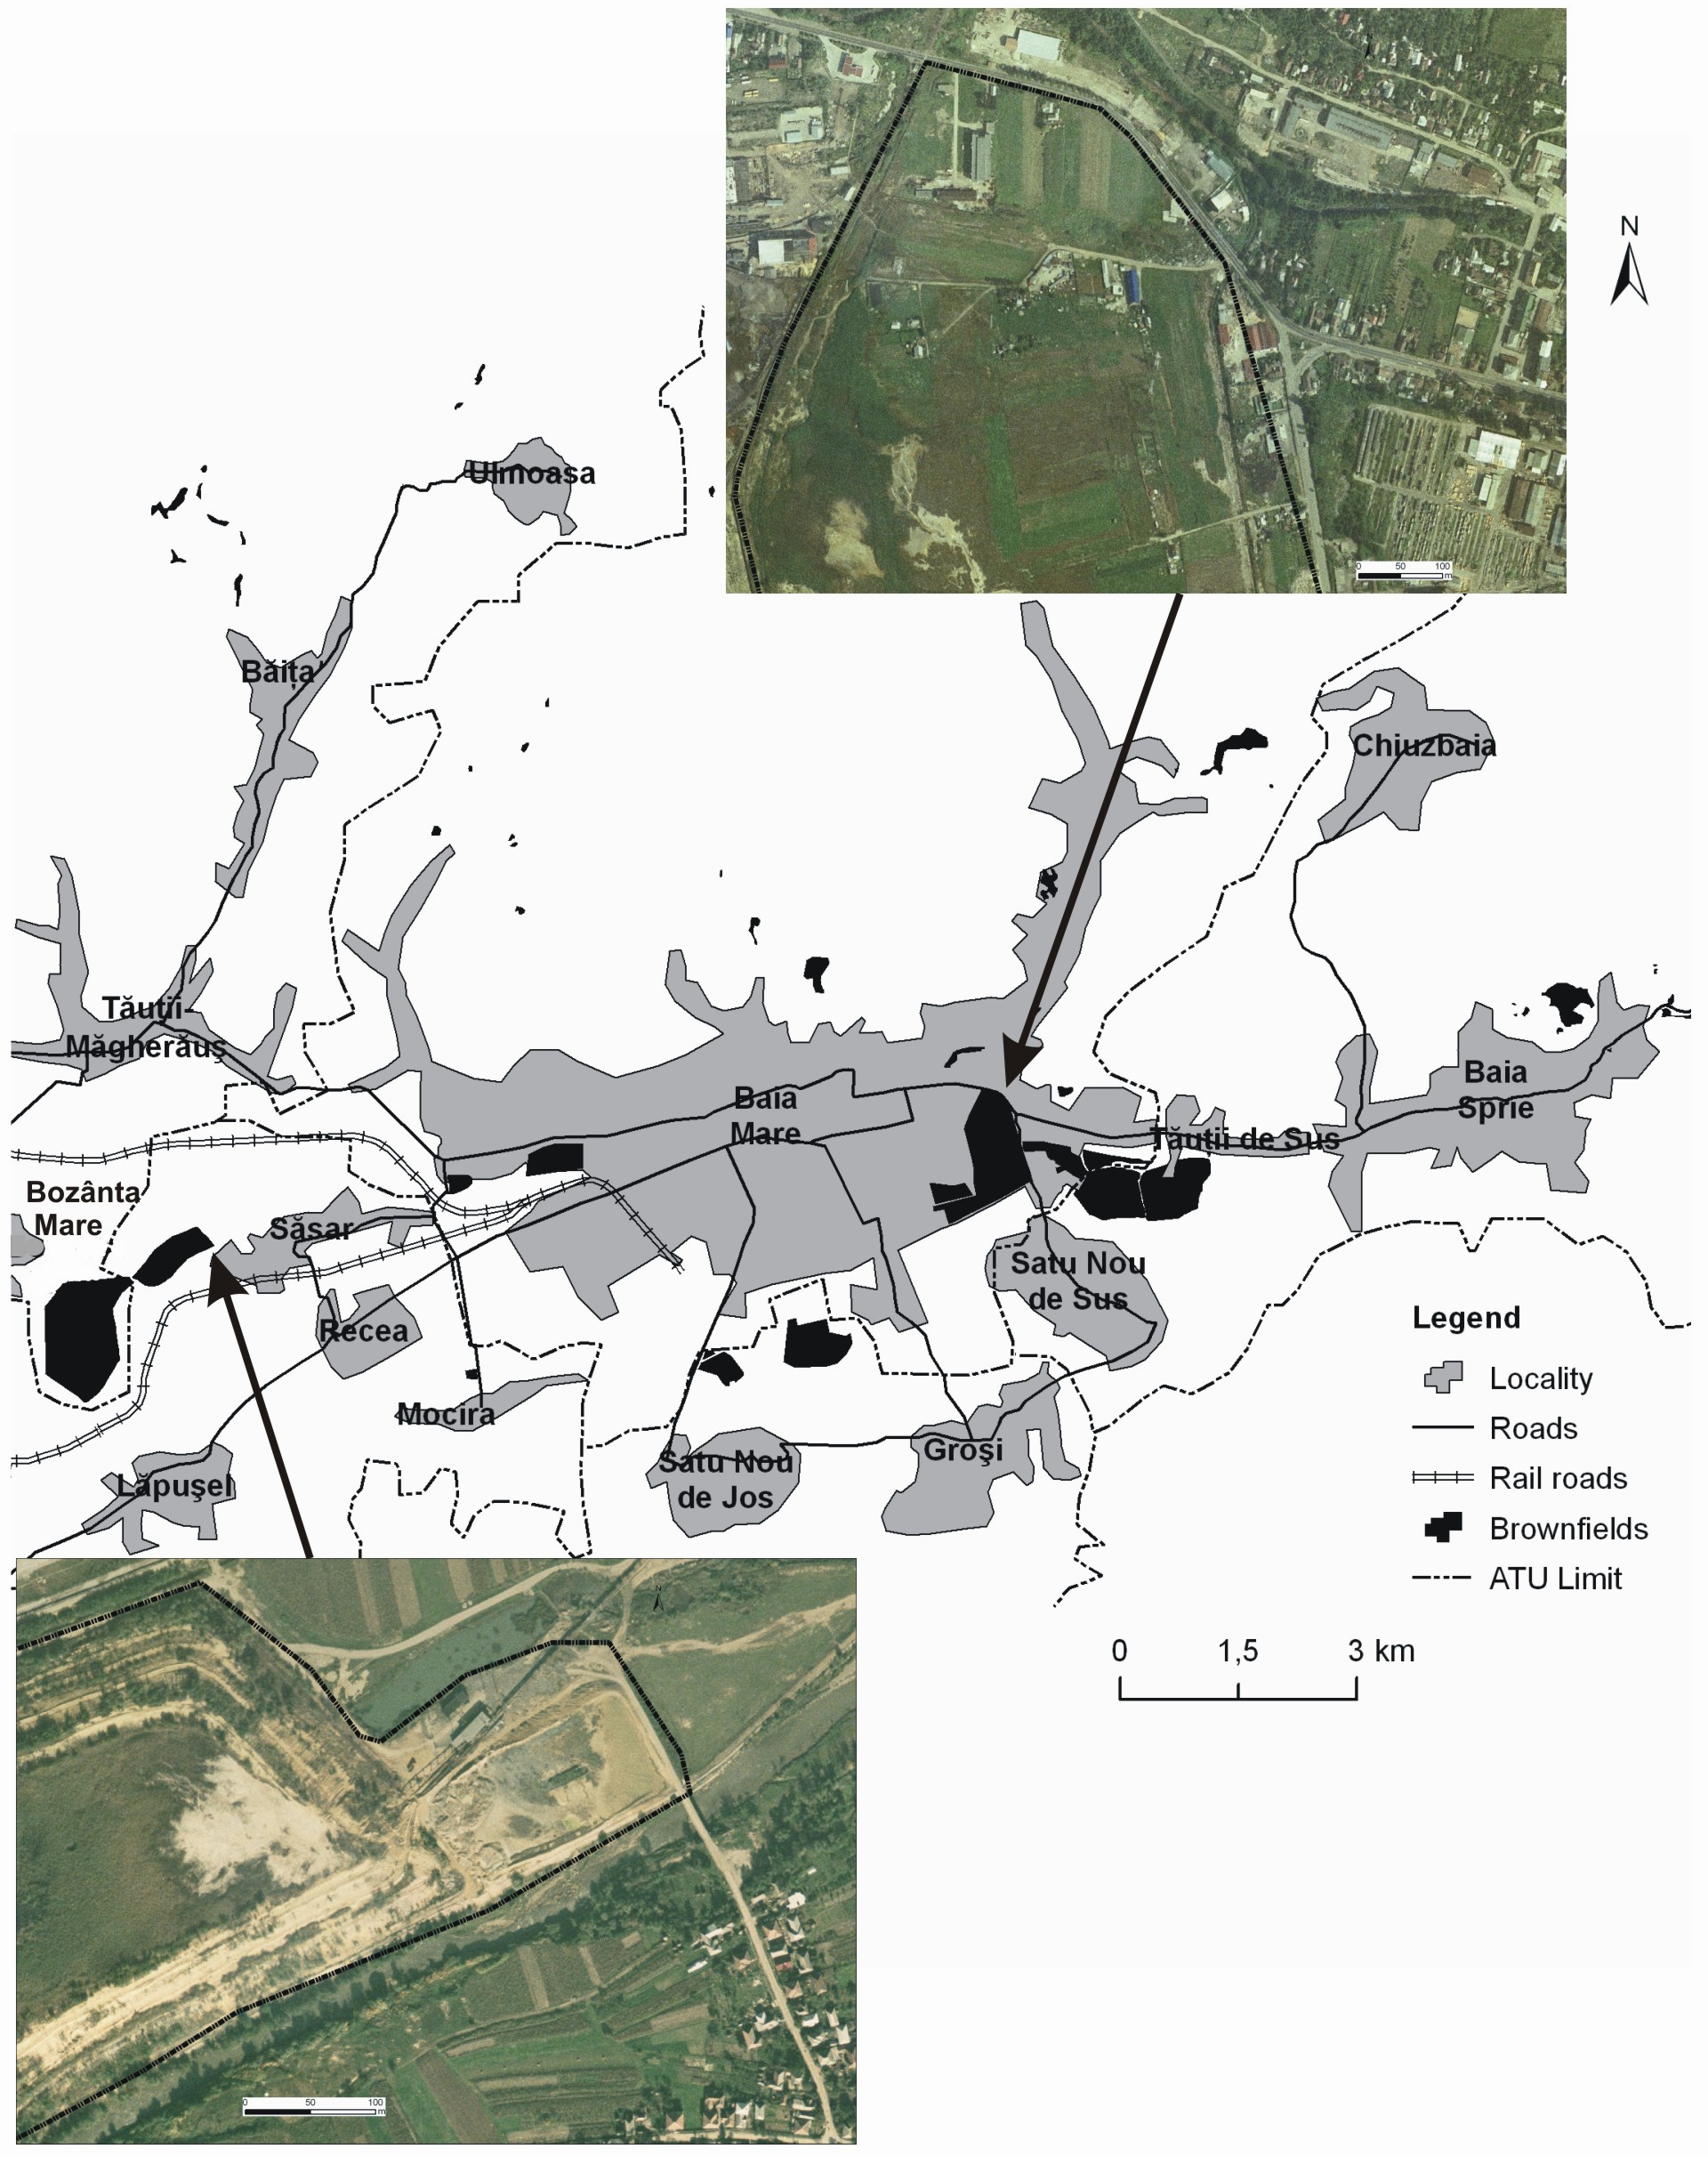

Figure 2. Distribution of brownfield lands in the peri-urban area of Baia Mare Municipality

In the context of an increasing space crisis, the benefits of revalorizing the brownfields are worth being taken into consideration, especially in the intensely urbanized belt in the middle region (Tăuţii Măgherăuş – Baia Mare – Baia Sprie): stopping the extension of the built-up areas towards the mountainous area and in the interface with the depression area, liable to landslides, and redirecting the development towards areas of low geomorphologic restrictiveness (1), usage of interstitial spaces within the built-up areas of the localities (2), and preservation of the interurban space, by avoiding a contiguous development (wall to wall) (3).
From the territorial planning viewpoint, some actions to prevent the appearance or the extension of brownfields appear as necessary. Thus, at regional level, the following are required:
- the adoption of a policy to support the sustainable economic activities;
- the adoption of an active policy for the rehabilitation of degraded areas resulted from industrial activities;
- the enhancement of economic agents’ responsibility with regard to the impact upon environment and the maximization of the efficiency of the “polluter pays” principle;
- the creation of a stimulating financial environment for ecologization activities (e.g. exemption from taxes, tax reduction, etc.).
At local level, these elements must be supplemented with actions to promote sustainable spatial forms, as a corollary of the establishment and the assumption of the spatial extension limits.
Based on the presented aspects, it can be considered that the issue of regional and local development must reconsider the manner of approaching brownfield lands, having as main objective their transformation from repulsive lands into available areas in relation to different necessities of territorial development. The attainment of this objective must be correlated with the utmost exploitation of the existent territorial potential, in relation to both the residential and the non-residential functions.

REFERENCES

cocean p., filip s. (2008), Geografia regională a României [Regional Geography of Romania], Presa Universitară Clujeană, Cluj-Napoca.
cocean p., (2004), Planul de amenajare a teritoriului Regiunii de Nord-Vest. Coordonate majore. [Spatial Arrangement Plan of the North-West Region. Major Coordinates], Presa Universitară Clujeană, Cluj-Napoca.
DAMIAN FLOAREA, DAMIAN GH., LĂCĂTUŞU R., MACOVEI GH., IEPURE GH., NĂPRĂDEAN IOANA, CHIRA R., KOLLAR LENUŢA, RAŢĂ LOANA, ZAHARIA DORINA CORINA, (2008), Soils from the Baia Mare zone and the heavy metals pollution, Carpathian Journal of Earth and Environmental Science, 3, 1.
DEZSI ŞT., (2006), Ţara Lăpuşului. Studiu de geografie regională [The Land of Lăpuş. Study of Regional Geography], Presa Universitară Clujeană, Cluj-Napoca.
DRIGA B., NICULESCU GH., CHENDEŞ V., CĂLIN D., CIUPITU D., ŞERBAN MIHAELA, ZAHARIA S., (2004), Riscuri antropice cauzate de activităţi miniere în zona Borşa (jud. Maramureş) [Anthropic Risks Generated by Mining Activities in Borşa Area, Maramureş County], in Riscuri şi catastrofe, 1, Casa Cărţii de Ştiinţă, Cluj-Napoca.
DOHOTAR V., (2008), Organizarea spaţiului geografic în bazinul superior al Vişeului [Organization of the Geographical Space in the Upper Basin of the Vişeu], Teza de doctorat, Facultatea de Geografie, Cluj-Napoca.
FILIP S., (2008), Depresiunea şi Munceii Băii Mari. Studiu de geomorfologie environmentală [The Depression and the Hillocks of Baia Mare. Study of Environmental Geomorphology], Presa Universitară Clujeană, Cluj-Napoca.
FLOCA L.A., BEDELEAN I., DĂRĂBAN L., FIAT T., MARTA BAYER (1995), Caracterizarea fizico-economică a materialului de haldă din bazinele miniere Baia Mare şi Munţii Apuseni [Physical and economic characterization of mine-waste dump material in the mining basins of Baia Mare and of the Apuseni Mountains], Studia Universitatis Babeş-Bolyai, 1, Cluj-Napoca.
PETREA D., PETREA RODICA, (2005), Mining, anthropic landforms and environmental threatening in the urban area of Baia Mare (Romania), in vol. The 10th Romanian-Italian-Franco-Belgian Geomorphological Meeting: Geomorphology and Environment, Mangalia.
* * * (2000, 2007), Corine Land Cover, European Environment Agency, Copenhagen.
* * * (2007), Raport privind inspecţia tehnică şi controlul iazurilor de decantare din industria minieră [Report on technical inspection and control of tailings settling ponds in mining industry], Ministerul Mediului şi Gospodăririi Apelor, Bucureşti.

Assistant professor, Ph.D., Babeş-Bolyai University, Faculty of Geography, 5-7 Clinicilor Street, Cluj-Napoca, Romania. E-mail: sfilip@geografie.ubbcluj.ro

