**Universidad de las Fuerzas Armadas ESPE**



**Pitfalls Inspection.**

**Software Juniors Members:**

Flores Caetano

Guaman Jordan

Jaya Carlos

Jumbo Alexander

**Oriented Objects Programming**

**Professor:**

PhD. Edison Lascano

**NRC:**

9642

* **Duplicate code**
  + Duplicated code on all try and catch.
  + 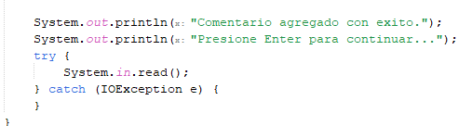
  + 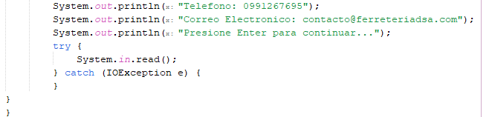
* **Inconsistent names**
  + FILE_NAME variable doesn’t follow the convention
  + 
* **Long methods**
  + method cart on Costomer class is large, can be splitted in other methods and reuse
  + 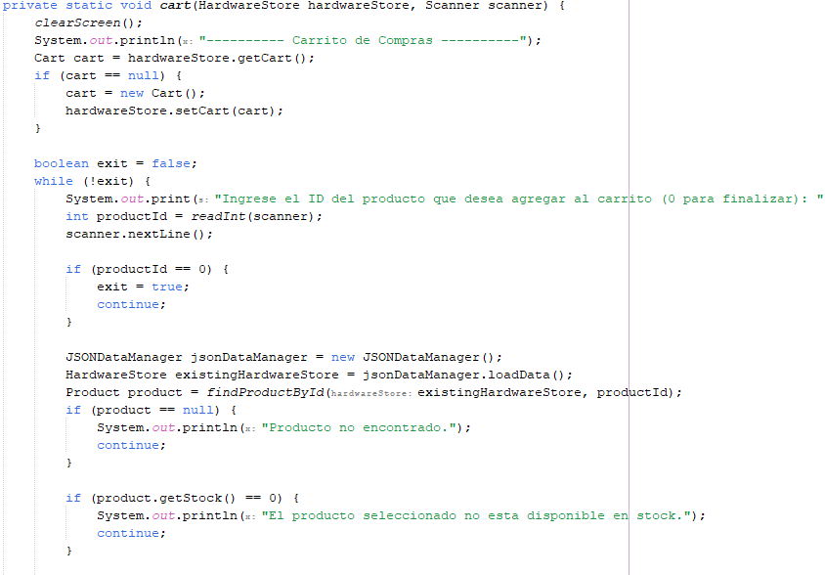
  + 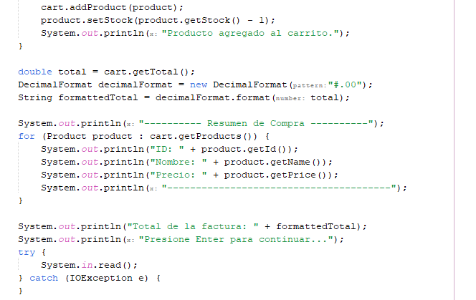
* **Death code**
  + Death code in Category
  + 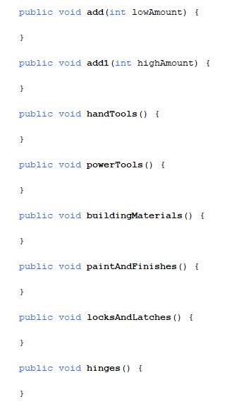
* **Speculative Generality**
  + Speculative methods in Hardware Store
  + 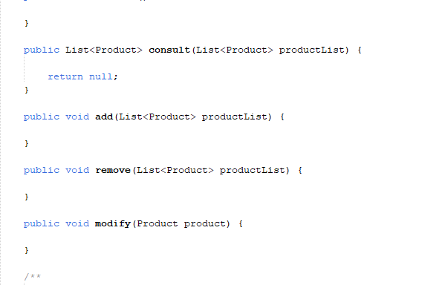

**RECOMMENDATIONS**

* **Duplicate code**
  + Create a method for “reading” exceptions
* **Inconsistent names**
  + Refactor “FILE NAME & FILE PATH” for fileName & filePath
* **Long methods**
  + Split the method cart in 2 or 3 parts
* **Death code**
  + Delete the code in Category
* **Speculative Generality**
  + Delete unused methods in HardwareStore