

Guidelines for use of BPM, BAM and BRMS in Transformation of Banking Applications to Hybrid Cloud

Marino Aguilera
Global Banking and Financial Markets Center of Competency
Marino.aguilera.sola1@ibm.com

Alfredo Muñoz Ríos
Global Banking and Financial Markets Center of Competency
alfredomunoz@es.ibm.com

Purpose of this Document
Business Process Management solutions in banking have not been historically very successful, especially when applied to core processes such as Loan Origination, Customer onboarding… which are complex processes than require business activities belonging to different domains in the bank, such as legal, risk management, compliance, marketing and sales…. The results are complex processes that run cross many applications and business owners
With the emerge of Hybrid Cloud Infrastructure which most banks aim to leverage to gain efficiency and agility, comes new requirements on how the applications for such environments should be. Hybrid Cloud requires hyper-modular solutions to achieve the expected availability and performance. Agility requires to decrease dependencies across applications, business units and IT teams. In this situation, business processes must be designed not to exceed the bounded contexts of the business domains in which applications are structured. This principle is usually not well understood and accepted by organizations that have always been “process centric” and not “service centered” or have little experience with practices such as Domain Driven Design.
This document addresses this difficulty and provides guidelines on the use of BPM, BAM and BRMS tools in transformation of Legacy to Hybrid Cloud. It´s structured in two topics:

- BPM and Business Monitoring. Identify the patterns to implement structured (BPM) and unstructured (Case Manager) processes, when business activity monitoring should be used and the boundaries between processes and UI flows.
- Business Rules Management Systems. When the BRMS will be used and what guidelines and constrains must be considered to make a proper use of this technology

Process Patterns

Options to implement business processes
- Programmatic approach
- Declarative approach (engines)
  - BPM Engine
    - Long running activities involving human interaction and automatic tasks supported by information systems.
    - Structured processes with a clear activity flow.
    - All types of activities are known in advance.
    - Based on BPMN standard.
  - Case Manager Engine
    - Long running activities involving human interaction and automatic tasks supported by information systems.
    - Unstructured process with no clear flow.
    - Not all the activities are known in advance.
    - Based on the CMMN standard (https://www.omg.org/spec/CMMN/1.1/PDF)

BPM and CM Objetives
Business Process Management (BPM) is a paradigm which its systems are designed to enforce a command and control management model to ensuring consistent work, adherence to policy and regulation, and generally repeatable, predictable modes of work. Where efficiency gains are realized, it is through standardizing how work is performed.
The Case Management Systems (CM) adapts to the context of the case, guiding the outcome base on the combination of rules, policies, data and application of knowledge worker know-how. So, CM is event-driven, content and context aware.
Where knowledge workers do spend most of their time (2/3 of their day as shown below) is at the nexus of both purely unpredictable work, where nothing ever happens the same way twice, the realm of barely repeatable processes, where work follows a pattern, but not a scripted pathway.
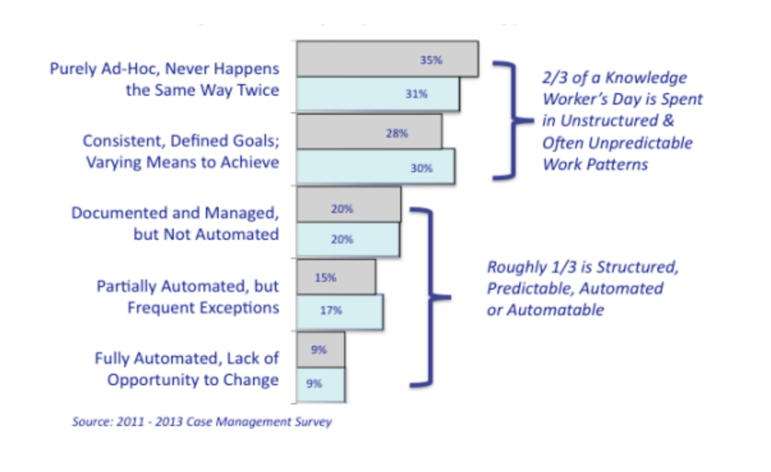
This is in contrast with traditional structured workflow, which may be complex in its definition, yet is comparatively much more narrowly focused, by virtue of the fact that it is entirely predefined. Whereas Case Management (as a means of facilitating knowledge work) involves specifically defined goals and milestones, inevitably the sequence to realize these changes varies from day-to-day. This spotlights the critical difference between Business Process Management (BPM) and workflow automation from Case Management, where both structured work and structured processes combine across the lifecycle of a business process.
BPM focuses on enabling compliance and scalability by predefining workflows. BPM processes are deterministic, where all possible paths are predetermined or known in advance, no mater how complex pathways maybe. The direction of the process is determined by the predefined path and current state. State is determined by the preceding activity, in other words, where it is the process.

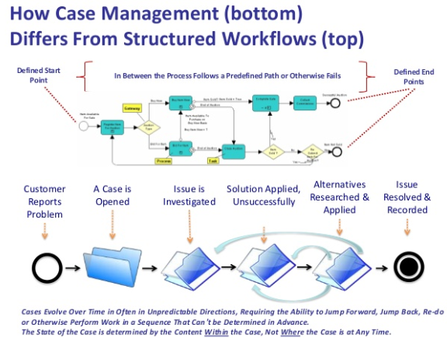

When to use BPM vs. Case Manager

The following table shows the key differences between business process management and case management. Depending on the business process we have to implement, it can be selected one option or another option.

Item | BPM | CM
Activity order | You can define an ordered sequence of activities that can be completed to solve a business challenge. | You can define an unordered set of activities that can be completed to solve a business challenge.
Activity prediction | The sequence of activities is stable and seldom changes; that is, the process is predictable and repeatable. | The activities occur in an unpredictable order.
Events and process | The process determines the events. The first activity determines the first set of events, which then leads to the next activity and the next set of events. The activities are wired to one another, which determines the sequence. | The events determine the process. As events occur, a worker selects the appropriate activity. The resulting process can vary depending on the current event and the subsequent selection by the worker. Activities are not wired to one another.
Activity nature | The activities are often programmatic. A repeatable sequence, such as selecting a set of potential credit card owners from a database, can be automated. | People primarily determine the activities. Handling a customer with a billing error is done by a person who uses judgment to determine the best resolution of this particular case.
External inputs | External inputs don’t belong to the process itself and have no meaning for the process. | External inputs can play a key role in a CM process. For instance, external documents could modify the behavior of the process itself. Receipts provide a record for how the problem that must be resolved began.

Some samples when to use BPM or CM

Type of process | BPM | CM
Back office process with a repeatable sequence of activities like document processing. | X
Incident Management as customer complaints are unpredictable in both the defining details and resulting ramifications. |  | X
Service Request Management are inherently event-driven, whether it’s a help desk scenario where a service request call is coming in or logged. |  | X

Type of interactions using BPM and CM
In general, when considering an interaction from one component (source or client) to another (target), the service client determines what type of invocation is used.
The invocation styles are:
- Synchronous
- Asynchronous
  - Asynchronous using one-way operation
  - Asynchronous with callback
A component can be called synchronously or asynchronously; independent of whether the implementation is synchronous or asynchronous. The component interfaces are defined in the synchronous form and asynchronous support is also generated for them. This definition is going to be determined by the business requirements and the NFRs.
The asynchronous type advertises to users of the interface that it contains at least one operation that can take a significant amount of time to complete. As a consequence, the calling service must avoid keeping a transaction open while waiting for the operation to complete and send its response.
Events are by nature asynchronous, as events are very important in the new architecture paradigm (microservices), most of interactions should be asynchronous. First, with events there is no completely predefined process schema anymore, instead, the interactions between producer and consumer that are not known in advance. Second, the interactions are asynchronous and cannot be assigned to a certain point in the process. Third these interactions are not only one-to-one but also one-to-many.

 | BPM | CM
Interaction patterns | One-to-one | One-to-one, one-to-may, many-to-may
Predefined | All interactions predefined | Predefined and not predefined interactions
Synchronous / asynchronous interactions | Synchronous and asynchronous interactions | Synchronous and asynchronous interactions

BPM Guidelines
For the purpose of this document, we´ll use the term “domain” of each of the sub-domains contained in a BIAN Service Domain.
At the moment of redacting this document there´s no final decision on the technology to support BPM and Case Manager, although the current position if to use RedHat PAM solution. Nevertheless, these guidelines will be valid for both two scenarios: a containerized solution as PAM or a Platform Solution (single instance supporting processes belonging to different domains).
Guidelines:
- Business Process or Cases will never pass the boundaries of the domain the belong to. For example, the agreement fulfillment process will never exceed the boundaries of the “product agreement” domain. Underwriting process or case will never exceed the boundaries of the underwriting domain
  - Activities within the process or case will never directly invoke APIs from other domains or received events from other domains. They will only be accessed to the domain APIs and Event hander. BPM and CM will follow the same isolation patterns as defined in Microservice Development Guidelines such as external data management or event handling separation
  - For BPM/CM platform solutions, the processes or cases belonging to different domain will be isolated from each other using the available tools in the solution. A process in a domain can never invoke as a subprocess, a process belonging to other subdomains.
  - BPM / CM APIs will never be exposed externally to the domain, but only through the domain APIs.
- Whether to use a BPM, CM, or none of them will be decided in a case by case basis and will be responsibility of the design authority. A decision criteria document (checklist) will be created and will be improved with any analysis and decision taken during the projects. The initial criteria will be the one described above in this document in “When to use BPM vs. Case Manager” section.

BAM

BAM objective
Business Activity Monitoring (BAM) allows decision making based on monitoring business processes in real time. Plus, these tools allow the correlation of work events, identifying behavior tendencies and patterns, along with the possibility to offer action completion, generating new events. The main objective of BAM is to know a process’ behavior and evolution.

When to use Business Monitoring

Usage Pattern | Description
Business Events | When a business event is triggered, this event should be monitored by the BAM solution. A Business Event is something that happens and is relevant for the business. So, BAM solution should track all the business events.
Learning and AI systems | When we want to extract and process information, we should have a learning and AI system that allows the system to recommend steps to follow in decision making. For example, it should be capable of identifying tendencies and warning about them.
Business Processes and Case Manager | We would like to know a bottom-up view of our business processes, we should have the possibility to provide a bottom-up view in such a way that the user who accesses the control panel can also access process-level information (bottlenecks, inbound payments, etc.) and system level information (network failure, server memory full, device switched off, etc.).
Third party integration | If we want to deal with third party partners, our BAM tool must be able to integrate with any kind of third-party application easily. It must be kept in mind that during a process many applications from different developers can intervene, and our tool must be capable of accessing relevant information on all of them.
Real time information | We have business requirements to provided information in real time, so BAM is needed, it must be capable of giving information and updating the dashboard in real time.
Event correlations | It is needed to make correlations between event, so BAM it is needed, it must have the capacity to correlate events and take action based on those events.
Report system needed | This is really important since the system has to allow not only showing data in a very clear way, but also it must have the possibility to generate understandable reports to be sent and analyzed by third persons.

When to use Business Monitoring in the Domain Model

Usage Pattern | Description
Business Event | Every time a business event is triggered, this event should be monitored by the BAM solution. We have to remember that a Business Event is something that happens and is relevant for the business. For example, the event "account creation requested" is very meaningful for the business because it will trigger the process to prepare an account for creation. So, it is very important the BAM solution tracks all the business events.
Domain Event | Every time a domain event is triggered, this event should be monitored by the BAM solution. A Domain Event represents a Business Event generated by a Domain, usually because of a change in the aggregate of the Domain. Domain Events are the most important elements in the communications between domains. So, it is crucial the BAM solution keeps the track of all these events.
Business Processes and Case Manager | Every time a business process is launched, this business process should be monitored by the BAM solution. As we known, a business process is a sequence of business events and the things that triggers such business events, such as another events and commands. So, all these relevant events from business point of view it is important that BAM solutions tracks these events.

Some samples when to use Business Monitoring

Sample | Description
Accounting | Notifies the accounting department if a new account is added to the system.
Operations | Monitors relevant business fields such as expire dates, client data, etc.
Sales and marketing | Notifies clients when their products or services are available and automatically sends bills when the process finishes.
Risks | Follow up on credit card transactions to avoid possible frauds.

BAM Guidelines
For the purpose of this document we´ll use the term “domain” of each of the sub-domains contained in a BIAN Service Domain.
At the moment of redacting this document there´s no selection for a BAM solution. The assumption is made that the BAM solution will be the one provided together with the BPM/CM. This guideline will serve both scenarios with a solution that can be containerized or with platform solutions (single instance for several monitoring models.
Guidelines:
- A business monitoring model will never overpass the boundaries of a domain.
  - Monitoring models expanding events in different domains will require the definition of a new domain, the description of the aggregate which activity will be monitored. The monitoring model becomes as domain on its own and must be placed within a BIAN Service Domain.
  - A monitoring model will only consume the business events handled by the domain. If other events are to be included in the model, they will be acquired through the domain (this is to better govern and identify impact in changes in events).
  - A monitoring model will be deployed as a separate container or, for platform BAM solution, will be isolated from other monitoring models using the available tools in the solution. For example, in this last scenario, the monitoring model for a domain cannot consumed events that are not handled by its domain, even if they are already being captured by the BAM solution (this is to minimize coupling and improve impact analysis of changes in the events).
- BAM tool will be used for monitoring models that monitors business events. There may be other monitoring models that uses no BAM tool and directly reads into domain databases using the domain APIs. This has to be evaluated in a case by case basis.
- There may me monitoring models associated to processes implemented in the BPM and CM, but also for domain implemented without such as tools. Due to the event-driven nature of the microservice design, the implementation of monitoring models will be easier and straightforward than in legacy systems.
- Monitoring Models for BPM and CM will be tightly coupled with the processes and cases. This means that will leverage the out of the box integration between such tools as provided by the vendor.
- The decision to create a business monitoring model must derive from business requirements. A model will not be created without such as requirement. As usual, a business monitoring model requires a business owner and must not have more than one.

BRMS

What is a business rule?

A business rule is a statement of business logic that:
- Business users can author and understand.
- Applications can invoke for execution

From the business perspective a business rule is a precise statement that describes, constrains, or controls some aspect of your business.
From the IT perspective, business rules are a package of executable business policy statements that can be invoked from an application
How you define a business rule can depend on your perspective. Generally, a business rule is a statement of business logic that can be understood both by the business users who author the rules, and by the application that invokes the rules for execution.
From the business perspective, rules relate to the expression of decisions that are needed to respond to a business request. If you are a business user, you might define a business rule as a precise statement that describes, constrains, or controls some aspect of your business.
From the development or IT perspective, rules relate to the implementation of a decision system, and integration into an existing infrastructure, such as application-based or service-oriented architecture. A developer sees business rules as a package of executable business policy statements that can be invoked from an application.

What is Decision Management?
Decision Management is a business discipline that combines business expertise with software:
- Automate, optimize, and govern repeatable business decisions.
- Capture, change, and govern decision logic in a controlled and scalable way.
- Automate decisions so that they can be called in real time by processes, applications, and other business solutions;
Not every business decision can be automated. However, for repeatable decisions, the technology makes it possible to record the rules you use in your business every day, codify those rules in a user interface, and easily change and manage those rules.

Why use a Decision Management System?
Decision management externalizes the decision logic from processes and applications, which provides visibility for business users and enables reuse across business systems. The separation of decision logic from code puts business experts in control of maintaining the logic and the response to various events or situations.

When decision management is separate from application code, business experts can define and manage the business logic themselves. This separation reduces the amount of time and effort that are required to update that business logic in production systems and increases the ability of an organization to respond to changes in the business environment.
Decision automation also reduces the load on people, which frees them to use their skills more effectively and maximizes straight-through processing. Automation provides faster, consistent, predictable, and traceable decision making.

Types of business rules

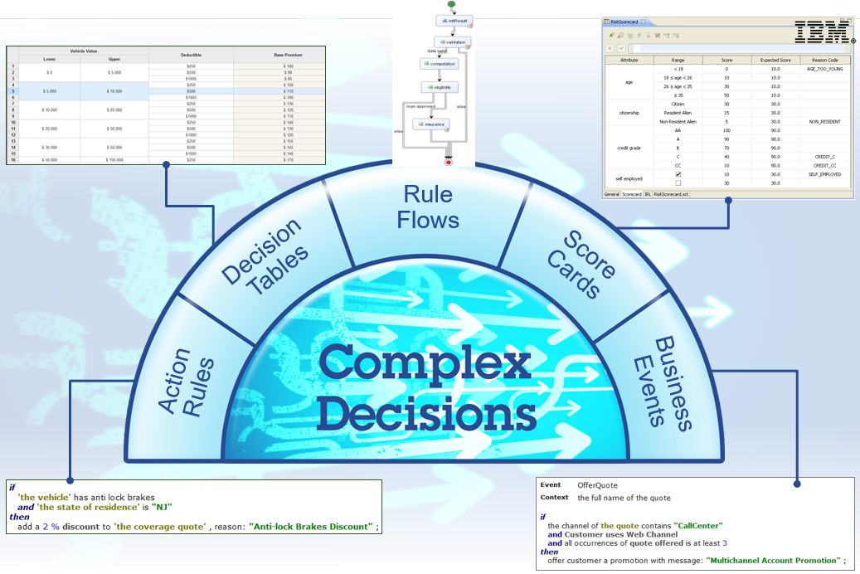

When to use a business rule engine

Item | Description | Answer
Item | Description | Yes | No
Project size | Is your project small, possibly with less than 20 rules? then a rule engine would probably be an overkill?  However, think twice before making a decision, because many systems start small, but as more requirements are implemented, it suddenly becomes unmanageable. | Do not use | Use
Quality of business logic | Is your business logic well-defined or static and doesn't change often? | Do not use | Use
Quality of business logic | Do you need to change rules at runtime? | Use | Do not Use
Logic self-contained | Are your rules simple, self-contained, usually spanning only a single object (for example, a check that a user's age is less than 21)?  You don't need a rule engine if in pseudocode, you don't have more than two nested if-then statements. Again, consider this carefully because every system grows in complexity overtime. | Do not use | Use
Performance concerns | Is the performance your primary concern? Are you implementing some algorithm where you want to have precise control over its execution? Do you have a memory-constrained environment? | Do not use | Use
One-shot effort | Is your project a one-shot effort and it will never be used again or maintained over time? | Do not use | Use

Benchmarking Drools & Blaze

Comparatives:
https://www.itcentralstation.com/categories/business-rules-management
https://www.trustradius.com/compare-products/OperationalDecisionManager-vs-drools-vs-red-hat-decision-manager

Drools:
https://www.drools.org/

Blaze:
https://www.fico.com/en/products/fico-decision-management-suite#overview

END OF THE DOCUMENT

If the BRMS tool allows changes in hot

